Submitted by the expert from The Netherlands Informal document GRSG-119-16
(119th GRSG, 6-9 October 2020,
Agenda item 7b)

Proposal for amendments to Regulation No. 110 – CNG/LNG vehicles

The text reproduced below was prepared by The Netherlands proposing the introduction of requirements to UN Regulation No. 110 for the state-of-the-art test requirements and harmonization with ISO15500 and NGV3.1 components used in LNG/CNG systems. Also suggestions are made to correct errors in the existing document. Modifications to the original text are marked in bold italic and underline for new characters and strikethrough for deleted characters.

- Proposal

Insert manual valve in the table paragraph 8.4-8.11 (currently missing in the table), to read:

Paragraph | Component | Annex
8.4. | Automatic valve  Check valve or non-return valve  Pressure relief valve  Pressure relief device (temperature triggered)  Excess flow valve  “Manual valve”  Pressure relief device (pressure triggered) | 4A
8.5. | Flexible fuel line-hose | 4B
8.6. | CNG filter | 4C
8.7. | Pressure regulator | 4D
8.8. | Pressure and temperature sensors | 4E
8.9. | Filling unit or receptacle | 4F
8.10. | Gas flow adjuster and gas/air mixer, injector or fuel rail | 4G
8.11. | Electronic control unit | 4H

Replace the test mercurous nitrate mentioned at Annex 3A A.24.

(c) Exposed brass pressure retaining components of pressure relief devices shall withstand, without stress corrosion cracking, a mercurous nitrate test as described in ASTM B154. The pressure relief device shall be immersed for 30 minutes in an aqueous mercurous nitrate solution containing 10 g of mercurous nitrate and 10 ml of nitric acid per litre of solution. Following the immersion, the pressure relief device shall be leak tested by applying an aerostatic pressure of 26 MPa for one minute during which time the component shall be checked for external leakage; Any leakage shall not exceed 200 cm3/h; “immersion in ammonia.

a) Subject each test sample to the physical stresses normally imposed on, or within, a part as a result of its assembly with other components. Apply these stresses to the sample prior to testing and maintain them throughout the test. Samples with thread, intended to be used for installing the product in the field, shall have the threads engaged and tightened to the torque specified in the instruction manual of the sample or specified by the manufacturer. Polytetrafluorethylene (PTFE) tape or pipe compounds shall not be used on the threads.

b) Degrease three samples and expose them continuously for 10 days at a set position to a moist ammonia–air mixture, maintained in a glass chamber of approximately 30 l in capacity with a glass cover. Aqueous ammonia having a specific gravity of 0,94 shall be maintained at the bottom of the glass chamber, below the samples, at a concentration of 21,2 ml/l of chamber volume. Maintain approximately 600 cm3 of aqueous ammonia, with a relative density (specific gravity) of 0,94, at the bottom of the glass chamber, below the samples. Position the samples 40 mm above the aqueous ammonia solution, supported by an inert tray. Maintain the moist ammonia–air mixture in the chamber at atmospheric pressure and at a temperature of 34 °C ± 2 °C.
After being subjected to the conditions of this procedure, samples shall show no evidence of cracking when examined at a magnification of 25×.”

Insert the in bold underlined and italic new description for Annex 4A:

3.2.3 The non-return valve, being in the normal position of use specified by the manufacturer, is submitted to 20,000 operations; then it is deactivated.
“Following 20 000 cycles of operation, subject the check valve to 240 h of chatter flow at a flow rate that causes the most chatter. Failure in any sense during the procedure shall constitute a failure of the check valve. All parts shall remain in position and function properly after this test.”
The non-return valve shall remain leak-proof (external) at a pressure of 1.5 times the working pressure (MPa) (see Annex 5B).

Insert the in bold underlined and italic new description for Annex 5L:
Annex 5L
Durability test (continued operation)
(c)Low temperature cycling

The component shall be operated through 2 per cent of the total cycles at the appropriate minimum temperature specified at rated service pressure. The component shall comply with the leakage test of Annex 5B at the appropriate minimum temperature specified at the completion of the low temperature cycles.
Following cycling and leakage re-test, the component wheel style valves shall be capable of completely opening and closing when a torque not greater than that specified in Table 5.3 below is applied to the component handle in a direction to open it completely and then in the reverse direction. “For a lever operated valve the appropriate maximum torque is to be determined by applying a pull force of 150 N to the end of the handle operating mechanism.”

II. Justifications

- This document is intended to serve as a discussion paper for the experts to modify:
  - Errors/mistakes in the current R110
  - Update paragraphs being in line with the requirements coming from the ISO15500 and NGV3.1 (industry standards for the CNG):
    - Annex 3A test A.24. the current mentioned mercurous nitrate test is replaced by a 10 day ammonia immersion. Mercurous nitrate is known as an CMR substance and need therefore to be replaced.
    - Annex 4a, after the duration test on a check valve it is common to perform a chatter flow. This chatter flow is something that can occur in practice at a filling station. To determine the closing function this test is added after the duration test. (being in line with ISO15500 and NGV3.1).
    - Annex 5L durability test on an manual valve is updated with the distinctions between a wheel style valve and lever operated valve. in the current text there is no distinction in requirements between the two versions. Having the new proposed wording will give a more dedicated requirement.

By introducing the above given requirements The Netherlands aims to make this regulation up to date and at the same time ensuring an adequate safety level.

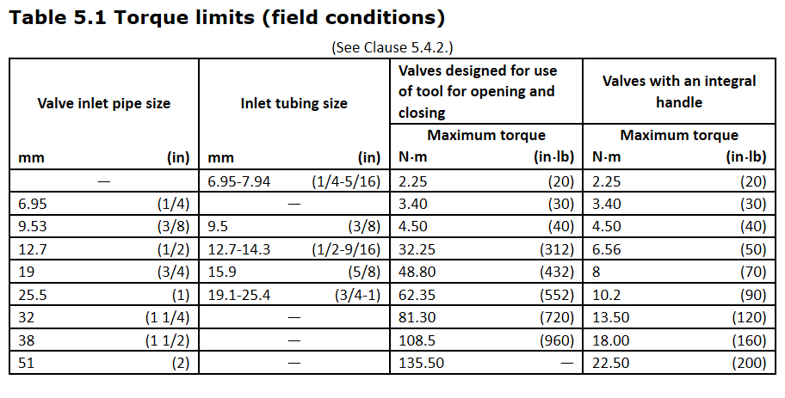

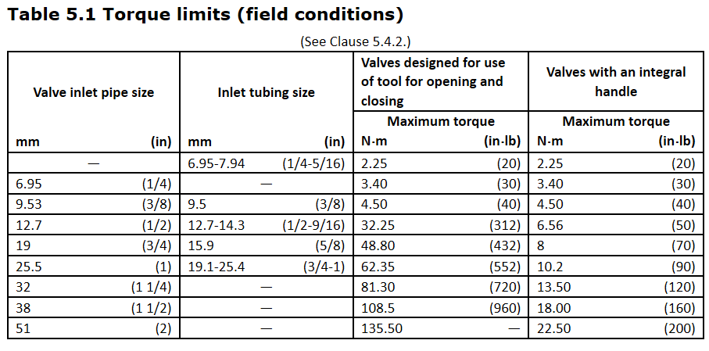

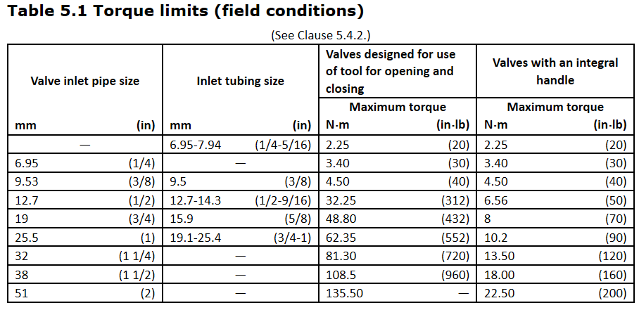

3

