|  |  |  |  |
| --- | --- | --- | --- |
|  | United Nations | ECE/TRANS/2020/3 | |
| _unlogo | **Economic and Social Council** | | Distr.: General  18 December 2019  Original: English |

**Economic Commission for Europe**

Inland Transport Committee

**Eighty-second session**

Geneva, 25–28 February 2020  
Item 4 (a) of the provisional agenda  
**Strategic questions of a horizontal policy**

**or regulatory nature: Status of accession to international**

**United Nations inland transport conventions and agreements**

Status of accessions to United Nations transport agreements and conventions under the purview of the Inland Transport Committee

Note by the secretariat[[1]](#footnote-2)\*

|  |
| --- |
| *Summary* |
| This document presents the status of accessions by ECE and non-ECE member States to the United Nations transport agreements and conventions administered by ECE. |
| On 1 December 2019, the total number of contracting parties to the 59 United Nations legal instruments in the field of transport administered by ECE was 1,767, with 11 new contracting parties to seven legal instruments. |
| The Committee may wish to **invite countries**, which have not yet done so, to accede to the United Nations conventions and other legal instruments in inland transport administered by the Committee and its subsidiary bodies. |
|  |

I. Overview

1. Figure I below shows the growth of the total number of contracting parties to legal instruments on inland transport concluded under the purview of the Inland Transport Committee (ITC). On 1 December 2019, the total number of contracting parties to the 59 United Nations legal instruments in the field of transport administered by the United Nations Economic Commission for Europe (ECE) was 1,767, with eleven new contracting parties to seven legal instruments (see annex for details). Out of these 59 legal instruments, ten have not yet entered into force. The summary tables on the status of signatures, ratifications and accessions for all legal instruments are available at www.unece.org/trans/conventn/intro.html.

Figure I

**Annual Growth of Contracting Parties to Legal Instruments on inland transport under the purview of ITC**

*Source*: ECE

2. Figure II below illustrates the evolution of accessions by ECE and non-ECE member States since 1950.

Figure II

**Accession of ECE and non-ECE Contracting Parties (1950**–**2019)**

*Legend:* Solid line: ECE member States - Dotted line: non-ECE member States

*Source*: ECE

3. Of the 193 United Nations member States, 148 States (77 per cent) are contracting parties to at least one legal instrument on inland transport, in addition to two Permanent Observers to the United Nations and one non-State contracting party. Almost eleven per cent of the United Nations member States are contracting parties to at least 30 legal instruments.

**II. Geographical Distribution of Contracting Parties**

4. The total number of contracting parties to the 59 transport conventions is 1,767 (as of 1 December 2019). Of these, 1,362 are ECE member States and 405 are non-ECE member States.

5. Of the 148 United Nations Member States that are contracting parties, 92 (62 per cent) are non-ECE United Nations Member States.

6. Out of the 59 legal instruments under the purview of ITC, 49 are in force. Non-ECE member States are contracting parties to 32 transport conventions, representing 30 per cent of the total number of accessions to these conventions. This also means that about 60 per cent of United Nations transport conventions serviced by ECE and in force, have a geographical coverage beyond the territory of ECE. On average, each ECE member State is party to 24 legal instruments, while each non-ECE member State is party to 4.3 legal instruments.

Figure III

**ECE and non-ECE Contracting Parties   
to at least one United Nations Transport Convention**

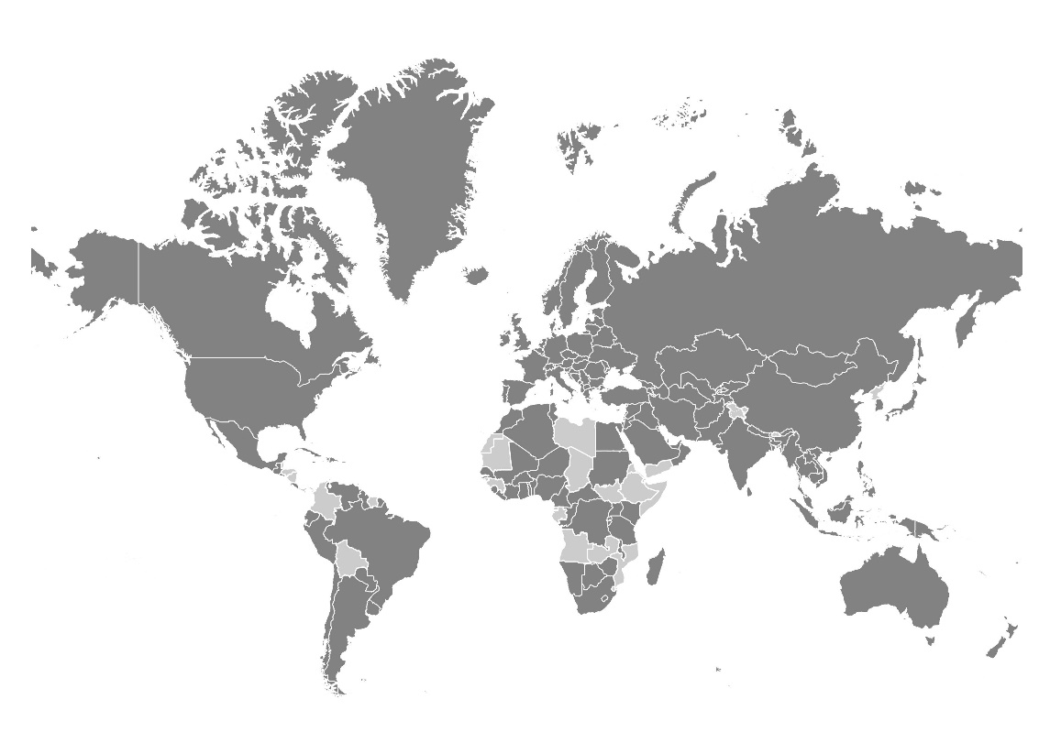

*Legend:* Dark grey: contracting parties - Light grey: non-contracting parties

*Source:* ECE

7. The European Union is currently the only non-State contracting party to United Nations legal instruments under the purview of the Committee. It is party to seven legal instruments.

8. Forty-five United Nations Member States are not contracting parties to any legal instruments on inland transport concluded under the purview of ITC: Angola, Belize, Bhutan, Bolivia (Plurinational State of), Brunei Darussalam, Chad, Colombia, Comoros, Democratic People's Republic of Korea, Djibouti, Dominica, Equatorial Guinea, Eritrea, Ethiopia, Gabon, Gambia, Grenada, Guinea, Guinea-Bissau, Honduras, Kiribati, Libya, Maldives, Marshall Islands, Mauritania, Micronesia (Federated States of), Mozambique, Nauru, Nicaragua, Palau, Panama, Saint Kitts and Nevis, Saint Lucia, Saint Vincent and the Grenadines, Samoa, Sao Tome and Principe, Somalia, South Sudan, Suriname, Swaziland, Timor-Leste, Tuvalu, Vanuatu, Yemen and Zambia.

9. The Committee may wish to **consider** this information and **provide guidance** on ways to increase the number of new accessions to the legal instruments under its purview.

**Annex**

Accessions registered from 1 January – 1 December 2019

| *Date* | *Contracting party* | *Convention* |
| --- | --- | --- |
|  |  |  |
| 18/11/19 | Malta | Protocol amending article 1 (a), article 14 (1) and article 14 (3) (b) of ADR |
| 11/11/19 | State of Palestine | Convention on Road Traffic, of 8 November 1968 |
| 26/09/19 | Portugal | Additional Protocol to the CMR concerning the electronic consignment note (e-CMR) |
| 09/07/19 | Tajikistan | Additional Protocol to the CMR concerning the electronic consignment note (e-CMR) |
| 26/06/19 | Myanmar | Convention on Road Traffic, of 8 November 1968 |
| 26/06/19 | Myanmar | Convention on Road Signs and Signals, of 8 November 1968 |
| 13/06/19 | Poland | Additional Protocol to the CMR concerning the electronic consignment note (e-CMR) |
| 30/05/19 | Pakistan | Protocol to the Convention on the Contract for the International Carriage of Goods by Road (CMR), of 5 July 1978 |
| 03/05/19 | Pakistan | Convention on the Contract for the International Carriage of Goods by Road (CMR), of 19 May 1956 |
| 14/03/19 | Romania | Additional Protocol to the CMR concerning the electronic consignment note (e-CMR) |
| 07/02/19 | Belarus | Additional Protocol to the CMR concerning the electronic consignment note (e-CMR) |
| 04/02/19 | Lithuania | Convention on Road Traffic, of 19 September 1949 |
| 11/01/19 | Finland | Additional Protocol to the CMR concerning the electronic consignment note (e-CMR) |

1. \* This document was scheduled for publication after the standard publication date owing to circumstances beyond the submitter's control. [↑](#footnote-ref-2)