Proposal for amendments to ECE/TRANS/WP.29/GRE/2019/03
I. Proposal
Paragraph 6.2.6.1.2., replace the blue figure by the figure in red (as agreed during the GRE 81st session):
“
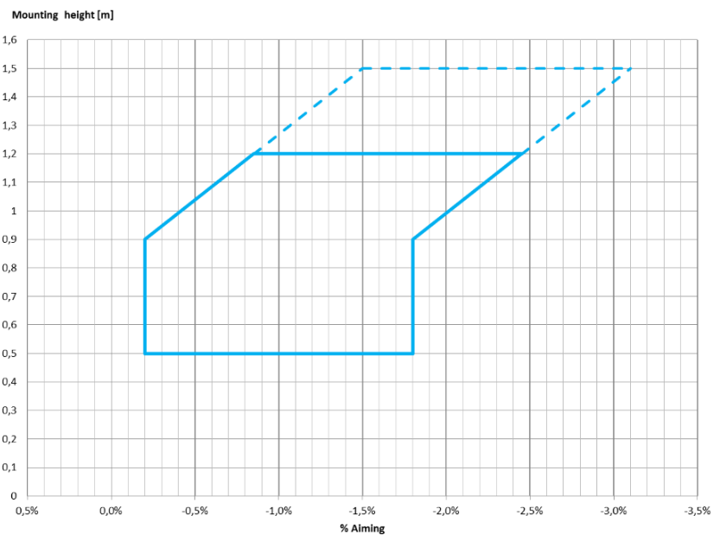
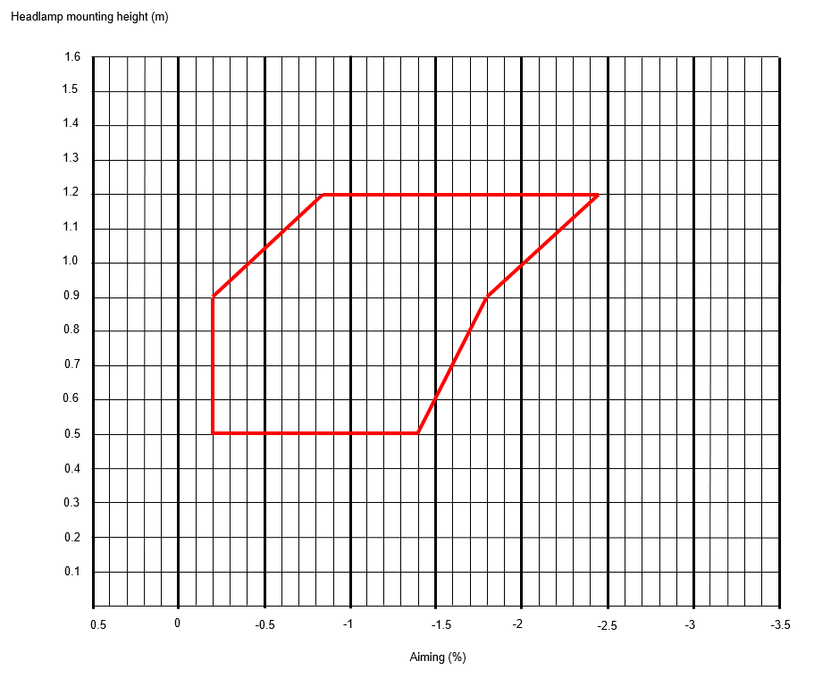
…”
II. Justification
- This is the agreed results to amend the blue diagram under paragraph 6.2.6.1.2. It shall be the basis for updating document ECE/TRANS/WP.29/GRE/2019/03
--------

