|  |  |  |  |
| --- | --- | --- | --- |
|  | United Nations | ECE/TRANS/WP.29/2019/119 | |
| _unlogo | **Economic and Social Council** | | Distr.: General  29 August 2019  Original: English |

**Economic Commission for Europe**

Inland Transport Committee

**World Forum for Harmonization of Vehicle Regulations**

**179th session**

Geneva, 12-14 November 2019

Items 4.16.1 and 16 of the provisional agenda

**1958 Agreement:  
Proposals for amendments to Mutual Resolutions**

**1998 Agreement:**

**consideration of amendments to Mutual Resolutions**

Proposal for Amendment 2 to Mutual Resolution No. 1 (MR.1) – Draft Addendum 3

Submitted by the experts from the Working Party on Passive Safety[[1]](#footnote-2)\*

The text reproduced below was adopted by the Working Party on Passive Safety (GRSP) at its sixty-fifth session (ECE/TRANS/WP.29/GRSP/65, para. 7). It is based on ECE/TRANS/WP.29/GRSP/2019/4. It is submitted to the World Forum for Harmonization of Vehicle Regulations (WP.29) and to the Executive Committee of the 1998 Agreement (AC.3) for consideration at their November 2019 sessions.

Proposal for Amendment 2 to Mutual Resolution No. 1 (MR.1) — Draft Addendum 3

*Contents*, amend to read:

"Contents

*Page*

Preamble

I. Statement of technical rationale and justification

II. Mutual Resolution (M.R.1) of the 1958 and 1998 Agreements concerning the description   
and performance of test tools and devices necessary for the assessment of compliance of   
wheeled vehicles, equipment and parts according to the technical prescriptions specified in Regulations and global technical regulations

1. Scope

2. General provisions

3. Specific provisions

Appendix

Addendum 1 - [Reserved for Bio Rear Impact Dummy (BioRID) specifications]

Addendum 2 - Specifications for the Construction, Preparation and Certification of the   
World Side Impact 50th percentile adult male anthropomorphic test device   
(WorldSID 50th male)

Addendum 3 - Specifications for the Construction, Preparation and Certification of the   
flexible Pedestrian Legform Impactor (FlexPLI) "

*Section II,*

*Paragraphs 3. and 3.1., Specific provisions,* amend to read:

"**3. Specific provisions**

3.1. The table below details the individual addenda to this Mutual Resolution in which details of the design, construction, maintenance and preparation of the test devices or equipment can be found.

| *ECE/TRANS/WP.29/1101* | *Generic name of the Test Tool* | *Regulation(s) requiring the test Tool Device* | *Global technical regulation(s) requiring the Test Tool or Device* | *Date of adoption of the Addendum* |
| --- | --- | --- | --- | --- |
| …  - Addendum 1 to M.R.1 | (Reserved)  BioRID Dummy | … | … | … |
| Amend.1  - Addendum 2 to M.R.1 | WorldSID 50th male Dummy | No. 135 | No. 14 | 12 Nov. 2014 |
| Amend.2  - Addendum 3 to M.R.1 | FlexPLI | No. 127 | No. 9 |  |

"

*Appendix,* amendto read:

"Addendum 1 – [Reserved for Bio Rear Impact Dummy (BioRID) specifications]

Addendum 2 – Specifications for the Construction, Preparation and Certification of the World Side Impact 50th percentile adult male anthropomorphic test device (WorldSID 50th male)

Addendum 3 – Specifications for the Construction, Preparation and Certification of the flexible Pedestrian Legform Impactor (FlexPLI)

**Contents**

***Page***

1. General provisions. 4

2. General design 4

2.1. Physical properties 4

2.2. Instrumentation 7

3. Assembly and disassembly 8

4. Maintenance 9

5. Certification 10

5.1. Static certification tests 10

5.2. Dynamic certification tests (pendulum test) 14

5.3. Dynamic certification tests (inverse test) 15

**Annexes**

***Page***

1 Engineering drawings 17

Table 1: Drawing revisions 17

Table 2: Parts "and drawings" index 17

2 FlexPLI User Manual 21

1. General provisions

1.1. This Addendum provides the specifications for the flexible Pedestrian Legform Impactor (FlexPLI) that is to be used for the testing of motor vehicles and their pedestrian safety performance. Detailed specifications for the design, certification and assembly/disassembly of FlexPLI are published on the website of the Informal Group on GTR No. 9 – Phase 2.

1.2. WP.29 introduced Phase 2 of the global technical regulation No. 9 on Pedestrian Safety in the 1998 Agreement and the 01 series to Regulation 127 which are on the approval of motor vehicles and their pedestrian safety performance under the 1958 Agreement. To ensure consistency in applying the test requirement in these regulations, it is imperative to include accurate information on the test devices in the reference material for the regulators, Type Approval Authorities and Technical Services.

2. General design

The flexible Pedestrian Legform Impactor is designed to represent anthropometry of the right leg of a 50th percentile male.

2.1. Physical properties

The flexible Pedestrian Legform Impactor shall consist of the flesh and skin, flexible long bone segments (representing femur bone and tibia bone), and the knee joint as shown in Figure 1.

The assembled impactor shall have a total mass of 13.2 ± 0.4 kg. The dimensions of the fully assembled impactor shall be as defined in Figure 1, measured at the vertical centre line.

Brackets, pulleys, protectors, connection parts, etc. attached to the impactor for the purposes of launching and/or protection may extend beyond the dimensions and tolerances shown in Figures 1 and 2.

The cross-sectional shape of the femur main body segments, the tibia main body segments and their impact faces shall be as defined in Figure 2 (a).

The cross-sectional shape of the knee joint and its impact face shall be as defined in Figure 2 (b).

The masses of the femur and the tibia without the flesh and skin, including the connection parts to the knee joint, shall be 2.46 ± 0.12 kg and 2.64 ± 0.13 kg respectively. The mass of the knee joint without the flesh and skin shall be 4.28 ± 0.21 kg. The assembled mass of the femur, the knee joint and the tibia without the flesh and skin shall be 9.38 ± 0.3 kg. The screws that attach femur and tibia to the knee are part of the knee assembly.

The centres of gravity of (a) the femur and tibia without the flesh and skin, including the connection parts to the knee joint, and (b) the knee joint shall be as defined in Figure 1.

The moment of inertia of the femur and the tibia without the flesh and skin, including the connection parts inserted to the knee joint, around the X-axis through the respective centre of gravity shall be 0.0339 ± 0.0016 kg/m² and 0.0486 ± 0.0023 kg/m² respectively. The moment of inertia of the knee joint around the X-axis through the respective centre of gravity shall be 0.0180 ± 0.0009 kg/m².

For each test, the impactor (femur, knee joint and tibia without flesh and skin) shall be covered by the flesh and skin composed of synthetic rubber sheets (R1, R2) and foamed neoprene sheets (N1F, N2F, N1T, N2T, N3) as shown in Figure 3. The size of the sheets shall be within the requirements shown in Figure 3. The sheets are required to have compression characteristics as shownin Figure 4. The compression characteristics shall be checked using material from the same batch as the sheets used for the impactor flesh and skin.

Figure 1

**Flexible Pedestrian Legform Impactor: Dimensions and centre of gravity locations of femur, knee joint and tibia (side view)**

**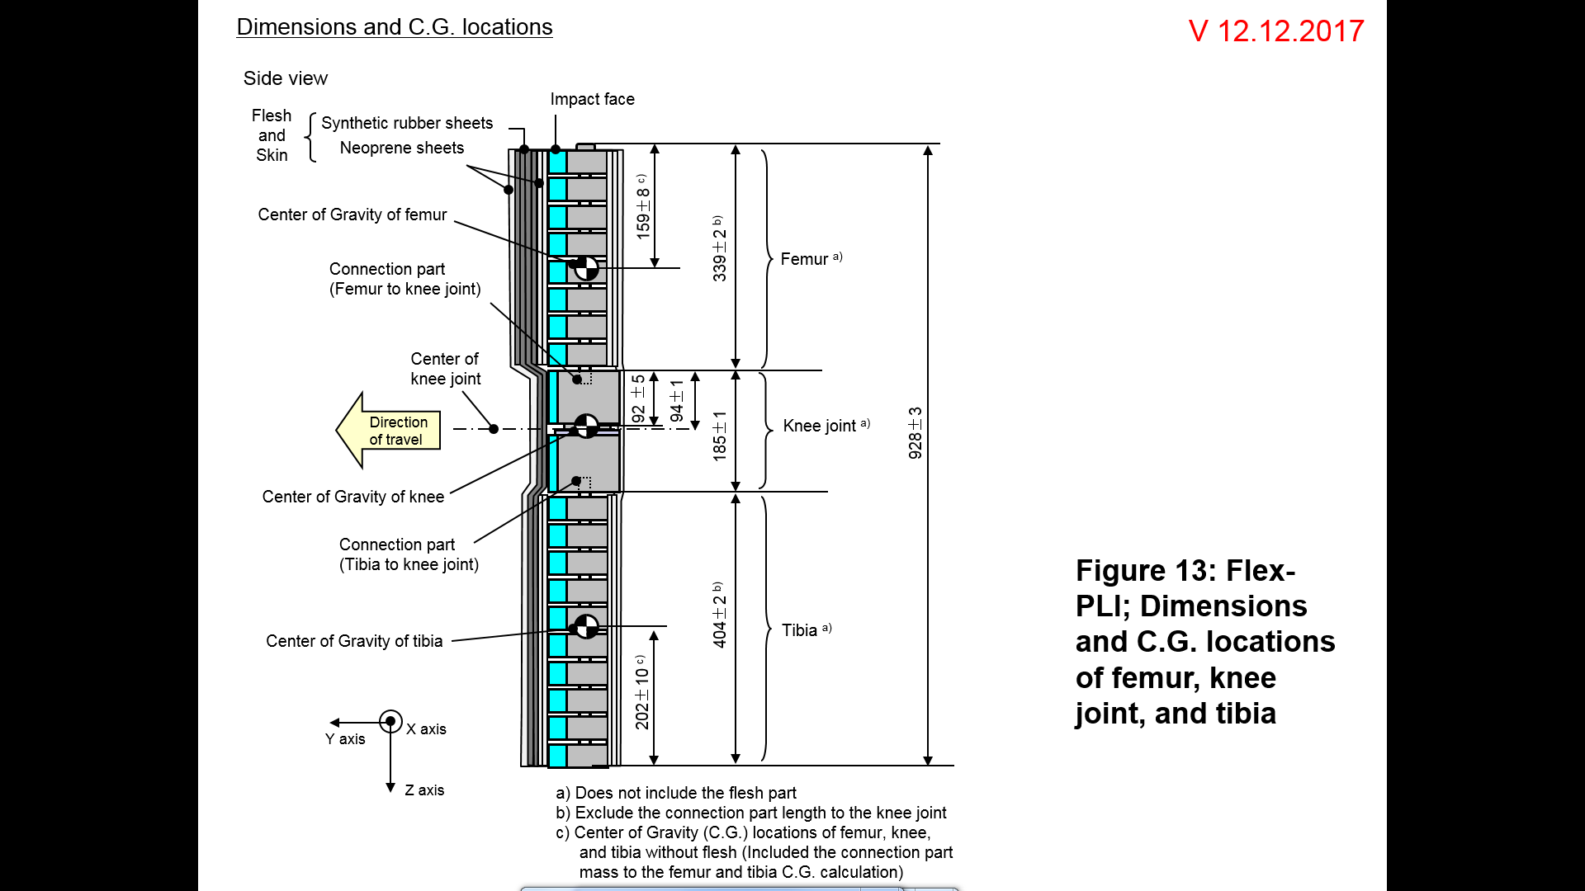**

[all dimensions in mm]

Figure 2

**Flexible Pedestrian Legform Impactor: Schematic plan views of femur, tibia and knee dimensions (top view, main body segments)**

**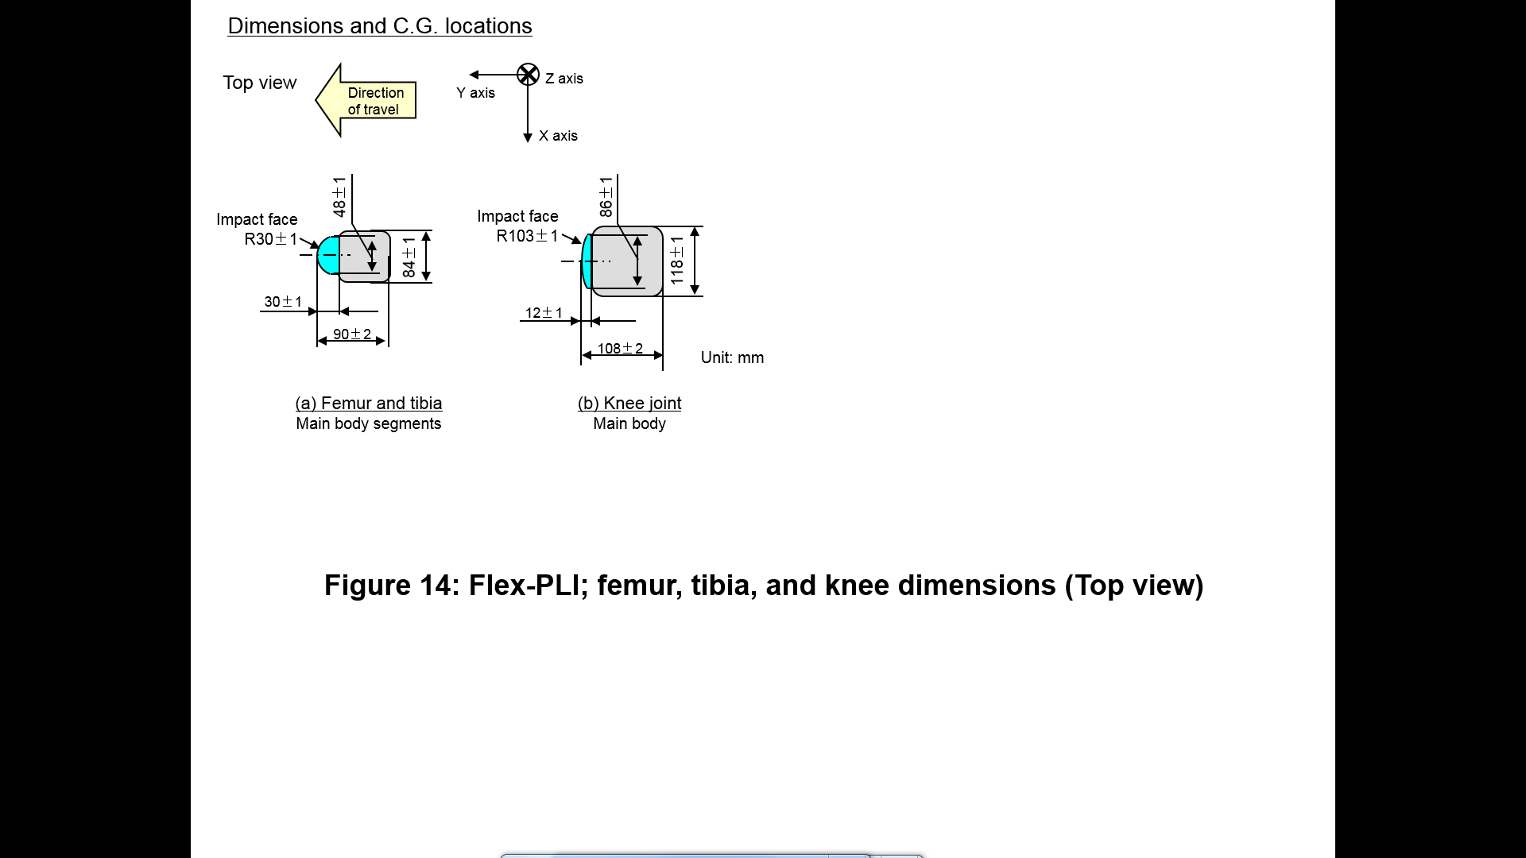**

[all dimensions in mm]

Figure 3  
**Flexible Pedestrian Legform Impactor: Flesh and skin dimensions**

**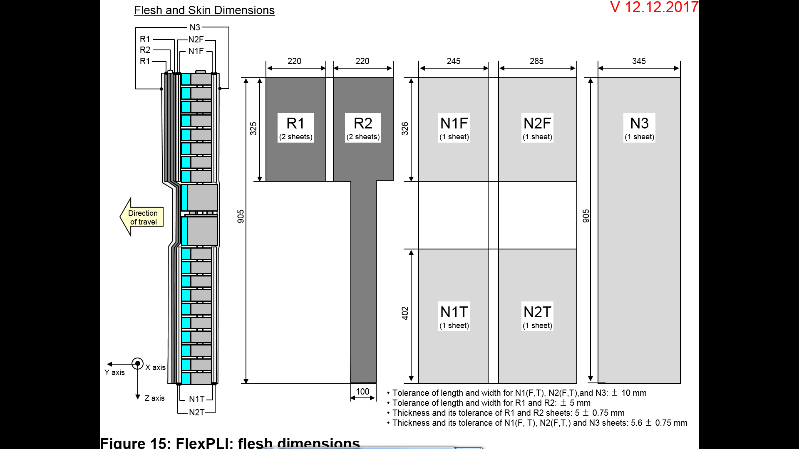**

[all dimensions in mm]

Figure 4  
**Flexible Pedestrian Legform Impactor: Flesh and skin compression characteristics**

**(a) Synthetic rubber sheets**

****

**(b) Foamed neoprene sheets**

****

2.2. Instrumentation

The FlexPLI shall be equipped with at least the following instrumentation:

Four transducers shall be installed on the tibia bone core to measure bending moments at locations within the tibia part of the flexible Pedestrian Legform Impactor.

Three transducers shall be installed in the femur to measure bending moments applied to the femur. The sensing locations of each of the transducers are as defined in Figure 5.

Three transducers shall be installed in the knee joint to measure elongations of the Medial Collateral Ligament (MCL), Anterior Cruciate Ligament (ACL), and Posterior Cruciate Ligament (PCL). The measurement locations of each transducer are shown in Figure 5. The measurement locations shall be within ± 4 mm along the X-axis from the knee joint centre.

The FlexPLI may offer a range of additional optional instrumentation for research purposes. Such instrumentation is no part of the requirements set forth in UN Regulations.

The instrumentation response value Channel Frequency Class (CFC), as defined in ISO 6487:2002, shall be 180 for all transducers. The Channel Amplitude Class (CAC) response values, as defined in ISO 6487:2002, shall be 30 mm for the knee ligament elongations and 400 Nm for the tibia and femur bending moments. This does not require that the impactor itself is able to physically elongate or bend until these values.

Figure 5

**Flexible Pedestrian Legform Impactor: Location of the transducers**

**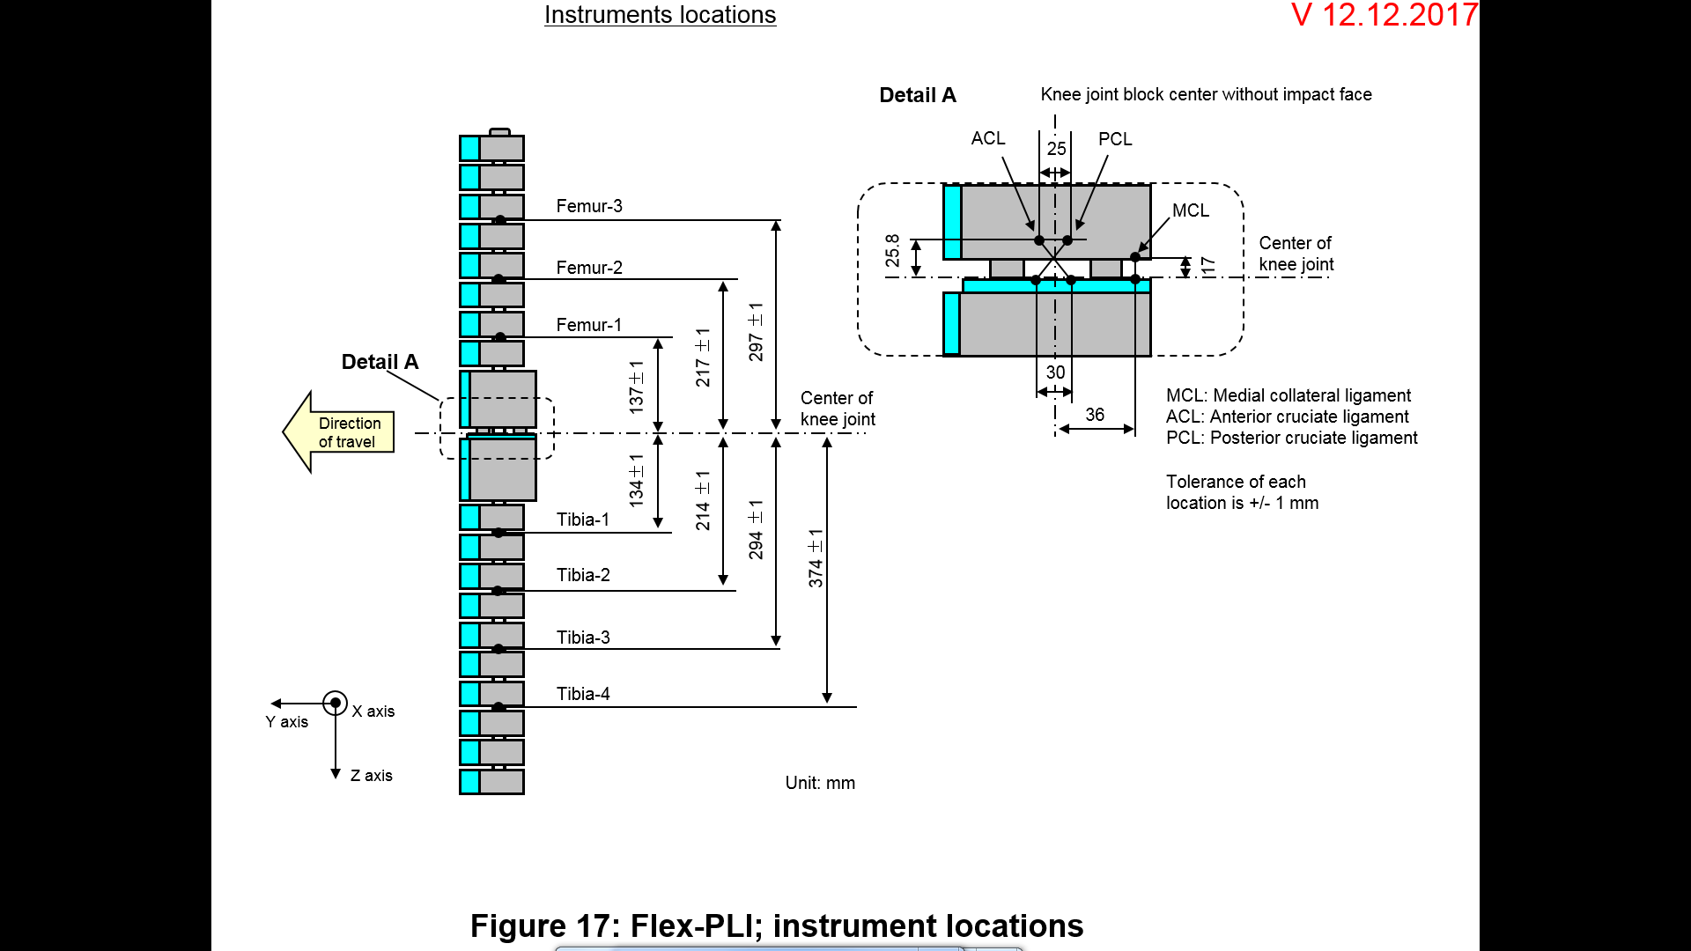**

[all dimensions in mm]

3. Assembly and disassembly

The assembly and disassembly are described in detail in the FlexPLI user manual. [[2]](#footnote-3)

The exploded view of the FlexPLI is shown in Figure 6.

Figure 6

**Exploded view of legform assembly (1 - Knee assembly, 2 – Tibia assembly, 3 – Femur assembly)**

**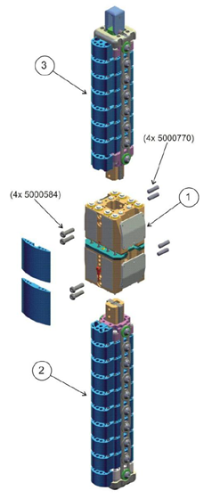**

4. Maintenance

The FlexPLI which passes the certification tests is the main indicator that the impactor is suitable for continued testing. If the FlexPLI does not pass, this would indicate that wear or damage has taken place and that the problem needs to be investigated and corrected.

Any parts which became cracked and/or worn and the damages that may have an influence on the testing or test results shall be replaced.

Maintenance is described in detail in the FlexPLI user manual. 1

5. Certification

5.1. Static certification tests

The stabilized temperature of the impactor during the certification tests shall be 20° ± 2°C.

The CAC response values, as defined in ISO 6487:2002, shall be 30 mm for the knee ligament elongations and 4 kN for the applied external load. For these tests, low-pass filtering at an appropriate frequency is permitted to remove higher frequency noise without significantly affecting the measurement of the response of the impactor.

5.1.1. The femur and the tibia of the flexible Pedestrian Legform Impactor shall meet the following:

The edges of the femur and tibia, without flesh and skin, non-bending parts, shall be mounted to the support rig firmly as shown in Figures 9 and 10. The Y-axis of the impactor shall be parallel to the loading axis within 180 ± 2° tolerance. To obtain repeatable loading, low friction Polytetrafluoroethylene (PTFE) plastic pads are used under each support (see Figures 9 and 10).

The centre of the loading force shall be applied at the centre of the femur and the tibia within ± 2mm tolerance along the Z-axis. The force shall be increased so as to maintain a deflection rate between 10 and 100 mm/minute until the bending moment at the centre part (Mc) of the femur or tibia reaches 380 Nm.

During this test, the applied moment and the generated deflection at the centre of the femur and the tibia (Mc and Dc) shall be within the corridors shown in Figure 7.

5.1.2. The knee joint of the flexible Pedestrian Legform Impactor shall meet the following:

The ends of the knee joint, without flesh and skin, shall be mounted to the support rig firmly as shown in Figure 11. The Y-axis of the impactor shall be parallel to the loading axis within ± 2° tolerance. To obtain repeatable loading, low friction Polytetrafluoroethylene (PTFE) plastic pads are used under each support (see Figure 11). To avoid impactor damage, a foamed neoprene sheet shall be set between the loading ram and the impactor face of the knee joint, which is described in Figure 11, shall be removed. The foamed neoprene sheet used in this test shall have compression characteristics as shown in Figure 4.

The centre of the loading force shall be applied at the knee joint centre within ± 2°mm tolerance along the Z-axis (see Figure 1). The external load shall be increased so as to maintain a deflection rate between 10 and 100 mm/minute until the bending moment at the centre part of the knee joint (Mc) reaches 400 Nm.

During this test, MCL, ACL and PCL elongations and applied bending moment or the force at the centre of the knee joint (Mc or Fc) shall be within the corridors shown in Figure 8.

Figure 7

**Flexible Pedestrian Legform Impactor: Requirement corridors of the femur and the tibia, without flesh and skin, in the static certification test**

**(a) Femur bending moment corridor**

****

**(b) Tibia bending moment corridor**

****

Figure 8

**Flexible Pedestrian Legform Impactor: Requirement corridors for the knee joint, without flesh and skin, in the static certification test (see paragraph 8.1.1.3.)**

******

Figure 9

**Flexible Pedestrian Legform Impactor: Test set-up for the femur in the static certification test**

**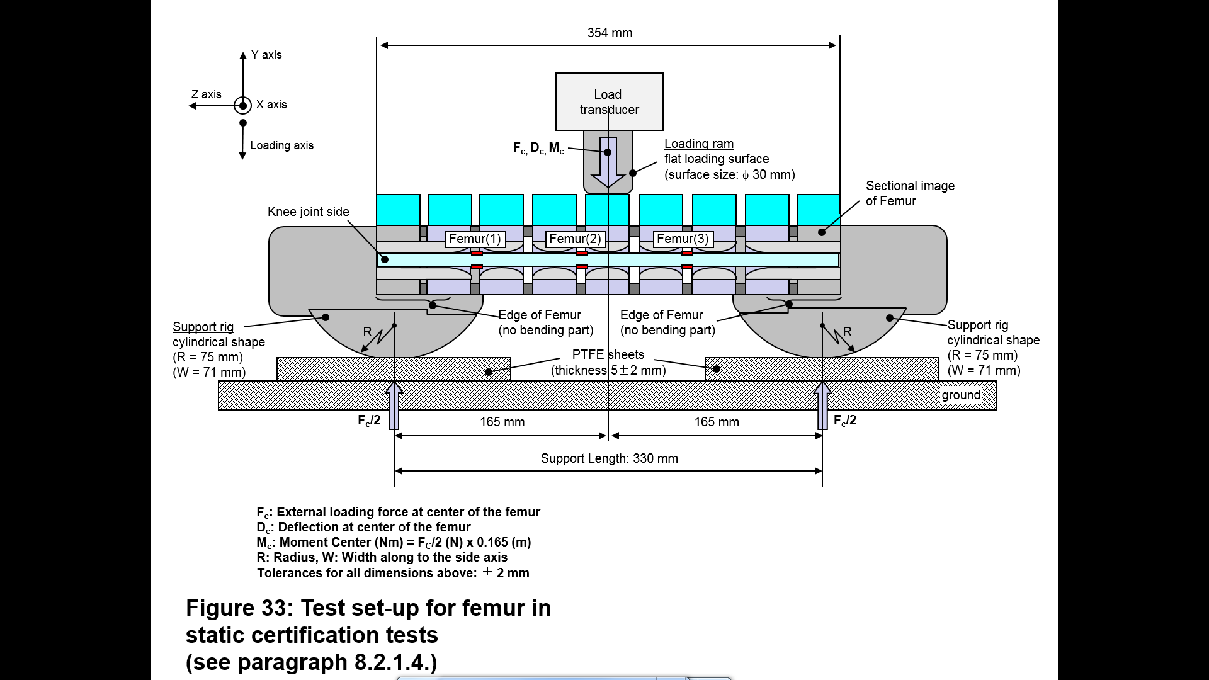**

Figure 10

**Flexible Pedestrian Legform Impactor: Test set-up for the tibia in the static certification test**

**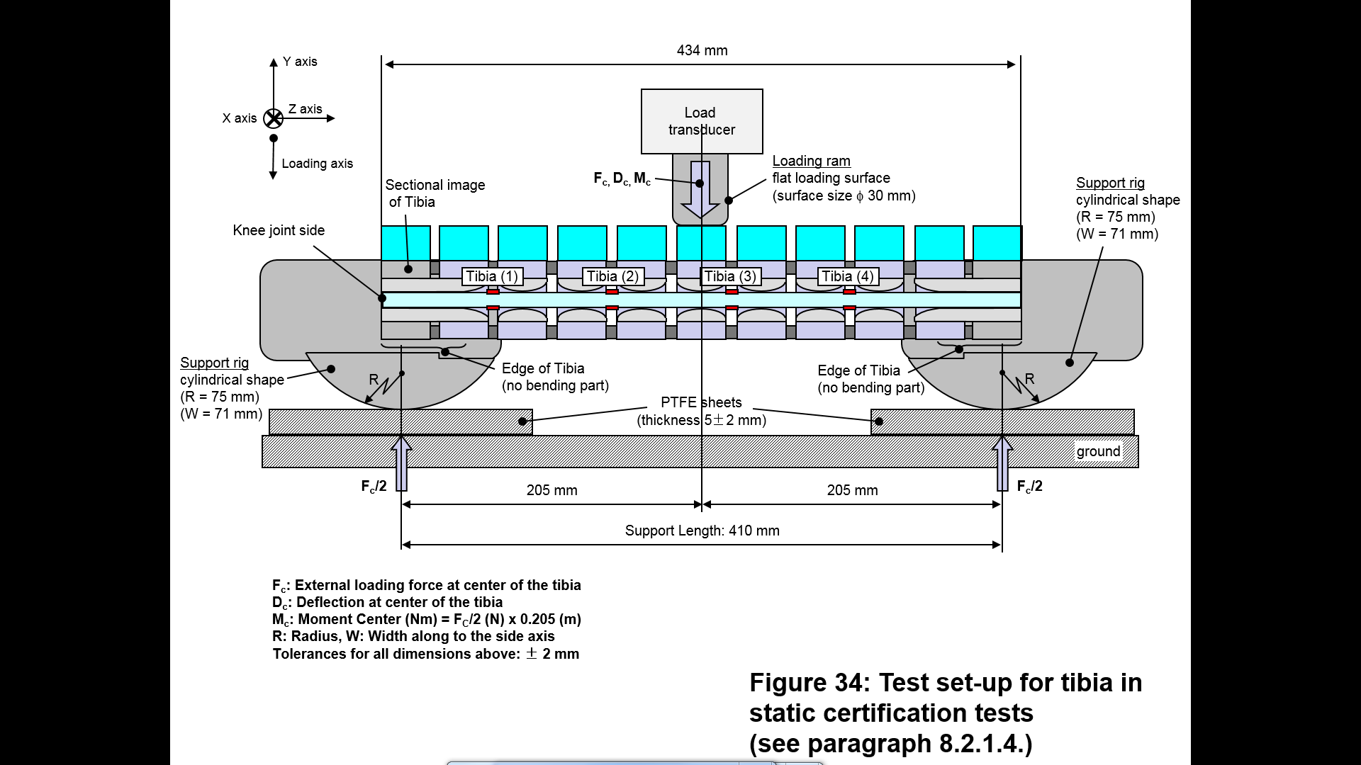**

Figure 11

**Flexible Pedestrian Legform Impactor: Test set-up for the knee joint in the static certification test**

**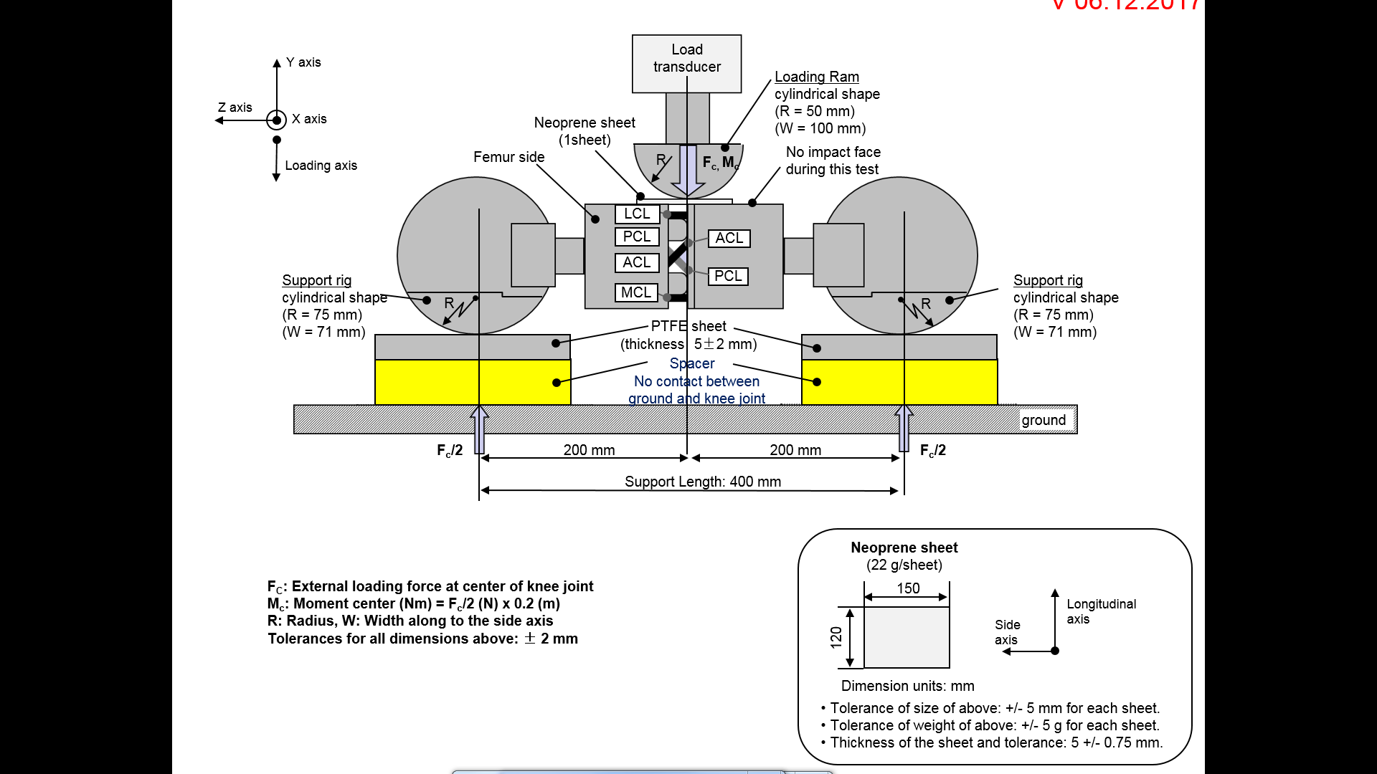**

5.2. Dynamic certification tests (pendulum test)

The test facility used for the certification test shall have a stabilized temperature of 20 ± 2 °C during the test.

The temperature of the certification area shall be measured at the time of certification and recorded in a certification report.

The instrumentation response value CFC, as defined in ISO 6487:2002, shall be 180 for all transducers. The CAC response values, as defined in ISO 6487:2002, shall be 30 mm for the knee ligament elongations and 400 Nm for the tibia bending moments. This does not require that the impactor itself is able to physically elongate or bend until these values.

5.2.1. The assembled flexible Pedestrian Legform Impactor shall meet the following:

As shown in Figure 12, the flexible Pedestrian Legform Impactor, including the flesh, skin and the additional mass, shall be suspended from the dynamic certification test rig 15 ± 1° upward from the horizontal. The impactor shall be released from the suspended position and fall freely against the pin joint of the test rig.

The knee joint centre of the impactor shall be 30 ± 1 mm below the bottom line of the stopper bar, and the tibia impact face without the flesh and skin shall be located 13 ± 2 mm from the front upper edge of the stopper bar when the impactor is hanging freely as shown in Figure 12.

When tested, the absolute value of the maximum bending moment of the tibia shall be:

(a) 235 Nm ≤ 272 Nm at tibia-1;  
(b) 187 Nm ≤ 219 Nm at tibia-2;  
(c) 139 Nm ≤ 166 Nm at tibia-3;  
(d) 90 Nm ≤ 111 Nm at tibia-4.

The absolute value of the maximum elongation shall be:

(a) 20.5 ≤ 24.0 mm of MCL;  
(b) 8.0 ≤ 10.5 mm of ACL;  
(c) 3.5 ≤ 5.0 mm of PCL.

For all these values for the maximum bending moment and the maximum elongation, the readings used shall be from the initial impact timing to 200 ms after the impact timing.

5.3. Dynamic certification tests (inverse test)

The test facility used for the certification test shall have a stabilized temperature of 20 ± 2 °C during the test.

The temperature of the certification area shall be measured at the time of certification and recorded in a certification report.

The instrumentation response value CFC, as defined in ISO 6487:2002, shall be 180 for all transducers. The CAC response values, as defined in ISO 6487:2002, shall be 30 mm for the knee ligament elongations and 400 Nm for the tibia bending moments.

5.3.1. The assembled flexible Pedestrian Legform Impactor shall meet the following:

The assembled flexible Pedestrian Legform Impactor (with the flesh and skin) shall be hung vertically and freely suspended from a test rig as shown in Figure 13. It is then impacted by the upper edge of a linearly guided aluminium honeycomb impactor, covered by a thin paper cloth with a maximum thickness of 1 mm, at an impact speed of 11.1 ± 0.2 m/s. The legform shall achieve a free flight condition within 10 ms after the time of first contact of the honeycomb impactor.

The honeycomb of 5052 alloy, which is attached in front of the moving ram, shall be 200 ± 5 mm wide, 160 ± 5 mm high and 60 ± 2 mm deep and shall have a crush strength of 517.1 kPa ± 10 per cent (75 pound per square inch (psi) ± 10 per cent). The honeycomb should have cell sizes of either 4.76 mm (3/16 inch) or 6.35 mm (1/4 inch) and a density of 32.0 kg/m³ (2.0 pound per cubic foot (pcf)) for the 4.76 mm (3/16 inch) cell size or a density of 36.8 kg/m³ (2.3 pound per cubic foot (pcf)) for the 6.35 mm (1/4 inch) cell size.

The upper edge of the honeycomb face shall be in line with the rigid plate of the linearly guided impactor. At the time of first contact, the upper edge of the honeycomb shall be in line with the knee joint centre line within a vertical tolerance of ± 2 mm. The honeycomb shall not be deformed before the impact test.

At the time of the first contact, the flexible Pedestrian Legform Impactor pitch angle (rotation around the Y-axis) and, therefore, the pitch angle of the velocity vector of the honeycomb impactor shall be within a tolerance of ± 2° in relation to the lateral vertical plane. The flexible Pedestrian Legform Impactor roll angle (rotation around the X-axis) and, therefore, the roll angle of the honeycomb impactor shall be within a tolerance of ± 2° in relation to the longitudinal vertical plane. The flexible Pedestrian Legform Impactor yaw angle (rotation around the Z-axis) and, therefore, the yaw angle of the velocity vector of the honeycomb impactor shall be within a tolerance of ±2°.

When tested, the absolute value of the maximum bending moment of the tibia shall be:

(a) 230 Nm ≤ 272 Nm at tibia-1;  
(b) 210 Nm ≤ 252 Nm at tibia-2;  
(c) 166 Nm ≤ 192 Nm at tibia-3;  
(d) 93 Nm ≤ 108 Nm at tibia-4.

The absolute value of the maximum elongations shall be:

(a) 17.0 ≤ 21.0 mm of MCL;  
(b) 8.0 ≤ 10 mm of ACL;  
(c) 4.0 ≤ 6.0 mm of PCL.

For all these values for the maximum bending moment and the maximum elongation, the readings used shall be from the initial impact timing to 50 ms after the impact timing.

Figure 12

**Flexible Pedestrian Legform Impactor: Test set-up for the dynamic Pedestrian Legform Impactor certification test (pendulum test)**

**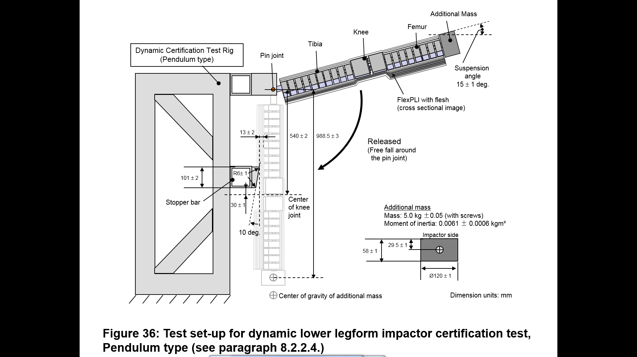**

[all dimensions in mm]

Figure 13

**Flexible Pedestrian Legform Impactor: Test set-up for the dynamic Pedestrian Legform Impactor certification test (inverse test)**

**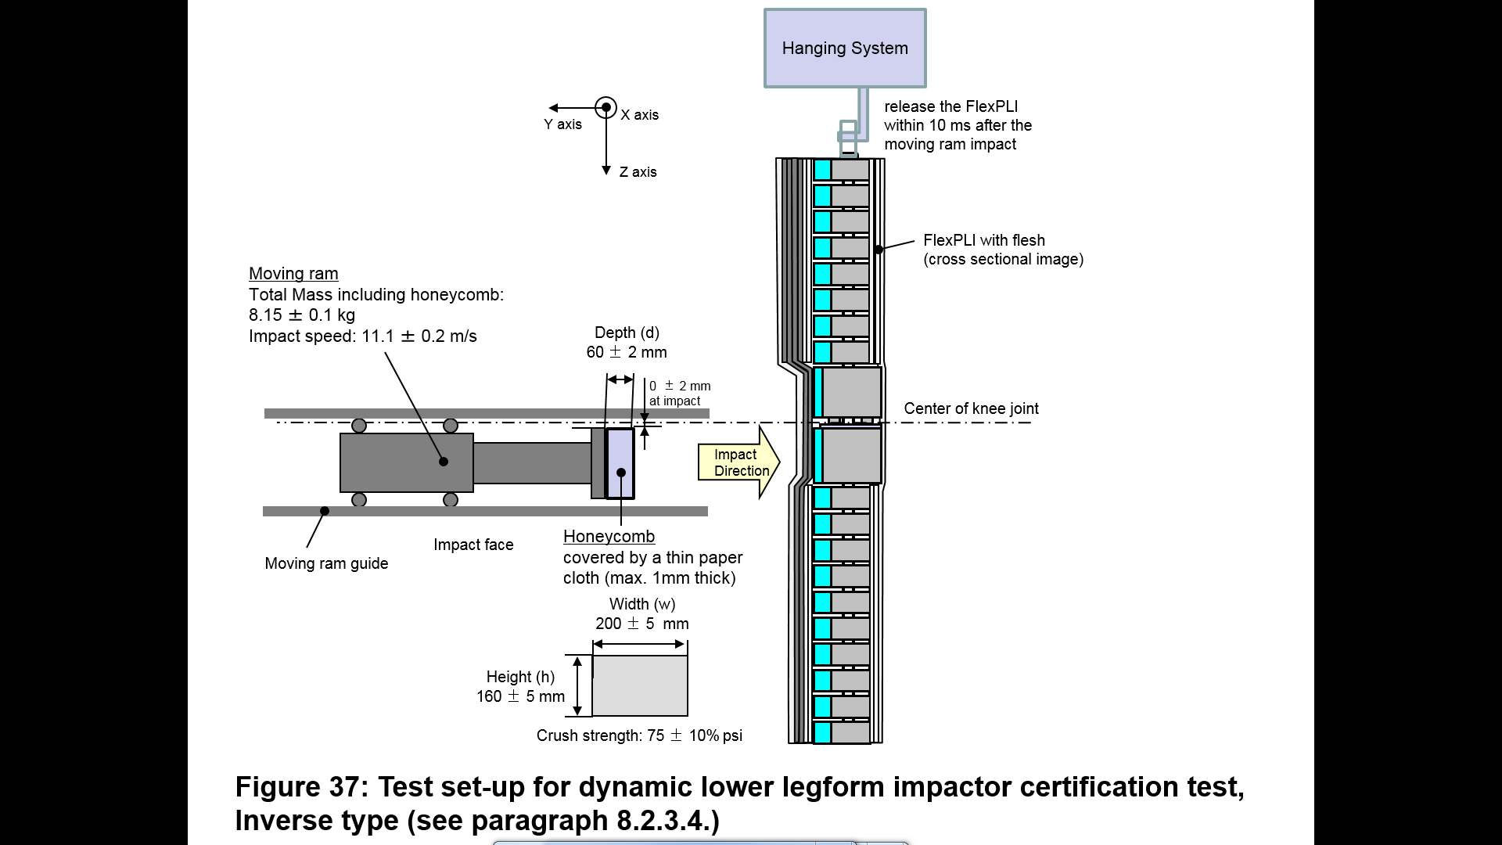**

5.4 Certification procedures are described in detail in the FlexPLI user manual.1

Annexes

**1. Engineering drawings**

Table 1

**Drawing revisions**

*Note:* This table lists all drawing revisions that are entered in detail in any of the following Appendices.

| *Drawing Ref*  *TRANS/WP.29/1101/Add.1/...* | *Appendix / Table* | *Title* | *Description of change* |
| --- | --- | --- | --- |
| *--* | -- | -- | -- |

Table 2

**Parts "and drawings" index**

*Note:* Drawing revisions should be entered immediately after the drawing they replace. The revision is also recorded in the Table 1, "Drawing Revisions”.

| *ECE/TRANS/WP.29/1101/Add.3/...[[3]](#footnote-4)* | *Part Number* | *Description* | *Drwg Revision* | *No of Sheets* | *Qty per Assy* | *Qty per Leg* | *Common with Addenda(s)* |
| --- | --- | --- | --- | --- | --- | --- | --- |
| Drg 1 | 133-5000 | FlexPLI Instrumented Leg | A | 1 |  |  |  |
| Drg 10 | 133-5013 | Cover Inner Femur | A | 1 | 1 | 1 |  |
| Drg 11 | 133-5014 | Cover Outer Femur | A | 1 | 1 | 1 |  |
| Drg 12 | 133-5015 | Cover Inner Tibia | A | 1 | 1 | 1 |  |
| Drg 13 | 133-5016 | Cover Outer Tibia | A | 1 | 1 | 1 |  |
| Drg 14 | 133-5017 | Cover FlexPLI | A | 1 | 1 | 1 |  |
| Drg 16 | 133-5019 | Hook and Loop Tie | A | 1 | 6 | 6 |  |
| Drg 17 | 133-5020 | Buffer Sheet Assembly Leg | A | 1 | 1 | 1 |  |
| Drg 7 | 133-5010 | Buffer Femur | A | 1 | 2 | 2 |  |
| Drg 8 | 133-5011 | Buffer Leg | A | 1 | 2 | 2 |  |
|  |  | Double Sided carpet Tape 20 mm wide |  |  | A/R | A/R |  |
| Drg 26 | 133-5100 | Femur Assembly | A | 2 | 1 | 1 |  |
| Drg 38 | 133-5165 | PCB Bone Assembly Femur | B | 2 | 1 | 1 |  |
|  |  | ID Chip |  |  | 4 | 12 |  |
|  |  | Resistor 150 Ohm 1/16W 0.1% 0603 SMD |  |  | 8 | 16 |  |
|  |  | Resistor200 Ohm 1/16W 0.1% 0603 SMD |  |  | 8 | 16 |  |
|  |  | Ribbon Cable |  |  | A/R | A/R |  |
|  |  | Cable Tie 2-7/8-inches |  |  | 1 | 2 |  |
|  |  | Connector 16 Pin Circular Male w/Latch |  |  | 1 | 2 |  |
|  | 734-2008 | Backshell 16 Pin Circular w/Latch |  |  | 1 | 2 |  |
| Drg 34 | 133-5109 | Tape Acrylic Foam | A | 1 | 1 | 2 |  |
| Drg 27 | 133-5101 | Femur Bone | B | 1 | 1 | 1 |  |
|  |  | Strain Gage (350 Ohm) |  |  |  |  |  |
| Drg 67 | 133-5508 | Bone Clamp Thin Knee | A | 1 | 1 | 2 |  |
| Drg 62 | 133-5503 | Bone Clamp Thin Femur/Tibia | A | 1 | 1 | 2 |  |
| Drg 65 | 133-5506 | Bone Clamp Thick Knee | A | 1 | 1 | 2 |  |
| Drg 61 | 133-5502 | Bone clamp Thick Femur/Tibia | A | 1 | 1 | 2 |  |
| Drg 64 | 133-5505 | Spacer Bone Contact Thick | B | 1 | 5 | 12 |  |
| Drg 63 | 133-5504 | Shim Bone Clamp (0.4 Thick) optional | A | 1 | A/R | A/R |  |
| Drg 69 | 133-5510 | Rubber Buffer Femur/Tibia End | A | 1 | 1 | 2 |  |
| Drg 66 | 133-5507 | Spacer Bone Contact Thin | B | 1 | 5 | 12 |  |
| Drg 68 | 133-5509 | Shim (0.4 Thick) optional | A | 1 | A/R | A/R |  |
| Drg 73 | 133-5514 | Inner Segment Knee | A | 1 | 1 | 2 |  |
| Drg 86 | 133-5535 | Inner Segment Assy Closest to Knee | B | 1 | 1 | 2 |  |
| Drg 71 | 133-5512 | Rubber Buffer | A | 1 | 4 | 32 |  |
| Drg 72 | 133-5513 | Inner Segment | A | 1 | 1 | 14 |  |
| Drg 85 | 133-5534 | Inner segment Assembly | B | 1 | 5 | 12 |  |
| Drg 71 | 133-5512 | Rubber Buffer | A | 1 | 2 | 32 |  |
| Drg 72 | 133-5513 | Inner Segment | A | 1 | 1 | 14 |  |
|  |  | Screw BHCS M6 x 18 Zinc Plated |  |  | 28 | 60 |  |
|  | 133-5515 | Link | A | 1 | 14 | 32 |  |
| Drg 33 | 133-5108 | Segment Top Femur | A | 1 | 1 | 1 |  |
| Drg 28 | 133-5102 | Plate Top | A | 1 | 1 | 1 |  |
| Drg 29 | 133-5103 | Launch Guide | A | 1 | 1 | 1 |  |
| Drg 30 | 133-5104 | Washer 12 ID x 26 OD x 3 | A | 1 | 4 | 8 |  |
| Drg 31 | 133-5106 | Shoulder Bolt | A | 1 | 16 | 36 |  |
|  |  | Washer Flat M6 Zinc Plated |  |  | 2 | 2 |  |
|  |  | Screw SHCS M6 x 14 Zinc Plated |  |  | *2* | *2* |  |
|  |  | Screw SHCS M6 x 30 Zinc Plated |  |  | 1 | 1 |  |
| Drg 32 | 133-5107 | Roller | A | 1 | 1 | 1 |  |
| Drg 71 | 133-5521 | Washer Cable | A | 1 | 8 | 16 |  |
| Drg 35 | 133-5110 | Cable Assembly Femur | A | 1 | 4 | 4 |  |
|  |  | Hex Lock Nut M5 |  |  | 4 | 20 |  |
| Drg 75 | 133-5516 | End Cover | A | 1 | 1 | 2 |  |
| Drg 83 | 133-5525 | Insert Molded End Cover | A | 1 | 4 | 8 |  |
|  |  | Screw BHCS M6 x 16 |  |  | 6 | 12 |  |
|  |  | Screw BHCS M5 x 8 Zinc Plated |  |  | 4 | 8 |  |
|  |  | Screw SHCS M3 x 6 Zinc Plated |  |  | 4 | 8 |  |
|  |  | Screw MFSSP M8 x 16 |  |  | 2 | 4 |  |
| Drg 18 | 133-5025 | Tape Impact Segment | A | 1 | 6 | 14 |  |
| Drg 21 | 133-5028 | Tape End Cover 12 x 24 | A | 1 | 1 | 2 |  |
| Drg 20 | 133-5027 | Tape End Cover 10 x 12 | A | 1 | 4 | 8 |  |
| Drg 19 | 133-5026 | Tape End Cover 12 x 16 | A | 1 | 2 | 4 |  |
| Drg 77 | 133-5518 | Cover End Impact | A | 1 | 1 | 2 |  |
| Drg 78 | 133-5519 | Cover End Impact Knee End | A | 1 | 1 | 2 |  |
| Drg 76 | 133-5517 | Impact Segment | A | 1 | 6 | 14 |  |
| Drg 2 | 133-5001 | Shim T 0.5 optional | A | 1 | A/R | A/R |  |
| Drg 3 | 133-5002 | Shim Bone Clamp (T 0.05) optional | A | 1 | A/R | A/R |  |
| Drg 4 | 133-5003 | Shim Bone Clamp (T0.5) optional | A | 1 | A/R | A/R |  |
| Drg 5 | 133-5004 | Shim Bone Clamp (T 0.6) optional | A | 1 | A/R | A/R |  |
| Drg 6 | 133-5005 | Shim (T 0.6) optional | A | 1 | A/R | A/R |  |
| Drg 9 | 133-5012 | Shim 0.05 (optional) | A | 1 | A/R | A/R |  |
|  |  | Cable Tie 5/8 inch Bundle Dia |  |  | 2 | 4 |  |
| Drg 22 | 133-5029 | Shim 0.1 Thick (optional) | A | 1 | A/R | A//R |  |
| Drg 23 | 133-5030 | Shim 0.2 Thick (optional) | A | 1 | A/R | A/R |  |
| Drg 24 | 133-5031 | Shim 0.4 Thick (optional) | A | 1 | A/R | A/R |  |
| Drg 39 | 133-5300 | Knee Assembly FlexPLI | A | 1 | 1 | 1 |  |
| Drg 57 | 133-5330 | Knee Block Tibia FlexPLI | A | 1 | 1 | 1 |  |
| Drg 51 | 133-5312 | Insert M1.6 (M3 OD) | A | 1 | 3 | 3 |  |
| Drg 52 | 133-5313 | Meniscus Assembly | A | 1 | 1 | 1 |  |
| Drg 40 | 133-5301 | Meniscus Plate | A | 1 | 1 | 1 |  |
| Drg 42 | 133-5303 | String Guide Knee | A | 1 | 2 | 2 |  |
| Drg 42 | 133-5307 | String Guide AP | A | 1 | 2 | 2 |  |
| Drg 48 | 133-5309 | Cable Guide AP Ligament | A | 1 | 4 | 4 |  |
|  |  | M3 Insert for Plastic x 5.6 long |  |  | 2 | 2 |  |
| Drg 47 | 133-5308 | Wire Retainer Knee | A | 1 | 2 | 2 |  |
|  |  | Screw FHCS M3 x 6 |  |  |  |  |  |
| Drg 90 | 61-503-05-01-00 | Cable Assy Right String Pot | A | 1 | 2 | 2 |  |
| Drg 91 | 61-507-05-01-00 | Cable Assy Left String Pot | A | 1 | 2 | 2 |  |
|  |  | Screw SHCS M5 x 10 Low Head |  |  | 4 | 4 |  |
| Drg 56 | 133-5320 | Knee Block Femur | A | 1 | 1 | 1 |  |
| Drg 41 | 133-5302 | Attachment Plate String Pot | A | 1 | 1 | 1 |  |
|  |  | Spring 12 Od x 6 ID x 40 long 71.1 N/mm |  |  | 8 | 8 |  |
|  |  | Spring 18 OD x 9 ID x 80 long 76.7 N/mm |  |  | 16 | 16 |  |
| Drg 49 | 133-5310 | Spring Cap | A | 1 | 8 | 8 |  |
| Drg 55 | 133-5318 | Spring Cap Knee Block Tibia | A | 1 | 8 | 8 |  |
| Drg 50 | 133-5311 | Cable Washer | A | 1 | 8 | 8 |  |
| Drg 58 | 133-5350 | Cable Assembly Knee ML | A | 1 | 8 | 8 |  |
|  |  | Screw FHCS M3 x 10 |  |  | 2 | 2 |  |
| Drg 54 | 133-5315 | Cover Knee Femur Right Side | A | 1 | 1 | 1 |  |
| Drg 44 | 133-5306 | Cover Knee | A | 1 | 2 | 2 |  |
| Drg 53 | 133-5314 | Cover Knee Tibia Left Side | A | 1 | 1 | 1 |  |
|  |  | Screw FHCS M4 x 8 Zinc Plated |  |  | 16 | 16 |  |
| Drg 59 | 133-5360 | Cable Assembly Knee AP | A | 1 | 4 | 4 |  |
|  |  | Hex Lock Nut M5 |  |  | 12 | 20 |  |
|  |  | Screw MSSFP M8x30 |  |  | 4 | 4 |  |
|  |  | Screw BHCS M8 x 35 Zinc Plated |  |  | 4 | 4 |  |
| Drg 15 | 133-5018 | Tape Front cover | A | 1 | 4 | 4 |  |
| Drg 43 | 133-5304 | Cover Upper Knee FlexPLI | A | 1 | 1 | 1 |  |
| Drg 44 | 133-5305 | Cover Lower Knee FlexPLI | A | 1 | 1 | 1 |  |
| Drg 60 | 133-5500 | Tibia Assembly FlexPLI | A | 2 | 1 | 1 |  |
| Drg 87 | 133-5565 | PCB Bone Assembly 4 Channel Tibia | A | 2 | 1 | 1 |  |
|  |  | ID Chip |  |  | 4 | 12 |  |
|  |  | Resistor 150 Ohm 1/16W 0.1% 0603 SMD |  |  | 8 | 16 |  |
|  |  | Resistor 200 Ohm 1/16W 0.1% 0603 SMD |  |  | 8 | 16 |  |
|  |  | Ribbon Cable 20 conductor |  |  | A/R | A/R |  |
|  |  | Cable Tie 2-7/8 inch |  |  | 1 | 2 |  |
| Drg 34 | 133-5109 | Tape Acrylic Foam | A | 1 | 1 | 2 |  |
| Drg 79 | 133-5520 | Tibia Bone | A | 1 | 1 | 1 |  |
|  |  | Connector 16 Pin W/Latch |  |  | 1 | 2 |  |
|  |  | Connector 7 Pin W/Latch |  |  | 1 | 6 |  |
|  | 734-2008 | Backshell 16 Pin Circular Connector w/Latch |  |  | 1 | 2 |  |
|  | 734-2007 | Backshell 7 Pin Circular Connector w/Latch |  |  | 1 | 6 |  |
|  |  | Strain Gage (350 Ohm) |  |  | 8 | 14 |  |
|  |  | Cable 16 Conductor |  |  | A/R | A/R |  |
|  |  | Cable 7 Conductor |  |  | A/R | A/R |  |
| Drg 61 | 133-5502 | Bone Clamp Thick Femur/Tibia | A | 1 | 1 | 2 |  |
| Drg 62 | 133-5503 | Bone Clamp Thin Femur/Tibia | A | 1 | 1 | 2 |  |
| Drg 63 | 133-5504 | Shim Bone Clamp (0.4 Thick) optional | A | 1 | A/R | A/R |  |
| Drg 64 | 133-5505 | Spacer Bone Contact Thick | B | 1 | 7 | 12 |  |
| Drg 65 | 133-5506 | Bone Clamp Thick Knee | A | 1 | 1 | 2 |  |
| Drg 66 | 133-5507 | Spacer Bone Contact Thin | B | 1 | 7 | 12 |  |
| Drg 67 | 133-5508 | Bone Clamp Thin Knee | A | 1 | 1 | 2 |  |
| Drg 68 | 133-5509 | Shim (0.4 Thick) optional | A | 1 | A/R | A/R |  |
| Drg 69 | 133-5510 | Rubber Buffer Femur/Tibia End | A | 1 | 1 | 2 |  |
| Drg 70 | 133-5511 | Segment Bottom Tibia | A | 1 | 1 | 1 |  |
| Drg 85 | 133-5534 | Inner Segment Assembly | B | 1 | 7 | 12 |  |
| Drg 71 | 133-5512 | Rubber Buffer | A | 1 | 2 | 32 |  |
| Drg 72 | 133-5513 | Inner Segment | A | 1 | 1 | 14 |  |
| Drg 86 | 133-5535 | Inner Segment Assembly Close to Knee | B | 1 | 1 | 2 |  |
| Drg 71 | 133-5512 | Rubber Buffer | A | 1 | 4 | 32 |  |
| Drg 72 | 133-5513 | Inner Segment | A | 1 | 1 | 14 |  |
| Drg 73 | 133-5514 | Inner Segment Knee | A | 1 | 1 | 2 |  |
| Drg 74 | 133-5515 | Link | A | 1 | 18 | 32 |  |
| Drg 30 | 133-5104 | Washer 12 ID x 26 OD x 3 | A | 1 | 4 | 8 |  |
| Drg 31 | 133-5106 | Shoulder Bolt | A | 1 | 20 | 36 |  |
| Drg 80 | 133-5521 | Washer Cable | A | 1 | 8 | 16 |  |
| Drg 84 | 133-5530 | Cable Assembly Tibia | A | 1 | 4 | 4 |  |
|  |  | Screw BHCS M6 x 18 Zinc Plated |  |  | 32 | 60 |  |
|  |  | Hex Lock Nut M5 |  |  | 4 | 20 |  |
| Drg 75 | 133-5516 | End Cover | A | 1 | 1 | 2 |  |
| Drg 83 | 133-5525 | Insert Molded End Cover | A | 1 | 4 | 8 |  |
|  |  | Screw BHCS M6 x 16 |  |  | 6 | 12 |  |
|  |  | Screw BHCS M5x8 Zinc Plated |  |  | 4 | 8 |  |
|  |  | Screw SHCS M3x6 Zinc Plated |  |  | 4 | 8 |  |
|  |  | Screw MSSFP M8 x 16 |  |  | 2 | 4 |  |
| Drg 13 | 133-5025 | Tape Impact segment | A | 1 | 8 | 14 |  |
| Drg 21 | 133-5028 | Tape End Cover 12 x 24 | A | 1 | 1 | 2 |  |
| Drg 20 | 133-5027 | Tape End Cover 10 x 12 | A | 1 | 4 | 8 |  |
| Drg 19 | 133-5026 | Tape End Cover 12 x 16 | A | 1 | 2 | 4 |  |
| Drg 78 | 133-5519 | Cover End Impact (Knee End) | A | 1 | 1 | 2 |  |
| Drg 76 | 133-5517 | Impact Segment | A | 1 | 8 | 14 |  |
| Drg 77 | 133-5518 | Cover End Impact | A | 1 | 1 | 2 |  |
| Drg 2 | 133-5001 | Shim T 0.5 optional | A | 1 | A/R | A/R |  |
| Drg 3 | 133-5002 | Shim Bone Clamp T 0.05 optional | A | 1 | A/R | A/R |  |
| Drg 4 | 133-5003 | Shim Bone Clamp T 0.5 optional | A | 1 | A/R | A/R |  |
| Drg 5 | 133-5004 | Shim Bone Clamp T 0.6 optional | A | 1 | A/R | A/R |  |
| Drg 6 | 133-5005 | Shim T 0.6 optional | A | 1 | A/R | A/R |  |
| Drg 9 | 133-5012 | Shim T 0.05 (optional) | A | 1 | A/R | A/R |  |
| Drg 81 | 133-5522 | Wire Exit Base | A | 1 | 2 | 2 |  |
| Drg 82 | 133-5523 | Wire Exit Clamp | A | 1 | 2 | 2 |  |
|  |  | Screw BHCS M5 x 12 Zinc Plated |  |  | 2 | 2 |  |
|  |  | Cable Tie 5/8"Bundle Diameter |  |  | 2 | 4 |  |
| Drg 22 | 133-5029 | Shim 0.1 Thick optional | A | 1 | A/R | A/R |  |
| Drg 23 | 133-5030 | Shim 0.2 Thick optional | A | 1 | A/R | A/R |  |
| Drg 24 | 133-5031 | Shim 0.4 Thick optional | A | 1 | A/R | A/R |  |
| Drg 25 | 133-5034 | Catch Rope Bracket | A | 1 | A/R | A/R |  |
| Drg 36 | 133-5112 | Wire Setting Tool | A | 1 | 1 | 1 |  |
| Drg 37 | 133-5113 | Setting Tool Knee Attachment | A | 1 | 2 | 2 |  |
| Drg 89 | 61-301-05-01-00 | Accel Assembly ASE-A-500 | A | 1 | 1 | 1 |  |
| Drg 88 | 61-201-05-01-00 | Accel Assembly 64C-2000 | A | 1 | 1 | 1 |  |
| Drg 95 | TE 133-8120 | Bone and Knee Assy Cal Fixtures | B | 2 | 1 |  |  |
| Drg 98 | 133-8124 | Side Plate Legs | A | 1 | 2 |  |  |
| Drg 99 | 133-8125 | Pivot Base | A | 1 | 2 |  |  |
| Drg 92 | 133-8031 | PTFE Sheet | A | 1 | 2 |  |  |
|  |  | Screw FHCS M8 x 30 |  |  |  |  |  |
| Drg 100 | 133-8126 | Knee Pivot Side Plate | A | 1 | 2 |  |  |
| Drg 101 | 133-8127 | Spacer | A | 1 | 2 |  |  |
| Drg 96 | 133-8121 | Knee Cal Insert Tibia Side | B | 1 | 1 |  |  |
| Drg 97 | 133-8122 | Knee Cal Insert Femur Side | B | 1 | 1 |  |  |
| Drg 94 | 133-8105 | Knee Loading Profile | A | 1 | 1 |  |  |
| Drg 93 | 133-8102 | Leg Loading Spigot | A | 1 | 1 |  |  |
|  |  | Screw, MSSFP M8 x 12 |  |  | 4 |  |  |
| Drg 200 | 13011401 | Repl. Bone Tibia (alternative cable routing) | A | 1 | 1 |  |  |
| Drg 201 | 13112701 | Repl. Bone Femur (alternative cable routing) | A | 1 | 1 |  |  |
| Drg 202 | 13011402 | Repl. FlexPLI Bone Clamp Thick (alternative cable routing) | A | 1 | 2 |  |  |
| Drg 203 | 13011403 | Repl. FlexPLI Bone Clamp Thin (alternative cable routing) | A | 1 | 2 |  |  |

**2. FlexPLI User Manual**1"

1. \* In accordance with the programme of work of the Inland Transport Committee for 2018–2019 (ECE/TRANS/274, para. 123 and ECE/TRANS/2018/21/Add.1, Cluster 3.1), the World Forum will develop, harmonize and update UN regulations to enhance the performance of vehicles. The present document is submitted in conformity with that mandate. [↑](#footnote-ref-2)
2. The user manual is available on the website of the Mutual Resolution No. 1 (M.R.1) of the 1958 and the 1998 Agreements: www.unece.org/trans/main/wp29/wp29wgs/wp29gen/wp29resolutions.html [↑](#footnote-ref-3)
3. All drawings may be consulted on the website of M.R.1.: www.unece.org/trans/main/wp29/wp29wgs/wp29gen/wp29resolutions.html [↑](#footnote-ref-4)