|  |  |  |  |
| --- | --- | --- | --- |
|  | United Nations | ECE/TRANS/2019/20 | |
| _unlogo | **Economic and Social Council** | | Distr.: General  7 December 2018  Original: English |

**Economic Commission for Europe**

Inland Transport Committee

**Eighty-first session**Geneva, 19–22 February 2019

Item 5 (k) of the provisional agenda

**Strategic questions of a modal and thematic nature:  
Transport statistics and data**

Data Visualization for Policy Development: E-Road Census

Note by the secretariat

|  |
| --- |
| *Summary* |
| The secretariat asks member States to conduct a census of traffic volumes on their main international road traffic arteries every five years. Data are requested in multiple formats for use in analysis and visualization. These traffic data are requested in tabular form and also in geographic information system (GIS) files which allow users to visualize the traffic on the road network across countries. Mapping these data can highlight areas of the network where traffic is highest, and in turn offers insights into where there may be potential for increased infrastructure investment or modal switching. Such visualization can also track progress in realizing Euro-Asian transport links. |
| Visualization in this way is thus a useful tool for monitoring the Sustainable Development Goals, in particular: |
| * Indicator 3.6.1 on reducing road traffic fatalities. When localized traffic levels are mapped together with road traffic accidents, accident hotspots (and safer segments) can be identified in terms of the number of accidents per vehicle per year as derived for each road segment. Such data may help with targeting appropriate policy responses. |
| * Indicator 9.1.2 on passenger and freight volumes. The E-Road census allows the direct measurement in a geospatial format of passenger and freight volumes, measured in total vehicles per day and with Heavy Goods Vehicles separately, and may also be useful for trade and international bus travel purposes. |
| The Committee may wish to **invite** its member States to encourage their national statistics offices, infrastructure agencies and other key actors to cooperate in order to provide the necessary data for 2020 to the secretariat in both a tabular format as well as in GIS files (preferably Shapefile format). The Committee may wish to **note** that the response rate has declined in recent years and **encourage** its members to address this. |

I. Background

1. The Working Party on Transport Statistics (WP.6), a subsidiary body of the Inland Transport Committee, has for decades conducted a quinquennial census of the E-Road network. The census collects, for individual segments as defined by the member State, infrastructure information such as number and size of lanes, and traffic information measured in Annual Average Daily traffic (AADT) for all vehicles as well as specific vehicle categories (motorized two wheelers, passenger cars and light goods vehicles, goods road vehicles, and buses and coaches).

2. The WP.6 document ECE/TRANS/WP.6/2018/11 sets out in further detail what is recommended that governments should include in the 2020 census. The purpose of this document is to highlight the importance of providing these data in a geospatial format, to maximize the utility of the disseminated data.

II. Motivation

3. In order to promote evidence-based transport policies, accurate, relevant and timely transport statistics are required. Statistics produced under the purview of WP.6 aim to meet this analytical demand, with data produced on all inland modes for infrastructure, transport equipment, traffic, transport measurement and accidents, on a national level for all ECE member States. In addition, the E-Road census can provide further insights into road transport on routes deemed of international importance by the European Agreement on main International Traffic Arteries (AGR). The census data complement the national-level data by providing information specific to individual corridors and roads.

4. Many ECE member States provide data for the E-Road census, though the response rate has reduced over time. In 2000, 31 member States provided at least some data, whereas in 2015 only 21 member States did. Of these 21 countries, only nine (Austria, Bulgaria, Czechia, France, Latvia, Lithuania, Poland, Slovenia and Sweden) provided the data in a geospatial format.

5. The tabular E-Road census data offers information useful to infrastructure and traffic management, but the addition of geospatial data to the census data provided allows for much richer insights. These are explored in the following paragraphs.

6. Road infrastructure information and traffic levels give insights into **maintenance and potential upgrade requirements**. As the E-Road network concerns roads of international importance, a comprehensive census map will allow member States to share infrastructure knowledge and better plan maintenance and road improvement projects that affect cross-border traffic.

7. Visualized road traffic levels (combined with infrastructure information such as the number and width of lanes) allow the identification of international traffic bottlenecks, allowing cost/benefit analysis of potential solutions. Further, when combined with details of rail and inland water networks in a geospatial environment, the **potential for modal switching** in certain corridors can be easily grasped.

8. Much importance is of course placed on realising certain critical corridors that will provide **Euro-Asian transport links**. Statistics tracking existing traffic on these routes, combined with infrastructure information, is important for predicting future growth, for identifying where infrastructure needs to be updated, and for tracking the efficiency of transport operations. This is in support of the recent ECE Working Party on Transport Trends and Economics workshops entitled “Workshop on Making Euro-Asian transport Corridors Operational” (2018) and “Transport Infrastructure Corridors along Europe and Asia” (2017).

9. Census data can also help in estimating the **value of border crossings**. The example below shows that the census map can be used to highlight the importance of individual border crossings, in terms of their value for trade (in both directions). These data could also be useful for policymakers when considering future plans for border and customs resource allocation.

**Example of border crossing valuation: the case of Belarus and Lithuania**

In 2015 according to Eurostat, Lithuania’s imports from Belarus by road were valued at 259 million euros. The E-Road census map shows that the countries have two major border crossings, at Medininkai/Kamenny Log, and at Šalčininkai/Benyakoni (there are three other border crossings with lower traffic levels). The first has an AADT of 2,343, of which 506 vehicles are HGVs. The second has an AADT of 1,341, of which 374 vehicles are HGVs. Making the assumption that all goods trade by road is through HGVs, and that cross-border trade is proportional to each border crossing’s HGV capacity as reported by the Belarusian Government (as some of the minor border crossings handle HGVs as well), it can be estimated that the Medininkai/Kammenny Log border crossing handled 120 million euros of Belarus to Lithuania imports in 2015, and Šalčininkai/Benyakoni handled 60 million euros.

**Screenshot from the 2015 E-Road census map of traffic near the Lithuania/Belarus border**

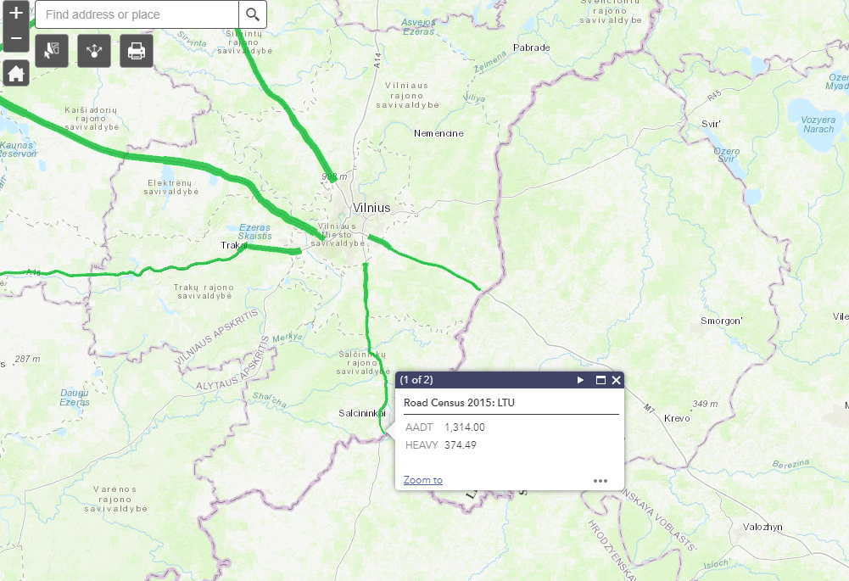

10. In collaboration with Eurostat, WP.6 has recognised the need for better bus statistics for some time, and at the 2018 session decided to make its longstanding pilot data collection on the topic permanent (see ECE/TRANS/WP.6/175, para. 45). In discussions (and evidenced in the data collected) many member States note that accurately reporting **international bus travel** and/or splitting data between domestic and international travel, remains a challenge. The census currently splits AADT by vehicle category for each E-Road (taking an average of its entire length). Data on the specific AADT of buses (vehicle category D in the census) at the segment crossing the border would add real value in tracking international bus and coach movements. This was not a part of the 2015 census questionnaire but has been added for the 2020 round.

11. With improving granularity in road accident statistics, in particular the geospatial locations of accident sites, the visualized census data could be used to **identify** **road traffic accident hotspots** (and conversely the best performing segments) on internationally important roads, in terms of fatalities (or injuries) per vehicle per year. This would provide a more useful metric of accident monitoring than simply comparing roads in terms of total fatalities (or injuries).

III. Relevance to the Sustainable Development Goals

12. These geospatial data will be a useful addition to the monitoring of the Sustainable Development Goals. As noted above the census would provide direct measurement of indicator 9.1.2 on passenger and freight volumes, and would also allow identification of areas of the E-Road network that are performing well and badly in terms of road traffic accidents (indicator 3.6.1). WP.6 is beginning a collaboration with the Directorate-General for Mobility and Transport (DG MOVE) of the European Commission on combining road traffic census data with DG MOVE road traffic accident data to provide more understanding in this area.

IV. Conclusions

13. It is expected that the E-Road census will continue to provide insights into traffic on the E-Road network, but the value of this exercise will be greatly increased if many more member States can provide GIS files (preferably in Shapefile format) of the results. Breakdowns of different types of vehicle would further enrich potential analyses. The decrease over time in the number of member States providing census data is cause for concern and the Committee may wish to **encourage** its members to treat the provision of these data as a priority.

14. The E-Road census, in particular the visualization of the census data, is valuable for the reasons set out above, which include monitoring the Sustainable Development Goals among other uses, adding a geospatial to the goals’ measurement.

15. Member States are therefore **strongly** **encouraged to take note** of the 2020 E-Road census recommendations set out in ECE/TRANS/WP.6/2018/11, and **endorse** the draft resolution as set out in that document.

16. This document has concentrated on the E-Road census, but there are similar benefits to producing geospatial data related to the E-Rail census, such as traffic measurement, identifying opportunities for modal switching and monitoring Euro-Asian transport links. The Committee is encouraged to **also consider as a priority** the provision of the rail census data.