INF.9
Economic Commission for Europe
Inland Transport Committee 17 July 2019
Working Party on the Transport of Dangerous Goods English
Joint Meeting of Experts on the Regulations annexed to the European Agreement concerning the International Carriage of Dangerous Goods by Inland Waterways (ADN)
Thirty-fifth session
Geneva, 26-30 August 2019
Item 3 (c) of the provisional agenda
Implementation of the European Agreement concerning the International
Carriage of Dangerous Goods by Inland Waterways (ADN):
interpretation of the Regulations annexed to ADN
Loading and unloading rates
Transmitted by the Government of the Netherlands
- Introduction
Related documents:
Informal document INF.12 of the thirty-fourth session ECE/TRANS/WP.15/AC.2/70 (Paragraphs 16-17)
  - At the thirty-fourth session of the ADN Safety Committee, the Dutch delegation presented informal document INF. 12 regarding Loading and unloading rates. In 2018, a general format regarding maximum permissible loading and unloading flows has been developed as a best practice in the Netherlands, ensuring efficient filling operations and at the same time preventing electrostatic charging, spills and implosion or explosion of the cargo tank.
  - Some delegations expressed reservations regarding the development of a harmonized format and pointed out that, if work was done in this direction, transitional provisions would have to be considered. Industry representatives expressed their support for harmonized provisions.
  - The ADN Safety Committee welcomed the offer of the Dutch delegation to organize a presentation of the developed practice at the thirty-fifth session of the ADN Safety Committee. Given the fact that this issue contains a lot of technical aspects and taking into account that industry representatives contributed substantially to the developed format/best practice, the Dutch delegation requested the representative of EBU to deliver this presentation. Fortunately, the representative of EBU was willing to take up this work. On the following pages the sheets to be used during the presentation can be found.

INF.9
- Follow-up
4. The Dutch delegation requests the ADN Safety Committee to discuss the information provided in the presentation by the representative of EBU, and to take action as it deems appropriate.

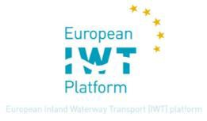
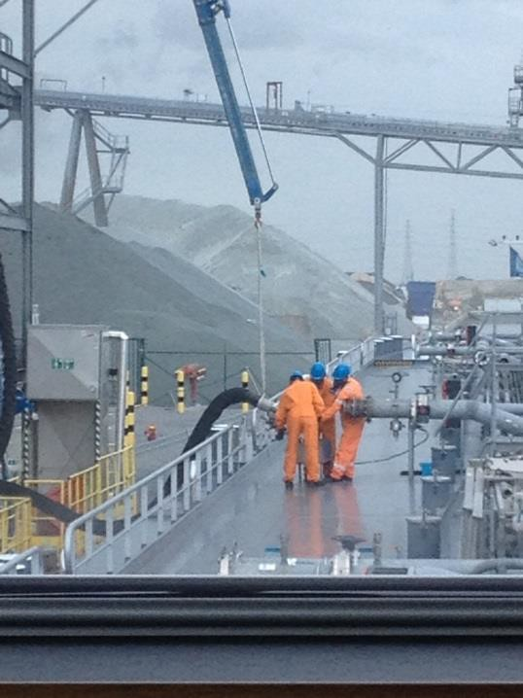
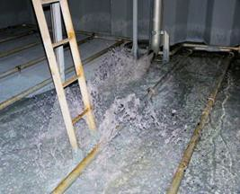
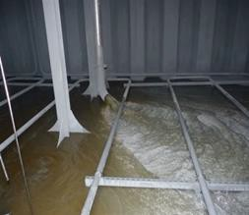

Safe Loading rates

The Loading and unloading instructions
During loading of many flammable liquids in tanks, there is the risk of electrostatic accumulation and discharge in the form of a spark.

This risk is present at the start of loading, but also during the middle speed.

This risk can be limited by:
- At the start: reducing the maximum loading rate to a flow of 1 m/sec
- During the middle speed: reducing the maximum loading rate to a flow of 7 m/sec

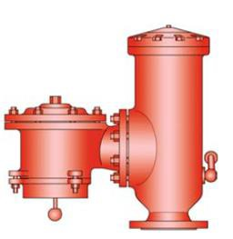
The Loading and unloading instructions
During loading of all liquids in tanks, due to a too high loading speed there is the risk of:
- Blowing off cargo vapours, by opening of the high velocity vent valve (health
risk for crew);
- Blowing up the cargo tanks (damage to the barge)

This risk can be limited by:
Respecting the max loading rate, based on the vapour return line system characteristics

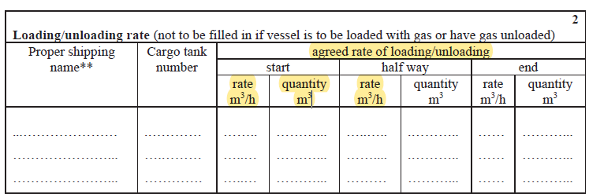
The Loading and unloading instructions
ADN 7.2.4.16.1 The loading rate (and the maximum operational pressure of the cargo pumps) shall be determined in agreement with the personnel of the shore installation.
The loading rate shall be agreed in the ADN Checklist of 8.6.3.

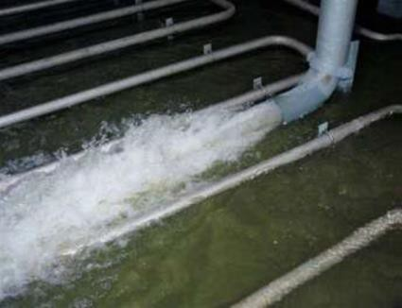
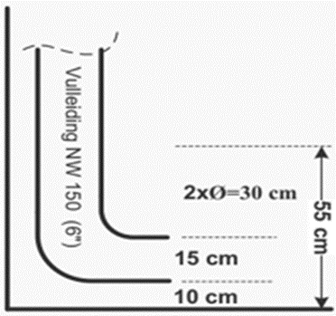
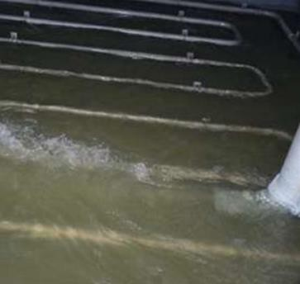
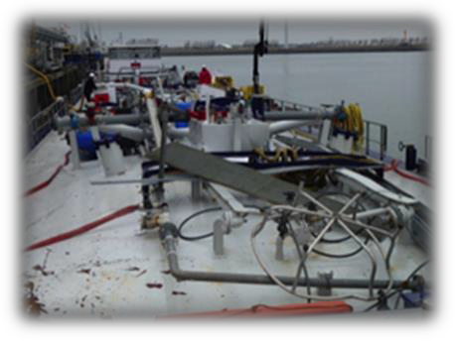
The Loading and unloading instructions
ADN 7.2.4.16.15 The initial cargo throughput established in the loading instructions shall be such as to ensure that no electrostatic charge exists at the start of loading.

The Loading and unloading instructions
- is referred to in ADN:
  - 1.4.3.3 (s) (Filler obligations) and 1.4.3.7. (j) (unloader obligations)
  - 7.2.4.16.15 (initial cargo throughput to avoid electrostatic discharge)
  - 8.1.2.3. the following documents shall be carried on board tank vessels:
( i )The instructions relating to the loading and unloading flows prescribed in 9.3.2.25.9 or 9.3.3.25.9;
  - 8.6.1.3 (Certificate of Approval)
  - 9.3.x.25.9 (Pumps and piping – the permissible loading and unloading rates shall be
calculated, based on the barges configuration and substance characteristics)
- are meant as barge specific instructions, to determine loading (and unloading) rates and quantities in different stages and ensure a safe cargo transfer; but…..

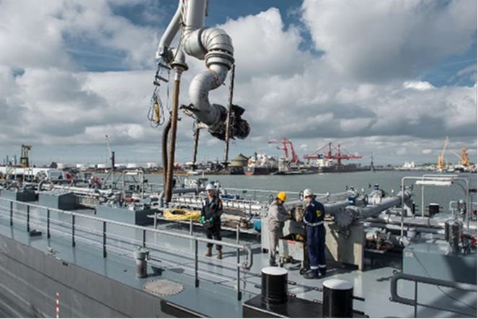
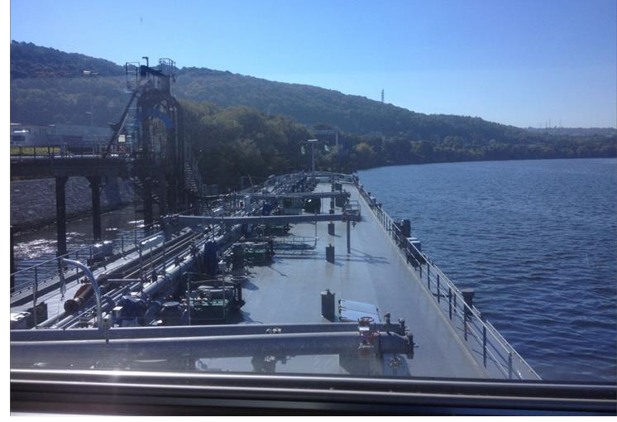
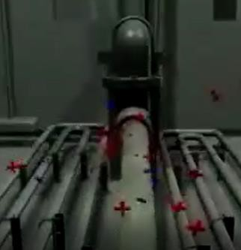
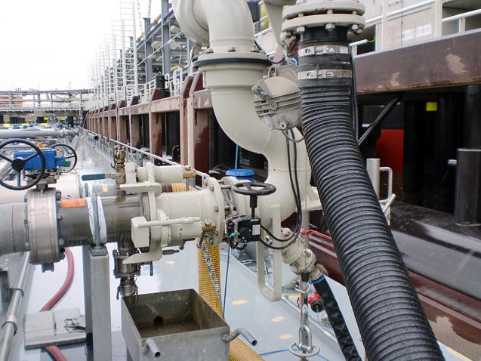
The Loading and unloading instructions

The required (uniform) Loading and unloading instructions
are missing in practice!!!

Preliminary conclusion
- Due to the lack of correct loading and unloading instructions the following safety aspect are not guaranteed:

- during the start-loading rate the crew, barge, cargo and environment are not protected efficiently against a possible explosion, due to a potential electrostatic discharge

- during the half way – loading rate, the crew, barge and environment are not protected against exposure and/or damage of cargo tanks due to high loading rates on the basis of missing or bad interpretable data

Summary
In practise is often missing:
  - A document, as a ‘tool’ for barge master and filler representative, to determine the maximum start and half way loading rate;
  - The technical barge data (piping configuration) to calculate and agree
the most safe start and half way loading rates;
  - The vapour density data, to be provided by the filler.

In the ADN is missing:
  - A definition for loading and unloading instructions;
  - Who is providing and who is responsible for the loading and unloading instructions?
  - Responsibilities to provide vapor data and calculate the max rate.

Initiative and benefits
- In the NL an uniform format is proposed by a working group of inspection bodies, filling industry and barge industry associations and operators;
- This uniform format shall be filled in for each barge once, by the ADN safety advisor regarding piping configurations
- Than, the format can easily assist the barge crew and filling terminal representative in determining the operational details of safe loading rates, at the start and middle speed
- Uniform format provides better understanding by all parties involved
- Mutual positive experiences working with the format so far

Conclusion - Safety improvement
- Initial filling rate: using a correct loading instruction facilitates in proper agreement of initial loading rate, based on specific barges’ configuration;
- ADN 7.2.4.15 can be respected regarding electrostatic discharge;
- 9.3.x.25.9 can be respected regarding the theoretical part of vapor densities and the risk of emissions during loading is minimalized;
- An uniform approach provides clarity, knowledge and vision;
- This results in a safety benefit and compliance towards the meaning
of the ADN regarding the ‘loading instruction’

