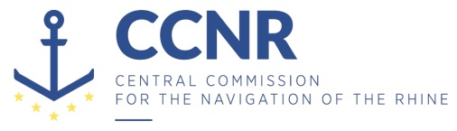
CCNR-ZKR/ADN/WP.15/AC.2/2019/25 corr. 1

Distr.: General
10 October 2019
Or. GERMAN

JOINT MEETING OF EXPERTS ON THE REGULATIONS ANNEXED TO THE AGREEMENT CONCERNING THE INTERNATIONAL CARRIAGE OF DANGEROUS GOODS BY INLAND WATERWAYS (ADN) (SAFETY COMMITTEE)
(35th meeting, Geneva, 26 - 30 August 2019)
Item 3 d) of the provisional agenda
Implementation of the European Agreement concerning the International Carriage of Dangerous Goods by Inland Waterways ADN: training of experts
Report of the 20th meeting of the informal working group on the training of experts
Corrigendum
Transmitted by the Central Commission for the Navigation of the Rhine (CCNR)*, **

- Paragraph 37

Replace with:
“37. The informal working group decided that its next meetings would be held in Strasbourg from 24 to 26 March 2020. The meetings would begin at 2 p.m. and finish at 1 p.m.”.

***

* Distributed in German by the Central Commission for the Navigation of the Rhine under the symbol CCNR/ZKR/ADN/WP.15/AC.2/2019/25 corr. 1.
** In accordance with the programme of work of the Inland Transport Committee for 2018–2019 (ECE/TRANS/2018/21/Add.1 (9.3)).

