|  |  |  |  |
| --- | --- | --- | --- |
| . | United Nations | ECE/TRANS/WP.15/AC.1/2019/26 | |
| _unlogo | **Economic and Social Council** | | Distr.: General  19 June 2019  Original: English |

**Economic Commission for Europe**

Inland Transport Committee

**Working Party on the Transport of Dangerous Goods**

**Joint Meeting of the RID Committee of Experts and the**

**Working Party on the Transport of Dangerous Goods**

Geneva, 17–27 September 2019

Item 2 of the provisional agenda

**Tanks**

Tanks: Vacuum-Operated Waste Tanks (VOWTs) – diverting vapours from the outlets of pump/exhauster units to a place where they will not cause danger

Transmitted by the Government of the United Kingdom[[1]](#footnote-2), [[2]](#footnote-3)\*\*

|  |
| --- |
| *Summary* |
| **Executive summary:**  This paper proposes amendments to RID/ADR to permit an alternative method of effectively diverting flammable or toxic vapours from the outlet of pump/exhauster units of Vacuum-Operated Waste Tanks to a place of safety. |
| **Action to be taken:** Proposal to amend 6.10.3.8 (a) to allow Vacuum-Operated Waste Tanks to be constructed with an outlet that is not directed to a safe place but is designed for an external hose to be connected. Proposal to amend the operational requirements of Chapter 4.5 to mandate the coupling of an external hose before loading commences. |
| **Related documents:** Informal documentsINF.31 and INF.39 (paragraph 2) of the March 2019 session. |
|  |

Introduction

1. Following concerns raised by inspection bodies in the United Kingdom regarding different interpretations of the construction requirements for Vacuum-Operated Waste Tanks (VOWTs) in Chapter 6.10 of RID/ADR, the United Kingdom has been looking closely at the construction requirements for these vehicles.

2. When loading such tanks, a pump/exhauster unit extracts toxic vapours from inside the vessel and exhausts them to atmosphere. RID/ADR requires the outlet of this pump/exhauster unit to be designed such that any flammable or toxic vapors are diverted to a place where they will not cause a danger (RID/ADR 6.10.3.8 (a)).

3. The construction requirement in 6.10.3.8 (a) does not however, allow configurations that are designed and constructed to be connected to an additional pipe that directs vapours to a place where they will not cause a danger.

4. Given that the attachment of an additional pipe is likely to improve the safe use of such tanks, we propose RID/ADR is amended to allow VOWTs to be constructed and used with such configurations.

Proposal 1

Introduce new text to 6.10.3.8 to read (new wording in bold and underlined):

“The tanks shall be fitted with the following additional service equipment:

(a) The outlet of a pump/exhauster unit shall be so arranged as to ensure that any flammable or toxic vapours are diverted to a place where they will not cause danger;

(b) **The requirement in 6.10.3.8 (a) shall be considered to have been met if the outlet is:**

**(i) equipped with a connection designed for the attachment of a flexible pipe; and**

**(ii) clearly marked with a label stating that a flexible pipe to divert flammable or toxic vapours to a place where they will not cause danger shall be connected before loading commences.**”

Renumber existing paragraphs (b), (c), (d) etc.

Proposal 2

Introduce new text to 4.5.2 to read (new wording in bold and underlined):

“**4.5.2.7 When any vacuum pump/exhauster having an outlet as described in 6.10.3.8 (b)(i) is operated, a flexible pipe as described in 6.10.3.8 (b)(ii) shall be attached to the outlet before loading commences.**”

**Justification**

5. 6.10.3.8 (a) of RID/ADR requires the outlet of any vacuum pump/exhauster unit to be designed and constructed in such a way that toxic vapours are directed to a safe place. If a low-level outlet is used however, it is difficult to see how this could be considered safe when climatic conditions could redirect harmful vapours to the loader/operator and similarly, with high-level outlets, it would also seem possible for the operator to be exposed to any vapours that may be heavier than air.

6. To address these risks, we are aware that VOWT’s are being fitted with low level outlets that have a mechanism for connecting to an external hose, as shown in the following image:

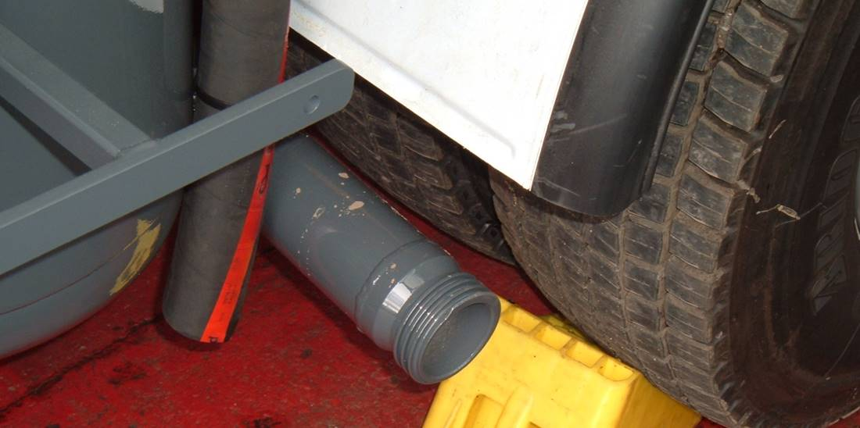

7. A flexible pipe will be connected which directs vapours to either (a) an on-site device that cleans the output from the vacuum pump or (b) an extension hose that is approximately 15m long and allows the vapours to be vented in a safe place (i.e. away from potential hazards, sources of ignition and personnel). An example of such a design in operation is shown below:

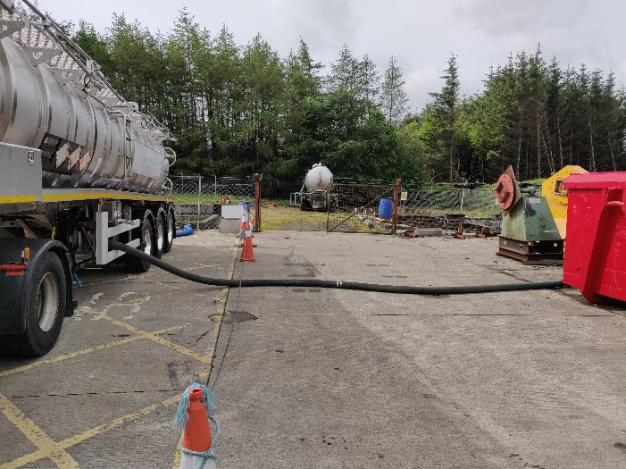

8. These designs create a safe solution for operators but given the specific construction requirement of RID/ADR 6.10.3.8 (a), this type of arrangement would not seem to be currently permitted.

9. In our opinion therefore, RID/ADR should be amended to allow VOWTs to be constructed with an outlet that is not directed to a safe place but are designed for an external hose to be connected. An amendment to the operational requirements of Chapter 4.5, mandating the coupling of an external hose before loading commences is also needed to ensure operator safety.

1. In accordance with the programme of work of the Inland Transport Committee for 2018-2019, (ECE/TRANS/2018/21/Add.1, Cluster 9, (9.2)). [↑](#footnote-ref-2)
2. \*\* Circulated by the Intergovernmental Organisation for International Carriage by Rail (OTIF) under the symbol OTIF/RID/RC/2019/26. [↑](#footnote-ref-3)