INF.30
Economic Commission for Europe
Inland Transport Committee
Working Party on the Transport of Dangerous Goods
Joint Meeting of the RID Committee of Experts and the
Working Party on the Transport of Dangerous Goods 15 March 2019
Bern, 18-22 March 2019
Item 2 of the provisional agenda
Tanks
United Kingdom interpretation of construction requirements applicable to the opening ends of Vacuum-Operated Waste Tanks (VOWTs)
Transmitted by the Government of the United Kingdom

Summary
Executive summary: This paper provides delegates with information on guidance that the United Kingdom intends to provide to its inspection bodies and manufacturer’s regarding compliance with ADR 6.10.3.5.
Action to be taken: The United Kingdom would welcome an exchange of views on the UK interpretation of ADR 6.10.3.5.

Related documents: None.
Introduction
1. Following concerns raised by inspection bodies in the United Kingdom regarding different interpretations of the construction requirements for Vacuum-Operated Waste Tanks (VOWTs) in Chapter 6.10 of ADR, the United Kingdom has been looking closely at the construction requirements for VOWT vehicles.
2. Accordingly, the United Kingdom is developing guidance that seeks to assist inspection bodies and manufacturers in the interpretation of Chapter 6.10 of ADR. However, in developing this guidance, the United Kingdom would appreciate the views of other member countries as to whether, in their opinion, the United Kingdom interpretation of certain aspects of Chapter 6.10 concurs with their understanding and application of the requirements.
3. In respect of ADR 6.10.3.5 (“openable ends” of VOWTs), our intention is to include guidance on the interpretation of this paragraph by including examples of locking devices that are considered to meet the requirements of this section. The guidance will of course, also recognize that other designs may be acceptable if they offer an equivalent (i.e. the same or better) level of safety and inspection bodies will be expected to make an engineering judgement, on a case by case basis, as to whether an alternative design may be appropriate.

Requirements for ‘openable ends’
4. ADR 6.10.3.5 states:
“6.10.3.5 The tanks may be equipped with openable ends. Openable ends shall comply with the following conditions:
(a) The ends shall be designed to be secured leaktight when closed;
(b) Unintentional opening shall not be possible;
(c) Where the opening mechanism is power operated the end shall remain securely closed in the event of a power failure;
(d) A safety or breakseal device shall be incorporated to ensure that the openable end cannot be opened when there is still a residual over pressure in the tank. This requirement does not apply to openable ends which are power-operated, where the movement is positively controlled. In this case the controls shall be of the dead-man type and be so positioned that the operator can observe the movement of the openable end at all times and is not endangered during opening and closing of the openable end; and
(e) Provisions shall be made to protect the openable end and prevent it from being forced open during a roll-over of the vehicle, tank-container or tank swap body.”
Interpretation
5. The United Kingdom interpretation is that robust design solutions must be in place to ensure the requirements of 6.10.3.5 are met with respect to the locking mechanisms fitted to openable ends. Our understanding is that there are three types of locking mechanism commonly fitted to the openable ends of VOWTs:
(a) Manual hand wheel door clamps.
The clamps are protected by the substantial brackets on the tank and door from damage during a roll-over. In the event of a roll-over occurring, the hand wheels are designed to fracture and leave a nut securing the door in place.

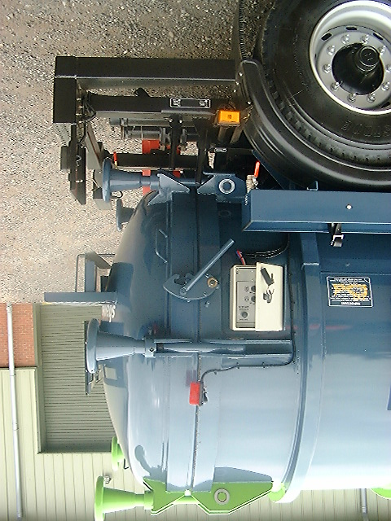

It should be noted that, as required by ADR 6.10.3.5 (d), the above locking arrangement incorporates a safety device to prevent the door opening when there is still residual pressure in the tank.

Safety Catch

(b) Hydraulic wedge type door clamps.
This type of clamp is fully automatic, controlled by hydraulic linear actuators. The wedge on the end of the ram is guided though slotted brackets on the door and the end of the tank vessel and the wedge pulls the seal tight onto the sealing face. The hydraulic oil is locked in the rams preventing the rams from opening. The position of the rams around the door ring is likely to ensure that the openable end is not forced open in the event of a roll-over and allow the loss of any products being carried.

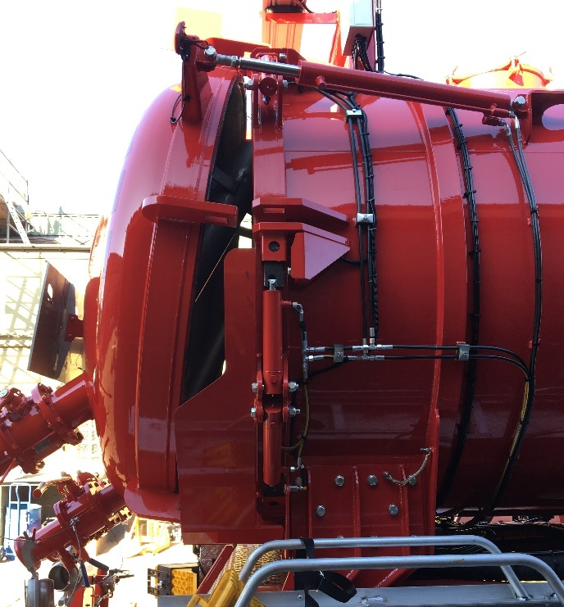
(c) Hydraulic over centre type clamps
This type of clamp is fully automatic, controlled by hydraulic linear actuators. A hook style clamp is connected to a hydraulic ram with a series of linkages. When the ram extends, the hook clamp rotates on a pivot and clamps the door shut.

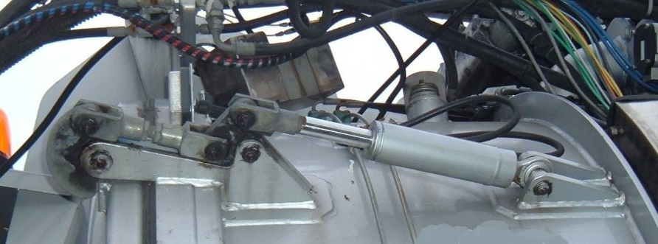
6. In our opinion the examples shown in (a) and (b) above would seem to meet the requirements of 6.10.3.5 (e). In respect to example (c) however, given the door clamping mechanism would appear to be vulnerable to damage and allow the door to be forced open in the event of a roll-over incident, in our view this design would not seem to meet the requirements of 6.10.3.5 (e) unless additional measures were to be put in place to protect the locking mechanism.
Conclusion
7. To ensure a consistent approach to interpreting the requirements of 6.10.3.5 (e), we would welcome an exchange of views with other member countries as to whether, in their opinion, the UK interpretation of this section concurs with their understanding of the requirements.

