UN/SCETDG/56/INF.30
Committee of Experts on the Transport of Dangerous Goods
and on the Globally Harmonized System of Classification
and Labelling of Chemicals 27 November 2019
Sub-Committee of Experts on the Transport of Dangerous Goods
Fifty-sixth session

Geneva, 4 –10 December 2019
Item 4 (a) of the provisional agenda
Electric storage systems: testing of lithium batteries
Phone number on lithium battery mark
Transmitted by The Rechargeable Battery Association (PRBA) and the Advanced Rechargeable & Lithium Batteries Association (RECHARGE)
Introduction
1. This document addresses whether the phone number should be part of the lithium battery mark and the issues raised by ICAO in informal document INF.34 (55th session).
2. The Model Regulations require the lithium battery mark below found in Section 5.2.1.9 to be placed on nearly all packages containing small lithium ion and lithium metal batteries when shipped in accordance with Special Provision 188. The mark is also widely used on packages of consumer electronic devices such as cellular phones, notebooks, tablets, and power tools that are packed with or contain lithium ion or lithium metal batteries. The single asterisk on the mark indicates the location for the required identification number UN3480, UN3481, UN3090, or UN3091. The double asterisk indicates the location for a phone number. PRBA and RECHARGE have always understood this number is intended to be used when a package is badly damaged and a carrier or freight forwarder needs to contact the shipper or a third-party emergency response company for instructions on repackaging the product.
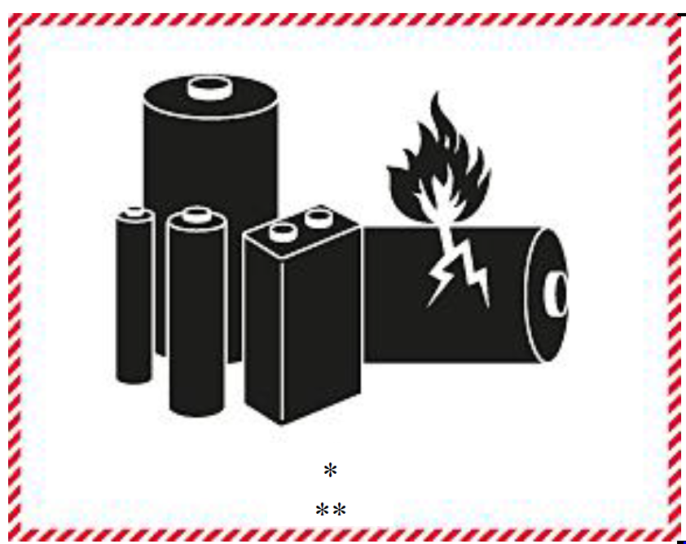
3. Questions have been raised by members of this Sub-Committee and ICAO regarding the intended use of the phone number, whether it needs to be a 24/7 emergency response phone number, and how it is being implemented by shippers and carriers. See Informal document INF.34 (55thsession) from ICAO discussed during the fifty-fifth session.

4. Some companies incorporate the lithium battery mark into their retail packaging as shown below on the left. Most companies, however, place the mark on a fibreboard box as shown below on the right. In some cases, the phone number used is from the company that originally manufactured and shipped the lithium battery or product while others use a phone number from a third-party emergency response company. Two such companies based in the United States are CHEMTREC and Infotrac.
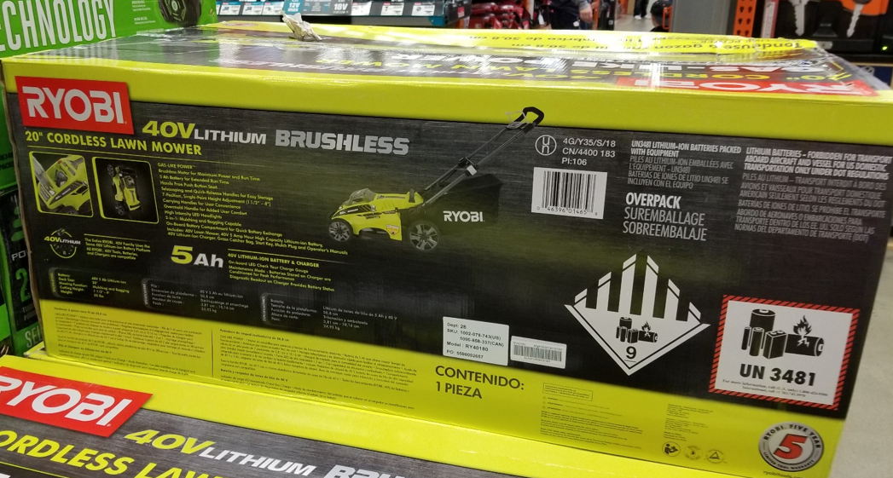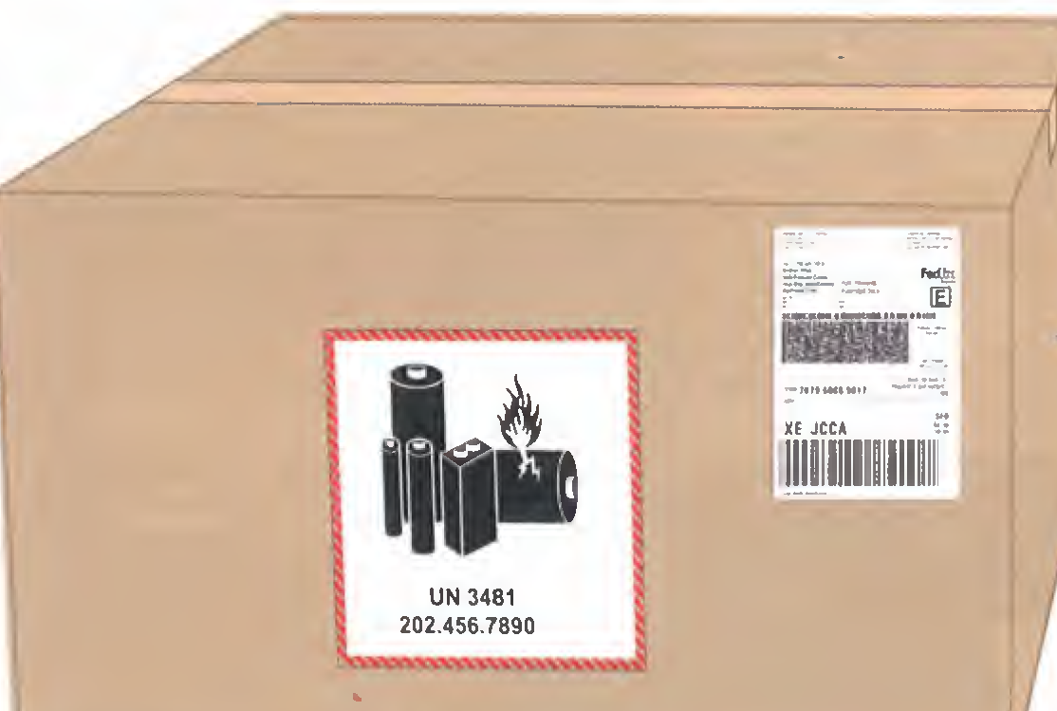
5. It is very common for packages of small lithium batteries and products powered by them to be shipped by original manufacturers in Asia to distribution centers worldwide where they are often stored for a period of time. When these packages are reoffered for transport by the distribution center, they often have the original manufacturer’s lithium battery mark and phone number like the retail package shown above. Thus, these reoffered packages – while fully compliant with the dangerous goods regulations – often do not contain a phone number for the new shipper (e.g., distribution center). This obviously could cause confusion for freight forwarders or carriers in the logistics chain who may utilize the original manufacturer’s phone number on the lithium battery mark.
6. PRBA and RECHARGE have learned from its members that the phone numbers on the lithium battery mark are rarely used by companies in the logistics chain. For example, one PRBA member has shipped approximately 330 million devices (e.g., cellular phones, tablets) every year for the past three years and there were no calls to the phone number on their lithium battery mark. Similarly, our discussions with emergency response companies in the U.S. like CHEMTREC and Infotrac find a very low volume of calls to the phone numbers on the lithium battery mark.
7. In 2017, approximately 7.2 billion lithium ion cells, 2 billion cellular phones, and 330 million notebooks and tablets were manufactured and shipped worldwide. The lack of calls to the phone numbers on the lithium battery mark even in the face of these large volumes of shipments reflects the industry’s excellent safety record for packaging and shipping their high-quality products worldwide and the well-established hazard awareness resulting from the use of the lithium battery mark. This greater awareness associated with lithium batteries in transport is also noted in ICAO’s Informal document INF.34 (55thsession).
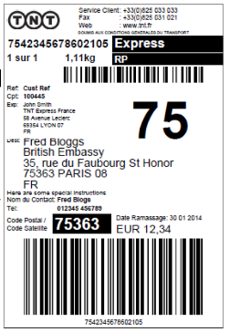
8. PRBA and RECHARGE believe the lithium battery mark with a UN number provide an adequate level of hazard communication for small lithium batteries and equipment shipped in accordance with Special Provision 188. Eliminating the phone number will not reduce the effectiveness of the lithium battery mark and will in fact simplify the dangerous goods regulations for shippers. If a carrier or freight forwarder needs to contact the correct shipper (consignor) regarding a damaged package of lithium batteries, that information is readily available on packages or is accessible through the use of bar codes or QR codes. Below are several examples from packages recently used to ship electronic devices with lithium ion batteries that contain the shipper’s contact information.
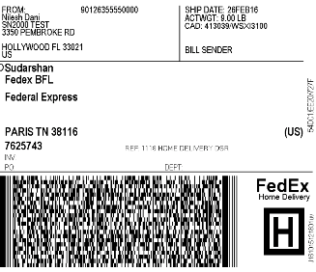
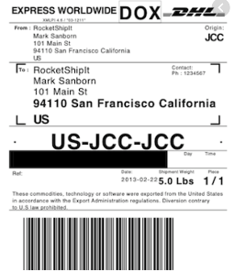

9. PRBA and RECHARGE would appreciate comments from members of the Sub-Committee on whether removing the phone number from the lithium battery mark would reduce the effectiveness of the mark. If there is a general consensus that, based on years of transport experience (such as cited above), the phone number adds little practical value and that removing the phone number would not reduce the effectiveness of the mark, we will prepare a Working Document proposing to remove the number for consideration during the 57th session of the Sub-Committee.

