|  |  |  |  |
| --- | --- | --- | --- |
|  | United Nations | ST/SG/AC.10/C.3/2019/38 | |
| _unlogo | **Secretariat** | | Distr.: General  27 May 2019  English  Original: English and French |

**Committee of Experts on the Transport of Dangerous Goods  
and on the Globally Harmonized System of Classification  
and Labelling of Chemicals**

|  |
| --- |
| **Sub-Committee of Experts on the Transport of Dangerous Goods** |
| **Fifty-fifth session**  Geneva, 1-5 July Item 3 of the provisional agenda  **Listing, classification and packaging** |

Transport of transformers with gas cylinders

Transmitted by the expert from Germany[[1]](#footnote-2)\*

Introduction

1. For operational reasons, transformers are pressurized with nitrogen or with synthetic or dried air or also with a mixture of these gases. However, as the transformers are not gas-tight, low quantities of gas are constantly supplied through a pressure regulator from a gas cylinder connected to the transformer. So far, transformers have been transported by sea under UN 3363, Class 9. Due to the quantity limit of dangerous goods in machinery or apparatus having been exceeded, an approval in accordance with special provision 301 was issued by the competent authority. For this approval, it was implicitly taken into account that the transformer is not gas-tight and the condition was stipulated that the transformer must be transported on deck or in a well-ventilated cargo hold.

2. As of 1 January 2020, at the latest, such transformers will fall under UN 3538, Division 2.2. It must therefore be clarified how the problem of the lack of gas-tightness of the transformers should be dealt with.

3. Packing instruction P006 which applies to UN 3538 provides that transformers may be transported unpackaged. It does not explicitly require the transformer to be gas-tight. With regard to the connected gas cylinder, however, (3)(d) of the packing instruction applies; therefore 4.1.6 and 6.2 must complied with. In accordance with 4.1.6.1.5, the valves shall remain closed during transport.

Conclusion

4. With regard to safety, it generally does not present a problem if low quantities of gases which are not flammable, toxic, corrosive or oxidizing are released into the environment provided that an asphyxiant gas accumulation in confined spaces is prevented. This is also shown by the comparison with cryogenic receptacles: in the refrigerated liquefied state, such gases may be transported in open cryogenic receptacles which allow for continuous venting of the gas in order to maintain the receptacle at atmospheric pressure. A requirement for manufacturing gas-tight transformers would thus be disproportionate.

5. To avoid the necessity of issuing an exemption each time such transformers are transported, the regulations should contain a provision to this effect. A special provision should be assigned to UN 3538 laying down safety requirements for pressurizing transformers with gas. Pictures with examples of such transformers are included in the Annex.

Proposal

6. Add the following special provision in Chapter 3.3:

“XXX Where large and robust articles are transported with connected gas cylinders containing nitrogen of UN 1066 or compressed or synthetic air of UN 1002 or UN 1956, the valves of the gas cylinders may remain open if the gas cylinders are connected with the article through pressure regulators and fixed piping in such a way that the pressure of the gas (gauge pressure) in the article does not exceed 35 kPa (0.35 bar). Gas cylinders, pressure regulators and piping shall be protected by wooden crates or other suitable means.”.

7. In Chapter 3.2, insert “xxx” in column 6 of the Dangerous Goods List for UN 3538.

Annex

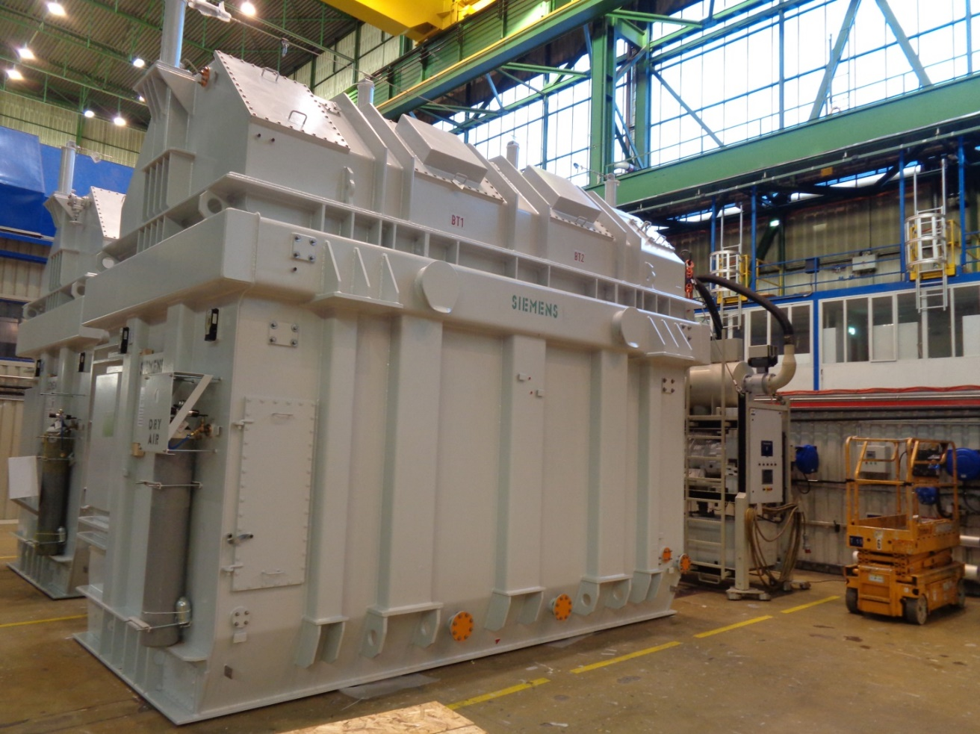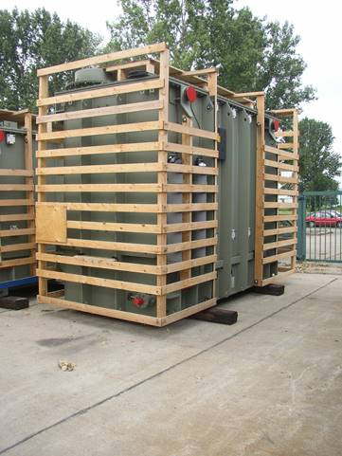



1. \* In accordance with the programme of work of the Sub-Committee for 2019–2020 approved by the Committee at its ninth session (see ST/SG/AC.10/C.3/108, paragraph 141 and ST/SG/AC.10/46, paragraph 14). [↑](#footnote-ref-2)