Note by the secretariat | Informal document No. GRSG-115-03  (115th GRSG, 9-12 October 2018  agenda item 20)

Proposal for a corrigendum to Revision 3 of UN Regulation No. 58

The text reproduced below aims to correct the current text of UN Regulation No. 58 on the marking provisions. The modifications are marked in bold for new or strikethrough for deleted characters.

A. Proposal

Annex 4 (Arrangements of approval marks), Model B, correct to read (footnote ¹ remains unchanged):

"Model B
(see paragraphs 6.5., 15.5., 24.5. of this Regulation)
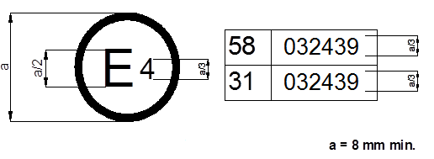

The above approval mark affixed to a vehicle shows that the vehicle type concerned has been approved in the Netherlands (E 4) pursuant to UN Regulations Nos. 58 and 31.¹ The approval numbers indicate that, at the dates when the respective approvals were given, UN Regulation No. 58 included the 03 series of amendments and UN Regulation No. 31 also included the 03 series of amendments was still in its original form.

B. Justification

The provisions on the model B of the approval mark needs to be corrected as the figure refers correctly to the latest 03 series of amendments of UN Regulation No. 31. In this respect, the text of the example has to be adapted/corrected accordingly (in all 3 official languages).

____________

