|  |  |  |  |
| --- | --- | --- | --- |
|  | United Nations | ECE/TRANS/WP.29/2018/41 | |
| _unlogo | **Economic and Social Council** | | Distr.: General  9 April 2018  Original: English |

**Economic Commission for Europe**

Inland Transport Committee

**World Forum for Harmonization of Vehicle Regulations**

**175th session**

Geneva, 19-22 June 2018

Item 4.6.5 of the provisional agenda

**1958 Agreement:  
Consideration of draft amendments**

**to existing UN Regulations submitted by GRSP**

Proposal for Supplement 4 to the 01 series of amendments to UN Regulation No. 129 (Enhanced Child Restraint Systems)

**Submitted by the Working Party on Passive Safety**[[1]](#footnote-2)\*

The text reproduced below was adopted by the Working Party on Passive Safety (GRSP) at its sixty-second session (ECE/TRANS/WP.29/GRSP/62, para. 31). It is based on ECE/TRANS/WP.29/GRSP/2017/35, not amended. It is submitted to the World Forum for Harmonization of Vehicle Regulations (WP.29) and to the Administrative Committee AC.1 for consideration at their June 2018 sessions.

Supplement 4 to the 01 series of amendments to UN Regulation No. 129 (Enhanced Child Restraint Systems)

*Paragraph 7.2.8.,* amend to read:

"7.2.8. The complete seat, or the component fitted with ISOFIX attachments (e.g. ISOFIX base) if it has a release button, is attached rigidly to a test rig in such a way that ISOFIX connectors are aligned as shown in Figure 3. A 6 mm diameter bar, 350 mm long, shall be attached to the ISOFIX connectors. A force of 50 ± 1 N shall be applied to the extremities of the bar."

*Figure 3*, amend to read:

"Figure 3

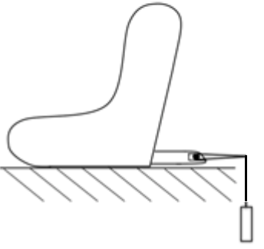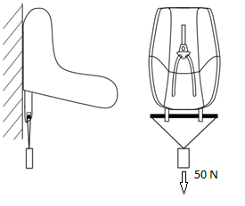

"

1. \* In accordance with the programme of work of the Inland Transport Committee for 2018–2019 (ECE/TRANS/274, para. 123 and ECE/TRANS/2018/21/Add.1, cluster 3.1), the World Forum will develop, harmonize and update UN Regulations in order to enhance the performance of vehicles. The present document is submitted in conformity with that mandate. [↑](#footnote-ref-2)