|  |  |  |  |
| --- | --- | --- | --- |
|  | United Nations | ECE/TRANS/WP.29/2018/32 | |
| Description: _unlogo | **Economic and Social Council** | | Distr.: General  27 December 2017  Original: English |

**Economic Commission for Europe**

Inland Transport Committee

**World Forum for Harmonization of Vehicle Regulations**

**174th session**

Geneva, 13-16 March 2018

Item 4.14.1 of the provisional agenda

**1958 Agreement:**

**Proposal for amendments to the Consolidated Resolution**

**on the common specification of light source categories (R.E.5)**

Proposal for Amendment 1 to the Consolidated Resolution on the common specification of light source categories (R.E.5)

**Submitted by the Working Party on Lighting and Light-Signalling**[[1]](#footnote-2)\*

The text reproduced below was adopted by the Working Party on Lighting and Light-Signalling (GRE) at its seventy-eighth session (ECE/TRANS/WP.29/GRE/78, para. 16). It is based on ECE/TRANS/WP.29/GRE/2017/18 and Annex III to the report. It is submitted to the World Forum for Harmonization of Vehicle Regulations (WP.29) for consideration at its March 2018 session.

Amendment 1 to the Consolidated Resolution on the common specification of light source categories (R.E.5)

*The Status table*, amendto read:

"**Status table**

This consolidated version of this Resolution contains all provisions and amendments adopted so far by the World Forum for Harmonization of Vehicle Regulations (WP.29) and is valid from the date as indicated in the following table until the date on which the next revision of this Resolution becomes valid:

|  |  |  |  |  |
| --- | --- | --- | --- | --- |
| *Version of the Resolution* | *Date \* as from which the version is valid* | *Adopted by WP.29* | | *Clarification* |
| *Session No.* | *Amendment document No.* |
| 1 (Original) | 2017-06-22 | 170 | ECE/TRANS/WP.29/2016/111 | Based upon Annexes 1 of Regulations:   * No. 37, up to and including Supplement 44 * No. 99, up to and including Supplement 11 * No. 128, up to and including Supplement 5 |
| [2] | [2018-xx-xx] | [174] | [ECE/TRANS/WP.29/2018/xx] | Amended details in sheets:  C21W/2, H1/1, H3/1, H3/2, H4/4, H9/1, H11/2, H13/4, H14/1, H15/5, H20/3, H20/4, HIR2/1, HS6/1, P13W/3, P21W/1, P21/5W, P27/7W/3, PSX26W/3, R5W/1, R10W/1, T1.4W/1, W15/5W/1, W21/5W/1, WT21W/1 |

\* This date is the date of adoption of the amendment to the Resolution by WP.29 or the date of entering into force of an amendment to Regulation No. 37, 99 or 128 adopted by AC.1 as a package with the amendment to the Resolution in the same session of WP.29.

”

*Annex 1,*

*Sheet C21W/2,* amend to read:

"Test procedure and requirements

1. The filament light source is placed in a holder (socket) capable of being so rotated through 360° about the reference axis that the front elevation is seen on the screen on to which the image of the filament is projected. The reference axison the screen shall coincide with the centre of the filament light source. The central axis sought on the screen shall coincide with the centre of the filament light source length.

2. ..."

*Sheet H1/1,* amend to read:

"

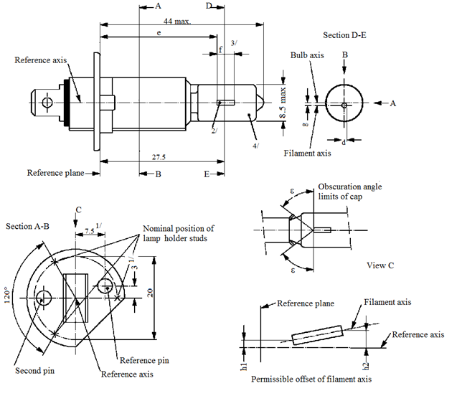

8.5 max.

Filament axis

44 max.

E

B

D

A

A

B

d

g

Reference axis

Reference plane

Section D-E

Bulb axis

27.5

3

Permissible offset of filament axis

h2

h1

Nominal position of filament light source holder studs

Obscuration angle

limits of cap

Section A-B

ε

ε

View C

Second pin

Reference pin

Reference axis

Reference plane

Filament axis

Reference axis

C

120°

20

7.5 1/

e

f

3/

2/

1/

4/

Reference axis

"

*Sheet H3/1,* amend to read:

"

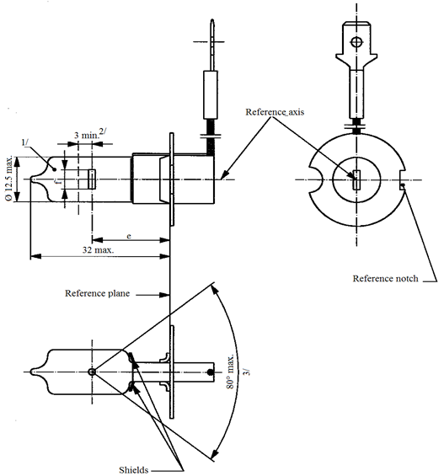

Reference axis

Reference plane

Reference notch

Shields

32 max

80° max.

3 min.2/

e

1/

3/

Ø 12.5 max

Reference axis

"

*Sheet H3/2,* amend to read:

"

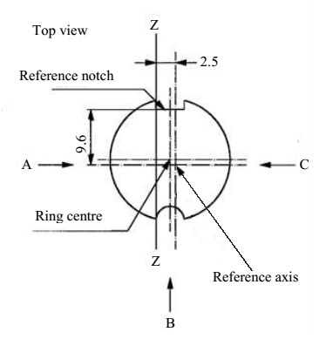

Definition: Ring centre and reference axis4/

9.6

Top view

Z

Definition of Z - Z

Z

B

9.6

2.5

C

A

Reference axis

Ring centre

Reference notch

"

*Sheet H4/4, table, last row but two,* amend to read:

"….….

|  |  |  |  |  |  |
| --- | --- | --- | --- | --- | --- |
| … | … | … | … | | … |
| IC 11/, 12/ | 5.5 | 5.25 | ±0.50 | ±0.80 | ±0.35 |
| … | … | | … | | … |
| … | … | | … | | … |

"

*Sheet H9/1, figure 1,* amend to read:

"



e

f

Reference axis2/

Reference plane1/

e

f

Category H9

Category H9B

B

A

B

4/

A

4/

Reference axis2

Figure1 – Main drawings

*Sheet H11/2, top right drawing,* amend to read:

"

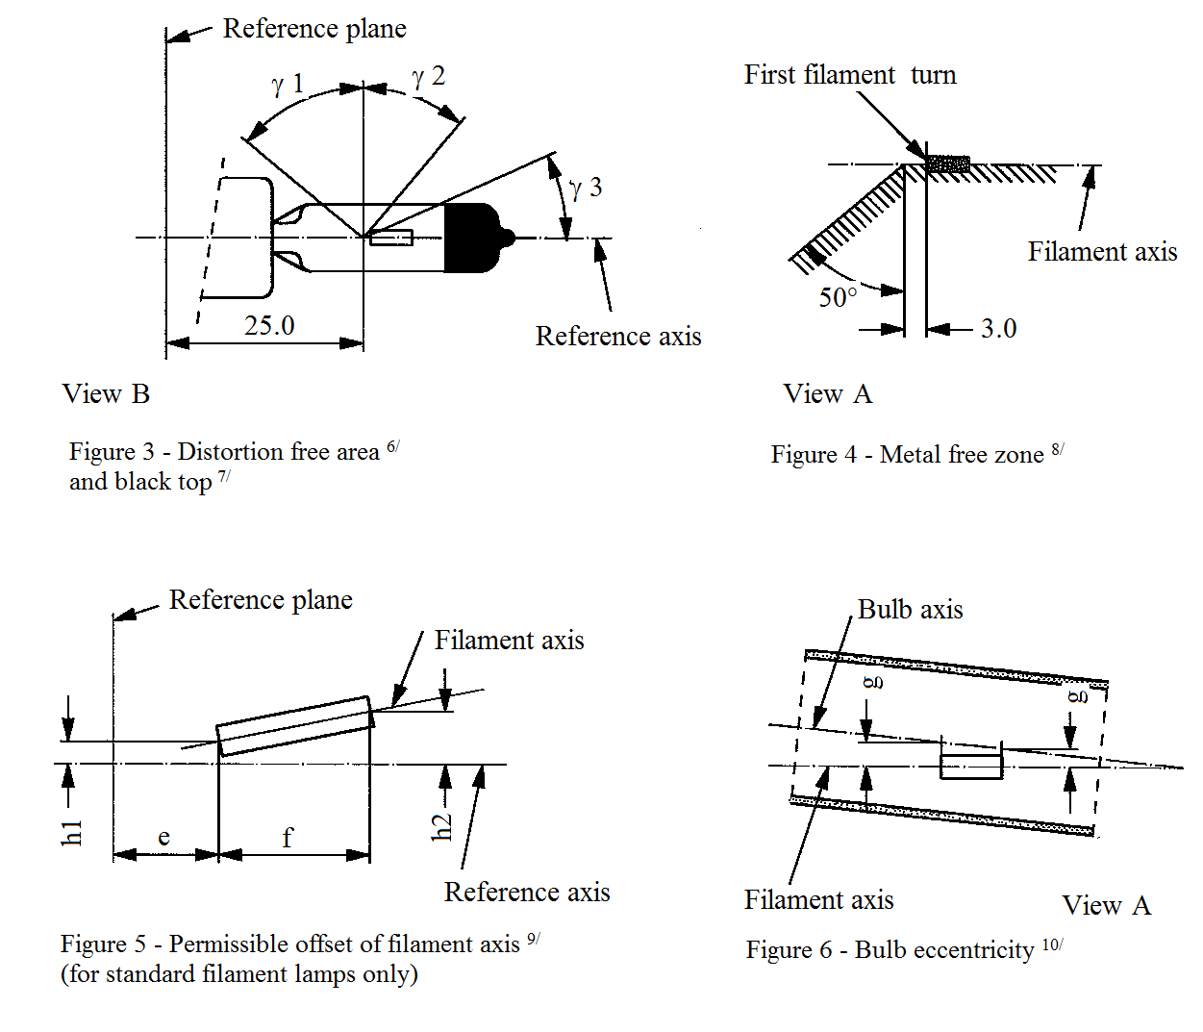

Reference plane

Reference plane

Reference axis

Reference axis

Filament axis

Filament axis

View A

View A

Filament axis

View B

Distortion free area6 and black top7

Bulb axis

Figure 4 – Metal free zone8

Figure 6 – Bulb eccentricity10

Figure 5 – Permissible offset of filament axis9

(for standard filament light sources only)

ɣ1

ɣ2

ɣ3

50°

3.0

25.0

f

e

h1

h2

g

g

First filament turn

"

*Sheet H13/4, rows m and n,* amend to read:

"

| *Dimensions in mm* | | *Tolerance* | |
| --- | --- | --- | --- |
| *Filament light sources of normal production* | *Standard filament light source* |
| … | … | … | … |
| m 11/ | 0 | ±0.20 | ±0.13 |
| n 11/ | 0 | ±0.20 | ±0.13 |
| … | … | … | … |

"

Sheet H14/1, figure 1, amend to read:

"

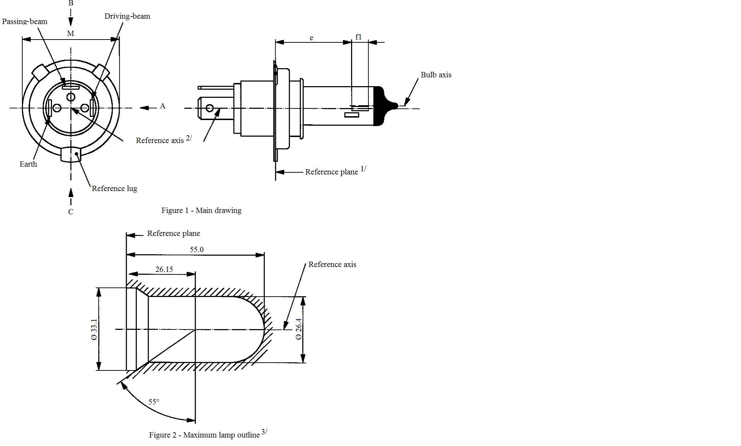

Passing-beam

Driving-beam

Reference lug

Earth

Reference axis2/

Reference plane1/

Reference axis

Figure 2 – Maximum filament light source outline3/

**Reference plane**

Figure 1 – Main drawing

B

M

A

C

55.0B

26.15

55°

Bulb axis

e

f1

Ø 33.1

Ø 26.4

"

*Sheet H15/5, note 10,* amend to read:

"10 "e" denotes the distance from the reference plane to the beginning of the high wattagefilament as defined above."

*Sheet H20/3, note 8*, amend to read:

"8 The ends of the filament are defined as the points where, when the viewing direction is direction A as shown in Figure 1 on sheet H20/1, the projection of the outside of the end turns crosses the filament axis."

*Sheet H20/4, last paragraph*, amend to read:

"The ends of the filament as defined on sheet H20/3, note 8, shall lie between lines Z1 and Z2 and between Z3 and Z4."

*Sheet HIR2/1, the drawing View B left bottom,* replace "Reference axis" with "Filament axis".

*Sheet HS6/1, figure 1,* amend to read:

"

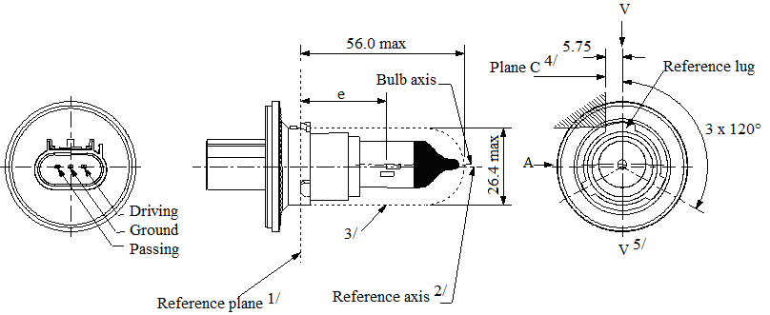

56.0 max.

5.75

3 x 120°

Plane C4/

V5/

V

B

3/

e

A

Bulb axis

Reference axis2/

Reference plane1/

Reference lug

Driving

Ground

Passing

Ø 26.4 max.

"

*Sheet P13W/3,* amend to read:

"…

The ends of the filament as defined on sheet P13W/2, footnote 5/, shall lie between Z1 and Z2 and between the lines Z3 and Z4.

…"

*Sheet P21W/1, table,* amend to read:

"…

|  |  |
| --- | --- |
| Cap BA15s in accordance with IEC Publication 60061 (sheet 7004-11A-10) 2 |  |

…"

*Sheet P21/5W/1, table,* amend to read:

"…

|  |  |
| --- | --- |
| Cap BAY15d in accordance with IEC Publication 60061 (sheet 7004-11B-8) |  |

…"

*Sheet P27/7W/3,* amend to read:

"

Ø 27.9 to

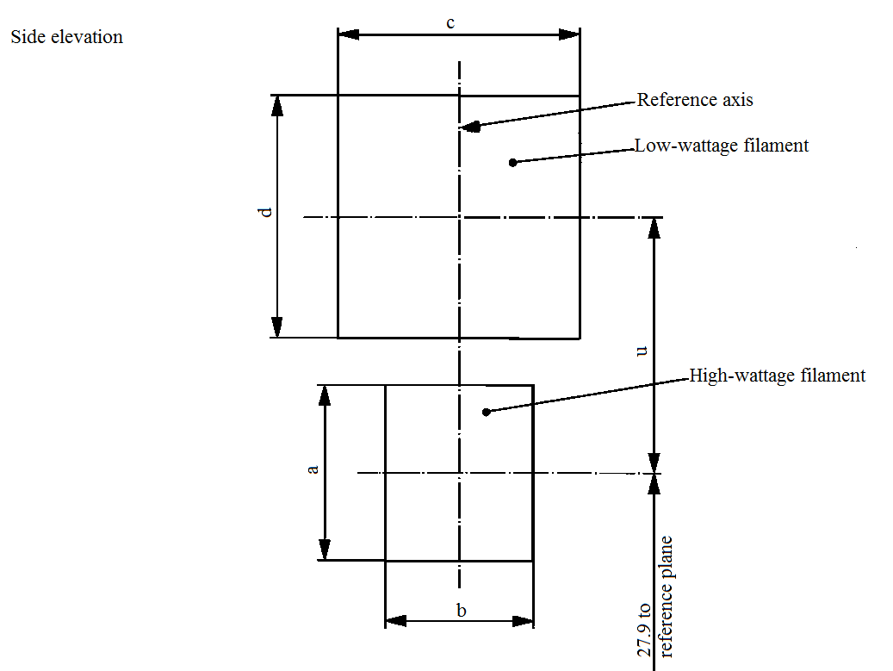

reference plane

Reference axis

Side elevation

Low wattage filament

High wattage filament

c

b

a

d

u

…

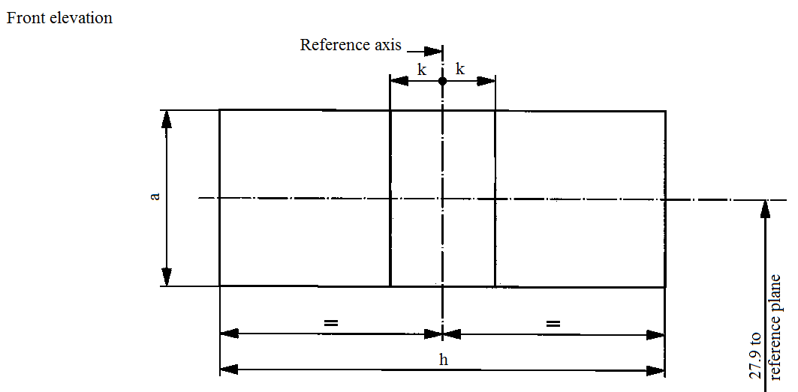

reference plane

Reference axis

Front elevation

k

k

h

a

"

*Sheet PSX26W/3,* amend to read:

"The ends of the filament as defined on sheet PSX26W/2, footnote 5/, shall lie between Z1 and Z2 and between the lines Z3 and Z4."

*Sheet R5W/1, table,* amend to read:

"…

|  |  |  |
| --- | --- | --- |
| |  | | --- | | R5W: BA15s in accordance with IEC Publication 60061 (sheet 7004-11A-10) 1/ | |  |

…"

*Sheet R10W/1, table,* amend to read:

"…

|  |  |  |
| --- | --- | --- |
| |  | | --- | | R10W: BA15s in accordance with IEC Publication 60061 (sheet 7004-11A-10) 1/ | |  |

…"

*Sheet T1.4W/1, figure,* amend to read:

"

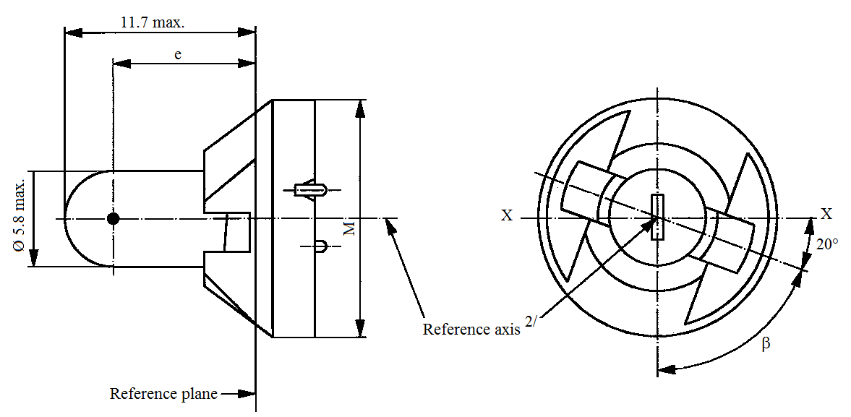

11.7 max.

Ø 5.8 max.

Reference axis2/

Reference plane

e

X

X

β

20°

M

"

*Sheet W15/5W/1, drawing,* amend to read:

"

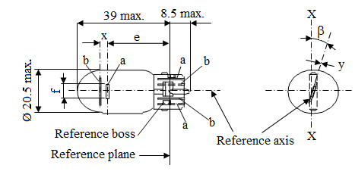

39 max.

8.5 max.

Ø 20.5 max.

Reference plane

Reference axis

Reference boss

f

X

X

y

ß

x

e

b

b

b

a

a

a

"

*Sheet W21/5W/1,* right drawing, amend to read:

"

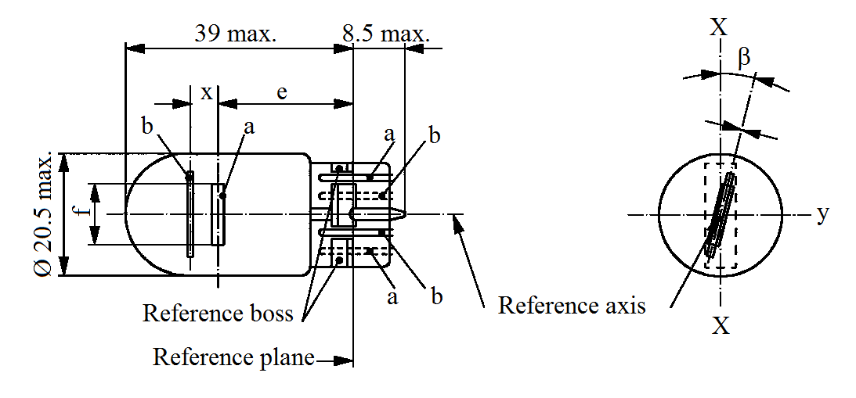

Ø 20.5 max.

Reference axis

Reference boss

Reference plane

X

X

ß

b

b

b

a

a

a

e

x

y

"

*Sheet WT21/W/1, note 2,* amend to read:

"2 Maximum lateral deviation of the filament centre from two mutually perpendicular planes both containing the reference axis and one containing the axis through the reference keys."

1. \* In accordance with the programme of work of the Inland Transport Committee for 2016–2017 (ECE/TRANS/254, para. 159 and ECE/TRANS/2016/28/Add.1, cluster 3.1), the World Forum will develop, harmonize and update Regulations in order to enhance the performance of vehicles. The present document is submitted in conformity with that mandate. [↑](#footnote-ref-2)