|  |  |  |  |
| --- | --- | --- | --- |
|  | United Nations | ECE/TRANS/WP.11/239 | |
| _unlogo | **Economic and Social Council** | | Distr.: General  25 October 2018  Original: English |

**Economic Commission for Europe**

Inland Transport Committee

**Working Party on the Transport of Perishable Foodstuffs**

**Seventy-fourth session**

Report of the Working Party on the Transport of Perishable Foodstuffs on its seventy-fourth session

held in Geneva from 8-12 October 2018

Contents

*Paragraphs Page*

[I. Attendance 1-3 5](#_Toc528146958)

[II. Adoption of the agenda (agenda item 1) 4 5](#_Toc528146959)

[III. Round table discussion on ways of improving the functioning of the   
Working Party (agenda item 2) 5-22 5](#_Toc528146960)

[IV. Activities of ECE bodies of interest to the Working Party (agenda item 3) 23-31 8](#_Toc528146961)

[A. Inland Transport Committee 23-29 8](#_Toc528146962)

[B. Working Party on Agricultural Quality Standards 30-31 9](#_Toc528146963)

[V. Activities of other international organizations dealing with issues of interest   
to the Working Party (agenda item 4) 32-49 9](#_Toc528146964)

[A. International Institute of Refrigeration (IIR) 32 9](#_Toc528146965)

[B. Transfrigoroute International 33-35 10](#_Toc528146966)

[C. Standardization organizations 36-49 10](#_Toc528146967)

[1. CEN/TC 413 Working Group 2 37-39 10](#_Toc528146969)

[2. CEN/TC 413 Working Group 1 40-43 11](#_Toc528146970)

[3. Revision of EN 12830 44-45 11](#_Toc528146971)

[4. Revision of EN 13485 and EN 13486 46 12](#_Toc528146972)

[5. ISO standards concerning thermal maritime insulated   
refrigerated containers 47-48 12](#_Toc528146974)

[6. Other standardization activities of interest to WP.11 49 12](#_Toc528146975)

[VI. Status and implementation of the Agreement on the International Carriage of   
Perishable Foodstuffs and on the Special Equipment to be Used for such   
Carriage (ATP) (agenda item 5) 50-61 13](#_Toc528146976)

[A. Status of application of the Agreement 50 13](#_Toc528146977)

[B. Status of amendments 51-52 13](#_Toc528146978)

[C. Test stations officially designated by the competent authorities of   
countries Parties to ATP 53-54 13](#_Toc528146979)

[D. Exchange of information among Parties under Article 6 of ATP 55-56 13](#_Toc528146980)

[E. Interpretation of ATP 57-61 14](#_Toc528146981)

[1. Proposed amendment to Annex 1, Appendix 2, paragraph 6.5:   
Cool down test, measuring the outside temperature 57-59 14](#_Toc528146982)

[2. Explanations regarding the completion of the ATP certificate form 60-61 14](#_Toc528146983)

[VII. Proposals of amendments to ATP (agenda item 6) 62-105 14](#_Toc528146984)

[A. Pending proposals 62-82 14](#_Toc528146985)

[1. Additions to Appendix 1 to Annex 2 to the ATP with regard to   
references to the national standards of the Russian Federation along   
with references to European regional standards 62-64 14](#_Toc528146986)

[2. Amendments to Annex 1, Appendix 2, paragraph 3.2.6 and to   
Annex 1, Appendix 3 65-68 15](#_Toc528146987)

[3. Clarification in ATP regarding the overall coefficient of heat transfer   
of the bodies of special equipment (the K coefficient), replacing the   
margin of error with uncertainty, and in the ATP Handbook,   
regarding the recommended methods to find the uncertainty of   
measurement of the K coefficient 69 15](#_Toc528146988)

[4. Amendments and additions to the definitions proposed in document ECE/TRANS/WP.11/2015/17 for inclusion in annex I to the Agreement 70-71 15](#_Toc528146989)

[5. Amendments to annex 1, appendix 2, of ATP on accounting for errors   
(uncertainty) in measuring the overall heat transfer coefficient of the   
body in determining the category of special transport equipment and   
correction of a typo in the Russian version of 2.3.1   
of ATP annex 1, appendix 2 72-73 16](#_Toc528146990)

[6. Changes in the models of reports on the measurement of the   
K coefficient in connection with the need to take account of the   
power of the fans used in thermal tests to provide for the circulation   
of air that turns into heat inside the body of special transport equipment 74 16](#_Toc528146991)

[7. Amendments to article 3, paragraph 1, ATP 75 16](#_Toc528146992)

[8. Editorial correction of an error in the Russian translation of ATP 76 16](#_Toc528146993)

[9. Proposal of amendment to ATP to assign, at the stage of approving   
new equipment, a class to insulated equipment, refrigerated equipment,   
heated equipment and refrigerated and heated equipment. 77-79 16](#_Toc528146994)

[10. Tests requirements for fixed dividing walls to measure their K coefficient 17](#_Toc528146995)

[11. Minimal insulated foams specifications 17](#_Toc528146996)

[12. Amendment concerning the model certificate which define the   
specifications of equipment and tank-containers intended for the   
carriage of liquids resulting from the need to take into account the   
technological evolution brought about by the use of   
new insulating foams 80-82 17](#_Toc528146997)

[B. New proposals 83-105 17](#_Toc528146998)

[1. Annex 1, Appendix 2, paragraph 1.2 83 17](#_Toc528146999)

[2. Incorporation of a new subtitle 84 17](#_Toc528147000)

[3. Proposal of amendment to ATP to introduce special provisions   
applicable to packages and vehicles and containers containing   
substances presenting a risk of asphyxiation when used for cooling   
or conditioning purposes (such as dry ice (UN 1845) or nitrogen,   
refrigerated liquid (UN 1977) or argon, refrigerated liquid (UN 1951)) 85-86 17](#_Toc528147001)

[4. Proposal to amend Annex 1, Appendix 2, paragraph 3.4: Measuring   
the effective heating capacity 87 18](#_Toc528147002)

[5. Proposal to amend Annex 1, Appendix 2, paragraph 4.3.4 (ii):   
Standards for the measurement of air circulation 88-89 18](#_Toc528147003)

[6. Proposal to amend Annex 1, Appendix 2, paragraph 4.2.1:   
Specification of Calorimeter Box 90 18](#_Toc528147004)

[7. Editorial correction of an error in the English version of ATP 91 18](#_Toc528147005)

[8. Amendment to Model 12 Test Report 92 18](#_Toc528147006)

[9. Proposal to amend Annex 1, Appendix 2, paragraph 6: Replacing   
existing refrigerants with new refrigerants with a lower GWP 93-94 18](#_Toc528147007)

[10. Proposal to amend Model No. 12, Annex 1, Appendix 2:   
Validity of test reports for mechanical refrigeration units 95 18](#_Toc528147008)

[11. Correction to ATP 96 19](#_Toc528147009)

[12. Temporary certificate for a limited production of prototypes 97-99 19](#_Toc528147010)

[13. Correction to French wording of Model Nº12 100 19](#_Toc528147011)

[14. Degrees Celsius and Kelvin 101 19](#_Toc528147012)

[15. Report of the informal working group on improvements to the   
approval system of ATP equipment and thermal units 102-105 19](#_Toc528147013)

[VIII. ATP Handbook (agenda item 7) 106-107 20](#_Toc528147014)

[A. ATP Handbook: Annex 1, Appendix 2, paragraph 1.2 106 20](#_Toc528147015)

[B. Clarification in ATP regarding the overall coefficient of heat transfer of the   
bodies of special equipment (the K coefficient), replacing the margin   
of error with uncertainty, and in the ATP Handbook, regarding the   
recommended methods to find the uncertainty of measurement   
of the K coefficient 107 20](#_Toc528147016)

[XII. Election of officers (agenda item 11) 108 20](#_Toc528147017)

[XIII. Other business (agenda item 12) 109-112 21](#_Toc528147018)

[XIV. Adoption of the report (agenda item 13) 113 21](#_Toc528147019)

Annexes

[I.](#_Toc528147020)  [Proposed amendments to ATP 22](#_Toc528147021)

[II.](#_Toc528147042) [Corrections to ATP 26](#_Toc528147043)

[III](#_Toc528147046). [Additions to the ATP Handbook 27](#_Toc528147047)

I. Attendance

1. The Working Party on the Transport of Perishable Foodstuffs (WP.11) held its seventy-fourth session from 8-12 October 2018 with Mr. T. Nobre (Portugal) as Chairman and Mr. K. de Putter (Netherlands) as Vice-Chairman.

2. Representatives of the following countries took part in the session: Armenia, Belgium, Czech Republic, Croatia, Denmark, Finland, France, Germany, Ireland, Italy, Kingdom of Morocco, Latvia, Luxembourg, Moldova, Netherlands, Poland, Portugal, Russian Federation, Serbia, Slovenia, Spain, Switzerland, Turkey, United Kingdom of Great Britain and Northern Ireland and United States of America.

3. The intergovernmental organization International Institute of Refrigeration (IIR) and the non‑governmental organizations International Association of the Body and Trailer Building Industry (CLCCR) and Transfrigoroute International (TI) also took part in the session.

II. Adoption of the agenda (agenda item 1)

*Documents*: ECE/TRANS/WP.11/238

ECE/TRANS/WP.11/238/Add.1

*Informal document* : INF.1 (Secretariat)

4. The provisional agenda (ECE/TRANS/WP.11/238 and -/Add.1) was adopted as amended by informal document INF.1 to take account of informal documents INF.1 to INF.15

III. Round table discussion on ways of improving the functioning of the Working Party (agenda item 2)

*Document*: ECE/TRANS/WP.11/2018/4

5. The Working Party considered the proposal in document ECE/TRANS/WP.11/2018/4 from the Russian Federation to forward the following topics for further discussion with the view of improving the ATP Agreement:

1. Preserving the quality of all perishable foodstuffs for which temperature conditions specified in regulations must be maintained during carriage, rather than only that of the goods specified in the current text of ATP;
2. Adapting ATP standards and requirements to the climatic and technical conditions encountered during the carriage of perishable foodstuffs in different climatic zones;
3. Inadmissibility of differences of interpretation of the articles and annexes of ATP by Contracting Parties to ATP and national and international organizations;

6. Regarding point (a), some country representatives believed the scope of the ATP should not be expanded as it is ensuring that foodstuffs will remain safe for consumption after transport. Others welcomed the possibility of expanding the scope of ATP to address new challenges facing countries such as protecting consumers from bad quality products and considerably reducing food waste to avoid wasting very scarce or non-renewable resources which are required to produce food, such as land, water and energy.

7. After a vote, deciding on whether to expand the scope of the ATP, 6 countries voted in favour (France, Luxembourg, Portugal, Russia, Serbia and Spain) and 5 countries against (Denmark, Germany, Netherlands, United Kingdom and United States).

*Document* ECE/TRANS/WP.11/2018/17

8. WP.11 considered additional topics that would help improving its methods of work and keeping the agreement up to date as reflected in the proposals contained in document ECE/TRANS/WP.11/2018/17:

**Points (a) to (d):**

1. *Agree on a clear definition of the scope of the ATP including an opening clause/extension clause to provide flexibility to extend the scope of application if necessary.*
2. *Include in the agreement a definition of “perishable foodstuffs”.*
3. *Seek a common interpretation of the preamble of the agreement, particularly related to the quality vs safety issue.*
4. *Agree on the elaboration of a list of goods covered by the scope of application. (see Dangerous Goods List (Table A) of ADR).*

9. Regarding the expansion of the scope of ATP, please see paragraphs 6 and 7 of the present report.

10. As there is no consensus among the Contracting Parties on the issue of inclusion of fresh fruit and vegetables in annex 3, some Contracting Parties considering that their carriage should be subject to the conditions of ATP, others considering that these foodstuffs present no risk to public health and it is therefore not necessary to impose temperature control requirements for their carriage, the Working Party agreed to explore the possibility of including provisions for the transport of fresh fruits and vegetables as recommendations for countries to apply as necessary in a non-legally binding way.

11. The secretariat was requested to find a suitable place to incorporate these recommendations in the agreement and to prepare a proposal of placement for the next session. As previously discussed (see annex IV of ECE/TRANS/WP.11/235), this could be achieved by either introducing in annex 3 a list of foodstuffs that could be regulated optionally together with provisions specifying what conditions would apply in international carriage in case a Contracting party would like to apply this optional list or by creating a separate annex to the agreement.

12. The Working Party was invited to work on the list of foodstuffs and on the conditions that would apply in international transport.

13. Other proposals, e.g. to agree on a set of general definitions or to set minimum temperature requirements for perishable foodstuffs included in annex 3, will be considered at future sessions.

**Point (e):**

1. *To examine best practices and learned lessons from the work of other Working Parties. (Joint Meetings / Harmonization Meetings).*

14. WP.11 is in favour of examining best practices from other Working Parties and also to organized joint meetings, expert groups or round tables with groups working in topics relevant to ATP.

**Point (f):**

1. *Creation of informal working groups for topics in which expert knowledge is required (i.e. technical requirements for cooling systems/control systems, etc.).*

15. It was clarified that these informal working groups would be mandated in session to discuss complicated technical subjects that are not suitable for discussion in plenary. The informal working group would then report its conclusions back to WP.11.

**Points (g) and (h):**

1. *Check in general the significance of ISO standards for ATP (is referencing useful or deliberate contrary development of standard Commission to develop standards).*
2. *Check establishment of a permanent standard working group, which would revise and update the standards that are referenced or may be referenced in the ATP*

16. WP.11 agreed with the creation of a permanent standards working group as it considers that checking for problems of implementation when standards are referenced or included for mandatory application in the agreement is a very important activity.

**Point (i):**

1. *Achieve a common understanding, that the agreement is the instrument and warrantor for high quality products and health protection worldwide. Only by being up to the economic, technological and political developments will keep /make it attractive in order to increase the number of contracting parties globally and to achieve a greater geographical coverage of the standards of ATP. It is important to understand that nowadays other regions intend to lead the development of standards. So the Contracting Parties might wish to keep the role of proactively improve the standards of the transport of perishable foodstuff.*

17. The Working Party considered that while reaching a common understanding on the scope and objectives of the ATP agreement would be highly beneficial, the wording was outside the scope of the agreement and too ambitious. This point was not adopted.

**Points (j) and (k):**

1. *Agree on the change of the cycle of meetings per year by having shorter meetings ex. twice a year (3 days /2 days). Advantage is the development of proposals by keeping discussion more stringent and present for participants.*
2. *Agree on an extension of the cycle of amendments to two years, so that all amendments agreed on during the last two years enter into force simultaneously, and dates for new ATP versions are foreseeable (for example the 1 January of every second year).*

18. After considering several possibilities, the Working Party decided to increase the number of sessions in the biennium to 3, with one session on the first year and 2 sessions on the second year. It also agreed on extending the cycle of amendments to 2 years with the possibility of notifying amendments dealing with urgent matters at any time during the cycle.

19. Other ways to further improve the functioning and effectiveness of WP.11 were identified as follows:

(a) Increasing the number of adopted amendments by taking the responsibility of negotiating proposals with other contracting parties in advance before submitting the documents. Also, representatives were encouraged to take all the necessary steps to come to the meetings ready to make decisions on proposals and to show some flexibility when changes were proposed.

(b) Agree on the effective use of communication instruments, such as working documents, informal documents and discussion of proposals during the sessions as laid out in point 6 (b) of the document.

20. Regarding the use of multilateral/bilateral agreements, the Working Party agreed that in order to change article 7 of ATP a formal proposal should be made by an interested party and be carefully discussed at a future session.

21. WP.11 decided not to change the Rules of Procedure of the Working Party or article 18 of the ATP agreement to remove the consensus requirement. It considered that there are other ways of increasing the number of amendments adopted and keeping the agreement relevant. It encouraged members to work harder between sessions to negotiate proposals and to explain clearly the reasons for rejection, so proposals can be improved. It was also suggested to make a clear distinction between the articles of the agreement and technical provisions/conditions of use, to facilitate the adoption of amendments of technical nature.

22. Overall, it was agreed that further steps to increase harmonization on the implementation of the agreement should be taken:

(a) A single database containing ATP model certificates may be created to help reduce forgery, misuse and to simplify the procedure for issuing new ATP certificates in the case of transfer of special equipment to another State.

(b) Contracting Parties should strive to homogenize procedures for enforcement, checks and penalties across countries. WP.11 was encouraged to analyse the way other Working Parties are dealing with similar problems of harmonization and implementation and take notes of best practices.

IV. Activities of ECE bodies of interest to the Working Party (agenda item 3)

A. Inland Transport Committee

23. The Working Party was informed about the results of the eightieth session of the Inland Transport Committee (ITC), (20-23 February 2018) as reflected in its report (ECE/TRANS/274, paragraphs 104-108).

24. The ITC adopted the reports of its subsidiary bodies (ECE/TRANS/274, para. 118).

*Document*: ECE/TRANS/WP.11/2018/2 (Secretariat)

25. WP.11 was informed that the ITC noted the proposed changes to the Rules of Procedure as reflected in ECE/TRANS/WP.11/237 and that at the request of the Russian Federation, ITC recommended that this issue be further discussed at WP.11. During the Round Table discussions, it was decided not to change the Rules of Procedure at this time.

*Informal document*: INF.15 (Secretariat)

26. The Secretary of the Inland Transport Committee (ITC) introduced the proposal for a new ITC strategy for sustainable mobility. He reported that the ITC strategy was based on the ministerial resolution (ECE/TRANS/2017/2) established at the seventieth anniversary of ITC and was discussed during its eightieth session, in February 2018. He added that, following a consultation process involving all ITC Working Parties, the ITC strategy would be submitted for adoption at the eighty-first ITC session in 2019. All members of the Working Party were encouraged to send their contributions to the new ITC strategy by the end of October 2018.

27. Key changes for the new United Nations budget system as of 2020, were also presented. The new system will be based on annual budget plans and it will be different from the previous framework, both in the process and in the content. He underlined important changes through the implementation of new indicators for measuring success that will have a considerable impact on the number of deliverables.

28. He also highlighted the importance of taking actions at the ECE level that would better align its activities to the United Nations Sustainable Development Goals by defining nexus areas of sustainable mobility and smart connectivity, sustainable use of natural resources, and the development of a new urban agenda.

29. The Chair of WP.11 further emphasized the importance of facilitating the implementation of the Sustainable Development Goals of the United Nations (SDGs) through the work of WP.11.

B. Working Party on Agricultural Quality Standards

30. The activities of the Working Party on Agricultural Quality Standards (WP.7) of interest to WP.11 are:

(a) Workshop “Quality matters – sustainable trade of fruits, vegetables and nuts”   
11-13 September 2018, Tashkent, Uzbekistan

(b) Seventy-fourth session of the Working Party on Agricultural Quality Standards (WP.7), 12-14 November 2018, Palais des Nations, Geneva, Switzerland.

31. For more information on these and other activities, please visit WP.7 website at <http://www.unece.org/trade/agr/welcome.html>.

V. Activities of other international organizations dealing with issues of interest to the Working Party (agenda item 4)

A. International Institute of Refrigeration (IIR)

*Informal document*: INF.3 (IIR)

32. WP.11 was informed about the results of the meeting of the IIR sub-commission on refrigerated transport held in held in Munich, Germany 18-19 April 2018. The sub-commission had given its support for proposals to WP.11 including:

* Minimal insulated foam specification;
* Panel van calculation;
* Internal airflow;
* Measurement of K-coefficient for fixed bulkheads;
* Testing of prototype equipment in ATP;
* Testing of fridge unit (in-service) with a change of refrigerants (drop-in);
* Measuring the outside temperature during a pull-down test.

B. Transfrigoroute International

*Informal document*: INF.11 (Transfrigoroute International)

33. The representative from Transfrigoroute International (TI) informed WP.11 about the activities of TI in support of the refrigerated transport industry as reflected in informal document INF.11.

34. The Working Party took note of the points raised in INF.11, especially the ones regarding the importance of reaching an agreement on the use of refrigerants with low Global Warming Potential (GWP) and on the provisions to test retrofitted, in-service equipment.

35. TI is also concerned with temperature-controlled transport for short and medium distances, as the activity goes largely unregulated. A working group is being set up to focus on developing standards for these kinds of transport.

C. Standardization organizations

36. WP.11 was informed about the status of work on the development and revision of standards.

EN Standards

1. CEN/TC 413 Working Group 2

37. Experts from France, Italy, United Kingdom and Germany with informal participation of experts from other European Nations have had several meetings and working group meetings during the last 12 months.

38. EN 16440 – 1:2015-01 Testing methodologies of cooling equipment for insulated means of transport — Part 1: Mechanical refrigeration devices with forced air circulation evaporator with or without heating devices. The final version was published in January 2015.

39. Following additional parts will be still under consideration:

* Part 2: Eutectic Systems: The actual working draft is still under consideration for the final version, especially the test provisions for cooling capacities and consumption for new equipment’s with eutectic systems as well equipment’s in daily operation sequences.
* Part 3: Transport refrigeration systems with dry ice. Started to consider the requirements for dry ice refrigeration devices. It is being considered to stop this project due to the lack of experts at the technical committee.
* Part 4: Controlled gas refrigeration systems with direct evaporation. This part of should be rejected because there is no market for those systems.
* Part 5: Controlled gas refrigeration systems with indirect evaporation. This part of should be rejected because there is no market for those systems. It is also being considered to stop this project due to the lack of experts at the technical committee.
* An additional part 6: Special requirements on multitemp systems – is scheduled as a further project.

2. CEN/TC 413 Working Group 1

40. Experts from France, Finland, Italy, Slovak Republic, Czech Republic, Ireland, United Kingdom and Germany with informal participation of experts from other European Nations have had several meetings and working group meetings during the year.

41. The scope of the project committee will be a standard with the title: Insulated means of transport for temperature sensitive goods – requirements and testing. The standard applies to thermally insulated means of transport used for temperature sensitive goods in order to limit the heat exchange to the external conditions. If certain temperatures have to be maintained, they could be additionally provided with a cooling and/or heating source. The actual decisions taking into account inside temperatures between – 30°C and + 25°C and ambient conditions between -30°C and +43°C.

42. The standard is projected with different parts as:

* prEN 17066 Part 1: Container - Insulated means of transport for temperature sensitive goods – Requirements and testing to define the terminology, the specific requirements, test provisions, dimensioning of insulated bodies including evaluation of k value. Final draft is published for commenting until end of October 2018.
* Part 2: Equipment - Combination of insulated bodies and their cooling and/or heating devices including verification of cooling and heating capacities for long distance transport as well distribution.
* Part 3: Small containers for multiple use with an internal volume not more than 2 m³.
* An additional part: Special requirements on multitemp systems – is scheduled as a further project.

43. The actual project will be taken into consideration during the next meeting to be held 12-13 November 2018 in Paris.

3. Revision of EN 12830

44. Revision of the EN 12830:1999 – Temperature recorders for the transport, storage and distribution of chilled, frozen, deep-frozen/quick-frozen food and ice cream – Tests, performance, suitability.

45. A new version of EN 12830:2018-10 - Temperature recorders for the transport, storage and distribution of temperature sensitive goods – Tests, performance, suitability is published. It takes into account actual technical developments and requirements. The scope of the revised standard has an increased to the temperature range from – 80 to + 85°C for temperature sensitive goods in the cold chain.

4. Revision of EN 13485 and EN 13486

46. The actual project was started on 4 October 2018 by a first meeting of the CEN TC 423 PC in Berlin with experts from Germany, France, Great Britain, Italy and Spain. Next meeting will be held on 6 February 2019 in Paris and will include the following:

* Revision of the EN 13485:2002 - Thermometers for measuring the air and product temperature for the transport, storage and distribution of chilled, frozen, deep-frozen/quick-frozen food and ice cream - Tests, performance, suitability; and
* Revision of the EN 13486:2002 - Temperature recorders and thermometers for the transport, storage and distribution of chilled, frozen, deep-frozen/quick-frozen food and ice cream - Periodic verification to adopt modifications and actual technical development of the published EN 12830:2018-10 - Temperature recorders **for the transport, storage and distribution of temperature sensitive goods –** Tests, performance, suitability.

ISO Standards

5. ISO standards concerning thermal maritime insulated refrigerated containers

47. ISO 1496 PART II ISO/TC104/ SC2/ WG1 -Specification and testing - Thermal containers:

(a) Positive vote for DIS stage now proceeding to FDIS and publication later this year;

(b) New container effectively a K value of 0.3W/m2 °C, therefore should not exceed 0.4W/m2 °C over its life as described in a new informative annex on ageing showing the deterioration of thermal container insulation over time;

(c) K value testing now identical to that of ATP. Airflow circulation requirement along with load line and floor heights now included. A new part load energy consumption tests now included;

(d) New annex H showing optional generator backup.

48. It was clarified that testing requirements would apply to new equipment and that as the standard was on the late stages of approval, no new changes on the design temperature should be expected.

6. Other standardization activities of interest to WP.11

49. Information on Korean projects in ISO/TC 122 "Packaging". Two Korean projects within ISO/TC 122/WG 16 "Temperature controlled product packaging", Convenorship: Korea are being developed:

* ISO/NP 22982-1, Temperature controlled transport packaging - Part 1: General requirements of temperature-controlled transport packages for parcel shipping; and
* ISO/NP 22982-2, Temperature controlled transport packaging - Part 2: General specifications of testing of temperature-controlled transport packages for parcel shipping.

VI. Status and implementation of the Agreement on the International Carriage of Perishable Foodstuffs and on the Special Equipment to be Used for such Carriage (ATP) (agenda item 5)

A. Status of application of the Agreement

50. There have been no new accessions to ATP since the last session and the number of Contracting Parties remains at 50.

B. Status of amendments

51. Proposed amendments to the ATP adopted by WP.11 at its seventy-second session in 2016, and contained in Annex I to the report of that session (ECE/TRANS/WP.11/235), (depositary notification C.N.58.2017.TREATIES-XI.B.22), are deemed accepted as of 8 May 2018 (depositary notification C.N.244.2018.TREATIES-XI.B.22), for entry into force on 8 November 2018.

52. Proposed corrections to the ATP adopted at the seventy-third session of WP.11 in 2017 (ECE/TRANS/WP.11/237, Annex II) were notified to ATP Contracting Parties by the United Nations Treaty Section on 6 February 2018 (C.N.70.2018.TREATIES-XI.B.22). Corrections were deemed accepted on 7 May 2018 (C.N.240.2018.TREATIES-XI.B.22).

C. Test stations officially designated by the competent authorities of countries Parties to ATP

53. At its seventy-third session the Working Party requested the secretariat to send a letter to all contracting parties stating, among other things, the obligation of Contracting Parties to keep the contact information of Competent Authorities up to date.

54. As a result, several countries have updated their Competent Authorities' contact details. All the information received is included in the list of competent authorities and officially designated test stations at the following link: <http://www.unece.org/trans/main/wp11/teststationsnew.html>

D. Exchange of information among Parties under Article 6 of ATP

*Document*: ECE/TRANS/WP.11/2018/1 (Secretariat)

*Informal document* INF.8 (Morocco)

55. At the last session, WP.11 thanked the 23 countries that had provided data in response to the questionnaire on the implementation of ATP in 2016 and stressed that it was mandatory to have information from all ATP contracting parties and that it was a means of harmonizing implementation of the agreement. The information received for the year 2017 is presented in ECE/TRANS/WP.11/2018/1 and informal document INF.8. Countries were also asked to respond to additional questions regarding implementation of the ATP, answers received by the secretariat are included in the annexes to document ECE/TRANS/WP.11/2018/1.

56. At the request of the Working Party at its seventy-third session, the secretariat sent a letter to all contracting parties requesting them to fulfil their obligation under article 6 of ATP of replying to the annual questionnaire, but the number of responses received did not improve considerably from previous years.

E. Interpretation of ATP

1. Proposed amendment to Annex 1, Appendix 2, paragraph 6.5: Cool down test, measuring the outside temperature

*Document*: ECE/TRANS/WP.11/2018/15 (Finland)

*Informal documents* INF.12 (Finland) and INF.3 (Russian Federation)

57. WP.11 agreed in principle with the proposed amendment and remarked that it was necessary to ensure a harmonized use of the test methodology. It was also pointed out that an impact assessment should be conducted before adopting the proposed changes to the test methodology.

58. Some questions were raised while discussing the technical details and the Working Party decided to transfer the document to an informal working group, mandated to resolve these questions as well as the questions contained in informal document INF.3.

59. The informal working group would submit a new proposal for consideration at the next session. Representatives from Finland, France, Russian Federation and IIR expressed their intention to participate.

2. Explanations regarding the completion of the ATP certificate form

*Informal document* INF.14 (Russian Federation)

60. The Working Party agreed with the principle that the "alloted by" field in the certificate was required to be able to link the certificate to the correct equipment, as licence plates or registration numbers can change at any time. It was also clarified that as some countries use a registration number for trailers while others do not, the inclusion of the registration number in the certificate was not mandatory.

61. The Russian Federation representative pointed out that it was still not clear to them which information should be indicated in paragraph 3 of the certificate and it might be necessary to add a remark in the ATP Handbook clarifying this point.

VII. Proposals of amendments to ATP (agenda item 6)

A. Pending proposals

1. Additions to Appendix 1 to Annex 2 to the ATP with regard to references to the national standards of the Russian Federation along with references to European regional standards

*Document*: ECE/TRANS/WP.11/2018/3 (Russian Federation)

62. WP.11 agreed with the inclusion of other standards in the ATP if the standards referenced are not available in all the official languages of the agreement.

63. Some concerns were raised regarding the specific proposal in the document:

(a) For standards included in ATP, the year of issuance is not included so the last version of the standard would automatically apply. The Working Party asked whether Russian standards were treated in the same way.

(b) The Working Party was not able to determine if the changes proposed to the Russian version of the agreement were introducing important differences among all language versions of ATP.

64. In light of these concerns, the Working Party decided not to adopt the proposal, with Morocco and United Kingdom opposing its adoption.

2. Amendments to Annex 1, Appendix 2, paragraph 3.2.6 and to Annex 1, Appendix 3

*Document*: ECE/TRANS/WP.11/2018/5 (United Kingdom)

*Informal document* INF.10 (Finland)

65. The Working Party agreed that air circulation requirements are missing from the regulations and that work should continue to find a suitable way of including them in the ATP. It was remarked that the number of necessary air changes per hour was very difficult to determine as it must consider the thermal insulation, temperature distribution, type of products transported, configuration of the special equipment, among other factors. Further studies on the subject are necessary and therefore the proposal was not adopted.

66. It was also pointed out that bilateral or multilateral agreements would not work as requirements need to be more stringent than those in the agreement and Finland would need to find other interested parties to sign such agreement.

67. The representative of Finland clarified that these vehicles are used mainly for transport in their national territory, but some might cross the border to Sweden. Finland does not apply ATP for national transport of perishable foodstuffs but despite this fact, a remarkable number of consigners require ATP certificated equipment to transport their products, so changes in the agreement would have an impact in their national market.

68. It was also clarified that the volume of air changes per hour is referring to the empty volume of the special equipment as it is the standard procedure.

3. Clarification in ATP regarding the overall coefficient of heat transfer of the bodies of special equipment (the K coefficient), replacing the margin of error with uncertainty, and in the ATP Handbook, regarding the recommended methods to find the uncertainty of measurement of the K coefficient

*Document*: ECE/TRANS/WP.11/2018/20 (Russian Federation)

69. After a few concerns raised during the discussion were addressed, the proposal was adopted as amended (see annex I)

4. Amendments and additions to the definitions proposed in document ECE/TRANS/WP.11/2015/17 for inclusion in annex I to the Agreement

*Document*: ECE/TRANS/WP.11/2018/21 (Russian Federation)

70. The Working Party agreed that more work needed to be done in the definitions, mostly regarding harmonization of terms in all three languages of the agreement. It was decided to create an informal working group to study in detail the proposal of the Russian Federation regarding definitions of ATP terms and consider a consolidated document at the next session.

71. The Russian Federation proposed to hold a meeting of the informal working group in the Russian Federation during which the following questions could also be considered:

(a) the list of perishable foodstuffs for inclusion in the ATP or the ATP Handbook;

(b) inclusion of the term "perishable foodstuffs" in the ATP or the ATP Handbook; and

(c) other questions brought up in documents 2018/03 and 2018/04.

5. Amendments to annex 1, appendix 2, of ATP on accounting for errors (uncertainty) in measuring the overall heat transfer coefficient of the body in determining the category of special transport equipment and correction of a typo in the Russian version of 2.3.1 of ATP annex 1, appendix 2

*Document*: ECE/TRANS/WP.11/2018/22 (Russian Federation)

72. It was mentioned that if the purpose of the proposal was to account for aging this would not resolve entirely the problem.

73. The proposal was not adopted, with Finland, Netherlands and Portugal voting against its adoption.

6. Changes in the models of reports on the measurement of the K coefficient in connection with the need to take account of the power of the fans used in thermal tests to provide for the circulation of air that turns into heat inside the body of special transport equipment

*Document*: ECE/TRANS/WP.11/2018/23 (Russian Federation)

74. After some clarifications, the proposal was adopted as amended (see annex I).

7. Amendments to article 3, paragraph 1, ATP

*Document*: ECE/TRANS/WP.11/2018/24 (Russian Federation)

75. Document was withdrawn by the authors.

8. Editorial correction of an error in the Russian translation of ATP

*Document*: ECE/TRANS/WP.11/2018/25 (Russian Federation)

76. Proposal of correction was already adopted at the seventy-third session, document was therefore withdrawn.

9. Proposal of amendment to ATP to assign, at the stage of approving new equipment, a class to insulated equipment, refrigerated equipment, heated equipment and refrigerated and heated equipment.

*Document*: ECE/TRANS/WP.11/2018/26 (Russian Federation)

77. The Working Party could not agree on whether it was necessary to include the proposed clarification in the text of agreement. Country representatives that agreed to the inclusion of the text in ATP, expressed some reservations as to its placement due to the lack of clarity on the intended scope.

78. It was emphasised that the Competent Authority is the one responsible for the issuance of certificates of compliance and classification of the special equipment. It was also clarified that the Competent Authority could designate a competent body/entity to carry out these activities.

79. When put to the vote, the proposal was rejected, with 3 countries voting against (Denmark, Germany and United Kingdom).

10. Tests requirements for fixed dividing walls to measure their K coefficient

*Informal document* INF.4 (France)

11. Minimal insulated foams specifications

*Informal document* INF.5 (France)

12. Amendment concerning the model certificate which define the specifications of equipment and tank-containers intended for the carriage of liquids resulting from the need to take into account the technological evolution brought about by the use of new insulating foams

*Informal document* INF.6 (France)

80. Informal documents INF.4, 5 and 6 were presented by France to the Working Party, seeking comments and recommendations for future proposals.

81. WP.11 thanked France for the proposals and concluded that they were addressing important topics and therefore work should continue in all of them. For informal document INF.5, an informal working group will be created and representatives of France, Germany, Netherlands, TI and Portugal expressed their intention to participate.

82. It was also agreed that CERTE was not the best forum to discuss issues concerning the proposal in informal document INF.6 and that France would be responsible for developing the proposal in collaboration with other interested parties.

B. New proposals

1. Annex 1, Appendix 2, paragraph 1.2

*Document*: ECE/TRANS/WP.11/2018/7 (Germany and United Kingdom)

83. Proposal was adopted (see annex I)

2. Incorporation of a new subtitle

*Document*: ECE/TRANS/WP.11/2018/8 (Spain)

84. Proposal was adopted (see annex I)

3. Proposal of amendment to ATP to introduce special provisions applicable to packages and vehicles and containers containing substances presenting a risk of asphyxiation when used for cooling or conditioning purposes (such as dry ice (UN 1845) or nitrogen, refrigerated liquid (UN 1977) or argon, refrigerated liquid (UN 1951))

*Document*: ECE/TRANS/WP.11/2018/9 (Switzerland)

85. The Working Party thanked the representative of Switzerland for the proposal and considered that the information was valuable and worth disseminating but considered that it was outside the scope of the ATP and therefore did not agree with its inclusion in the agreement.

86. Some members pointed out that it would be possible to include a cross-reference to the ADR text either in the ATP Handbook or the ATP itself. The representative of Switzerland was invited to present a proposal at the next session for the consideration of WP.11.

4. Proposal to amend Annex 1, Appendix 2, paragraph 3.4: Measuring the effective heating capacity

*Document*: ECE/TRANS/WP.11/2018/11 and /Corr.1 (Germany)

87. Proposal was adopted (see annex I)

5. Proposal to amend Annex 1, Appendix 2, paragraph 4.3.4 (ii): Standards for the measurement of air circulation

*Document*: ECE/TRANS/WP.11/2018/12 (Germany)

88. The Working Party agreed with the proposal in principle, but opinions were divided on whether to include the dates of the standards in the text of ATP. It was recommended that the informal working group on standards study this issue in light of its legal implications and propose a proper approach for referencing standards in ATP.

89. It was decided to adopt the proposal without modifications (see annex I)

6. Proposal to amend Annex 1, Appendix 2, paragraph 4.2.1: Specification of Calorimeter Box

*Document*: ECE/TRANS/WP.11/2018/14 (Germany)

90. Proposal was adopted as amended (see annex I)

7. Editorial correction of an error in the English version of ATP

*Document*: ECE/TRANS/WP.11/2018/16 (Italy)

91. Proposal was adopted (see annex I)

8. Amendment to Model 12 Test Report

*Document*: ECE/TRANS/WP.11/2018/18 (United Kingdom)

92. Proposal was adopted as amended (see annex I)

9. Proposal to amend Annex 1, Appendix 2, paragraph 6: Replacing existing refrigerants with new refrigerants with a lower GWP

*Document*: ECE/TRANS/WP.11/2018/10 (Germany)

93. After a long debate aimed at clarifying all the issues raised during the discussion, the proposal was adopted as amended (see annex I).

94. It was remarked that the proposal was adopted in the spirit of compromise given the urgency of the matter, but further revisions may be needed.

10. Proposal to amend Model No. 12, Annex 1, Appendix 2: Validity of test reports for mechanical refrigeration units

*Document*: ECE/TRANS/WP.11/2018/13 (Germany)

95. The Working Party agreed in principle with the proposal but was not able to decide the correct placement in the text of ATP. The representative of Germany was invited to study the matter carefully and come back with a new proposal for consideration at the next session.

11. Correction to ATP

*Document*: ECE/TRANS/WP.11/2018/19 (Secretariat)

96. Correction was adopted (see annex II).

12. Temporary certificate for a limited production of prototypes

*Document*: ECE/TRANS/WP.11/2018/27 (Transfrigoroute International)

97. It was clarified that the scope of the document was to test new technologies on prototypes and that these tests should be performed on the road for different climatic conditions. It was also noted that it was very difficult to find the appropriate range of climatic conditions within the borders of one country.

98. It was suggested to look at how other Working Parties are dealing with temporary certification of prototypes and try to find a way forward by either issuing derogations or special permits.

99. A revised document will be submitted at the next session and should also include a proposal for marking or identification of prototypes.

13. Correction to French wording of Model Nº12

*Informal document*: INF.7 (Spain)

100. Correction was adopted (see annex II).

14. Degrees Celsius and Kelvin

*Informal document*: INF.9 (Spain)

101. The representative of Spain was invited to present the proposal in a working document for consideration at the next session.

15. Report of the informal working group on improvements to the approval system of ATP equipment and thermal units

*Informal document*: INF.13 (Netherlands on behalf of the informal working group)

102. The Working Party thanked the representative of the Netherlands and the informal working group for the work and the detailed report. It was recognized that problems of harmonizing practices in the implementation of the agreement need to be solved and therefore the work of the informal working group was very important.

103. WP.11 decided to extend the mandate of the group to work on the following topics/activities:

(a) To circulate a questionnaire to all contracting parties to supply the required information if possible before the end of November 2018;

(b) To develop two definitions one for testing stations performing laboratory tests and one for testing station performing the other checks of equipment;

(c) More detailed provisions should be developed to appoint testing stations in order to guarantee an equal level of competence;

(d) A new overview of testing stations should be developed clearly indicating the capabilities. It should be considered if this overview should be periodically reviewed;

(e) Develop wording to clarify that the issue of a type approval certificate is the responsibility of the competent authority;

(f) Develop wording to make the supervision of serial production the responsibility of the competent authority that issues a type approval certificate;

(g) Ask the IIR/IIF CERTE meeting to develop an overview of information required for a laboratory test for the different tests in Annex 1 Appendix 2 of the ATP;

(h) Development of a harmonized set of information for the test reports to prevent delays in the approval of equipment in the contracting parties;

(i) Develop more appropriate wording for paragraph 6 (b) of Annex 1, Appendix 1;

(j) Develop a guideline to harmonize the aspects to be considered during an audit of a manufacturer and the report of an audit to prevent repetition by other contracting parties;

104. 26-27 November 2018 were reserved for a future session to be held in Brussels.

105. WP.11 invited the secretariat to send the proposed amendments it had adopted which were contained in annex I to ECE/TRANS/WP.11/237 and annex I to the present report as well as the corrections in annex III to the United Nations Treaty Section for official notification to ATP contracting parties.

VIII. ATP Handbook (agenda item 7)

A. ATP Handbook: Annex 1, Appendix 2, paragraph 1.2

*Document*: ECE/TRANS/WP.11/2018/6 (United Kingdom)

106. Proposal was adopted (see annex III)

B. Clarification in ATP regarding the overall coefficient of heat transfer of the bodies of special equipment (the K coefficient), replacing the margin of error with uncertainty, and in the ATP Handbook, regarding the recommended methods to find the uncertainty of measurement of the K coefficient

*Document*: ECE/TRANS/WP.11/2018/20 (Russian Federation)

107. The Working Party thanked the Russian Federation for the proposal and considered it was useful to include it in the ATP Handbook as a reference for testing stations that are not ISO accredited and might not have a proper methodology for estimating the uncertainty when calculating the K coefficient. The proposal was therefore adopted (see annex III)

XII. Election of officers (agenda item 11)

108. The Working Party elected Mr. T. Nobre (Portugal) as Chairman, Mr. K. de Putter (Netherlands) and Mr. J. M. Bonnal (France) as Vice-Chairmen for its seventy-fifth session in 2019. The Working Party thanked the officers and the secretariat for their work.

XIII. Other business (agenda item 12)

109. The Working Party was informed that Mr. Devin (France) moved to new functions and would not therefore participate any longer in WP.11 sessions. All delegations thanked Mr. Devin for his active contribution to the work of WP.11 and wished him the best of luck in his future endeavours.

110. The Russian Federation noted the issue of application of regional standards in international agreements (e.g. ATP). The Russian Federation maintains the position that for international agreements ISO standards should be used, or if ISO standards are not available, the relevant texts from regional standards should be included in the text of the Agreement.

111. The representative of Croatia asked the Working Party about the possibility of digitally signing certificates. It was explained that the Competent Authority should decide how to implement the signature procedure in each country but that signing ATP certificates digitally is an option in some countries. It was proposed to ask Contracting Parties to share how they are implementing the signature procedure as well as other techniques used to avoid or reduce forgery.

**Dates of the seventy-fifth session**

112. The dates of 8-11 October 2019 (Tuesday to Friday) have been reserved for the seventy-fifth session of WP.11. The deadline for submission of documents is 16 July 2019

XIV. Adoption of the report (agenda item 13)

113. The WP.11 adopted the report on its seventy-fourth session based on a draft prepared by the secretariat.

Annex I

Proposed amendments to ATP

Proposal of amendment 1

1. Annex 1, appendix 2, section 1.2

Replace “Si = (((WI × LI) + (WI × LI) + (Wi × Wi)) x 2)” by “Si = (((WI × LI) + (HI × LI) + (HI × WI)) × 2)”.

Replace “Se = (((WE × LE) + (WE × LE) + (We × We)) x 2)” by “Se = (((WE × LE) + (HE × LE) + (HE × WE)) × 2)”.

Replace “Wi is the Z axis of the internal surface area” by “HI is the Z axis of the internal surface area”.

Replace “We is the Z axis of the external surface area” by “HE is the Z axis of the external surface area”.

Replace “WI = (WIa × a/2 + WIb (a/2 + b/2) + WIc (b/2) / (a + b)” by “WI = (WIa × a/2 + WIb (a/2 + b/2) + WIc (b/2)) / (a + b)”.

Replace “WI = ((WIb × b)+(WIb × c) – ((WIb – WIc) × c) + (2 × ((WIb – WIa) × a ))) / (a + b + c)” by “WI = (WIa × a + WIb × b + (WIb + WIc)/2 × c) / (a + b + c)”.

Replace “Wi = (Wi back + Wi front) / 2” by “WI = (WI back + WI front) / 2”.

Replace “Wi back is the width at the bulkhead” by “WI back is the width at the bulkhead”.

Replace “Wi front is the width at the door end” by “WI front is the width at the door end”.

Replace “WE = WI + declared mean thickness” by “WE = WI + declared mean thickness × 2”.

Replace “LE = LI + declared mean thickness” by “LE = LI + declared mean thickness × 2”.

Replace “We= Wi + declared mean thickness” by “HE= HI + declared mean thickness × 2”.

*(Reference document: ECE/TRANS/WP.11/2018/7)*

Proposal of amendment 2

2. Annex 1, appendix 2, section 2.3.2

Replace “maximum margin of error” by “an expanded uncertainty”.

Add a new last sentence to read as follows: “In calculating the expanded uncertainty of measurement of the K coefficient, the confidence level should be at least 95%.”.

*(Reference document: ECE/TRANS/WP.11/2018/20, as amended)*

3. Annex 1, appendix 2, Model Nos. 2A and 2B

Replace “Maximum error of measurement with test used … %” by “Expanded uncertainty with test used ... % (coverage factor k = ... for an accepted confidence level ... %)³”.

New footnote 3 reads as follows: “³ The present provisions concerning the use of expanded uncertainty instead of the maximum error are applicable to the tests carried out after 1 January 2021”.

Renumber existing footnote 3 to 4.

*(Reference document: ECE/TRANS/WP.11/2018/20, as amended)*

Proposal of amendment 3

4. Annex 1, appendix 2, Model No., 2A and 2B

Replace “Power absorbed by fans” by “Portion of power absorbed by the fans entering the body”.

*(Reference document: ECE/TRANS/WP.11/2018/23, as amended)*

Proposal of amendment 4

5. Annex 1, appendix 2, section 2.1.4

*The amendment only applies to the English and Russian versions of the ATP.*

Remove “, to within ± 0.5 K”.

*(Reference document: ECE/TRANS/WP.11/2018/16)*

Proposal of amendment 5

6. Annex 1, appendix 2, section 3.4.3

Renumber existing text as subparagraph (b) and amend the beginning to read as follows: "When the measurement is carried out on equipment, the basic requirements…". Remainder unchanged.

Insert a new subparagraph (a) to read as follows:

"(a) The general procedure for measuring the effective refrigerating capacity of mechanically refrigerated appliances stipulated in paragraph 4.1 and 4.2 shall be applied after adapting it such that it can be used to measure heating appliances using a calorimeter box.

The temperature at the air inlet of the thermal appliance or at the air inlet of the evaporator inside the calorimeter box shall be +12°C.

For the measurement of the effective heating capacities of classes A, E and I, one test at a mean outside temperature (Te) of -10°C shall be carried out.

For the measurement of the effective heating capacities of classes B, F and J, tests at two mean outside temperatures (Te) shall be carried out: one at -10°C and the other at -20°C.

For the measurement of the effective heating capacities of classes C, D, G, H, K, or L, three tests shall be carried out. One test at a mean outside temperature (Te) of -10°C, another test at the minimum outside temperature required by the class and one test at an intermediate outside temperature to allow an interpolation for the effective heating capacities for other in-between class temperatures.

For purely electric heating systems a minimum of one test shall be carried out to measure the effective heating capacities of classes A, B, C, D, E, F, G, H, I, J, K or L. This test should be carried out at +12°C at the air inlet of the evaporator and the minimum outside temperature required by the class.

(i) If the measurement of the effective heating capacity is carried out at the lowest outside temperature required by the class, no further test shall be required.

(ii) If the measurement of the effective heating capacity is not carried out at the lowest temperature required by the class, an additional functional test of the heating appliance shall be carried out. This functional test shall be done at the minimum temperature required by the class (e.g. -40°C for class L) to verify that the heating appliance and its drive system (e.g. diesel engine driven generator) starts and works properly at the lowest temperature."

*(Reference documents: ECE/TRANS/WP.11/2018/11and -/Corr.1)*

Proposal of amendment 6

7. Annex 1, appendix 2, section 4.2.1

In the penultimate paragraph, replace “total heat flow” by “effective refrigerating capacity”.

In the last paragraph, replace “heavily insulated” by “at least normally insulated”.

*(Reference document: ECE/TRANS/WP.11/2018/14 as amended)*

Proposal of amendment 7

8. Annex 1, appendix 2, section 4.3.4

Replace “ISO 5801: 2008, AMCA 210-99 and AMCA 210-07” by “ISO 5801: 2017 and AMCA 210-16”.

*(Reference document: ECE/TRANS/WP.11/2018/12)*

Proposal of amendment 8

9. Annex 1, appendix 2, Models 5 and 7

In the section for “Compressor”, in the subsection for “Drive”, after “hydraulic”, add “/other”.

*(Reference document: ECE/TRANS/WP.11/2018/18, as amended)*

10. Annex 1, appendix 2, Model 12

In the section for “Methods of drive”, after “vehicle motion”, add “, other”.

After the section for “Alternator” and before the section for “Speed of rotation” add a new line reading “Other: …”

*(Reference document: ECE/TRANS/WP.11/2018/18, as amended)*

Proposal of amendment 9

11. Annex 1, appendix 2, section 6.2

Create a new subsection 6.2.1 at the beginning of section 6.2 such that the existing line “Independent equipment” is the heading of the new subsection.

Create a new subsection 6.2.2 immediately before current item (iii) with the heading “6.2.2 Non-independent equipment”.

Renumber the existing items (iii) and (iv) to (i) and (ii).

Insert a new subsection 6.2.3 to read as follows:

“6.2.3 At the request of the manufacturer, replacement of the original refrigerant fluid of a mechanically refrigerated equipment in service is allowed for the refrigerants described in the table below on the following conditions:

|  |  |
| --- | --- |
| Original refrigerant | Drop-in refrigerant |
| R404A | R452A |

- a test report or addendum confirming equivalence to a similar mechanically refrigerated unit with the drop-in refrigerant fluid is available; and

- an efficiency test according to 6.2.1 has been successfully carried out.

The manufacturer plate shall be modified or replaced to indicate the replacement refrigerating fluid and the required charge.

The original test report number shall be retained on the ATP certificate of compliance supplemented by a reference to the test report or addendum on which the replacement is based.”

*(Reference documents: ECE/TRANS/WP.11/2018/8 and ECE/TRANS/WP.11/2018/10 as amended)*

Annex II

Corrections to ATP

1. Annex 1, section 6.1

*For* (date to be inserted) *read* 6 January 2018

*(Reference document: ECE/TRANS/WP.11/2018/19)*

2. Annex 1, appendix 2, Model 12

*Not applicable to English or Russian texts*

In the French text:

**Second table, heading of column Température**

*For* Température *read* Température moyenne autour de l'engin special

*(Reference document: informal document INF.7)*

Annex III

Additions to the ATP Handbook

1. Annex 1, appendix 2, section 1.2

In comments to paragraph 1.2, replace figures 1 to 5 by the following:

"

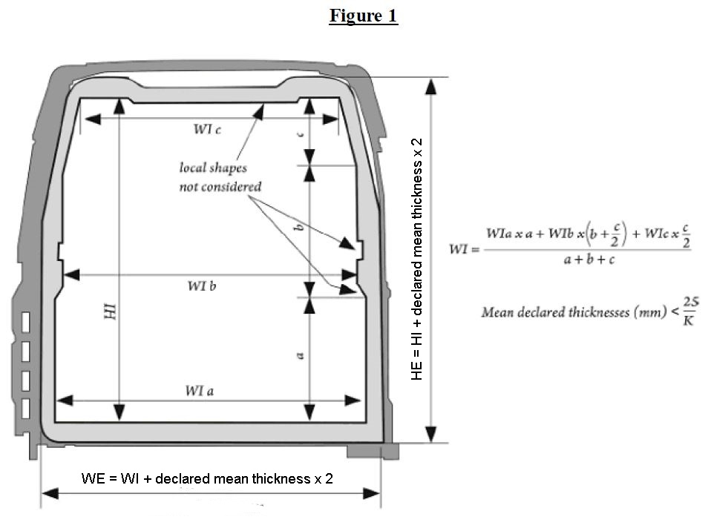

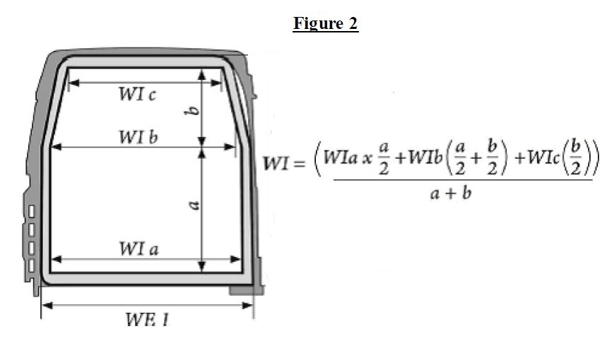

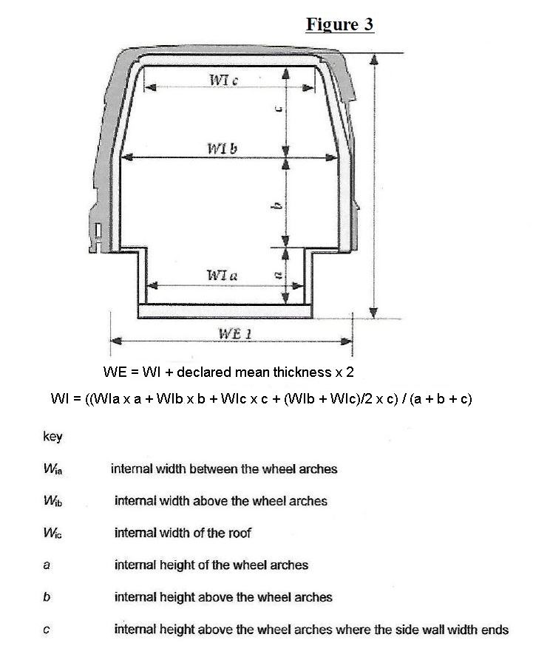



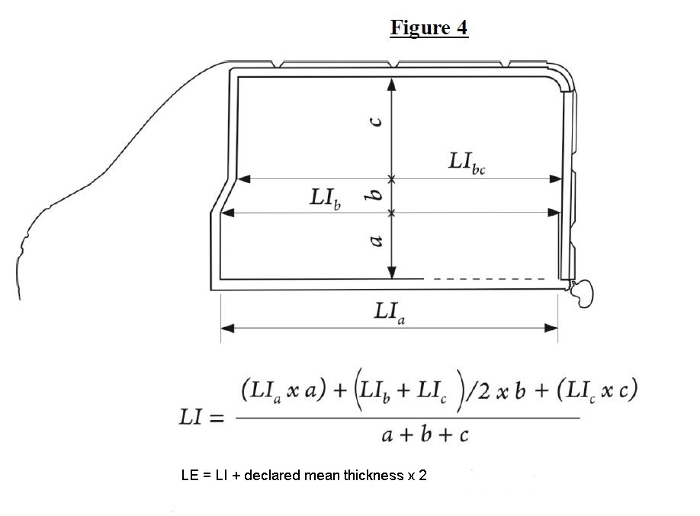

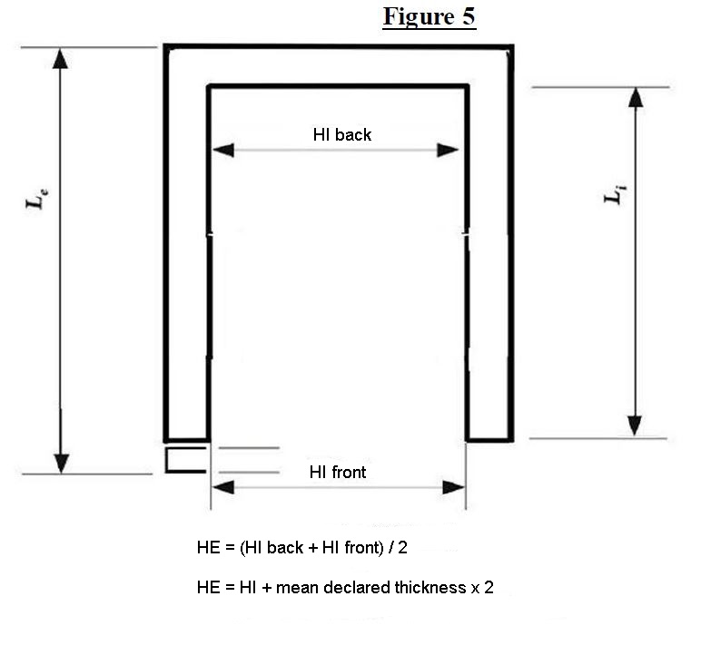

WI back

WI front

$$WI= \frac{WI back+WI front}{2}$$

WE = WI + mean declared thickness × 2".

*(Reference document: ECE/TRANS/WP.11/2018/6)*

**2. Annex 1, appendix 2, section 2.3.2**

Replace existing comments to paragraph 2.3 and paragraph 2.3.2 by the following:

*"Comments to 2.3.2:*

*1. Examples for the uncertainty which are normally taken into account by the test stations are temperature, heat output (or cold production) and the surface area of the body.*

*The expanded uncertainty of the measurement of the K coefficient, U(K), can be obtained using the recommendations in paragraph 6.3.3 of ISO/IEC Guide 98-3:2008. In this case:*

$$U\left(K\right)=k∙u_{c}\left(K\right)$$

*where:*

$k$*is the coverage factor for the selected confidence level (for a confidence level of 95% this may be taken as 2; for 99%, as 3);*

$u_{c}\left(K\right)$*is the combined standard uncertainty of the measurement of the K coefficient.*

*The combined standard uncertainty of the measurement of the K coefficient is an approximation of the standard deviation of the K coefficient and characterizes the range of values which may reasonably be assigned to the K coefficient.*

*Since the K coefficient is determined by a functional dependence that includes such physical values as heat output (or cold production) of heat exchangers, external and internal temperatures of the body and the mean surface area of the body, which are in turn measured with some standard uncertainty, the combined uncertainty of the measurement of the K coefficient can be calculated on the basis of the law of the propagation of uncertainty described in section 5 of ISO/IEC Guide 98-3:2008, taking into consideration the correlation (over time) of the internal and external temperatures of the body, the heat output (or cold production) and the inside temperature of the body:*

$$u_{c}\left(K\right)=\sqrt{\begin{aligned}{\left(\frac{u_{c}\left(W\right)}{\overline{S}∙\left(\overline{T_{e}}-\overline{T_{i}}\right)}\right)}^{2}+{\left(\frac{\overline{W}∙u_{c}\left(S\right)}{{\overline{S}}^{2}∙\left(\overline{T_{e}}-\overline{T_{i}}\right)}\right)}^{2}+… \\ \frac{{\overline{W}}^{2}∙\left({u_{c}\left(T_{i}\right)}^{2}+{u_{c}\left(T_{e}\right)}^{2}+2∙r\left(T_{e},T_{i}\right)∙u_{c}\left(T_{e}\right)∙u_{c}\left(T_{i}\right)\right)}{{\overline{S}}^{2}∙{\left(\overline{T_{e}}-\overline{T_{i}}\right)}^{4}}+… \\ \frac{2∙\overline{W}∙r\left(W,T_{i}\right)∙u_{c}\left(W\right)∙u_{c}\left(T_{i}\right)}{{\overline{S}}^{2}∙{\left(\left|\overline{T_{e}}-\overline{T_{i}}\right|\right)}^{3}}\end{aligned}}$$

*where:*

$\overline{W}$*, $\overline{T_{e}}, \overline{T_{i}}, \overline{S}$* *are sample mean values respectively for the heat output (or cold production), in W; the external and internal temperatures of the body, in °C; and the area of the average surface of the body, in m2;*

*,* *are the combined standard uncertainties of measurement, respectively of the heat output (or cold production), in W; the external and internal temperatures of the body, in °C; and the area of the average surface of the body, in m2;*

*,* . *are the correlation coefficients, respectively, of the value vectors of the external and internal temperatures of the body, and of the heat output (or cold production) and the internal temperature of the body.*

*The correlation coefficient may be calculated as a linear correlation coefficient (Pearson correlation coefficient). However, it should be borne in mind that changes in the values of the vectors for heat output (or cold production), and particularly for the external temperature of the body, produce corresponding changes in the vector of the internal temperature of the body, with some shift (or lag) over time. This time lag is due to heat exchange processes in the “air inside the special equipment-insulation-environment” system. If there is a change in the external temperature of the body, this may take several hours. The actual time lag can be established either visually (by looking at graphs of the changing values) or by selecting the maximum linear correlation coefficient, with consistent selection of the shift variants for the internal temperature vector.*

*The combined standard uncertainty of measurement of the heat output (or cold production), and that of the external and internal temperatures of the body, can be determined using the recommendations in sections 4 and 5 of ISO/IEC Guide 98-3:2008, according to the following formulae:*

$$u_{C}\left(W\right)=\sqrt{{u_{A}\left(\overline{W}\right)}^{2}+{u_{B}\left(W\right)}^{2}}=\sqrt{\frac{\sum_{k=1}^{n}{{\left(W_{k}-\overline{W}\right)}^{2}}}{n∙\left(n-1\right)}+{u_{B}\left(W\right)}^{2}}$$

$$u_{C}\left(T_{i}\right)=\sqrt{{u_{A}\left(\overline{T_{i}}\right)}^{2}+{u_{A}\left(\overline{\overline{T_{i}}}\right)}^{2}+{u_{B}\left(T_{i}\right)}^{2}}=\sqrt{\begin{aligned}\max_{1≤k≤n}\left(\frac{\sum_{i=1}^{l}{{\left({T_{i}}_{i,k}-\overline{{T_{i}}_{k}}\right)}^{2}}}{l∙\left(l-1\right)}\right)+… \\ \frac{\sum_{k=1}^{n}{{\left(\overline{{T_{i}}_{k}}-\overline{T_{i}}\right)}^{2}}}{n∙\left(n-1\right)}+… \\ {u_{B}\left(T_{i}\right)}^{2}\end{aligned}}$$

$$u_{C}\left(T_{e}\right)=\sqrt{{u_{A}\left(\overline{T_{e}}\right)}^{2}+{u_{A}\left(\overline{\overline{T_{e}}}\right)}^{2}+{u_{B}\left(T_{e}\right)}^{2}}=\sqrt{\begin{aligned}\max_{1≤k≤n}\left(\frac{\sum_{j=1}^{m}{{\left({T_{e}}_{j,k}-\overline{{T_{e}}_{k}}\right)}^{2}}}{m∙\left(m-1\right)}\right)+… \\ \frac{\sum_{k=1}^{n}{{\left(\overline{{T_{e}}_{k}}-\overline{T_{e}}\right)}^{2}}}{n∙\left(n-1\right)}+… \\ {u_{B}\left(T_{e}\right)}^{2}\end{aligned}}$$

$$u_{C}\left(S\right)=\sqrt{\frac{{\left(\overline{S_{i}}∙u_{c}\left(S_{e}\right)\right)}^{2}+{\left(\overline{S_{e}}∙u_{c}\left(S_{i}\right)\right)}^{2}}{4∙\overline{S_{e}}∙\overline{S_{i}}}}$$

*where:*

$u_{A}\left(\overline{W}\right)$, $u_{A}\left(\overline{T_{i}}\right), u_{A}\left(\overline{T_{e}}\right), u_{A}\left(\overline{\overline{T_{i}}}\right), u_{A}\left(\overline{\overline{T_{e}}}\right)$*are the standard uncertainties of measurement of the average values, respectively for: the heat output (or cold production), in W; and the internal and external temperatures of the body (within the limits of a single measurement on the basis of simultaneous readings of 12 thermometers), in K; and the internal and external temperatures of the body (steady state), in K, using type A evaluation;*

$u_{B}\left(W\right)$, $u_{B}\left(T_{i}\right), u_{B}\left(T_{e}\right)$*are the standard uncertainties of measurement respectively of the heat output (or cold production), in W; and of the internal and external temperatures of the body, in K, using type B evaluation;*

$u_{c}\left(S_{e}\right)$, $u_{c}\left(S_{i}\right)$*are the combined standard uncertainties of the values of the areas respectively of the internal and external surfaces of the body of the vehicle being tested (disregarding corrugation), in m2;*

*is the value of the heat output (or cold production) obtained at the kth measurement (in all, when $n$ measurements are taken at the end of the steady state, for the period of measurement), in W;*

${T_{i}}_{i,k}$, ${T_{e}}_{j,k}$*are the temperatures measured at the kth measurement, respectively using instrument i on the interior of the body of the vehicle under test (in all, with one measurement, simultaneously taken by l uniformly precise thermometers) and by instrument j on the exterior of the body of the vehicle under test (in all, with one measurement, simultaneously taken by m uniformly precise thermometers), in °C;*

$\overline{W}, \overline{T_{i}}, \overline{T_{e}}$*are the calculated average values (steady state), respectively, of the heat output (or cold production), in W; and the internal and external temperatures of the body, in °C;*

$\overline{{T_{i}}_{k}}, \overline{{T_{e}}_{k}}$*are the calculated average values (within the limits of the -th measurement), respectively, of the internal and external temperatures of the body, in °C;*

$\overline{S_{i}}$, $\overline{S_{e}}$*are the calculated average values of the areas, respectively of the internal and external surfaces of the body of the vehicle being tested (disregarding corrugation), in m2.*

*If the heat output (or cold production) of the heat exchangers has been determined on the basis of the values of electric energy consumption consumed by the heat exchangers, then the mathematical dependence on the basis of which the required calculations are carried out must be factored into the final result of the uncertainty as well.*

*Section 4.3 of ISO/IEC Guide 98-3:2008 addresses the evaluation of standard uncertainties for type B evaluation. In this commentary we provide a design formula to obtain the standard uncertainty on the basis of known boundaries (upper and lower limits) for the evaluation of the measured physical values. Such situations often occur in practice and correspond with concepts such as the accuracy class of the instrumentation and its margin of error. If the interval of the evaluations of measured physical values, x, is denoted as 2a (corresponding to the common notation for the margin of error of the instrumentation as ±a), then:*

$$u_{B}\left(x\right)=\frac{a}{\sqrt{3}}$$

*2. Under normal test conditions, $\overline{S_{i}} and \overline{S_{e}}$ can be measured with a high degree of accuracy. The combined standard uncertainty for such conditions may be accepted as equal to ± 1%. However, there are cases where it is impossible to measure with this precision.*

*Generally, the following method may be used to determine the combined standard uncertainty of $S_{i} and S_{e}$,which are used to determine the heat transfer surface area of the body, $S$.*

*If $S_{i}{ and S}_{e}$ are presented as functions of a series of repeated measurements, $p_{i} and p_{e}$ (for example, of the length, width and height measured at various places in the body of the vehicle):*

$$S_{i}=f_{1}\left({p_{i}}_{1}, {p_{i}}_{2},…,{p_{i}}_{y},…,{p_{i}}_{Y}\right)$$

$$S_{e}=f_{2}\left({p_{e}}_{1}, {p_{e}}_{2},…,{p_{e}}_{z},…,{p_{e}}_{Z}\right)$$

*then their combined standard uncertainties can be calculated according to the formulae:*

$$u_{c}\left(S_{i}\right)=\sqrt{\sum_{y=1}^{Y}{{\left(u_{c}\left({p_{i}}_{y}\right)∙\frac{∂f_{1}}{∂{p_{i}}_{y}}\right)}^{2}}}$$

$$u_{c}\left(S_{e}\right)=\sqrt{\sum_{z=1}^{Z}{{\left(u_{c}\left({p_{e}}_{z}\right)∙\frac{∂f_{2}}{∂{p_{e}}_{z}}\right)}^{2}}}$$

*where:*

$\frac{∂f_{1}}{∂{p_{i}}_{y}}, \frac{∂f_{2}}{∂{p_{e}}_{z}}$*are respectively the partial derivatives for the functions for calculating $S_{i} and S_{e};$*

$u_{c}\left({p_{i}}_{y}\right)$, $u_{c}\left({p_{e}}_{z}\right)$*are the combined standard uncertainties for the parameters ${p_{i}}_{y} and {p_{e}}_{z}$*

$$u_{c}\left({p_{i}}_{y}\right)=\sqrt{\frac{\sum_{v=1}^{V}{{\left({{p_{i}}_{y}}_{v}-\overline{{p_{i}}_{y}}\right)}^{2}}}{V∙\left(V-1\right)}+{u_{B}\left({p_{i}}_{y}\right)}^{2}}$$

$$\overline{{p_{i}}_{y}}=\frac{\sum_{v=1}^{V}{{{p_{i}}_{y}}_{v}}}{V}$$

*where:*

$V$*is the quantity of measurements carried out to determine the average value of parameter ${p_{i}}_{y};$*

${{p_{i}}_{y}}_{v}$*is the measured value of parameter ${p_{i}}_{y}$ at the -th measurement;*

$u_{B}\left({p_{i}}_{y}\right)$*is the standard uncertainty parameter ${p_{i}}_{y}$ evaluated for type B (for details on evaluation methods and techniques for type B uncertainties, see section 4.3 of ISO/IEC Guide 98-3:2008).*

$\overline{{p_{i}}_{y}} and u_{c}\left({p_{i}}_{y}\right)$*are calculated in a fashion similar to $\overline{{p_{e}}_{z}}u_{c}\left({p_{e}}_{z}\right)$* .

*3. Other uncertainties which have not been taken into consideration can have an effect on accuracy in determining the K coefficient.*

*(a) Latent errors due to admissible variations in the internal and external temperatures, which are a function of the thermal inertia of the walls of the equipment, the temperature and time;*

*(b) Uncertainties due to the variation of air velocity at the boundary layer and its effect on the thermal resistance.*

*If the internal and external air velocities are of equal value, the possible expanded uncertainty will be about 2.5% as between 1 and 2 m/s for a mean K coefficient of 0.40 W/m2K. For a K coefficient of 0.70 W/m2K, this expanded uncertainty will be nearly 5%. If there are significant thermal bridges, the influence of the speed and direction of the air will be greater.".*

*(Reference document: ECE/TRANS/WP.11/2018/20)*