|  |  |  |  |
| --- | --- | --- | --- |
|  | United Nations | ST/SG/AC.10/C.4/2018/18 | |
| _unlogo | **Secretariat** | | Distr.: General  1 October 2018  English  Original: English and French |

**Committee of Experts on the Transport of Dangerous Goods  
and on the Globally Harmonized System of Classification  
and Labelling of Chemicals**

**Sub-Committee of Experts on the Globally Harmonized  
System of Classification and Labelling of Chemicals**

**Thirty-sixth session**

Geneva, 5-7 December 2018

Item 2 of the provisional agenda

**Recommendations made by the Sub-Committee on its   
thirty-third, thirty-fourth and thirty-fifth sessions**

Consolidated list of draft amendments adopted by the Sub-Committee on its thirty-third and thirty-fifth sessions

Note by the secretariat[[1]](#footnote-2)

This document contains the consolidated list of drafts amendments to the seventh revised edition of the Globally Harmonized System of Classification and Labelling of Chemicals (ST/SG/AC.10/30/Rev.7) adopted by the Sub-Committee at its thirty-third and thirty-fifth session.

Chapter 1.2

In the Note under Definition of “oxidizing gas”, Replace “ISO 10156:2010” by “ISO 10156:2017”.

*(Reference document: ST/SG/AC.10/C.4/2018/2 and ST/SG/AC.10/C.4/70, annex I)*

Chapter 2.2

2.2.4.2.1 Replace “ISO 10156:2010” by “ISO 10156:2017”.

*(Reference document: ST/SG/AC.10/C.4/2018/2 and ST/SG/AC.10/C.4/70, annex I)*

2.2.4.2.4 Replace “ISO 10156:2010” by “ISO 10156:2017”.

*(Reference document: ST/SG/AC.10/C.4/2018/2 and ST/SG/AC.10/C.4/70, annex I)*

2.2.5 Replace “ISO 10156:2010” by “ISO 10156:2017”.

*(Reference document: ST/SG/AC.10/C.4/2018/2 and ST/SG/AC.10/C.4/70, annex I)*

Chapter 2.3

2.3.2.1 Amend the first sentence to read:

“Aerosols are classified in one of the three categories of this hazard class, according to Table 2.3.1, depending on:

– their flammable properties;

– their heat of combustion; and

– if applicable, test results from the ignition distance test, the enclosed space ignition test and the aerosol foam flammability test, performed in accordance with sub-sections 31.4, 31.5 and 31.6 of the *United Nations Recommendations on the Transport of Dangerous Goods, Manual of Tests and Criteria*.”.

*(Reference document: ST/SG/AC.10/C.4/2018/9 and ST/SG/AC.10/C.4/70, annex I)*

2.3.2.1 Insert the following table before Note 1:

**“Table 2.3.1: Criteria for aerosols**

| **Category** | **Criteria** |
| --- | --- |
| **1** | (1)Any aerosol that contains ≥ 85% flammable components (by mass) and has a heat of combustion of ≥ 30 kJ/g;  (2) Any aerosol that dispenses a spray that, in the ignition distance test, has an ignition distance of ≥ 75 cm; or  (3) Any aerosol that dispenses a foam that, in the foam flammability test, has:  (a) a flame height of ≥ 20 cm and a flame duration of ≥ 2 s; or  (b) a flame height of ≥ 4 cm and a flame duration of ≥ 7 s. |
| **2** | (1) Any aerosol that dispenses a spray that, based on the results of the ignition distance test, does not meet the criteria for Category 1, and which has:  (a) a heat of combustion of ≥ 20 kJ/g;  (b) a heat of combustion of < 20 kJ/g along with an ignition distance of ≥ 15 cm; or  (c) a heat of combustion of < 20 kJ/g and an ignition distance of < 15 cm along with either, in the enclosed space ignition test:  - a time equivalent of ≤ 300 s/m3; or  - a deflagration density of ≤ 300 g/m3; or  (2) Any aerosol that dispenses a foam that, based on the results of the aerosol foam flammability test, does not meet the criteria for Category 1, and which has a flame height of ≥ 4 cm and a flame duration of ≥ 2 s. |
| **3** | (1) Any aerosol that contains ≤ 1% flammable components (by mass) and that has a heat of combustion < 20 kJ/g; or  (2) Any aerosol that contains > 1% (by mass) flammable components or which has a heat of combustion of ≥ 20 kJ/g but which, based on the results of the ignition distance test, the enclosed space ignition test or the aerosol foam flammability test, does not meet the criteria for Category 1 or Category 2. |

”.

*(Reference document: ST/SG/AC.10/C.4/2018/9 and ST/SG/AC.10/C.4/70, annex I)*

2.3.2.1 Transfer existing Note under 2.3.2.2 as Note 2 under 2.3.2.1 and renumber existing Note 2 as Note 3.

*(Reference document: ST/SG/AC.10/C.4/2018/9 and ST/SG/AC.10/C.4/70, annex I)*

2.3.2.2 Delete.

*(Reference document: ST/SG/AC.10/C.4/2018/9 and ST/SG/AC.10/C.4/70, annex I)*

2.3.3 Renumber current Table 2.3.1 as Table 2.3.2.

*(Reference document: ST/SG/AC.10/C.4/2018/9 and ST/SG/AC.10/C.4/70, annex I)*

2.3.4 In the first sentence, delete “are not part of the harmonized classification system, but”.

*(Reference document: ST/SG/AC.10/C.4/2018/11 and ST/SG/AC.10/C.4/70, annex I)*

2.3.4.1 In the first sentence, delete “of the foam test (for foam aerosols) and” after “the results” and insert “and of the foam test (for foam aerosols)” at the end before “are required”.

*(Reference document: ST/SG/AC.10/C.4/2018/11 and ST/SG/AC.10/C.4/70, annex I)*

2.3.4.2 Amend the heading to read “*Guidance* *on specific heat of combustion*”.

*(Reference document: ST/SG/AC.10/C.4/2018/12 and ST/SG/AC.10/C.4/70, annex I)*

2.3.4.2.1 Amend to read as follows:

“2.3.4.2.1 For a composite formulation, the specific heat of combustion of the product is the summation of the weighted specific heats of combustion for the individual components, as follows:

ΔHc(product) =  [ w(i) × ΔHc(i)]

where:

ΔHc(product) = specific heat of combustion (kJ/g) of the product;

ΔHc(i) = specific heat of combustion (kJ/g) of component i in the product;

w(i) = mass fraction of component i in the product;

n = total number of components in the product.

The specific heats of combustion, which are given in kilojoules per gram (kJ/g), can be found in the scientific literature, calculated or determined by tests (see ASTM D 240 and NFPA 30B). Note that experimentally measured heats of combustion usually differ from the corresponding theoretical heats of combustion, since the combustion efficiency normally is less than 100% (a typical combustion efficiency is 95%).”.

*(Reference document: ST/SG/AC.10/C.4/2018/12 and ST/SG/AC.10/C.4/70, annex I)*

2.3.4.2.2 Delete.

*(Reference document: ST/SG/AC.10/C.4/2018/12 and ST/SG/AC.10/C.4/70, annex I)*

Chapter 2.4

2.4.1, Note Replace “ISO 10156:2010” by “ISO 10156:2017”.

*(Reference document: ST/SG/AC.10/C.4/2018/2 and ST/SG/AC.10/C.4/70, annex I)*

2.4.4.1 Replace “ISO 10156:2010” by “ISO 10156:2017”.

*(Reference document: ST/SG/AC.10/C.4/2018/2 and ST/SG/AC.10/C.4/70, annex I)*

2.4.4.2 Replace “ISO 10156:2010” by “ISO 10156:2017”.

*(Reference document: ST/SG/AC.10/C.4/2018/2 and ST/SG/AC.10/C.4/70, annex I)*

Annex 1

A1.19 In the table, in column “Hazard category”, in the first line, after “1” add “1A, 1B, 1Ca”. Table note a reads “Sub-categories may be applied where data are sufficient and where required by a competent authority.”. Existing table note a is renumbered as table note b.

*(Reference document: ST/SG/AC.10/C.4/2018/6 and ST/SG/AC.10/C.4/70, annex I)*

A1.23, A1.24 and A1.25 In the table, in column “Hazard category”, in the first line, replace “1 (both 1A and 1B)” by “1, 1A, 1B”.

*(Reference document: ST/SG/AC.10/C.4/2018/6 and ST/SG/AC.10/C.4/70, annex I)*

Annex 3

Section 1, table A3.1.2

For code H314, in column “Hazard category”, before “1A, 1B, 1C”, insert “1,”.

*(Reference document: ST/SG/AC.10/C.4/2018/6 and ST/SG/AC.10/C.4/70, annex I)*

For code H319, in column “Hazard category”, replace “2A” by “2/2A”.

*(Reference document: ST/SG/AC.10/C.4/2018/6 and ST/SG/AC.10/C.4/70, annex I)*

For codes H340, H350 and H360, in column “Hazard category”, replace “1A, 1B” by “1, 1A, 1B”.

*(Reference document: ST/SG/AC.10/C.4/2018/6 and ST/SG/AC.10/C.4/70, annex I)*

Section 2, table A3.2.2

For codes P201, P202 and P280, hazard classes “Germ cell mutagenicity (chapter 3.5)”, “carcinogenicity (chapter 3.6)”, “Reproductive toxicity (chapter 3.7)” in column “Hazard category”, before “1A, 1B, 2”, insert “1,”.

*(Reference document: ST/SG/AC.10/C.4/2018/6 and ST/SG/AC.10/C.4/70, annex I)*

For codes P260, P264, P280, hazard class “Skin corrosion (chapter 3.2)”, in column “Hazard category”, before “1A, 1B, 1C”, insert “1,”.

*(Reference document: ST/SG/AC.10/C.4/2018/6 and ST/SG/AC.10/C.4/70, annex I)*

For codes P264, P280, hazard class “Eye irritation (chapter 3.3)”, in column “Hazard category”, replace “2A” by “2/2A”.

*(Reference document: ST/SG/AC.10/C.4/2018/6 and ST/SG/AC.10/C.4/70, annex I)*

Section 2, table A3.2.3

For codes P301, P303, P304, P305, P310, P321, P330, P331, P338, P340, P351, P353, P361, P363, P304 + P340, P301 + P330 + P331, P303 + P361 + P353, P305 + P351 + P338, hazard class “Skin corrosion (chapter 3.2)”, in column “Hazard category”, before “1A, 1B, 1C”, insert “1,”.

*(Reference document: ST/SG/AC.10/C.4/2018/6 and ST/SG/AC.10/C.4/70, annex I)*

For codes P305, P313, P337, P338, P351, P337 + P313, P305 + P351 + P338, hazard class “Eye irritation (chapter 3.3)”, in column “Hazard category”, replace “2A” by “2/2A”.

*(Reference document: ST/SG/AC.10/C.4/2018/6 and ST/SG/AC.10/C.4/70, annex I)*

For codes P308, P313, P308+P313, hazard classes “Germ cell mutagenicity (chapter 3.5)”, “carcinogenicity (chapter 3.6)”, “Reproductive toxicity (chapter 3.7)” in column “Hazard category”, before “1A, 1B, 2”, insert “1,”.

*(Reference document: ST/SG/AC.10/C.4/2018/6 and ST/SG/AC.10/C.4/70, annex I)*

Section 2, table A3.2.4

For code P405, hazard class “Skin corrosion (chapter 3.2)”, in column “Hazard category”, before “1A, 1B, 1C”, insert “1,”.

*(Reference document: ST/SG/AC.10/C.4/2018/6 and ST/SG/AC.10/C.4/70, annex I)*

For code P405, hazard classes “Germ cell mutagenicity (chapter 3.5)”, “carcinogenicity (chapter 3.6)”, “Reproductive toxicity (chapter 3.7)” in column “Hazard category”, before “1A, 1B, 2”, insert “1,”.

*(Reference document: ST/SG/AC.10/C.4/2018/6 and ST/SG/AC.10/C.4/70, annex I)*

Section 2, table A3.2.5

For code P501, hazard class “Skin corrosion (chapter 3.2)”, in column “Hazard category”, before “1A, 1B, 1C”, insert “1,”.

*(Reference document: ST/SG/AC.10/C.4/2018/6 and ST/SG/AC.10/C.4/70, annex I)*

For code P501, hazard classes “Germ cell mutagenicity (chapter 3.5)”, “carcinogenicity (chapter 3.6)”, “Reproductive toxicity (chapter 3.7)” in column “Hazard category”, before “1A, 1B, 2”, insert “1,”.

*(Reference document: ST/SG/AC.10/C.4/2018/6 and ST/SG/AC.10/C.4/70, annex I)*

Section 3, matrix tables in paragraph A3.3.5.1

For the table applicable to “Skin corrosion/irritation (Chapter 3.2)”, for “Hazard category 1A to 1C”, replace “1A to 1C” by “1, 1A to 1C”.

*(Reference document: ST/SG/AC.10/C.4/2018/6 and ST/SG/AC.10/C.4/70, annex I)*

For the table applicable to “Eye damage/irritation (Chapter 3.3)”, for “Hazard category 2A”, replace “2A” by “2/2A”.

*(Reference document: ST/SG/AC.10/C.4/2018/6 and ST/SG/AC.10/C.4/70, annex I)*

For the table applicable to “Germ cell mutagenicity (Chapter 3.5)”, for “Hazard category 1”, replace “1” by “1, 1A, 1B”.

*(Reference document: ST/SG/AC.10/C.4/2018/6 and ST/SG/AC.10/C.4/70, annex I)*

For the table applicable to “Carcinogenicity (Chapter 3.6)”, for “Hazard category 1”, replace “1” by “1, 1A, 1B”.

*(Reference document: ST/SG/AC.10/C.4/2018/6 and ST/SG/AC.10/C.4/70, annex I)*

For the table applicable to “Reproductive toxicity (Chapter 3.7)”, for “Hazard category 1”, replace “1” by “1, 1A, 1B”.

*(Reference document: ST/SG/AC.10/C.4/2018/6 and ST/SG/AC.10/C.4/70, annex I)*

Section 5

Add the following new section A3.5.2:

“**A3.5.2 Precautionary pictograms “Keep out of reach of children”**

The following examples convey the meaning of precautionary statement P102 "Keep out of reach of children" and may be used to convey information in more than one way according to sections 1.4.4.1 (a) and A.3.3.1.8.

**A3.5.2.1 *AISE precautionary pictogram “Keep out of reach of children”***

The pictogram was developed by the International Association for Soaps, Detergents and Maintenance Products (AISE) and has been in use since 2004 in Europe and other jurisdictions for household care products.

Comprehensibility tests were carried out on the AISE Precautionary pictogram "Keep out of reach of children". The studies conducted in several countries according to Annex VI GHS demonstrated that this icon was adequately understood by 88.6% of the respondents, and that critical confusion about the icon was only sporadic (<1%).



**A3.5.2.2 *JSDA precautionary pictogram “Keep out of reach of children”***

The pictogram was developed by the Japan Soap and Detergent Association (JSDA) for voluntarily use on the label/packaging of consumer detergents products in Japan.

The JSDA safe use icon was tested in accordance with the Japanese standard JIS S 0102: "Testing procedure for graphical warning symbols for consumers". The icon passed the JIS S 0102 success criteria (comprehension >85%) with 96% correct understanding and only 1.7% of critical confusion.

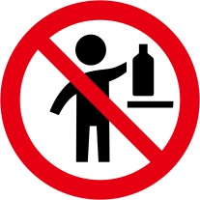”.

*(Reference document: ST/SG/AC.10/C.4/2018/5 and ST/SG/AC.10/C.4/70, annex I)*

Annex 4

Section 2, paragraph A4.3.2.3

Replace the last sentence (“The statement “May form explosible dust-air mixture if dispersed” is appropriate in the case of a dust explosion hazard.”) with the following: “To communicate combustible dust hazards, and thus a potential risk of dust explosions under the approach described in Annex 11 in a standardized manner, competent authorities may allow the use of the phrases identified in A11.2.7.3 on labels, SDSs and/or in operating instructions or may leave the choice to the manufacturer or supplier.”.

*(Reference document: ST/SG/AC.10/C.4/2017/3 and ST/SG/AC.10/C.4/66, annex)*

Annex 7

Add the following new example:

“Example 10: Labelling of - sets or kits

A set or kit is a combination packaging intended for defined applications. Generally a set or kit contains two or more small removable inner containers. Each inner container contains different products which can be hazardous or not hazardous substances or mixtures.

This example illustrates ways to label sets or kits where the manufacturer/supplier or competent authority has determined there is insufficient space to place together on each inner container within the kit, the GHS pictogram(s), signal word and hazard statement(s) in accordance with 1.4.10.5.4.1. This may occur when, for example, the inner containers are small, or there are a large number of hazard statements assigned to the chemical, or the information needs to be presented in multiple languages, so all the information cannot be printed on the label in a size that is easily legible. Two different scenarios where this may arise are illustrated, together with ways to provide the necessary GHS information.

Scenario A

The set or kit comprises an outer packaging containing the following inner containers: four cuvettes, each filled with the same substance or mixture (reagent 1) and two larger containers each filled with another substance or mixture (reagent 2).

The approach is to provide minimum information on each of the inner containers containing hazardous substances or mixtures, and to provide the full GHS label information for each hazardous substance or mixture on the outer packaging. For clarity, the full label information for each hazardous substance or mixture is grouped together on the outer packaging.

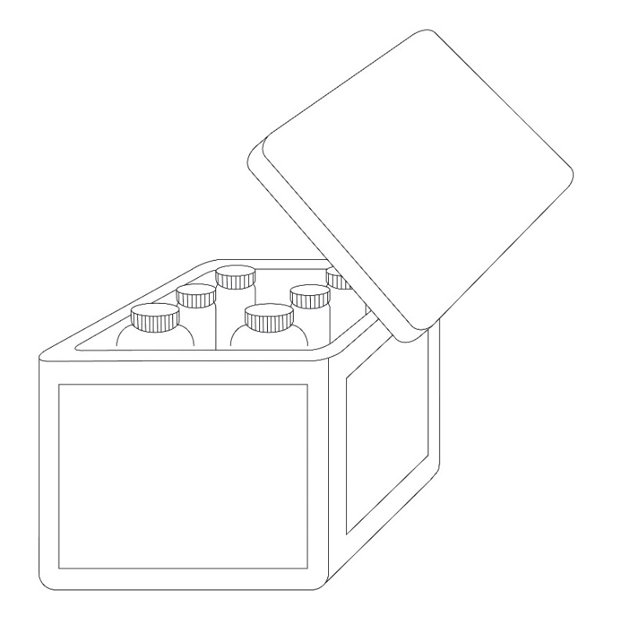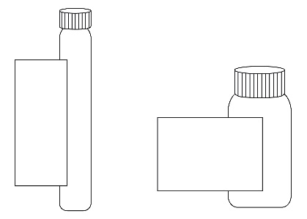

Inner containers

Outer packaging

Inner container label

As the area available for a label on the inner containers is not sufficient to include all the required GHS label elements, the following minimum information is included on the label of each hazardous substance or mixture:

- Product identifier[[2]](#footnote-3)1, and an identifier for each substance or mixture matching the identifier used on the outer packaging label and SDS for that substance or mixture, e.g., “Reagent 1” and “Reagent 2”

- Pictogram(s)

- Signal word

- The statement “Read full label”

- Supplier identification (i.e. name and telephone number)

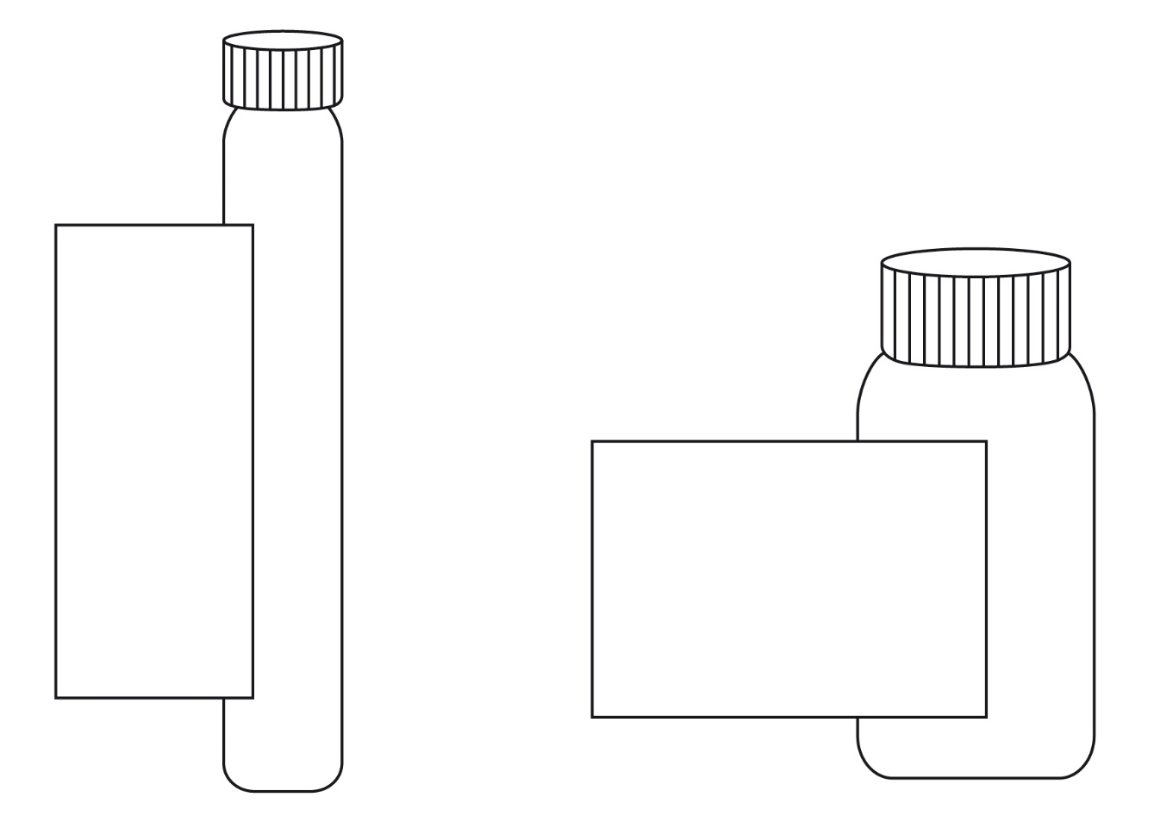

**Reagent 2**

**Product ident. (see 1.4.10.5.2 (d)(ii)) 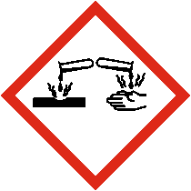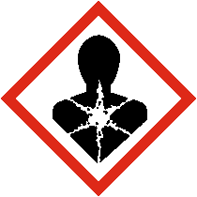**

**Signal word (see1.4.10.5.2(a))**

**Read full label**

**Company XYZ Phone +000000**

**number**

**Reagent 1**

**Product ident.**

**(see 1.4.10.5.2 (d) (ii))**

**Signal word**

**(see 1.4.10.5.2 (a))**

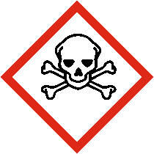 ****

**Read full label**

**Company XYZ Phone +000000**

Outer packaging label

In addition to the set or kit identifier, in this case Reagent Kit for water analysis (see below), all the required GHS label elements appear on the outer packaging for each hazardous substance or mixture.

The label elements for each substance or mixture on the outer packaging are grouped together in order to distinguish clearly which label elements are assigned to which substance or mixture.

However, the supplier identification need appear only once on the outer packaging. Where possible any supplemental information may also be included on the outer packaging.

When a large number of precautionary statements are required, the precautionary statements may be located separately from the rest of the label elements, though general precautionary statements (Table A3.2.1) and precautionary statements for storage need only appear once (see also A3.3.2 in Annex 3 on flexibility in the use of precautionary statements) to avoid inappropriate statements, taking into account the nature of the user (e.g. consumers, employers and workers) the quantities supplied, and the intended and foreseeable circumstances of use. In these circumstances, the precautionary statements for each substance or mixture should be grouped together on the same side of the outer packaging and on a surface that is visible under normal conditions of use.

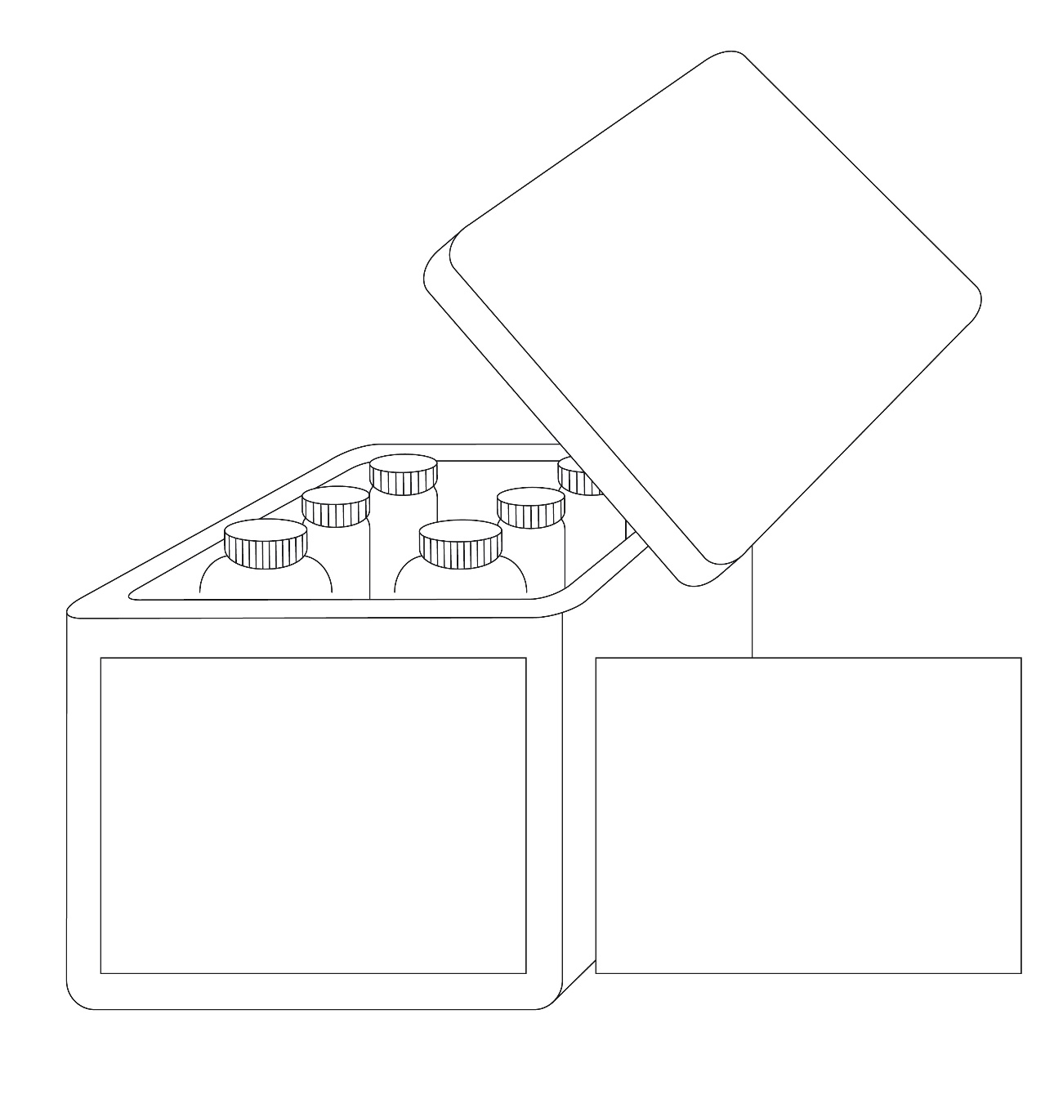

**Reagent kit for water analysis**

**Supplier identification** (see 1.4.10.5.2(e))

**Reagent 1**

  
**Signal word**(see 1.4.10.5.2(a))

**Hazard statements**(see 1.4.10.5.2 (b))

**Product identifier**(see 1.4.10.5.2 (d)(ii))

**Reagent 2**

  
**Signal word**  
(see 1.4.10.5.2(a))

**Hazard statements**  
(see 1.4.10.5.2 (b))

**Product identifier**(see 1.4.10.5.2 (d)(ii))

**Reagent 1**

**Precautionary statements (see 1.4.10.5.2 (c))**

**Storage conditions and general precautionary statements**

**Reagent 2**

**Precautionary statements (see 1.4.10.5.2 (c))**

Scenario B

This scenario addresses the situation where it is not possible to affix all appropriate GHS labelling elements for each hazardous substance or mixture in the kit directly on the outer packaging label (due to technical reasons such as the size and shape of this packaging).

This scenario presents a sample kit used for marketing purposes which consist of a large number of different substances or mixtures in individual containers (sample bottles) presented in an outer packaging (e.g. a box). Depending upon the contents of each bottle, some or all of the different substances or mixtures may be classified as hazardous. The individual inner containers (e.g. bottles) are stored in the outer packaging throughout the lifecycle of the sample kit. Customers may select individual bottles and remove them from the box to check clarity, colour or odour and then replace them into the open slot within the outer packaging.

**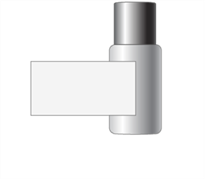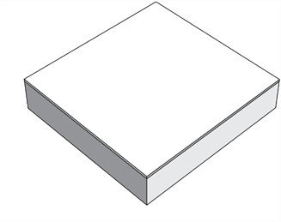**

Individual container

(Sample bottle)

Outer packaging

Individual container label

As the area available for a label on the different individual containers is not sufficient to include all required GHS label elements, the following minimum required information should be required:

- supplier identification (i.e. name and telephone number);

- product identifier[[3]](#footnote-4)2;

- pictogram(s);

- signal word;

- the statement “Read full label enclosed”.



**Sample 1**

**Product ident.**

**(see 1.4.10.5.2 (d) (ii))**

**Signal word**

**(see 1.4.10.5.2 (a))**

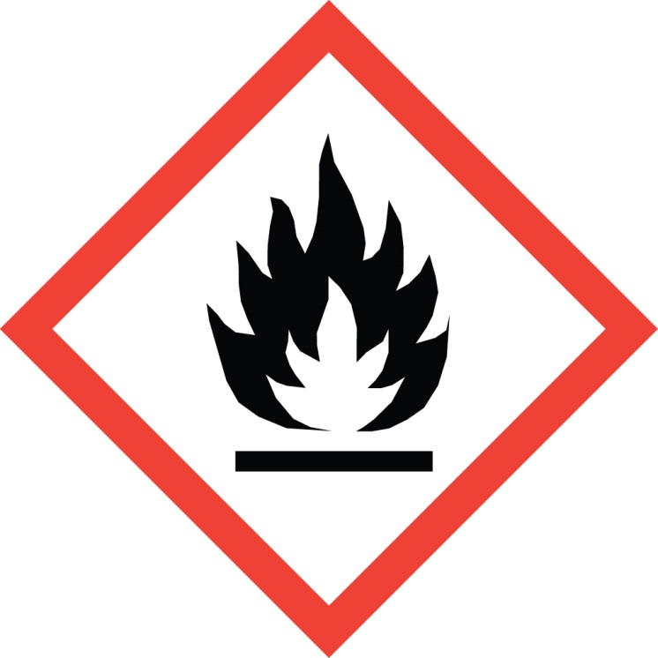****

**Company XYZ**

**Phone +000000**

**Read full label enclosed**

Example of individual container label

Full label information

Attached to the inside of the outer packaging is the full GHS label information for each individual container containing a hazardous substance or mixture. The individual product identifiers on the label align with the product identifier on the individual container label. An example of the content of the full label information is shown below.

| Product identifier  (see 1.4.10.5.2 (d) (ii)) | Pictogram(s) (see 1.4.10.4) | Signal word (see 1.4.10.5.2 (a)) | Hazard statement(s) (see 1.4.10.5.2 (b)) | Precautionary statement(s) (see 1.4.10.5.2 (c)) | Supplemental information  (see 1.4.10.5.4.2) |
| --- | --- | --- | --- | --- | --- |
| 123 |  | Warning | Flammable liquid and vapour.  Causes skin irritation.  Toxic to aquatic life with long lasting effects. | Keep away from heat, hot surfaces,sparks,open flames and other ignition sources. No smoking.  Keep container tightly closed.  Use explosion-proof equipment.  Use non-sparking tools.  Take action to prevent static discharge.  Avoid release to the environment.  Wear protective gloves.  IF ON SKIN (or hair): Take off immediately all contaminated clothing. Rinse skin with water.  In case of fire: Use dry sand, dry chemical or alcohol-resistant foam for extinction.  Store in a well-ventilated place. Keep cool. |  |

Although the contents of each inner container may not be classified as hazardous according to the GHS, and thus would not need to be identified, it may be identified with a statement such as “Not meeting classification criteria” or “Not classified as hazardous” so as to eliminate confusion on the part of the user if the contents of an inner container is omitted from the full label information.

The document containing the full GHS label information should be organized and printed in a format that allows the user to readily identify the information for each individual container. The visibility of the label elements should be ensured without the aid of any device other than corrective lenses. The approach of this scenario may become infeasible if, given the number of samples, required languages, and precautionary statements, the document grows so large it becomes difficult to locate quickly the label information for a particular inner container.

|  |  |
| --- | --- |
| As shown to the right, full label information regarding each inner container is contained within the outer packaging.  The sheets of full label information are permanently connected to the inside of the combination packaging using a secure method of attachment  (e.g. fold out label adhered to box tie or tag as shown) |  |

Outer packaging label

The outer box, given the limited area for labelling, will display:

- kit identifier (name of kit);

- supplier identification (see 1.4.10.5.2(e));

- storage and general precautionary statements for the kit as a whole;

- pictograms for each single hazardous substance or mixture, without duplication;

- signal word (the most stringent assigned to any component);

- the statement “Read full label enclosed”.

*(Reference document: ST/SG/AC.10/C.4/2018/10 and ST/SG/AC.10/C.4/70, annex)*

**MARKET KIT**

**Product ident. (see 1.4.10.5.2 (d) (ii))**

**Signal word (see 1.4.10.5.2 (a))**

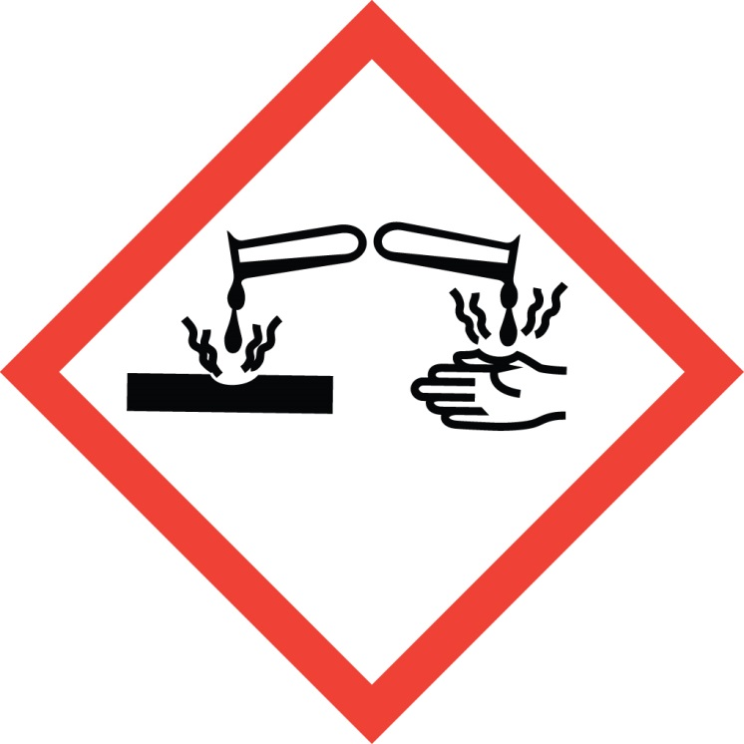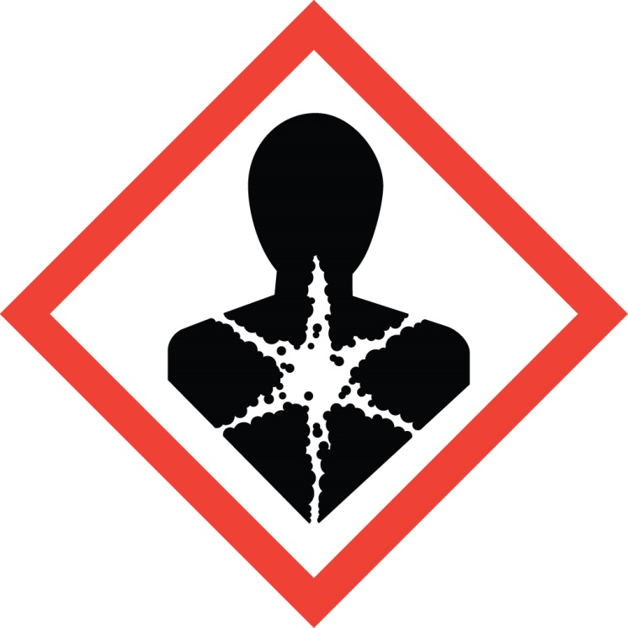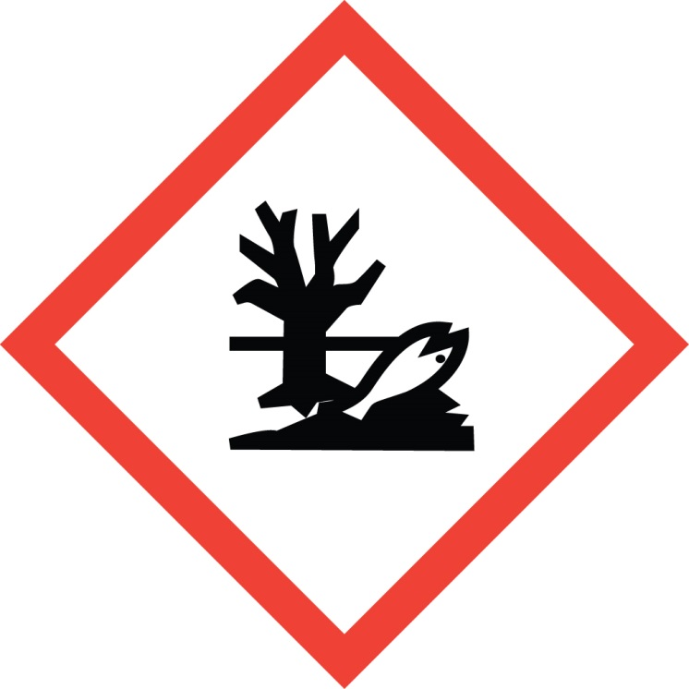

Precautionary Storage Statements (see 1.4.10.5.2 (c))

Read full label enclosed

Supplier identification (see 1.4.10.5.2 (e))

Annex 11

Add the following new Annex 11:

*(Reference document: ST/SG/AC.10/C.4/2017/3 and ST/SG/AC.10/C.4/66, annex)*

“Annex 11

GUIDANCE ON OTHER HAZARDS NOT RESULTING IN CLASSIFICATION

A11.1 Introduction

This guidance aims to provide information that facilitates the identification of hazards which do not result in classification, but which may need to be assessed and communicated.

A11.2 Dust explosions

This section provides guidance on the factors that contribute to a dust explosion hazard and on hazard identification and the need for risk assessment, prevention, mitigation, and communication.

A11.2.1 *Scope and applicability*

A11.2.1.1 Any solid substance or mixture, which is combustible, may pose a dust explosion risk when in the form of fine particles in an oxidizing atmosphere such as air. A risk assessment may be needed for many substances, mixtures, or solid materials, not just those classified as flammable solids according to Chapter 2.7. In addition, dusts may be formed (intentionally or unintentionally) during transfer or movement, or in a facility during handling or mechanical processing (e.g., milling, grinding) of substances/mixtures/solid materials (e.g., agricultural commodities, wood products, pharmaceuticals, dyes, coal, metals, plastics). Thus, the possibility of the formation of small particles and their potential accumulation should also be assessed. Where a dust explosion risk is identified, effective preventive and protective measures should be implemented as required by national legislation, regulations, or standards.

A11.2.1.2 This guidance identifies when combustible dusts may be present and thus, when the risk of a dust explosion should be considered. The guidance:

(a) Gives a flow chart specifying the key steps to identify a possible combustible dust;

(b) Identifies the factors contributing to a dust explosion;

(c) Sets out principles of hazard and risk management; and

(d) Indicates where expert knowledge is required.

A11.2.2 *Definitions*

In this annex, the following terms, specific to dust explosion hazards and risks, are used:

**Combustible dust***:* Finely divided solid particles of a substance or mixture that are liable to catch fire or explode on ignition when dispersed in air or other oxidizing media;

**Combustion*:*** Energy releasing (exothermic) oxidation reaction of (or with) combustible substances/mixtures/solid materials;

***Dispersion****:* Distribution of fine dust particles in the form of a cloud;

**Dust deflagration index (Kst)*:*** A safety characteristic related to the severity of a dust explosion. The larger the value for $K_{st}$, the more severe the explosion. *Kst* is dust specific and volume independent, and is calculated using the cubic law equation:

$${\left({d_{p}}/{d_{t}}\right)}_{max}∙V^{1/3}=const.=K_{st}$$

where:

(dp/dt)max = maximum rate of pressure rise

V = volume of testing chamber

Dusts are classified into dust explosion classes according to their Kst value:

St 1: 0 < Kst ≤ 200 bar m s-1

St 2: 200 < Kst ≤ 300 bar m s-1

St 3: Kst > 300 bar m s-1

The Kst value and the maximum explosion pressure are used to design appropriate safety measures (e.g. pressure relief venting).

**Explosible dust atmosphere*:*** A dispersion of a combustible dust in air which after ignition results in a self-sustaining flame propagation;

**Explosion*:*** Abrupt oxidation or decomposition reaction producing an increase in temperature, pressure, or both simultaneously;[[4]](#footnote-5)1

**Limiting oxygen concentration (LOC)*:*** maximum oxygen concentration in a mixture of a combustible dust and air and an inert gas, in which an explosion will not occur, determined under specific test conditions;

**Maximum explosion pressure*:*** Highest pressure registered in a closed vessel for a dust explosion at optimum concentration;

**Minimum Explosible Concentration (MEC)/Lower Explosible Limit (LEL):** The minimum concentration of a combustible dust dispersed in air measured in mass unit per volume that will support an explosion;

**Minimum ignition energy (MIE):** Lowest electrical energy stored in a capacitor, which upon discharge is sufficient to ignite the most sensitive dust/air mixture under specific test conditions;

**Minimum ignition temperature (MIT) of a dust cloud*:*** Lowest temperature of a hot surface on which the most ignitable mixture of a dust with air is ignited under specified test conditions;

**Particle size*:*** Smallest sieve aperture through which a particle will pass if presented in the most favourable orientation;[[5]](#footnote-6)2

A11.2.3 *Identification of combustible dust*

A11.2.3.1 The purpose of this section is to identify whether a combustible dust is present. If there is applicable data from a recognized and validated test method that supports a conclusion that the substance or mixture is or is not a combustible dust (see considerations in A11.2.3.2.10) then a decision can be made without the application of figure A11.2.1. Otherwise, figure A11.2.1 presents a flow chart that helps to identify whether a substance or mixture is a combustible dust and hence whether the risk of a dust explosion has to be assessed. Section A11.2.3.2 contains detailed explanations and guidance on the interpretation of each box used in the flow chart.

**Figure A11.2.1: Flow chart for decision on combustible dusts**



A11.2.3.2 Explanations to figure A11.2.1

A11.2.3.2.1 Care has to be taken when using available data, because the behaviour of combustible dusts is very sensitive to conditions such as particle size, moisture content etc. If the conditions under which available data were generated are not known, or are not applicable to the substance, mixture, or solid material under investigation, the data might not be relevant and a conservative approach is recommended when going through the flow chart.

Box 1: *Is there available data, evidence or experience confirming that the solid is a combustible dust?*

A11.2.3.2.2 Clear evidence for a combustible dust may be obtained from publicly available incident reports relevant to the substance, mixture, or solid material in question. Similarly, if experience has shown that the substance, mixture, or solid material is combustible in powder form, a dust explosion risk can be assumed. If a substance, mixture, or solid material is not classified as flammable, it may still have the potential to form an explosible dust-air mixture. Specifically any organic or metallic material handled in powder form or from which a powder may be formed in processing, should be assumed to be a combustible dust unless explicit evidence to the contrary is available.

A11.2.3.2.3 The following are examples of available data indicating a combustible dust:

(a) Classification of the substance or one of the components of the mixture as pyrophoric or flammable solid.

(b) Availability of relevant information such as MIE, Kst values, flammability limits, ignition temperatures.

(c) Results from screening tests (such as Burning index according to VDI 2263, Hartmann tube according to ISO IEC 80079-20-2).

A11.2.3.2.4 In the absence of data, it is common practice to assume the presence of a combustible dust and to apply appropriate risk management measures (see A11.2.6).

Box 2: Is the solid completely oxidized?

A11.2.3.2.5 When a solid substance or mixture is completely oxidized, e.g. silicon dioxide, further combustion will not occur. Consequently, the solid substance or mixture will not ignite, even if it is exposed to a source of ignition. However, if a solid substance or mixture is not entirely oxidized, combustion of the solid substance or mixture is possible if it is exposed to a source of ignition.

Box 3: Does the solid include particles of a nominal size ≤ 500 µm?

A11.2.3.2.6 When evaluating materials in relation to box 3, users should consider whether the material includes fine particles which might be released during normal or foreseeable conditions of use.

A11.2.3.2.7 When assessing the particle size with regard to the risk of dust explosions, only the fine particles with a size ≤ 500 µm are relevant[[6]](#footnote-7)3, even if the median particle size of the whole sample is larger than 500 µm. Hence, only the dust fraction itself, and not the mixture of coarse and fine particles, has to be considered to evaluate the risk of forming explosible dust atmospheres. However, a lower concentration limit for the dust particles in a solid (e.g., by weight percent) that will not lead to such a risk cannot be defined and therefore also small fractions of fine particles are relevant. For further explanation see A11.2.4.1.

Box 4 Is there a potential to form particles of a nominal size ≤ 500 µm in supply and transfer operations?

A11.2.3.2.8 At this stage in the flow chart the solid, as presented, does not include particles smaller than 500 µm. In that form it is not a combustible dust. However, it is not completely oxidized and fine particles could form during supply and transfer operations. Therefore, such conditions should be critically reviewed in detail, especially with respect to foreseeable effects which may lead to the formation of fine particles, e.g., mechanical stress such as abrasion during transport or transfer operations, or desiccation of moisturized material. If such effects cannot be excluded, expert opinion should be sought. See section A11.2.6.2.1 for considerations related to the generation of fine particles during operations and processing.

Box 5 Choose to test the solid for dust explosibility?

A11.2.3.2.9 If testing for dust explosibility is carried out, it should be done in accordance with recognized and validated testing standards, such as those listed in A11.2.8.1. Where a solid is tested, and the solid as presented does not consist of particles ≤ 500 µm, it has to be ground for the purposes of testing for dust explosibility.

Box 6 Do test results show that the solid is a combustible dust?

A11.2.3.2.10 Properties such as particle size, chemistry, moisture content, shape, and surface modification (e.g., oxidation, coating, activation, passivation) can influence the explosion behaviour. Standard tests determine whether a dust is actually able to form explosible mixtures with air.

A11.2.4 *Factors contributing to a dust explosion*

A dust explosion may occur when there is a combustible dust, air or another oxidizing atmosphere, an ignition source, and the concentration of the combustible dust dispersed in air or another oxidizing atmosphere is above the minimum explosible concentration. The relationship between these factors is complex. The following sections give further information on the specific factors that contribute to a dust explosion hazard. In some cases, expert advice may be needed.

A11.2.4.1 Particle characteristics (size and shape)

A11.2.4.1.1 The 500 μm size criterion is based on the fact that particles of greater size generally have a surface-to-volume ratio that is too small to pose a deflagration hazard. However, this criterion should be used with care. Flat platelet-shaped particles, flakes, or fibres with lengths that are large compared to their diameter usually do not pass through a 500 μm sieve, yet could still pose a deflagration hazard. In addition, many particles accumulate electrostatic charge in handling, causing them to attract each other, forming agglomerates. Often agglomerates behave as if they were larger particles, yet when they are dispersed they can present a significant hazard. In such cases, a conservative approach is recommended and the material should be treated as a combustible dust.

A11.2.4.1.2 The particle size influences the explosion severity as well as the ignition sensitivity. A decrease in particle size tends to lower the MIE and the MIT of a dust cloud while the maximum explosion pressure and KSt value will rise.

A11.2.4.1.3 A concentration limit for the fraction of small dust particles in a combustible solid substance or mixture (e.g., by weight percent) that will not lead to a combustible dust hazard cannot be defined because:

(a) Small amounts of dust are sufficient to form an explosible dust-air mixture. Assuming the lower explosion limit of a combustible dust is 30 g/m³, an amount of 0.3 g dispersed in 10 *l* of air would be sufficient to form a hazardous explosible dust atmosphere. Therefore, a (combustible) dust cloud with a volume of 10 *l* has to be considered as hazardous even when unconfined.

(b) Dust may not be equally distributed in a substance or mixture and may accumulate and/or separate.

A11.2.4.2 Concentration of combustible dust

A11.2.4.2.1 A dust explosion may occur if the concentration of combustible dust dispersed in air reaches a minimum value, the (MEC/LEL)[[7]](#footnote-8)4. This value is specific for each dust.

A11.2.4.2.2 The MEC/LEL of many materials have been measured, varying from 10 to about 500 g/m³. For most combustible dusts it may be assumed that 30 g/m³ is the MEC/LEL (it has to be taken into account that 30 g dispersed in 1 m³ of air~~,~~ resembles a very dense fog).

A11.2.4.3 Air or other oxidizing atmospheres

Generally air is the oxidizing agent in dust explosions, however, if combustible dusts are handled in other oxidizing gases or gas mixtures dust explosions may also occur.

A11.2.4.4 Ignition sources

A11.2.4.4.1 Dust explosions will occur when an effective ignition source is present in an explosible dust-air mixture (explosible atmosphere). The effectiveness of a potential source of ignition reflects the ability to ignite an explosible atmosphere. It depends not only on the energy of the ignition source, but also on its interaction with the explosible atmosphere.

A11.2.4.4.2 The assessment of ignition sources is a two-step procedure: First, possible ignition sources are identified. In the second step, each possible ignition source is assessed with respect to its ability to ignite the explosive atmosphere. The ignition sources identified as effective in this procedure then require appropriate preventive measures within the explosion protection concept (see A11.2.6.1).

A11.2.4.4.3 Potential sources of ignition include:

(a) Hot surfaces;

(b) Flames and hot gases;

(c) Mechanically generated sparks;

(d) Electric apparatus;

(e) Stray electric currents and cathodic corrosion protection;

(f) Lightning;

(g) Static electricity;

(h) Radio frequency electromagnetic waves (104 Hz - 3×1012 Hz) ;

(i) Electromagnetic waves (3×1011 Hz - 3×1015 Hz);

(j) Ionizing radiation;

(k) Ultrasonics;

(l) Adiabatic compression and shock waves;

(m) Exothermic reactions, including self-ignition of dusts, smouldering/glowing particles or dusts, and thermite reactions (e.g., between aluminium and rusty steel).

A11.2.5 *Other factors impacting the severity of a dust explosion*

In addition to the factors explained in A11.2.4, other conditions also influence how severe a dust explosion can be. The more significant of these are environmental factors and confinement, which are explained below. Since the list of factors presented in this section is not complete, expert advice should be sought as appropriate when assessing the risks in a given situation.

A11.2.5.1 Influence of temperature, pressure, oxygen availability, and humidity

A11.2.5.1.1 Safety relevant data are frequently given under the tacit assumption of atmospheric conditions and are usually valid in the following range (“standard atmospheric conditions”):

(a) Temperature –20 °C to +60 °C;

(b) Pressure 80 kPa (0.8 bar) to 110 kPa (1.1 bar);

(c) Air with standard oxygen content (21 % v/v).

A11.2.5.1.2 An increase in temperature may have multiple effects such as a decrease in MEC and MIE, thus increasing the likelihood of a dust explosion.

A11.2.5.1.3 An increase in pressure tends to lower the MIE and the MIT of a dust cloud while the maximum explosion pressure will rise. The effect is increased sensitivity, thus increasing the likelihood and severity of a dust explosion.

A11.2.5.1.4 Higher oxygen content can significantly increase the sensitivity of an explosible atmosphere and the severity of an explosion due to higher explosion pressures. Equally lower oxygen concentration can reduce the risk of an explosion. The LEL may also rise. Such a situation can occur when a process is undertaken under an inert atmosphere.

A11.2.5.1.5 Low or high humidity (of air, gas phase) may influence the occurrence of electrostatic discharges.

A11.2.5.1.6 Therefore, the risk and severity of dust explosions under non-standard atmospheric conditions should be evaluated by expert consideration of the actual process conditions.

A11.2.5.2 Confinement

Confinement means the dust is in an enclosed or limited space. A combustible dust (as defined above) can react without confinement or when confined. When confined, the explosion pressure is likely to be higher than when unconfined, as confinement allows pressure to build up, increasing the severity of an explosion. Using suitably sized and located explosion relief allows the burning dust cloud and hot products of a dust explosion to vent to safe places outside the confined area, reducing the potential for the pressure to increase, and so limiting the potential explosion severity. Expert advice may be needed on the possible application and design of explosion relief venting based upon the physical and chemical properties and potential health/physical hazards of the substance, mixture, or solid material.

A11.2.6 *Hazard prevention, risk assessment and mitigation*

A11.2.6.1 General explosion protection concept for dusts

A11.2.6.1.1 Table A11.2.1 shows the principles of explosion protection. The table presents both preventive and mitigative measures, and identifies which safety characteristics are most relevant to the measures proposed. For guidance on safety characteristics, refer to Annex 4, Table A4.3.9.3.

A11.2.6.1.2 The first priority should involve preventive measures such as substitution and application of dust-free processes to avoid where possible the presence of combustible dusts, as shown in the column “Avoidance of combustible dusts”.

A11.2.6.1.3 Where the presence of combustible dusts cannot be avoided, measures such as exhaust ventilation should be taken to prevent the concentration of combustible dusts reaching the explosible range; see the column “Avoidance of reaching the explosion range”. Good housekeeping practices are important to prevent the formation of dust clouds or – if that is not achieved - the propagation of pressure waves and fireballs from an initial explosion, e.g. inside equipment or enclosures, dispersing and igniting dust accumulations into a work area. Such secondary explosions can often be more destructive than the primary explosion. A written housekeeping plan with regular inspection for excessive dust levels, including emphasis on priority areas, is strongly recommended. Housekeeping should be conducted concurrently with operations.

A11.2.6.1.4 Where measures cannot be taken to avoid or reduce explosible dust atmospheres, then, ignition sources should be assessed and avoided where possible (see A11.2.4.4 and Table A11.2.2). Ignition sources can include fires and heat caused by the frictional energy of mechanical equipment. Heat or arcing caused by the failure of or the use of improper electrical equipment, such as lighting, motors, and wiring, have also been identified as ignition sources. Improper use of welding and cutting equipment can be a factor. Periodic inspections, lubrication, and adjustment of equipment can be a major tool to prevent ignitions which can lead to explosions. Additional examples of what to consider when evaluating ignition sources are in the column “Avoidance of ignition sources”.

A11.2.6.1.5 Where ignition of an explosible dust atmosphere cannot be excluded, the effects should be mitigated by protective measures. When containment is used as a mechanism to reduce the risk or when the dust is confined, then explosion-proof design or relief venting should be considered. Equipment and buildings with known combustible dusts should be equipped with devices or systems designed to prevent an explosion, minimize its propagation, or limit the damage it causes. Explosion relief venting is one of the most common approaches taken to reduce the explosion pressure. Examples of other mitigating measures are shown in the column “Minimizing effects of a dust explosion”.

A11.2.6.1.6 Section A11.2.8.2 contains a list of regulations and guidance documents on prevention and mitigation of dust explosions, including those discussing explosion prevention systems and the use of deflagration venting.

A11.2.6.1.7 Every facility where there is a potential for dust explosions should have a safety program and an established emergency action plan. A communication system is needed to notify everyone at the plant when there is an emergency and they might be at risk. A central alarm system, page system or horn can be used to signal the need for evacuation. All workers should be trained in the hazards of combustible dust, the risk of explosions, and proper preventive measures.

**Table A11.2.1: General concept to prevent and mitigate dust explosions**

|  |  |  |  |  |
| --- | --- | --- | --- | --- |
| **Prevention** | | |  | **Mitigation** |
|  |  |  |  |  |
| **Avoidance or reduction of explosible dust atmospheres** |  | **Avoidance of ignition sources** |  | **Minimizing effects of a dust explosion** |
|  |  |  |  |  |
| *Relevant safety characteristics*   * *Dust explosibility*   **Avoidance of combustible dusts by [examples below]**   * Substitution * Passivation * Application of dust-free processes * … |  | **Identification of relevant ignition sources**   * Identification of relevant areas and activities (zoning) * Identification of potential ignition sources * Determination of relevant safety characteristics (see below) |  | *Relevant safety characteristics*   * *Maximum explosion pressure* * *Deflagration index (Kst)*   **Explosion pressure proof design by [examples below]**   * Venting (reduction of explosion pressure) * Explosion resistance * … |
|  |  |  |  |  |
| *Relevant safety characteristics*   * *Lower explosible limit (LEL)/* *Minimum Explosible Concentration (MEC)*   **Avoidance of reaching the explosible range by [examples below]**   * Good house keeping * Exhaust ventilation * Dust reduced procedures * … |  | *Relevant safety characteristics*   * *Minimum ignition energy* * *Minimum ignition temperatures (dust clouds and dust layers)* * *Self-ignition behaviour*   **Prevention of effective ignition sources by [examples below]**   * Avoidance of open fire or flames * No smoking * Limitation of surface temperatures * Use of approved electrical and mechanical equipment (according to respective zone) * Prevention of electrostatic discharges (e.g., grounding, dissipative materials) * Prevention of mechanical heating or sparks (e.g., temperature monitoring, misalignment monitoring of moving parts, …) * Spark detection and extinguishing * … |  | **Explosion suppression by [examples below]**   * Explosion detection and dispersion of extinguishing media (powder, water, …) * … |
|  |  |  |  |
| *Relevant safety characteristics*   * *Limiting oxygen concentration (LOC)*   **Oxygen reduction by [examples below]**   * Inerting (N2, CO2, argon, flue gas, water vapour, …) |  |  | **Explosion isolation  by [examples below]**   * Ignition and flame resistant components (rotary valves, double acting valves, quick acting gate valves, …) * Extinguishing barriers * … |
|  |  |

A11.2.6.2 Considerations for dust explosion protection during operations and processing

A11.2.6.2.1 Processing operations may change the physical form of substances, mixtures, and solid materials such that smaller particles are formed (e.g., sieving, milling, grinding). When substances, mixtures, and solid materials that are not completely oxidized are subjected to such operations, this may result in the formation of combustible dusts. In such cases, the principles of this guidance apply equivalently, and the measures for hazard prevention, risk assessment and mitigation described in A11.2.6.1 should be considered. The responsible party (e.g., manufacturer, employer) at a facility performing processing operations has the best knowledge about the operation that is necessary to conduct an appropriate dust explosion risk assessment and determine the proper measures for hazard prevention and risk mitigation.

A11.2.6.2.2 Table A11.2.2 presents potential ignition sources that may be present during operations and that should be considered. The table uses ignition sources as an example when evaluating potential dust explosion protection measures during operations. Expert advice may be needed to develop and apply appropriate preventive and mitigative measures.

Table A11.2.2: Potential ignition sources during operations

|  | **Facility  management** | **Storage** | **Transfer-operations** | | | **Formulation and packaging** | | | | **Reaction and downstream processing** | | | | | |
| --- | --- | --- | --- | --- | --- | --- | --- | --- | --- | --- | --- | --- | --- | --- | --- |
| **Type of ignition source**  **[see A11.2.4.4.3]** | **Construction work, repair, maintenance** |  | **Conveying (solids)** | **Pumping (liquids)** | **Other transfer operations** | **Mixing (no reaction)** | **Sieving/milling/grinding** | **Formulation operations** | **Packaging** | **Reaction** | **Off-gas handling / scrubbing** | | **Work-up (phase  separation; crystallization; filtration, isolation)** | **Distillation** | **Drying** |
| **Hot surfaces** | Caused by friction of moving parts at bearings, shaft seals, etc. | | | | | Heated equipment, pipes, heat exchangers | | | | | | | | | |
| **Flames and hot gases** | Hot work: welding, cutting, etc. | Generally not relevant | | | | | | | | Possible formation of hot gases | Generally not relevant | | | | |
| **Mechanically generated sparks** | Sparks generated by use of tools  (e.g., hammering, drilling, grinding) | | Sparks generated due to grinding, friction or impact (frequently caused by  mechanical failures or entrainment of foreign parts into moving equipment or machinery) | | | | | | | | Generally not relevant | | | | Sparks generated due to grinding, friction or impact |
| **Electric apparatus** | Machines, process control technology installations, motors, switches, cables, lighting | | | | | | | | | | | | | | |
| **Stray electric currents and cathodic corrosion protection** | Stray currents, e.g., from welding or faulty equipment | Relevant in some cases, e. g.: backflow to electricity generation plants, train tracks, vicinity of electric system with high current | | | | | | | | | | | | | |
| **Lightning** | Relevant in some cases, e. g.: thunderstorm even with invisible lightning bolts, activities near lightning protection systems | | | | | | | | | | | | | | |
| **Static electricity** | Generally not  relevant | Relevant in some cases | Frequently generated by flow or separation processes | | | | | | | | | | | | |
| **Radio frequency electromagnetic waves** | Relevant in some cases, e. g.: radio transmitting station, high frequency generators for heating, curing, welding, cutting | | | | | | | | | | | | | |
| **Electromagnetic waves** | Relevant in some cases, e. g.: insolation, powerful light source, laser radiation | | | | | | | | | | | | | |
| **Ionizing radiation** | Relevant in some cases, e. g.: X-ray machine, radioactive materials | | | | | | | | | | | | | |
| **Ultrasonics** | Relevant in some cases, e. g.: ultrasound scanner, ultrasonic testing, sonic driller | | | | | | | | | | | | | |
| **Adiabatic compression and shock waves** | Generally not relevant | | Compression of gases, rapidly shutting valves when conveying / pumping material | | | Generally not relevant | | | | Relevant in some cases, e. g.: relaxation of high-pressure gases in pipelines, hammer blow | | | | | |
| **Exothermic reactions** | Generally not relevant | Pyrophoric and self-heating  substances | Transfer of smouldering nests into other areas | | | Pyrophoric and self-heating substances | | | | Strongly exothermic reaction | Self-heating and ignition of charcoal absorbers | Activated  catalysts or residues | | Possible  decomposition of residue | Self-ignition of dust layers (esp. spray drying) |

A11.2.7 *Supplemental information for hazard and risk communication*

A11.2.7.1 As explained in Chapter 1.4, paragraph 1.4.6.3, there are many communication elements which have not been standardized in the harmonized system. Some of these clearly need to be communicated to the downstream user. Competent authorities may require additional information, or suppliers may choose to add supplementary information on their own initiative. Each party producing or distributing a product that is determined to be hazardous, including if it becomes hazardous during downstream processing, should create and provide their downstream user with appropriate information, in the form of a Safety Data Sheet (SDS) or another format as appropriate, to alert the user to the hazards and risks.

A11.2.7.2 For substances, mixtures, or solid materials, sections 2, 5, 7, and 9 of the SDS, at a minimum, should provide information on combustible dusts. Annex 4 in the GHS provides further guidance on each section of the SDS. For example, section 2 (A4.3.2) addresses hazards that do not result in classification; section 5 (A4.3.5) covers requirements for fighting a fire; section 7 (A4.3.7) provides guidance on safe handling practices and section 9 (A4.3.9) describes the physical and chemical properties of a substance, mixture, or solid material.

A11.2.7.3 To communicate combustible dust hazards, and thus a potential risk of dust explosions under the approach described in this annex in a standardized manner, competent authorities may require the use of the following phrases on labels, SDSs and/or in operating instructions or may leave the choice to the manufacturer or supplier:

(a) In the case where a substance or mixture is identified as a combustible dust according to Figure A11.2.1: “May form explosible dust-air mixture if dispersed”; or

(b) In the case where a substance, mixture, or solid material is to be further processed in such a manner that the processing creates a combustible dust according to A11.2.6.2.1, in combination with Figure A11.2.1: “May form explosible dust-air mixture if small particles are generated during further processing, handling, or by other means.”;

(c) In addition, the phrase “Warning” may be used in conjunction with items (a) or (b).

A11.2.8 *References*

A11.2.8.1 Test methods

Recognized and scientifically validated testing methods and standards, such as those listed below, should be used when evaluating dust explosibility.

International standards

ISO/IEC 80079-20-2, "Explosive atmospheres - Part 20-2: Material characteristics ‒ Combustible dusts test methods"

National standards

ASTM E1226, “Standard Test Method for Explosibility of Dust Clouds”

VDI[[8]](#footnote-9)\* 2263-1, "Dust Fires and Dust Explosions; Hazards ‒ Assessment ‒ Protective Measures; Test Methods for the Determination of the Safety Characteristics of Dusts"

A11.2.8.2 Regulations and guidance on prevention and mitigation

There are a number of documents available providing guidance on preventive and mitigation measures to minimize or eliminate dust explosions. A partial list is provided below. The use of country-specific documents, including those addressing specific hazards and risks associated with materials such as wood, coal, sulfur, combustible metals, and agricultural and food, is encouraged where available.

(a) Directive 1999/92/EC of the European Parliament and of the Council (ATEX), Annex 1

(b) U.S. OSHA’s Combustible Dust Directive (Combustible Dust National Emphasis Program)

(c) Health and Safety Executive, UK, HSG 103, Safe Handling of Combustible Dusts: Precautions Against Explosions

(d) U.S. National Fire Protection Association (NFPA)

NFPA 652: Standard on the Fundamentals of Combustible Dust

NFPA 654: Standard for the Prevention of Fire and Dust Explosions from the Manufacturing, Processing, and Handling of Combustible Particulate Solids

NFPA 68: Standard on Explosion Protection by Deflagration Venting

NFPA 69: Standard on Explosion Prevention Systems”

\_\_\_\_\_\_\_\_\_\_\_\_\_\_\_\_

1. In accordance with the programme of work of the Sub-Committee for 2017–2018 approved by the Committee at its eighth session (see ST/SG/AC.10/C.3/100, paragraph 98 and ST/SG/AC.10/44, paragraph 14). [↑](#footnote-ref-2)
2. 1 Where hazardous components are required to be identified on the label, they are displayed in the appropriate languages on the outer packaging label. [↑](#footnote-ref-3)
3. 2 Where hazardous components are required to be identified on the label they are displayed in the appropriate languages as part of the full label information attached to the inside of the kit. [↑](#footnote-ref-4)
4. 1 Explosions are divided into deflagration and detonation depending on whether they propagate with subsonic velocity (deflagration) or supersonic velocity (detonation). The reaction of a combustible dust which is dispersed in air and ignited normally propagates with subsonic speed, i.e. as a deflagration. Whereas explosive substances ("Explosives"; see Chapter 2.1) have the intrinsic potential for highly energetic decomposition and react in the condensed phase, combustible dusts need to be dispersed in the presence of an oxidizing atmosphere (generally oxygen) to create an explosible dust atmosphere. [↑](#footnote-ref-5)
5. 2 For further information on particle size see A11.2.4.1. [↑](#footnote-ref-6)
6. 3 Use of ≤ aligns with NFPA 652, Standard on the Fundamentals of Combustible Dust. However, this notation implies a precision which this parameter does not have in practice. [↑](#footnote-ref-7)
7. 4 Although there is an UEL for dusts in air, it is difficult to measure and imprecise. Furthermore, in practice it is not generally possible to consistently maintain a dust-in-air concentration above the UEL; tests in a blender showed dust explosibility even when 75% filled. In consequence, and in contrast to gases and vapours, seeking to maintain safety by operating with dust concentrations above the UEL is not generally a viable approach. [↑](#footnote-ref-8)
8. \* VDI stands for "Verein Deutscher Ingenieure" [↑](#footnote-ref-9)