UN/SCETDG/54/INF.12

Committee of Experts on the Transport of Dangerous Goods
and on the Globally Harmonized System of Classification
and Labelling of Chemicals 13 September 2018
Sub-Committee of Experts on the
Transport of Dangerous Goods
Fifty-fourth session

Geneva, 26 November-4 December 2018
Item 2 (d) of the provisional agenda
Recommendations made by the Sub-Committee on its fifty-first, fifty-second and fifty-third sessions and pending issues: electric storage systems
Meeting of the working group on lithium battery classification
Transmitted by the International Air Transport Association (IATA)
- At the fifty-third session session it was agreed to hold a meeting of the working group on lithium battery classification following the fifty-fourth session of the Sub-Committee.
- IATA agreed to host the meeting of the working group at the IATA building located at Geneva Airport. This INF paper is to provide information on the location of the IATA building and the transport options to get to the IATA building. The meeting will be held in room, Geneva 1, which is located on the fifth floor. Access to the fifth floor is by elevator to the fourth floor and then stairs up to the fifth floor.
- A map showing the location of the IATA building in relation to the Airport Terminal and train station at Geneva Airport is shown over the page.
- From the Palais the No. 28 bus that leaves from Avenue Appia (first street diagonally opposite Pregny exit from the Palais), stop Arena-Halle 7 is the closest and then Aeroport. From Geneva the best option is the train from Gare Cornavin. From Ferney-Voltaire there is the bus No. Y; stop Arena-Halle 7 is the closest and then Aeroport.
- All delegates who plan to attend the working group meeting will need to register so that access to the IATA building can be managed. Please send an email to David Brennan, email: brennand@iata.org to advise of your attendance.

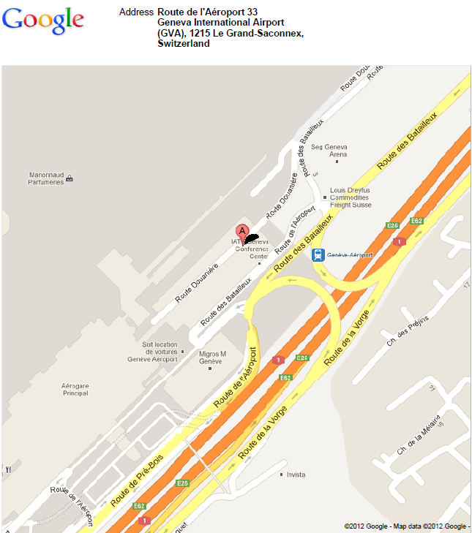
Bus stop Arena-Halle 7

