UN/SCETDG/53/INF.49
Committee of Experts on the Transport of Dangerous Goods
and on the Globally Harmonized System of Classification
and Labelling of Chemicals 18 June 2018
Sub-Committee of Experts on the
Transport of Dangerous Goods
Fifty-third session

Geneva, 25 June-4 July 2018
Item 6 (a) of the provisional agenda
Miscellaneous proposals for amendments to the Model Regulations on the Transport of Dangerous Goods: marking and labelling
Use of the term placard/rótulo/placardage (plaques-étiquettes)/information board (информационное табло) in the Model Regulations
Transmitted by the expert from the Russian Federation
Introduction
1. In accordance with the requirements of interstate standard GOST 19433-88 "Dangerous Goods. Classification and labelling"[1] Rules of transportation of dangerous goods (Annex 2 to SMGS) [2], each loading unit containing dangerous goods must be marked, which characterizes the type and severity of the cargo. The marking should contain:
"On the packaging and (or) transport package a label (sign of danger), the proper shipping name, the UN number;
On large packagings, wagon or container - a label, the UN number and the number of emergency cards during transportation by rail (if this number is set).
Labels shall be in the form of a square set at an angle of 45 ° (diamond). The size of the square should be for labels applied to:
- Packaging and (or) transport package - not less than 100 mm;
- Wagon or a container - not less than 250 mm."
2. Labelling must meet prescribed models and be affixed in such a way that they do not wear and remain clearly visible, for example by paint or other means.
3. From the text it is clear that in the Russian Federation and other CIS countries, only the term "label (danger sign – знак опасности)" is used both for labeling packages (minimum dimensions of 100 x 100 mm) and wagons, containers and large containers (minimum dimensions of 250 x 250 mm).
4. At the same time the UN Model Regulations (20th Edition) [3], the documents of the next level (ADR [4] ADN [5], RID [6]) in the labeling of wagons, containers and large packagings use an additional term denoting placard (minimum dimensions of 250 x 250 mm), painted on the wagon, container and large packagings. Moreover, the terms used in different language versions of the documents:
- Placard (poster, the poster) - the texts in English;
- Große zettel (big label) in the German language;
- Placardage (plaques-étiquettes) - poster-label - in French;
- Information board (information table – информационное табло) - the texts in Russian.
5. The analysis shows that the term "placard/große zettel/placardage (plaques-étiquettes)/Information board (информационное табло)" is used in the text:
- UN Model Regulations - 13 times (including the table of contents);
- Documents of the next level (ADR, ADN, RID) - more than 100 times (including the table of contents).
6. In our opinion, extremely unsuccessfully used the term "Information board (информационное табло)" in Russian, because in the Russian-speaking environment, the word "board" is used in areas far enough from the transport of dangerous goods, for example:
a) The board at the stadium:
b) The board in the waiting areas of bus terminals and train stations:
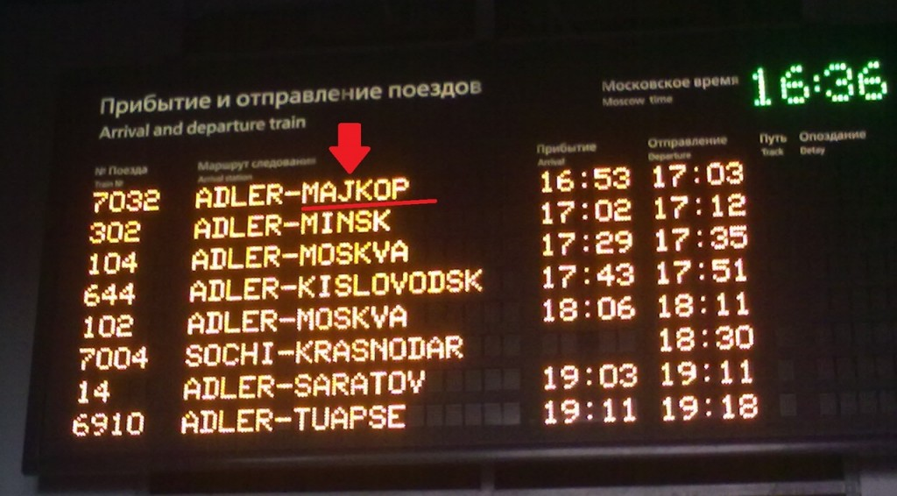
c) The board in the waiting areas of airports:
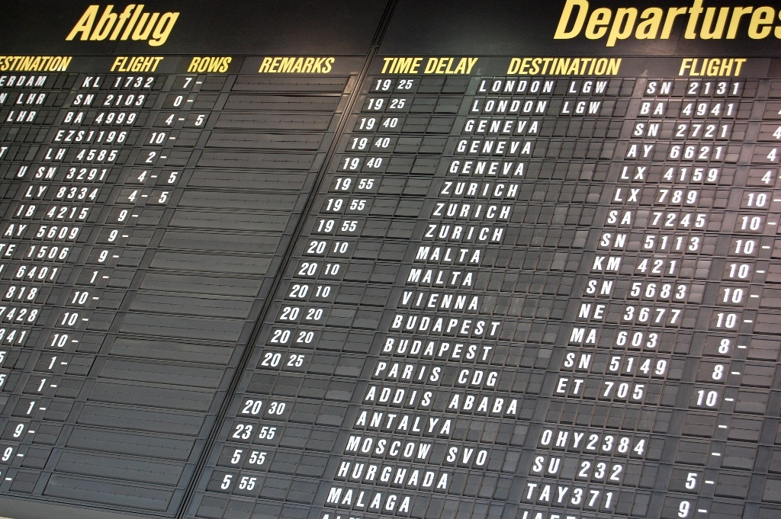
Proposal
7. Based on the above, we offer when updating the text of international regulations on the transport of dangerous goods in Russian in the future, the term "Information table (информационное табло)" to withdraw and use the term "Large label (Большой знак опасности)".
Justification
8. This amendment will result in the correct interpretation of the requirements for the labelling of wagons, containers and large packagings, by Russian-speaking individuals involved in the transport of dangerous goods.
Enforcement
9. No difficulties of enforcement are expected. After the adoption of this amendment, the text of the documents of the next level should be corrected.
List of sources used
1. GOST 19433-88 "Dangerous Goods. Classification and labeling."
2. Rules for the transport of dangerous goods (Annex 2 to SMGS) as of 01.07.2015.
3. Model Regulation UN Recommendations on the Transport of Dangerous Goods (20th edition).
4. ADR.
5. ADN.
6. RID.
7. Document ECE/TRANS/WP.15/AC.1/144

