|  |  |  |
| --- | --- | --- |
|  |  | **UN/SCETDG/53/INF.22** |

|  |  |
| --- | --- |
| **Committee of Experts on the Transport of Dangerous Goods  and on the Globally Harmonized System of Classification and Labelling of Chemicals 7 June 2018** | |
| **Sub-Committee of Experts on the  Transport of Dangerous Goods** |  |
| **Fifty-third session** |  |
| Geneva, 25 June-4 July 2018  Item 2 (b) of the provisional agenda  **Explosives and related matters: review of tests in parts I, II and III of the Manual of Tests  and Criteria** |  |

Recommendations for Test Series 8

Transmitted by the Institute of Makers of Explosives (IME)

Background

1. At the forty-seventh session it was concluded by the Working Group on Explosives (EWG) that the Koenen Test (UN Test 8(c)) was unsuitable for ammonium nitrate emulsions (ANEs). Previous studies conclusively showed that for ANEs, and specifically emulsions, the extended time required for a response in the Koenen Test has the effect of weakening the steel tube. This weakening of the steel and the corresponding tube failure gives a test result as a positive (fail) albeit a false positive.
2. At the fifty-first session it was proposed that IME lead work to investigate the possibility of modifying the 8(c) Koenen Test, and to determine suitability of the Minimum Burning Pressure (MBP) as an additional test within TS8.
3. Emulsion manufacturers are presently in a position where one of the classification tests has been deemed unsuitable for that form of ANEs.
4. Emulsions can be reformulated with higher volatility oils, which in turn will make them show a negative result (pass) with the Koenen Test. However, this will have a deleterious effect in the downstream process where the emulsion product will be pumped, since the lower volatility oils will produce emulsions with a lower MBP.
5. There will undoubtedly be changes in emulsion formulations that will need classification testing. Without a suitable test for emulsions, manufacturers will not be able to subject the new formulations to appropriate testing.

Discussion

1. ANEs have been manufactured and safely transported for over four decades. Incidents noted where there have been accidental explosions are also those in which there is adequate doubt as to whether the substance involved is a bona fide UN3375. The relatively “inert” behaviour of an ANE in a fire is largely attributed to its high water content. This high water content combined with use of a low volatility oil is what contributes to a longer testing time in the Koenen Test, typically over 100 seconds. In contrast, the substances used for experimental testing during the validation and development of the Koenen Test were of the order of one to 10 seconds. The longer heating time of the steel tube results in weakening the steel and produces a false positive.
2. The minimum burning pressure (MBP) is an intrinsic property of an energetic material. At pressures below the MBP the material cannot sustain a stable combustion irrespective of its size and the amount of energy used to ignite it. The MBP test provides insight of an ANE behaviour, and especially for emulsions, which have relatively high MBPs.
3. The studies shown in the Appendix further demonstrate that for ammonium nitrate emulsions[1] the Koenen test does not differentiate between those with high and low water contents. ANEs, typically with high MBPs from high water content and low volatility oils, will therefore have a different behaviour in a fire.

Proposal

1. To enable emulsion manufacturers to test their product the Sub-Committee should consider adopting the MBP test for emulsions within TS8 with an agreed threshold, and specifically as Test 8(c)(ii)[2]. The test would only be run if the substance fails the current 8(c) Koenen Test.
2. Substances that pass the Koenen Test, and Tests 8(a) and 8(b) will continue to be classified as an ANE.
3. A modified flowchart is given below.



Appendix 1.

The effect of water content of ANEs when evaluated by the Koenen and Minimum Burning Pressure Tests.

1. At the 47th session it was concluded by the Working Group on Explosives (EWG) that the Koenen Test was unsuitable for ANEs. Canada proposed the Minimum Burning Pressure (MBP) Test as an alternative to the Koenen Test. However, some members of the Working Group raised questions about the lack of any correlations between the results of the Koenen and MBP tests.
2. Previous work by Badeen et al (2014)[3] as investigated the effect of various formulation changes on MBP. As part of that study, the effect of variations in water content on the measured MBP of ammonium-nitrate and water-based emulsions (ANWE) formulations was reported. Figure 1 shows the published data. The study outcomes included a number of conclusions as follows.

(a) The MBP of all ANWEs increased linearly with water content for the water content range studied (11 – 25%). Furthermore, a linear regression line (also reproduced in Figure 1) clearly supported the view that water content is the major ingredient controlling the MBP of ANWEs.

(b) Substitution of AN in solution for solid AN in prill form in emulsions (green marker in Figure 1) did not have a significant effect on the MBP. To test this assumption, the study substituted 20% AN prill for 20% AN in the oxidizer solution. Therefore, it appears that although the total mass fraction of AN in the ANWE has an important effect on MBP, variations in the partitioning between AN in the source oxidiser versus AN prill has a negligible effect on MBP.

(c) Substitution of different fuel blends in the ANWEs (red versus blue markers in Figure 1) still led to very similar trends in MBP behaviour, despite these two series of emulsions having very different oil phases.

(d) Badeen et al (2014) concluded therefore that the MBP is essentially controlled by the water content. The type of oil phase used had a negligible influence on the MBP.

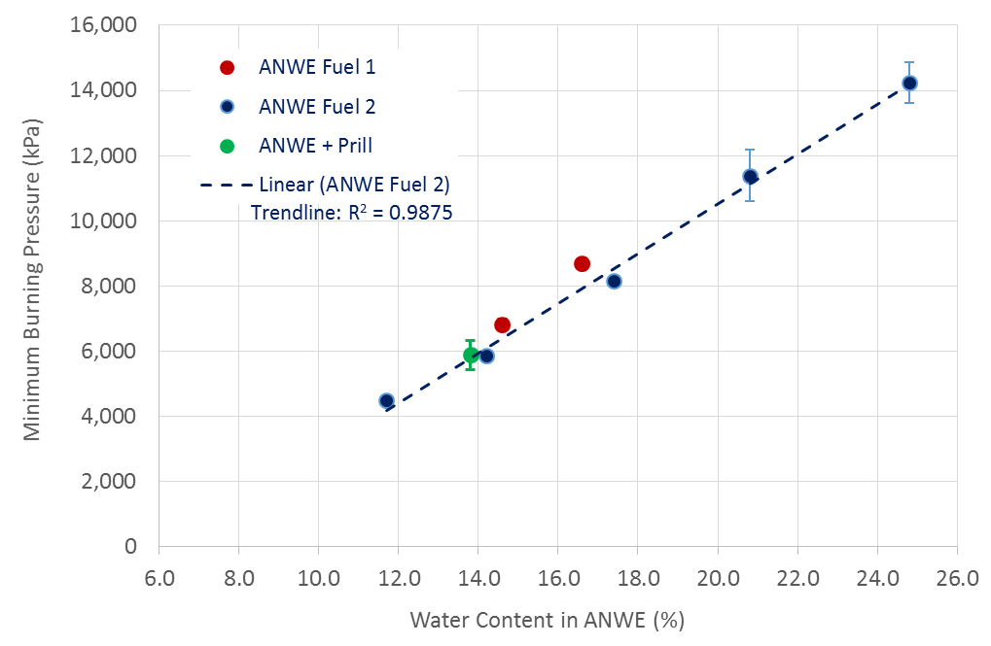

**Figure 1. Effect of Water Content in ANWE on Minimum Burning Pressure (after Badeen et al., 2014)**

1. In this work, a series of Koenen Tests were conducted on ANWE samples prepared to span the range of water content previously considered in the MBP testing by Badeen et al (2014). Water content was identified as a significant variable of effect, so this work investigated whether the Koenen test displays a similar discrimination in outcome as a function of water content.
2. The Koenen tests for the ANWE samples were all conducted in accordance with the procedures for UN Test Series 8 (c)[4]. Prior to each test, the heating rate in the Koenen apparatus was calibrated with dibutyl phthalate solution to confirm a heating rate of   
   3.3 K/s-1 between 50 and 250 °C. Each test was conducted in triplicate.
3. The details of the six ANWE samples prepared in this study for Koenen testing are described in Table 1 below.

**Table 1. Composition Details for Koenen Test Samples**



Note: The MBP listed in Table 1. for each ANWE sample was calculated from the least squares linear regression trend-line shown in Figure 1.

1. Samples ANWE1 to ANWE3 compositions as shown in Table 1 were manufactured using commercial-scale manufacturing equipment to span the range of final water contents from 23% to ~16%. However, as water content of the ANWE sample was progressively reduced in samples ANWE4 to 6, the effective operating temperature required for oxidiser preparation becomes impractical for atmospheric boiler systems. For example the temperature of crystallisation “fudge point” of the proposed oxidiser solutions for ANWE6 would exceed 100°C[5] even before superheat is added. It was shown that Badeen et al (2014) successfully substituted AN prill for AN oxidiser content. Similarly here, analytical grade anhydrous AN (Sigma Aldrich) was mixed in the proportions indicated in Table 1 to ANWE samples 4 to 6 to create the correct final water content. A similar fuel phase comprising a diesel fuel oil-PIBSA-based emulsifier combination was used for all ANWEs shown in Table 1. Note that the AN doping methodology described above for ANWEs 4 to 6 resulted in a reduced fuel phase ratio, however as described in Section 2. C. oil phase was found to have a negligible influence on MBP.
2. Figure 2 shows the results of Koenen testing for the samples described in Table 1. According to the criteria described by the UN Manual2, all Koenen test outcomes were a negative result.



**Figure 2. Comparison of Koenen and MBP Tests for ANWE products with varying Water Content. (MBP data after Badeen et al., 2014)**

1. At the completion of all Koenen tests for ANWEs 1 to 6, the testing tubes were inspected and it was confirmed that in all cases the samples had completely reacted and the tubes completely evacuated.
2. The results in Figure 2 clearly show that although the MBP test varies linearly with ANWE water content, there is no such discrimination with the Koenen test for ANWE water contents between the 8% and 23% w/w samples from this study.
3. The data above further support the finding of the Explosives Working Group that the Koenen Test is unsuitable for testing ANEs, specifically ANWEs.

1. The appendix refers to a report by Badeen et al (2014). In that report, ANEs are referred to as ANWEs (ammonium nitrate and water-based emulsions)
2. And renumbering the current 8(c) Koenen test as 8(c)(i)
3. Badeen, C., Goldthorp, S., Turcotte, R., Feng, H., Chan, S. K., Alilovic, I., (2014), Effect of Ingredients on the Minimum Burning Pressure of Ammonium Nitrate Emulsions, International Society of Explosives Engineers, 2014G (40th Annual Conference on Explosives and Blasting Techniques, Denver CO)
4. United Nations United Nations Committee of Experts Recommendations on the Transport of Dangerous Goods Manual of Tests and Criteria 5th Revised Edition
5. Shearon, W.H. and Dunwoody, W.B., (1953), Ammonium Nitrate, Ind. And Eng. Chem., 45 (3).