UN/SCETDG/53/INF.17

Committee of Experts on the Transport of Dangerous Goods
and on the Globally Harmonized System of Classification
and Labelling of Chemicals 1 June 2018
Sub-Committee of Experts on the Transport of Dangerous Goods
Fifty-third session

Geneva, 25 June-4 July 2018
Item 2 (j) of the provisional agenda
Explosives and related matters: miscellaneous
Transport of energetic samples for further testing
Transmitted by the European Chemical Industry Council (CEFIC)
Introduction
- Research and development groups in industry, public institutes, and universities frequently need to transport substances for the purpose of testing. These substances usually consist of organic molecules, which are active ingredients, building blocks or intermediates for pharmaceutical or agricultural chemicals.
- Although not designed to be explosives of Class 1, many of these substances carry functional groups listed in tables A6.1 and/or A6.3 in Annex 6 (Screening Procedures) of the Manual of Tests and Criteria, indicating potential explosive or self-reactive properties.
- Whereas the transport of samples of self-reactive substances and organic peroxides is permitted under the provisions of 2.4.2.3.2.4 (b) and 2.5.3.2.5.1, respectively, substances considered to meet the criteria for Class 1 are prohibited for transport by 2.0.4.2 (b).
- However, in the early stages of development, test data are usually not available to distinguish candidates for Class 1 and self-reactive substance of Division 4.1. Thus, there is a need to find a proper solution for the transport of energetic samples for the purpose of testing in small amounts, to define appropriate criteria for classification in cases of limited test data, and to specify the required packaging.
- CEFIC’s proposal ST/SG/AC.10/C.3/2016/61 was adopted in the last biennium. The new provisions in section 2.0.4.3 allow for the transport of small amounts of samples (up to 1 g or 1 ml) as self-reactive substances type C under certain restrictions in a very specific package.
- As a next step towards a comprehensive solution, CEFIC gave an informal presentation in the Explosives Working Group meeting during the summer 2017 session of the TDG Subcommittee, introducing their concept on how to proceed for samples in larger amounts. There was general support for the ideas brought forward, and CEFIC was encouraged to submit a flow chart for further discussions in the group.
- As a result of discussing informal paper INF.12 (52nd session), the Sub-Committee suggested that CEFIC prepare an overview of how self-reactive substances are classified and to explain how the proposal addresses sections 3.3(c) and 5.1(b) of Appendix 6 of the Test Manual.
- Accordingly, CEFIC submits this informal paper for further discussions. Both the Sub-Committee and the Explosives Working Group are invited to comment and are asked for guidance how to proceed further in this matter.
Discussion
Explosives, self-reactive substances and energetic substances
- An overview of the current classification criteria is shown in figure 1. For reasons of simplification, special cases such as pyrotechnics, articles and ANEs are summarized as “intentional explosives” and not discussed in this context since they are not relevant for the discussion in this paper.
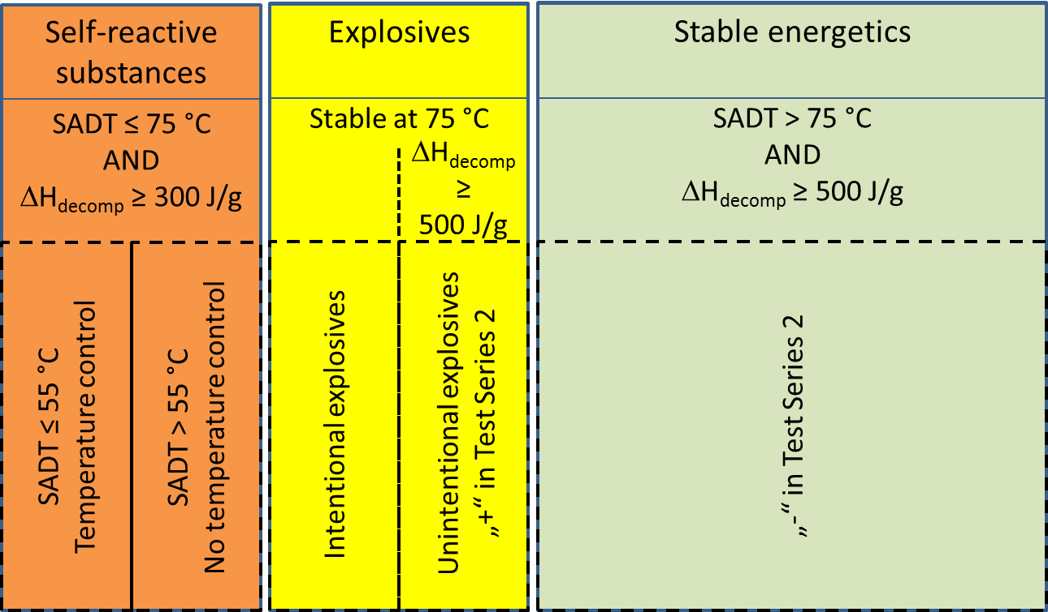
Figure 1 Classes of energetic substances
- As already mentioned in the introduction of this paper, the samples under consideration may contain substances carrying functional groups indicating potential explosive or self-reactive properties (tables A6.1 and A6.3 in Annex 6 of the Manual of Tests and Criteria).
- Self-reactive substances are defined in 2.4.2.3.1.1 of the Model Regulations as “thermally unstable substances liable to undergo a strongly exothermic decomposition even without participation of oxygen (air)”. Apart from differentiation criteria from other classes, substances should be classified as self-reactive if they have a decomposition energy of 300 J/g or more in combination with an SADT of 75 °C or less. The decomposition energy should be determined by differential scanning calorimetry (DSC) according to section 20.3.3.3 of the Test Manual.
- Section 5.1 (b) in Appendix 6 of the UN Test Manual states that classification as a self-reactive substances does not apply if either one of the two criteria described above is not fulfilled. Temperature control applies if the SADT is less than or equal to 55 °C (see 2.4.2.3.4) as shown in figure 1 above.
- According to 2.1.1.5 of The Model Regulations and 10.2.1 (b) of the UN Test Manual, any substance should be first considered for inclusion in Class 1.
- The so-called “acceptance procedure” is described in sections 2.1.3.2 and 2.1.3.3 of the Model Regulations, and a flow-chart is given in figure 10.2 of the UN Test Manual. For possible non-intentional explosives, test series 2 determines whether a substance is to be considered for Class 1 (Box 8 of the flow chart).
- Subsequently, thermal stability and mechanical sensitivity are determined (test series 3 and 4). If the substances is not thermally stable, class 1 is rejected (box 12). However, section 10.3.3.3 of the Test Manual suggests that for “a substance, not designed to have an explosive effect … it is more appropriate to start the testing procedure with test series 3”.
- If Class 1 is rejected due to insufficient thermal stability, a classification as a self-reactive substance will apply (see above).
- If a substance is thermally stable at 75 °C and passes Test Series 2, a classification as explosive (Class 1) and self-reactive (Division 4.1) is not applicable. Such substances would be assigned to the box denoted “stable energetics” in figure 1.
- Experience in industry has shown that the vast majority (> 95 %) of substances in the scope of this paper would be characterized as such stable energetics, a small percentage (2-5 %) as self-reactive and a negligible amount (far less than 1 %) explosive.
- Appendix 6, section 3.3 (c) of the UN Test Manual states that for organic substances containing chemical groups associated with explosive properties the Class 1 acceptance procedure does not have to be applied
- when the exothermic decomposition energy is less than 500 J/g, or
- when the onset of exothermic decomposition is 500 °C or above as indicated by Table A6.2.
- This text has been introduced in the Test Manual in the 43rd session of the TDG Subcommittee (June 2013) as a result of a proposal ST/SG/AC.10/C.3/2013/8 submitted by Sweden with the intention of clarification. However, in this context an important information in the original text was lost with respect to the temperature limit of 500 °C: “The temperature limit is to prevent the procedure being applied to a large number of organic materials which are not explosive but which will decompose slowly above 500 ºC to release more than 500 J/g.)”.
- That means the upper range for the evaluation of the decomposition energy should be 500 °C. Substances with a decomposition energy less than 500 J/g in a temperature range up to 500 °C should not be classified as explosive of Class 1.
Issues to be solved for the transport of energetic samples
- The classification depicted above as presented in figure 1 works on the presumption that all necessary data are available for a proper classification.
- Section 2.4.2.3.2.4 (b) permits the transport of self-reactive substances as type C provided that
- Available data indicate that the sample would not be more dangerous than type B;
- Packing method OP2 is applied with a upper limit of 10 kg per cargo transport unit; and
- Temperature control and dangerous phase separation are considered.
- How can this be applied in practice? As the text is written, it presumes that a classification as self-reactive is already established, i.e. decomposition energy ≥ 300 J/g and SADT ≤ 75 °C and subsequent measurements for temperature control have been determined by measurement. What has to be done in order to transport the sample to the test lab for SADT determination in the first step?
- On the other hand, for a substance that is thermally stable, about 2 kg of material are necessary to perform test series 2. Application of UN 0190 in such cases would be an intolerable burden both for industry and competent authorities and by no means appropriate, especially in cases where only amounts of 50 or 100 g are to be carried.
- Following numerous discussions with competent authorities, CEFIC has developed the concept of transporting energetic samples under the regime of self-reactive substances of division 4.1. Reasons are
- Provisions for the transport of self-reactive substances already exist (see above and 2.0.4.2 (c));
(ii) Self-reactive substances may have explosive properties (see 2.4.2.3.1.2), and appropriate packing instructions (P520) are prescribed;
(iii) Temperature control is applicable for substances of low thermal stability.
27. The Sub-Committee has supported this approach and adopted CEFIC’s proposal ST/SG/AC.10/C.3/2016/61 in the last biennium. The new provisions in section 2.0.4.3 allow for the transport of small amounts of samples (up to 1 g or 1 ml) as self-reactive substances type C under certain restrictions in a very specific package.
28 The adopted solution in section 2.4.0.3 for small samples (up to 1 g scale) is built on a safe design:
(i) The package is sufficiently strong to survive the detonation even of an intentional explosive (see proposal 2016/61), and
(ii) The inner design prevents a propagation of detonation from one sample to another.
29. For larger amounts of samples, this concept is obviously not applicable. Therefore, further proceedings have to be based on increased knowledge about safety-relevant properties of the sample.
Proposed way forward
30. In informal paper INF.12 (52nd session), CEFIC demonstrated that the energetic samples under consideration are clearly separated from intentional explosives in terms of their energy content (i.e. decomposition energy). This value can be easily determined by DSC methods (see Test of Manual and Criteria, section 20.3.3.3) and may be used as the basis for a preliminary assessment of the samples.
31. In the informal paper mentioned above, CEFIC derived and justified a concept to allow the transport of energetic samples as self-reactive substances Type C under the provisions of 2.4.2.3.2.4 (b) (see section 23 above) depending on their energy content as follows:
< 1500 J/g: No further testing required
≥ 1500 … < 2500 J/g: Tests for mechanical sensitivity (UN 3 (a) + 3 (b), outcome both “-“)
≥ 2500 J/g: Additional testing required; suggested: 1 Koenen test (UN E.1, not violent) AND 1 Trauzl test (UN F.3, outcome “no” or “low”).
32. Further details are not repeated here since the approach itself was not questioned during discussions in the Explosives Working Group.
33. Based on these considerations, a tentative flowchart incorporating already existing provisions has been drafted (see figure 2).
34. Boxes 1 through 9, 11 and 12 refer to already existing provisions in the Model Regulations
35. Box 4 refers to section 5.1 (b) of Appendix 6 of the UN Test Manual. Since the approach applies the self-reactives regime for all energetic compounds, the SADT criterion is not relevant in this context. Below a decomposition energy of 300 J/g, a classification as a self-reactive substance or as explosive can be ruled (see also figure 1 above).
36. Box 4 is not meant to have a mandatory measured value for the substance under concern. A possible valid way to escape to box 5 would be also experience with data from similar compounds, an extrapolation from data of a small molecule to a larger unit etc.
37. Boxes 6 through 9 refer to the provisions in section 2.4.0.3.
38. Box 10 would be new text requiring the determination of the decomposition behavior (energy and onset) of the sample for amounts exceeding 1 g or 1 ml per sample.
39. Box 11 identifies low energy samples that
(a) are not candidates for self-reactive substances due to their thermal stability, and
(b) do not require the Class 1 acceptance procedure based on the criteria outlined in table 6.2 of Annex 6 of the UN Manual of Tests and Criteria.
40. If the decomposition onset is ≥ 180 °C, a temperature of 80 °C is considered safe according to the “100 K rule” applied in worldwide chemical safety assessment as a practical rule of thumb. Therefore, the SADT is expected to be > 75 °C, and consequently, a classification as self-reactive according to 2.4.2.3.1.1 (e) can be ruled out (orange box in figure 1).
41. For explosives, a lower energy limit of 500 J/g applies according to section 3.3 (c) in appendix 6 of the UN Test Manual (yellow box in figure 1). With respect to the decomposition onset, see the discussion in section 19 to 21 in this paper.
42. Boxes 14 to 21 establish the criteria suggested in section 31 above.
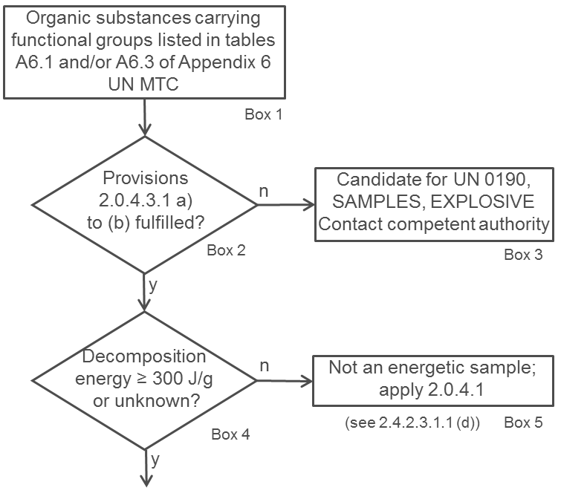
Figure 2: Tentative flowchart for energetic samples

Thermal stability
43. The remaining issues to be solved are thermal stability and, in this context, any possible temperature control requirements (see box 13 of the flowchart).
44. According to 2.4.2.3.4, temperature control is not required if the substance is thermally stable, i.e. SADT ≥ 60 °C.
45. Since SADT tests H.1 to H.4 are not designed for small sample amounts, a thermal stress test is suggested as alternative approach. One such test is described below, which can be easily performed by DSC measurements.
46. The concept is to determine whether the decomposition behavior changes after the application of thermal stress for a defined period of time. For practical reasons, 24 hours are suggested.
47. A screening DSC (heating rate 2-5 K/min in a closed crucible; see UN Manual of Tests and Criteria, section 20.3.3.3) is measured for the sample as offered for transport. A second sample is taken, and thermal stress is applied (practically realized by tempering the sample in a DSC crucible at a defined constant temperature over a certain period of time; see above).
48. If the decomposition behavior remains unchanged in terms of decomposition onset, shape of curve, and energy within a measurement uncertainty of 10%, then the sample is stable at the applied stress temperature. If the stress test is passed at 60 °C, no temperature control is required. For a conservative approach, the decomposition onset should be taken as the temperature of the first noticeable exothermic effect (i.e. the heat production signal leaves the baseline).
49. In case the stress test at 60 °C is not passed, the same procedure should be applied at decreasing temperatures in steps of 10 K until the decomposition behavior remains unchanged. That temperature should be deemed the estimated SADT of the sample, and the control and emergency temperatures may then be derived in accordance with section 28.2.3 and table 28.2 of the UN Manual of Tests and Criteria.
50. An example of a sample passing the thermal stress test as described above is given in figure 3. It is obvious that the shape, the location of the curve, as well as the energy values remain unchanged within the tolerance of measurement. Also, the endothermic melting peak has not changed.
Figure 3: Example of a sample passing the thermal stress test
51. An example of a negative outcome of the thermal stress test is given in figure 4: Upon thermal stress, the shape of the curve has changed dramatically. The first peak at about 100 °C has completely disappeared, and the decomposition energy has decreased by about 20%. These findings are clear evidence that a reaction has taken place under the conditions of thermal stress applied, and thus temperature control would be necessary.
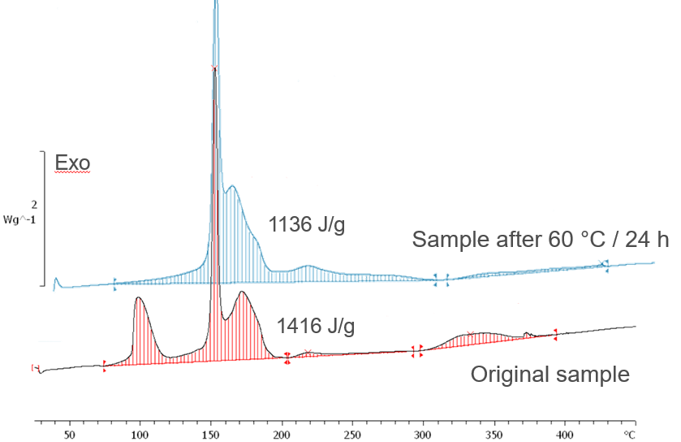
Figure 4: Example of a sample failing the thermal stress test
52. According to the so-called “100 K rule”, sufficient thermal stability may be assumed if the decomposition onset in the screening DSC is 160 °C or above, thus not requiring temperature control.
53. A flowchart for the procedure described above is shown in figure 5.

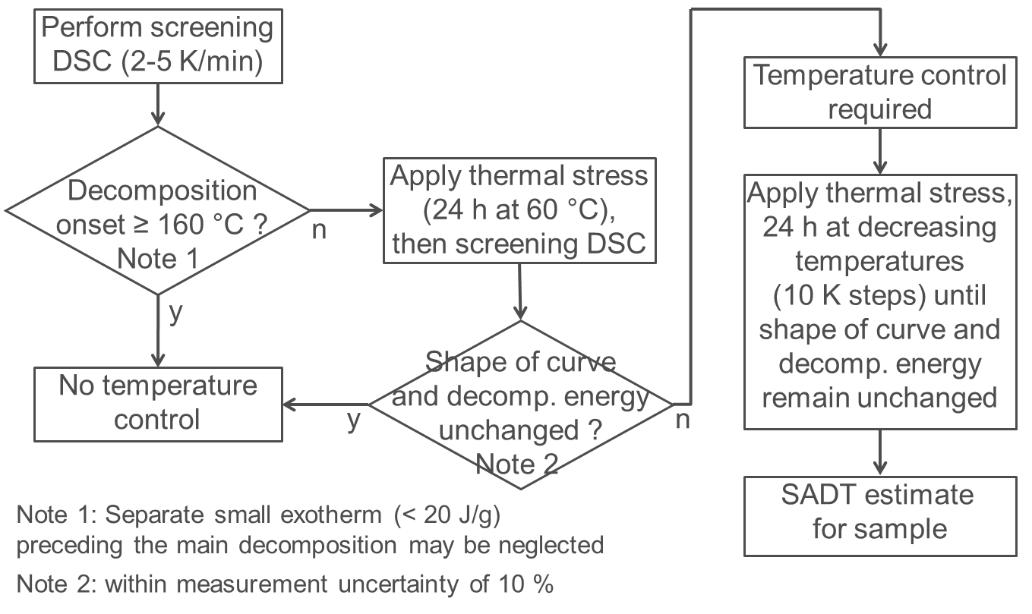

Figure 5: Flowchart for temperature control of energetic samples

Proposal
54. Based on the discussions above, CEFIC proposes to:
(a) Further develop the provisions in section 2.0.4.3 for energetic samples and to incorporate a flowchart based on figure 2, and
(b) To incorporate provisions about temperature control and estimation of SADT for energetic samples in the UN Manual of Tests and Criteria. An appropriate place appears to be in the context of section 20.3.3.3. Incorporation of a flowchart as presented in figure 5 is deemed helpful.

