|  |  |  |  |
| --- | --- | --- | --- |
|  | United Nations | ST/SG/AC.10/C.3/2018/37 | |
| _unlogo | **Secretariat** | | Distr.: General  3 April 2018  Original: English |

**Committee of Experts on the Transport of Dangerous Goods  
and on the Globally Harmonized System of Classification  
and Labelling of Chemicals**

**Sub-Committee of Experts on the Transport of Dangerous Goods**

**Fifty-third session**

Geneva, 25 June-4 July 2018

Item 4 (c) of the provisional agenda  
**Electric storage systems:   
transport provisions**

Harmonization of the proper shipping names of UN Nos. 3481 and 3091

Transmitted by the European Association for Advanced Rechargeable Batteries (RECHARGE) and the Rechargeable Battery Association (PRBA)[[1]](#footnote-2)\*

Introduction

1. Following the introduction of document ST/SG/AC.10/C.3/2017/39 at the fifty-second session, some remarks were made, aiming at clarification of the practical implementation of the proposal in the Model Regulations.
2. For clarification, the purpose of the proposal is reminded here: In the power tool industry, packages often contain a combination of lithium batteries contained in equipment together with additional spare lithium batteries packed with the equipment. The photo shows an example:

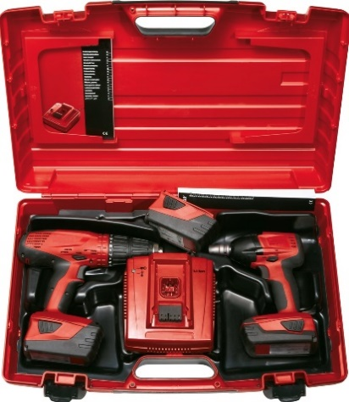

1. According to the Model Regulations, the classification in this example requires the following, with both proper shipping names:

UN 3481 Lithium ion batteries packed with equipment,

UN 3481 Lithium ion batteries contained in equipment, 9, or

UN 3091 Lithium metal batteries packed with equipment,

UN 3091 Lithium metal batteries contained in equipment, 9, respectively.

1. According to ICAO Technical Instructions, however, the dangerous goods classification in this example simplifies to:

UN 3481 Lithium ion batteries packed with equipment, 9 or

UN 3091 Lithium metal batteries packed with equipment, 9, respectively.

1. This is because special provision A181[[2]](#footnote-3)1 clarifies, that a package containing a combination of lithium batteries contained in equipment with lithium batteries packed with equipment is to be marked only as “lithium (metal or ion) batteries packed with equipment”.
2. The marking requirements according to the regulations under 3 and 4 above are not harmonized. This makes the marking unpractical when such products are transported in a combination of sea, road and air transport. It would be meaningful to harmonise the marking, based on the air transport special provision A181 clarification.
3. During the fifty-second session, comments indicated that the marking and documenting simplification should be referred to in packing instruction P903.
4. The proposal to introduce the marking simplification in a new sub-paragraph in special provision 230, was not supported by some member states, and recommendation was made to place it in a special provision about marking and documentation.
5. Based on these comments, the proposal has been modified. The Sub-Committee is invited to consider whether the proposal 1 is sufficient by itself, or if it should be complemented by the proposal 2.

Proposals

Proposal 1

10. It is proposed to add a new subparagraph in the packing instruction P903 as follows:

“(5) For packaging containing both cells or batteries packed with equipment and contained in equipment, the packaging instruction in paragraph (3) and (4) are respectively applicable. In addition, such package will be marked and documented as a package of cells or batteries packed with equipment.”

Proposal 2

11. Insert a new special provision “XXX” in Chapter 3.3 as follows:

“XXX When a package contains a combination of lithium batteries contained in equipment and lithium batteries packed with equipment, the following requirements apply:

(a) the package must be marked UN 3091 Lithium metal batteries packed with equipment, or UN 3481 Lithium ion batteries packed with equipment, as appropriate. If a package contains both lithium ion batteries and lithium metal batteries packed with and contained in equipment, the package must be marked as required for both battery types. However, button cell batteries installed in equipment (including circuit boards) need not be considered.

(b) the transport document must indicate UN 3091 Lithium metal batteries packed with equipment or UN 3481 Lithium ion batteries packed with equipment, as appropriate. If a package contains both lithium metal batteries and lithium ion batteries packed with and contained in equipment, then the transport document must indicate both UN 3091 Lithium metal batteries packed with equipment and UN 3481 Lithium ion batteries packed with equipment.”.

1. \* In accordance with the programme of work of the Sub-Committee for 2017–2018 approved by the Committee at its eighth session (see ST/SG/AC.10/C.3/100, paragraph 98 and ST/SG/AC.10/44, para. 14). [↑](#footnote-ref-2)
2. 1 **ICAO Special Provision A 181**

   When a package contains a combination of lithium batteries contained in equipment and lithium batteries packed with equipment, the following requirements apply:

   (a) the shipper must ensure that all applicable parts of both packing instructions are met. The total weight of lithium batteries contained in any package must not exceed the limits for passenger aircraft or cargo aircraft, as applicable;

   (b) the package must be marked UN 3091 Lithium metal batteries packed with equipment, or UN 3481 Lithium ion batteries packed with equipment as appropriate. If a package contains both lithium ion batteries and lithium metal batteries packed with and contained in equipment, the package must be marked as required for both battery types. However, button cell batteries installed in equipment (including circuit boards) need not be considered.

   (c) the Shipper’s Declaration must indicate UN 3091 Lithium metal batteries packed with equipment or UN 3481 Lithium ion batteries packed with equipment, as appropriate. If a package contains both lithium metal batteries and lithium ion batteries packed with and contained in equipment, then the dangerous goods transport document must indicate both UN 3091 Lithium metal batteries packed with equipment and UN 3481 Lithium ion batteries packed with equipment. [↑](#footnote-ref-3)