Collective amendments to Regulations Nos. 16, 44, 94, 129 and 137
Submitted by the expert from the European Commission*
The text reproduced below was prepared by the expert from the European Commission to harmonize information in the airbag warning label on the correct installation of Child Restraint Systems (CRS) on a passenger seat with activated frontal airbag. The modifications to the current text of the UN Regulations are marked in bold for new or strikethrough for deleted characters.
I. Proposal for Supplement X to the 06 series of Amendments and Supplement X to the 07 series of Amendments to Regulation No. 16 (Safety belts)
Paragraph 8.1.8., amend to read:
"8.1.8. Every passenger seating position which is fitted with a frontal protection airbag shall be provided with a warning against the use of a rearward-facing child restraint in that seating position. As a minimum, This information shall consist of a label containing clear warning pictograms as indicated below:
Figure 1
Warning label
…
The overall dimensions of the label shall be at least 120 x 60 mm or the equivalent area.
The label shown above may be adapted in such a way that the layout differs from the example shown here above; however, the content shall meet the precise above prescriptions. Furthermore, no other type of information shall be included on the label unless it is placed outside a clearly marked rectangle with at least the overall dimensions as required above. In derogation to the aforementioned, a part number, bar code or similar identification mark not exceeding 5 mm x 20 mm or the equivalent area may be placed on the label alongside one of its edges.
It shall also be ensured that no deviations in the shape and orientation of the provided pictograms are permitted, notably that any customised appearance of the prescribed pictogram images shall be prohibited, with the exception of the hand with pointing index finger and the open face booklet with letter 'i' on its right page provided that they are clearly recognisable as such.
Small irregularities concerning line thickness, label imprinting and other relevant production tolerances shall be accepted.
Figure 2
Pictogram according to ISO 2575:2004 - Z.01 that shall be used and that shall have an outer diameter of at least 38 mm
Figure 3
Pictogram depicting airbag deployment danger that shall be used and that shall measure 40 mm x 28 mm or proportionally larger
"
Paragraph 8.1.10., amend to read:
"8.1.10. Detailed information, making reference to the warning, shall be contained in the owner's manual of the vehicle; as a minimum, the following text in all official languages of the country or countries where the vehicle could reasonably be expected to be registered (e.g. i.e. within the territory of the European Union – all 24 official languages, in Japan – Japanese, in Russian Federation – Russian, in Egypt – Modern Standard Arabic or in New Zealand – English, etc.), shall at least include:
…"
II. Proposal for Supplement X to the 04 series of Amendments to Regulation No. 44 (Child restraint systems)
Paragraph 4.4., amend to read:
"4.4. On the visible inner surface (including the inside surface of any side wing beside the child's head) in the approximate area where the child's head rests within the child restraint system, rearward facing restraints shall have the following shown label permanently attached (the information shown is a minimum).
Label minimum size: 60 x 120 mm.
The overall dimensions of the label shall be at least 120 x 60 mm or the equivalent area.
The label may be adapted in such a way that the layout differs from the example shown here; however, the content shall meet the precise prescriptions. Furthermore, no other type of information shall be included on the label unless it is placed outside a clearly marked rectangle with at least the overall dimensions as required above. In derogation to the aforementioned, a part number, bar code or similar identification mark not exceeding 5 mm x 20 mm or the equivalent area may be placed on the label alongside one of its edges.
It shall also be ensured that no deviations in the shape and orientation of the provided pictograms are permitted, notably that any customised appearance of the prescribed pictogram images shall be prohibited, with the exception of the hand with pointing index finger and the open face booklet with letter 'i' on its right page provided that they are clearly recognisable as such.
Small irregularities concerning line thickness, label imprinting and other relevant production tolerances shall be accepted.
The label shall … any configuration.
Figure A
Warning label
…
Figure B
Pictogram according to ISO 2575:2004 - Z.01 that shall be used and that shall have an outer diameter of at least 38 mm
Figure C
Pictogram depicting airbag deployment danger that shall be used and that shall measure 40 mm x 28 mm or proportionally larger
"
III. Proposal for Supplement X to the 01 series of Amendments, Supplement X to the 02 series of Amendments and Supplement X to the 03 series of Amendments to Regulation No. 94 (Frontal collision protection)
Paragraph 6.2.1., amend to read:
"6.2.1. As a minimum, This information shall consist of a label containing clear warning pictograms as indicated below:
Figure 4
Warning label
…
The overall dimensions of the label shall be at least 120 x 60 mm or the equivalent area.
The label shown above may be adapted in such a way that the layout differs from the example shown here above; however, the content shall meet the precise above prescriptions. Furthermore, no other type of information shall be included on the label unless it is placed outside a clearly marked rectangle with at least the overall dimensions as required above. In derogation to the aforementioned, a part number, bar code or similar identification mark not exceeding 5 mm x 20 mm or the equivalent area may be placed on the label alongside one of its edges.
It shall also be ensured that no deviations in the shape and orientation of the provided pictograms are permitted, notably that any customised appearance of the prescribed pictogram images shall be prohibited, with the exception of the hand with pointing index finger and the open face booklet with letter 'i' on its right page provided that they are clearly recognisable as such.
Small irregularities concerning line thickness, label imprinting and other relevant production tolerances shall be accepted.
Figure 5
Pictogram according to ISO 2575:2004 - Z.01 that shall be used and that shall have an outer diameter of at least 38 mm
Figure 6
Pictogram depicting airbag deployment danger that shall be used and that shall measure 40 mm x 28 mm or proportionally larger
"
Paragraph 6.2.3., amend to read:
"6.2.3. Detailed information, making reference to the warning, shall be contained in the owner's manual of the vehicle; as a minimum, the following text in all official languages of the country or countries where the vehicle could reasonably be expected to be registered (e.g. i.e. within the territory of the European Union – all 24 official languages, in Japan – Japanese, in Russian Federation – Russian, in Egypt – Modern Standard Arabic or in New Zealand – English, etc.), shall at least include:
…"
IV. Proposal for Supplement X to the original series of Amendments and Supplement X to the 01 series of Amendments of Regulation No. 129 (Enhanced child restraint systems)
Paragraph 4.4., amend to read:
"4.4. On the visible inner surface (including the inside surface of any side wing beside the child's head) in the approximate area where the child's head rests within the child restraint system, rearward facing restraints shall have the following shown label permanently attached (the information shown is a minimum).
Label minimum size: 60 x 120 mm.
The overall dimensions of the label shall be at least 120 x 60 mm or the equivalent area.
The label may be adapted in such a way that the layout differs from the example shown here; however, the content shall meet the precise prescriptions. Furthermore, no other type of information shall be included on the label unless it is placed outside a clearly marked rectangle with at least the overall dimensions as required above. In derogation to the aforementioned, a part number, bar code or similar identification mark not exceeding 5 mm x 20 mm or the equivalent area may be placed on the label alongside one of its edges.
It shall also be ensured that no deviations in the shape and orientation of the provided pictograms are permitted, notably that any customised appearance of the prescribed pictogram images shall be prohibited, with the exception of the hand with pointing index finger and the open face booklet with letter 'i' on its right page provided that they are clearly recognisable as such.
Small irregularities concerning line thickness, label imprinting and other relevant production tolerances shall be accepted.
The label shall … any configuration.
Figure A
Warning label
…
Figure B
Pictogram according to ISO 2575:2004 - Z.01 that shall be used and that shall have an outer diameter of at least 38 mm
Figure C
Pictogram depicting airbag deployment danger that shall be used and that shall measure 40 mm x 28 mm or proportionally larger
"

V. Proposal for Supplement X to the original series of Amendments and Supplement X to the 01 series of Amendments to Regulation No. 137 (Frontal collision with focus on the restraint system)
Paragraph 6.2.1., amend to read:
"6.2.1. As a minimum, This information shall consist of a label containing clear warning pictograms as indicated below:
Figure 4
Warning label
…
The overall dimensions of the label shall be at least 120 x 60 mm or the equivalent area.
The label shown above may be adapted in such a way that the layout differs from the example shown here above; however, the content shall meet the precise above prescriptions. Furthermore, no other type of information shall be included on the label unless it is placed outside a clearly marked rectangle with at least the overall dimensions as required above. In derogation to the aforementioned, a part number, bar code or similar identification mark not exceeding 5 mm x 20 mm or the equivalent area may be placed on the label alongside one of its edges.
It shall also be ensured that no deviations in the shape and orientation of the provided pictograms are permitted, notably that any customised appearance of the prescribed pictogram images shall be prohibited, with the exception of the hand with pointing index finger and the open face booklet with letter 'i' on its right page provided that they are clearly recognisable as such.
Small irregularities concerning line thickness, label imprinting and other relevant production tolerances shall be accepted.
Figure 5
Pictogram according to ISO 2575:2004 - Z.01 that shall be used and that shall have an outer diameter of at least 38 mm
Figure 6
Pictogram depicting airbag deployment danger that shall be used and that shall measure 40 mm x 28 mm or proportionally larger
"
Paragraph 6.2.3., amend to read:
"6.2.3. Detailed information, making reference to the warning, shall be contained in the owner's manual of the vehicle; as a minimum, the following text in all official languages of the country or countries where the vehicle could reasonably be expected to be registered (e.g. i.e. within the territory of the European Union – all 24 official languages, in Japan – Japanese, in Russian Federation – Russian, in Egypt – Modern Standard Arabic or in New Zealand – English, etc.), shall at least include:
…"
VI. Justification
1. It has become evident that some vehicle manufacturers are adding random information to the airbag warning label to the detriment of child safety. This dilutes the compulsory information aimed to protect children transported in cars.
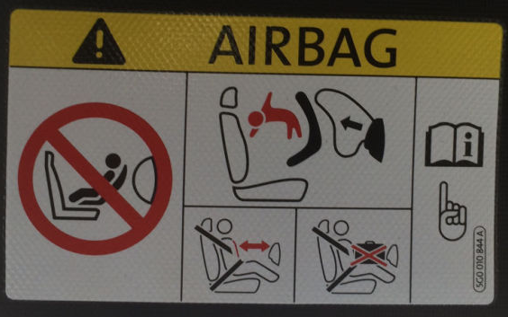
This intrusive information is not related to child safety and thus reduces the clarity, putting children at risk

2. The text on the warning not to use a rearward facing child restraint on a seat protected by an active airbag shall be included in the owner’s manual. Moreover, this warning shall be provided in all official languages of the country or countries where the vehicle could reasonably be expected to be registered. However, certain vehicle types are sold in the European Union market with the important warning only in one official language of the country where the vehicle is initially shipped by the manufacturer. Since, child safety should be one of the top priorities for all vehicle manufacturers the relevant requirements are more explicitly clarified.
3. Moreover, it seems that there are diverging interpretations on the wording: ‘pictogram images shall be grouped, exact or larger’. Notably, that pictogram images do not appear exactly as prescribed by the relevant regulations. It seems that altered versions are being authorised despite the clear rules, as shown in these examples.

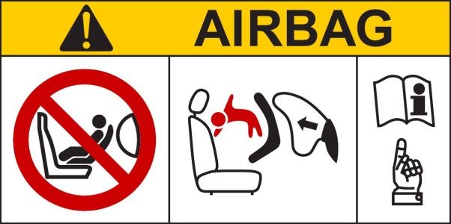
Label as prescribed in the regulations

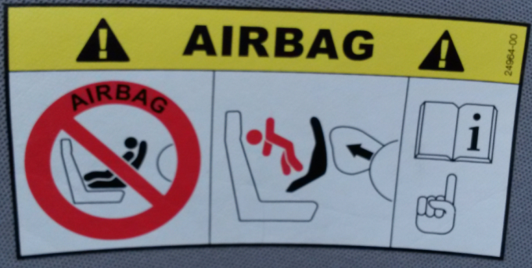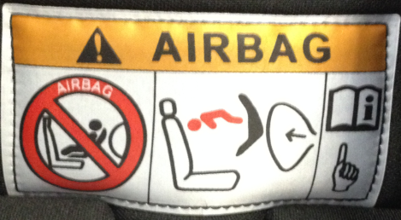
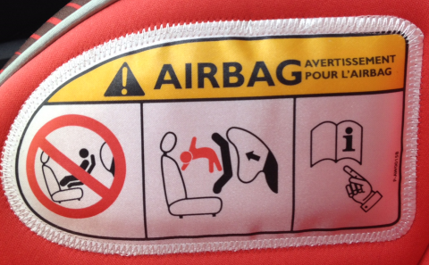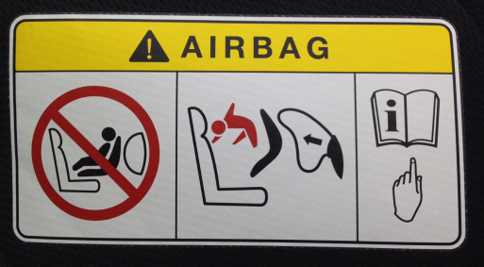
Labels as found in the field with altered pictogram images

4. Only in very rare cases the warning label is in conformity
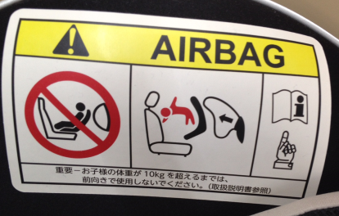
Label as found in the field with exact pictogram images and additional information outside the prescribed area
5. To provide the same harmonized basis for all the actors involved in the development, production and approval process of the warning labels, clarifications on what is and what is not permitted are deemed necessary.
6. Particularly, to ensure that there is no degradation of the level of safety for children transported in cars, any label that is not in compliance should be brought in line with the key aim of the legislative text on airbag warning labels.

* In accordance with the programme of work of the Inland Transport Committee for 2012–2016 (ECE/TRANS/224, para. 94 and ECE/TRANS/2012/12, programme activity 02.4), the World Forum will develop, harmonize and update Regulations in order to enhance the performance of vehicles. The present document is submitted in conformity with that mandate.

