|  |  |  |  |
| --- | --- | --- | --- |
|  | United Nations | ECE/TRANS/WP.29/GRSP/2017/38 | |
| _unlogo | **Economic and Social Council** | | Distr.: General  22 September 2017  Original: English |

**Economic Commission for Europe**

Inland Transport Committee

**World Forum for Harmonization of Vehicle Regulations**

**Working Party on Passive Safety**

**Sixty-second session**

Geneva, 12-15 December 2017

Item 12 of the provisional agenda

**UN Regulation No. 44 (Child restraint systems)**

Proposal for Supplement 14 to the 04 series of amendments to UN Regulation No. 44 (Child restraint systems)

Submitted by the expert from France on behalf of the Technical Service Group (TSG) [[1]](#footnote-2)\*

The text reproduced below was prepared by the expert from France on behalf of the Technical Services Group (TSG) on UN Regulation No. 44 to clarify the test protocol for positioning and securing the child restraint system on the vehicle. The modifications to the current text of UN Regulation are marked in bold for new characters.

I. Proposal

*Paragraph 6.1.8*., amend to read:

"6.1.8. Integral child restraint systems of the "universal" category, except ISOFIX universal child restraint systems, shall have a main load-bearing contact point, between the child restraint and the webbing **of** the adult safety-belt. This point shall not be less than **a** **radius of** 150mmfrom the Cr axis when measured with the child restraint **as indicated in figures below,** on the dynamic test bench installed in accordance with Annex 21 to this Regulation without a dummy.

Non-integral child restraint systems of the "universal" category, shall have a main load-bearing contact point, between the child restraint and the webbing of the adult safety-belt. This point shall not be less than 65 mm vertically above the test bench cushion and not be less than **a** **radius of** 150mm from the Cr axis when measured with the child restraint **as indicated in figures below,** on the dynamic test bench installed in accordance with Annex 21 to this Regulation without a dummy.

**Figures for the explanation of the measurement procedure**

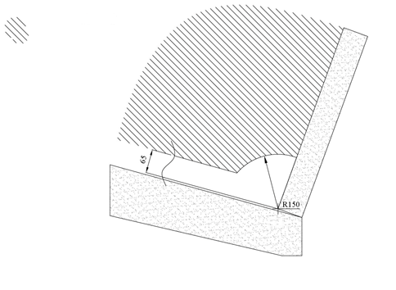

Main load-bearing contact point location area

Cr Point

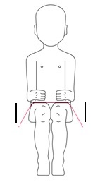 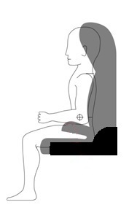

**The check shall be done at both sides of the CRS and along a longitudinal plane parallel to the median plane of the CRS.**

Additional alternative belt routes are allowed. Where an alternative belt route exists, the manufacturer shall make specific reference to the alternative route in the user instructions, as required in paragraph 15. When tested, using such alternative belt route(s), the restraint shall comply with all the requirements of **this** the Regulation."

*Paragraph 6.2.2*., amend to read:

"6.2.2. All restraint devices utilizing a "lap strap" shall positively guide the "lap strap" **equilateral** on both sides to ensure that the **load** transmitted by the "lap strap" are transmitted through the pelvis. The assembly shall not subject weak parts of the child's body (abdomen, crotch, etc.) to excessive stresses. "

In the case of booster cushions and booster seats , the lap portion of the adult seat belt shall be positively guided **equilateral** on both sides to ensure that the loads are transmitted by the adult lap belt are transmitted through the pelvis. The positive guidance of loads over the pelvis shall be realised from the moment that the child is installed; the lap belt shall pass over the top of the thigh, just touching the fold with the pelvis. The angles α and β between the tangent line in which the belt touches the thighs and the horizontal shall be greater than 10°."

# Figures of Strapped child

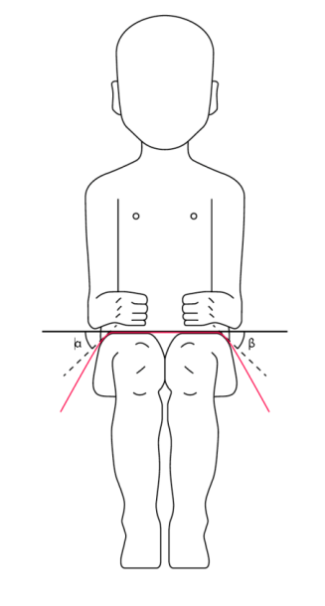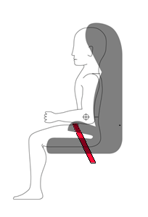

*Paragraph 7.2.1.1*., amend to read:

"7.2.1.1. The buckle shall be so designed as to preclude any possibility of incorrect manipulation. This means, inter/alia, that it shall not be possible for the buckle to be left in a partially closed position; it shall not be possible to exchange the buckle parts inadvertently when the buckle is being locked; the buckle shall only lock when all parts are engaged. Wherever the buckle and **/or the tongue are** in contact with the child, it shall not be narrower than the minimum width of strap as specified in paragraph 7.2.4.1.1. below. This paragraph is not applicable to belt assemblies already approved according to Regulation No. 16 or any equivalent standard in force. In the case of a "Special Needs Restraint" only the buckle on the primary means of restraint need comply with the requirements of this paragraph 7.2.1.1. to paragraph 7.2.1.9. inclusive."

II. Justification

This proposal is a follow-up to informal document GRSP-61-14-Rev.1 that was adopted at the sixty-first session of GRSP. The proposal clarifies the test procedure of paragraph 6.1.8.

1. \* In accordance with the programme of work of the Inland Transport Committee for 2016–2017 (ECE/TRANS/254, para. 159 and ECE/TRANS/2016/28/Add.1, cluster 3.1), the World Forum will develop, harmonize and update Regulations in order to enhance the performance of vehicles. The present document is submitted in conformity with that mandate. [↑](#footnote-ref-2)