GTB GUIDELINE

FOR INTRODUCTION AND EVALUATION OF LED LIGHT SOURCE CATEGORIES INTENDED FOR FORWARD LIGHTING APPLICATIONS

# **1. INTRODUCTION**

Categories of replaceable LED light sources according to Regulation No. 128 are grouped in accordance with their suitability for use in lighting and/or signalling devices (see ECE/TRANS/WP.29/2016/111). While developing the first proposal of a category for group 1 (*“LED light source categories without general restrictions”*) GTB experts have identified parameters, which are specifically relevant for forward lighting applications, and which therefore need to be defined for the corresponding LED light source categories. The specified values of these parameters determine whether a LED light source category can serve all applications or not. This procedure is comparable to what is described for filament light sources in the reference document GRE-66-01.

# **2. PHOTOMETRICAL CRITERIA FOR USE IN FORWARD LIGHTING**

Headlamps with reflector optics create images of the light-emitting-area of the light source, e.g. the “filament” of a Regulation No. 37 light source, or the “arrangement of LEDs” of a Regulation No. 128 light source. This means that the photometrical properties of the replaceable light source determine the maximum achievable beam quality.

The relevant parameters that determine the photometrical properties of the light source for use in forward lighting are defined in Regulation No. 128:

1. The contrast of the LED light source determines the minimum achievable glare compared to the maximum amount of light on the road in the far field (i.e. close to cut-off).
2. The uniformity parameter R0.7 for the LED light source determines the maximum achievable beam-gradient, i.e. the quality of the “cut-off”.
3. The uniformity parameter R0.1 for the LED light source is linked to potential inhomogeneity of the beam; i.e. the lower the value R0.1, the more variations can appear.
4. The size of the light-emitting-area of the LED light source (relative to the size of the nominal-emitter-box defined in the category sheet) is linked to the position accuracy of individual LEDs and impacts the range for re-aiming of the headlamp.

# **3. PHOTOMETRICAL LIMITS FOR USE IN PASSING BEAM**

3.1. Minimum contrast

The strictest beam requirement in terms of low glare combined with high road illumination in the far field is given for a class B passing beam in Regulation No. 112. According to Regulation No. 112, paragraph 6.2.4, the minimum required intensity in test point “75 R” is 10100 cd and the maximum required intensity in test point “HV”, respectively in zone III, is 625 cd.

High-performing headlamps typically have a design value of 30000 cd in “75 R”. Low-glare headlamps typically have a design value of 300 cd in zone III. Using these typical performance levels one can derive a contrast ratio (I75R: IZone III) of 100:1 (see figure 1). Taking into account headlamp tolerances, i.e. adding a “safety margin”, leads to a minimum contrast value of 200 at light source level in the given case.

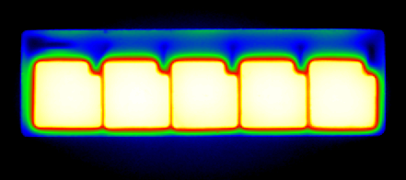 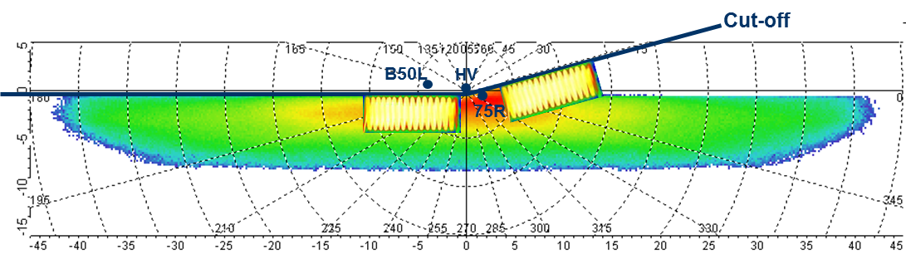

**Figure 1: Relevant test points in a typical passing beam according R112, including some visualization of images of a LED light source created by reflector optics**

3.2. Minimum uniformity (R0.7)

The strictest requirement of a “cut-off” required by headlamp regulations is given for a passing beam in Regulation No. 112. According to Regulation No. 112, Annex9, paragraph 2.2, the minimum sharpness is G0.1° = 0.13 over a vertical angle of 0.1°.

Based on a typical magnification (0.1 mm on light source level corresponds to 0.1° in the beam) used in LED headlamps with reflector optics, the sharpness of the beam cut-off can be related to the steepness of the edge of the light-emitting-area of the light source. A value of R0.7 = 70% means that at least 70% of the light-emitting-area has a luminance not less than 0.7*L1 (i.e. 70% of the mean luminance of the light-emitting-area).

In this sense the worst case LED-arrangement corresponds to the situation where the high-luminance part is located furthest from the edge (see arrangement in figure 2). As an example, an LED arrangement, based on a die dimension of 1.0 mm, can have a maximum distance of 0.15 mm (= half of 30% of 1.0 mm) at the edge of the light-emitting-area with a luminance in the range of 0.1*L1 to 0.7*L1. The resulting minimum steepness at light source level of G0.15mm = 0.845 could ideally be transferred to minimum sharpness of G0.15° = 0.845, respectively G0.10° = 0.563, in the beam. Even when a “safety margin” due to headlamp tolerances is included, the value of G0.10° is well above the required limit (G0.1° = 0.13).

1.0 mm

0.7 mm

0.15 mm

0.15 mm

Blue area: > 0.7L1

Green area : < 0.7L1 and > 0.1L1

**Figure 2: Luminance distribution (luminance limits) of the light-emitting-area in the worst case LED arrangement described under 3.2.**

3.3. Minimum uniformity (R0.1)

Similar to incandescent bulbs which can show “low-luminance” spots between the windings of the filament, LED light sources can have typical design-related “low-luminance” spots. A minimum value of R0.1 = 85% means that less than 15% of the light-emitting-area has a luminance below 0.1*L1 (= 10% of the mean luminance of the light-emitting-area). This limits unintentional patterns in the beam (e.g. “streaking”, dark spots) to a minimum, comparable to the situation with H7 (see figure 3).

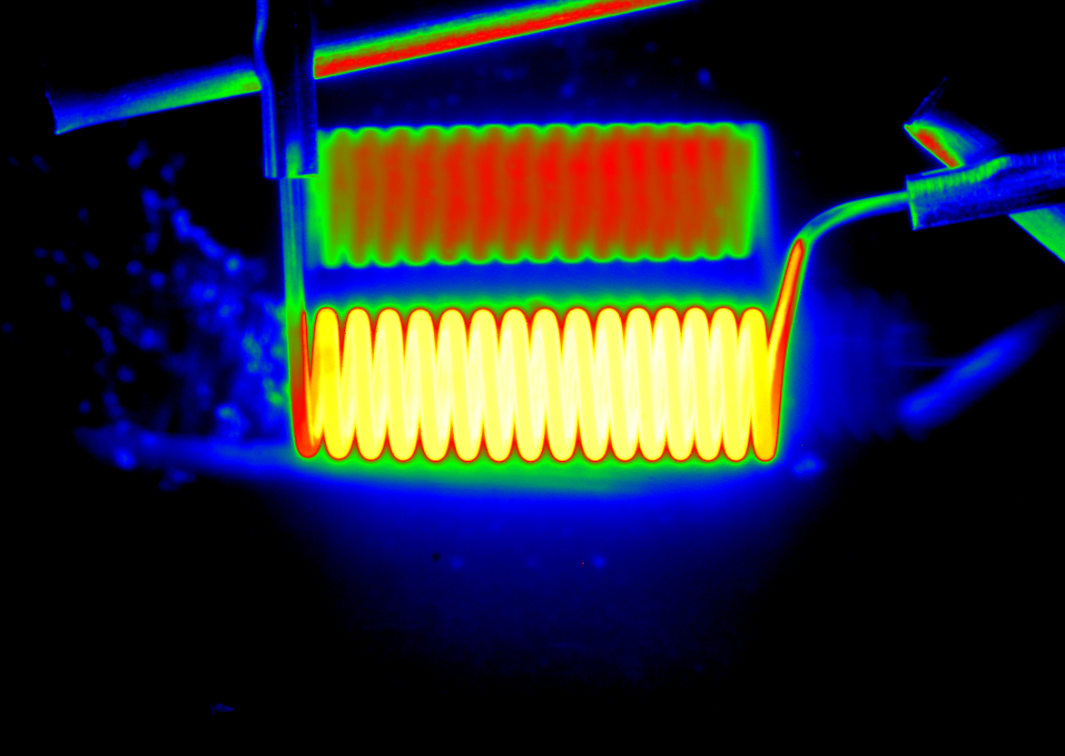 

**Figure 3: Luminance distribution of the light-emitting-area in case of a typical halogen bulb (left) and a typical LED arrangement for passing beam (right)**

3.4. Minimum size of the light-emitting-area

Similar to the situation with “non-restricted” incandescent bulbs (e.g. H7) a minimum fraction of the nominal-emitter-box (in R37 called “tolerance box”) by the light-emitting-area (in R37 called “filament”) is required for LED light source categories in group 1. Here, a minimum value of 80% represents even a higher level than for the best halogen bulb (H7, see figure 4).

*R37, H7 category (12V):*

*\* Minimum filament size: 4.1*d*

*\* Total box size: 4.6*d + 1.86*

*🡪 Fraction of the box covered by a typical filament: 65% - 70%*



**Figure 4: Box description of H7 category and exemplary calculation**

# **5. SUMMARY**

Sound specifications of the photometrical criteria given in section 2 are necessary for replaceable LED light sources intended for forward lighting applications. Due to the higher degree of design freedom compared to filament light sources, additional parameters – like contrast and uniformity – are defined for replaceable LED light sources.

In section 3 minimum limits are derived for the use of replaceable LED light sources in the most challenging application, which is a class B passing beam in Regulation No. 112 realized with reflector optics.