Proposal for amendments to Regulation No. 43 (Safety glazing)
The text reproduced below was prepared by the expert of CLEPA to amend figure 2a of Annex 18 to better reflect the meaning of paragraph 2.4.2.2 of Annex 18 mainly in respect to the lateral limits of any opaque obscuration in this area. The modifications to the current text of UN Regulation No. 43 are marked in bold for new characters and strikethrough for deleted characters.
- Proposal
Annex 18, Figure 2a, replace by:
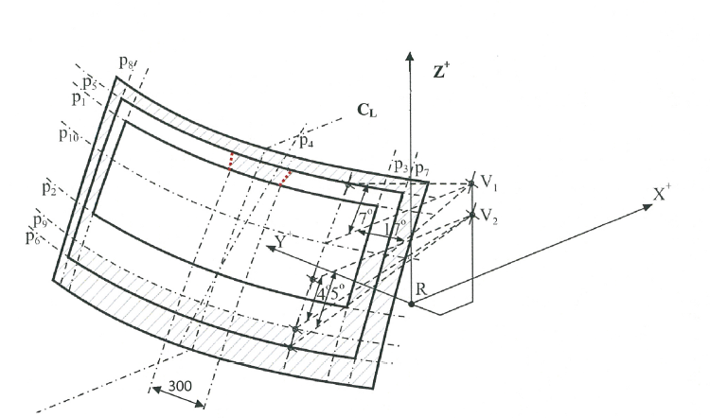
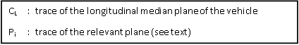

- Justification

Figure 2a shall be modified to reflect the meaning of paragraph 2.4.2.2 mainly with respect to the lateral limits of any opaque obscuration in this area. The current figure would be correct only in case the inclination of the windscreen is 90° from horizontal – this case is more than unlikely.

These lateral limits are parallel to the traces of planes 4 and 4’. On the trace of plane 1 this leads to a boundary width of 300 mm centred on the longitudinal median plane of the vehicle (C_{L}). The boundary width on the trace of plane 5 is given by the parallels to the traces of plane 4 and 4’.

____________________

