|  |  |  |  |
| --- | --- | --- | --- |
|  | United Nations | ECE/TRANS/WP.29/GRSG/2016/4 | |
| _unlogo | **Economic and Social Council** | | Distr.: General  10 February 2016  Original: English |

**Economic Commission for Europe**

Inland Transport Committee

**World Forum for Harmonization of Vehicle Regulations**

**Working Party on General Safety Provisions**

**110th session**

Geneva, 26–29 April 2016

Item 6 of the provisional agenda

**Regulation No. 55 (Mechanical couplings)**

Proposal for amendment to Regulation No. 55  
(Mechanical couplings)

Submitted by the expert from Poland [[1]](#footnote-2)\*

The text reproduced below was prepared by the expert from Poland and proposes to insert into the Regulation an amendment imposing a new general constraint for granting component type-approval for mechanical coupling devices dedicated to category M1 vehicles only if they are designed to tow trailers. The modifications to the current text of Regulation No. 55 are marked in bold characters.

**I. Proposal**

*Insert a new paragraph 8.2.,* to read:

"**8.2. Prior to granting component approval for a type of mechanical coupling device dedicated to a certain type of category M1 vehicle, the type-approval authority shall verify if that specific category M1 vehicle type is designed to tow a trailer by verifying in the vehicle type approval documentation, if the maximum permissible static vertical load on the coupling ball is higher zero. If that value is zero, an approval shall be refused.**"

*Paragraphs 8.2. to 8.5. (former),* renumber as paragraphs 8.3. to 8.6.

II. Justification

1. During a recent European Union Type Approval Authorities Meeting (TAAM) held in Island in 2015, the expert from Poland raised a problem with UN type approval certificates granted for devices which were dedicated for a type of vehicles that should, however, never tow a trailer (for the excerpt of the TAAM meeting minutes, see the attached annex).

2. Thus, this document proposes to insert a new general constraint for granting component approvals for mechanical coupling devices only if the vehicle type concerned is designed to tow trailers.

Annex (in English only)

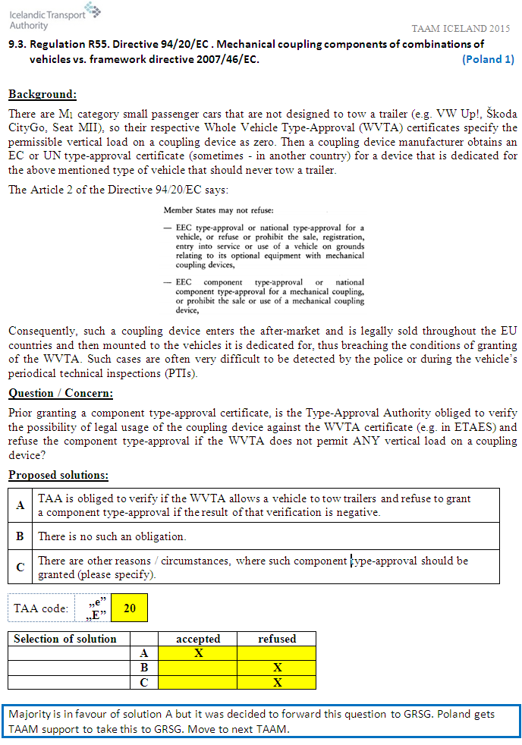

1. \* In accordance with the programme of work of the Inland Transport Committee for 2014–2018 (ECE/TRANS/240, para. 105 and ECE/TRANS/2014/26, programme activity 02.4), the World Forum will develop, harmonize and update Regulations in order to enhance the performance of vehicles. The present document is submitted in conformity with that mandate. [↑](#footnote-ref-2)