International Whole Vehicle Type Approval (IWVTA) on the harmonization of vehicle regulations under the 1958 Agreement.

- IWVTA informal group (starting June, 2012):

  - 1958 Agreement revision subgroup. The drafting subgroup for the review of the 1958 Agreement.
  - UN Regulation No. 0 subgroup. The drafting subgroup for the text of UN Regulation No. 0.

- Time line (More details at the end of this document ):
  - Extend the mandate of the IWVTA informal group (under the 1958 Agreement) until June, 2017.
  - December, 2015 to June, 2016_re-testing of UN Regulation No. 0 with several TS, Authorities and Manufacturers involved.
  - September 2016_Transmition of the proposal of the Revision 3 of the 1958 Agreement by one of the CPs to the Secretary General.
  - November 2016_Propose to set a permanent IWVTA IG from July 2017 to WP29.
  - November 2016_Final proposal of R0 will be submitted to WP29.
  - November 2016_ Finalize UN Regulations list A applicable to IWVTA, step 1.
  - March, 2017_ Submit of formal document for the text of UN Regulation 0 to WP.29.
  - March 2017:_Submit of proposal for updated “General Guidelines for UN regulatory procedures and transitional provisions in UN Regulations” (ECE/TRANS/WP.29/1044/rev.2).
  - May 2017_The proposal of the Revision 3 of the 1958 Agreement shall enter in force if no objection expressed.
  - January 2018_UN Regulation 0 will be considered for adoption.

- List A_UN Regulations applicable to IWVTA.
Number Topic UN-Regulation  1 Retro reflecting devices 3  2 Illumination of rear registration plates 4  3 Direction indicators 6  4 Front and rear position lamps, stop-lamps & end-outline marker lamps 7  5 Electromagnetic compatibility 10  6 Door latches & retention components 11  7 Steering impact 12  8 Safety Belts 16  9 Seats, their anchorages, & head restraints 17  10 Front fog lamps 19  11 Interior fittings 21  12 Reversing & manoeuvring lamps 23  13 External projections 26  14 Audible warning signals 28  15 Tyres 30  16 Filament lamps 37  17 Rear fog lamps 38  18 The Speedometer equipment 39  19 Safety glazing 43  20 Built-in Restraining device for children 44  21 Headlamp cleaners 45 | Number Topic UN-Regulation  22 Devices for indirect vision incl. installation 46  23 Sound emissions 51  24 Tyres for commercial vehicles 54  25 Rear underrun protective devices 58  26 Parking lamps 77  27 Steering equipment 79  28 Measurement of engine power 85  29 Side marker lamps 91  30 Frontal collision 94  31 Lateral collision 95  32 Headlamps with gas-charge light sources 98  33 Gas-charge light sources 99  34 Electric power train 100  35 Headlamps with filament lamps and/or LED modules 112  36 Tyre wet grip/Noise/RR 117  37 Cornering lamps 119  38 Hand controls and tell tales 121  39 Adaptive front-lighting systems 123  40 Forward field of vision 125  41 Pedestrian safety performance 127  42 LED light sources 128

List B _The GR R0 considers that the UN Regulations showed in list B are significantly important for IWVTA and therefore need to be reviewed by GRs if and how they can be included in draft UN R0.

UN Reg. | Topic | Expected agreement date by GR | Expected agreement date by WP.29 | Note
13H | Braking | February, 2016 | June, 2016 | Split provisions for ESC/BA
14 | Safety belts Anchorages | unknown | unknown | Australian proposal to harmonize the requirements is under consideration
34 | Prevention of fire risks | May, 2014 | November, 2017 | To be included in Annex 4 of UN R0 in November, 2017
48 | Installation of lighting and light-signalling devices
64 | Temporary tyres | February, 2016 | June, 2016 | Split provisions for TPMS
116 | Anti-theft and alarm systems | unknown | unknown | Task force was established for clarifying the scope and amending the Regulation
New | Tyre installation | February, 2016 | June, 2016 | IG was created for drafting the Regulation
WLTP | CO2 emissions | unknown | unknown | Need confirmation if the approach for the new “Regulation WLTP” is acceptable for IWVTA to enable harmonization.
WLTP | Exhaust emissions | unknown | unknown

The IWVTA group was informed on March 2016 about the intention of the transposition of GTR15 (WLTP) into UN Regulations during 72nd GRPE:
- UN Regulation on WLTP would be developed in a hierarchical manner with different levels of stringency.
- A top level – the most stringent requirements valid across all the regions.

SGR0-20-06 “Proposal to handle presence of systems and levels of stringency” transmitted by OICA.
- When developing IWVTA the issue of if-fitted systems in UN Regulations has been repeatedly discussed.
- If a requirement is formulated as if-fitted, it is not possible under mutual recognition to mandate it.
- Solution for systems like ESC, BAS, and TPMS has been to split UN Regulations. The same kind of discussion arises for DRL and rear fog lamps in conjunction with UN R-48: EU mandate both DRL and rear fog lamps and Japan will accept the systems in the future but does not intend to mandate them
A related discussion is how to implement different levels of stringency within a UN Regulation, when implementing WLTP.

Within one version of a UN Regulation a type approval authority can issue
- a type approval (as we are used to)
Or
- an attestation (new concept)
  - An attestation could be used when not all requirements of a UN Regulation are met.
  - It would explicitly identify the differences compared to a type approval (respective forms could be added to the Regulation text as appendices to Annex 1/communication form).
  - It would not be subject to full mutual recognition, except for those markets having the same requirements as those contained in the attestation.
  - However, it would have to be recognized by all CPs applying the UN Regulation for the content that it "certifies”.
In a way, the concept of an attestation is like a L-IWVTA (Limited–IWVTA) applied on the level of individual Regulations instead of on whole vehicle level.

Example on WLTP UN Regulation:
A future “hierarchical” Regulation on WLTP could include the possibility for
- type approval in case all requirements are met
- One attestation for each hierarchical level that is needed (It is not even necessary that the levels are truly hierarchical).

Using this concept, the limit values for different cycles (e.g. w/o high speed portion of WLTP) can be updated via single series of amendments

Required attestation forms could be included into the respective UN Regulations.

SGR0-20-07 “GR Chairmen’s meeting on IWVTA”
- Technical Secretary stated that IWVTA Ambassador to GRPE (Spain) had an idea of delegating an expert on IWVTA to GRPE session in order to come up with harmonized and compatible UN Regulation ‘WLTP’. Technical Secretary asked GRPE Chair’s opinion about it.
- GRPE Chair stated that he would appreciate it if IWVTA expert could participate in a Task Force to deal with the transposition of GTR No. 15 into UN Regulations ‘WLTP’ reporting to WLTP Informal Group. It was noted that the date for the meeting of this Task Force had not been decided yet

Working schedule of IWVTA IG

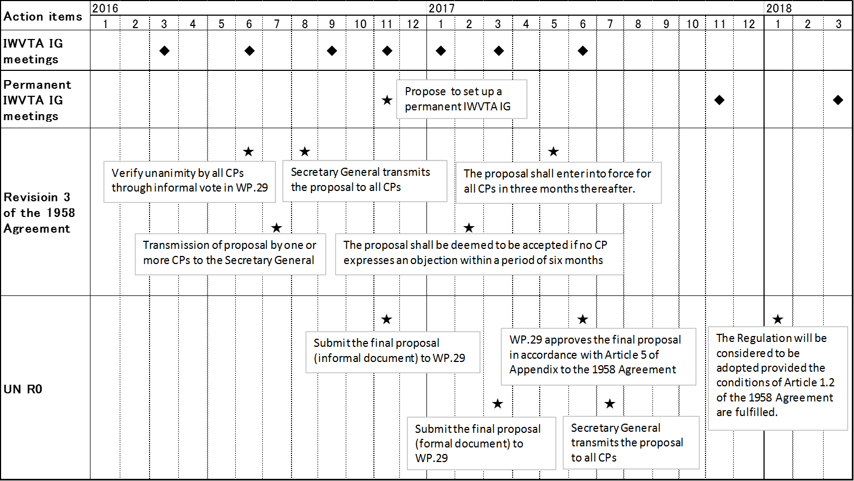

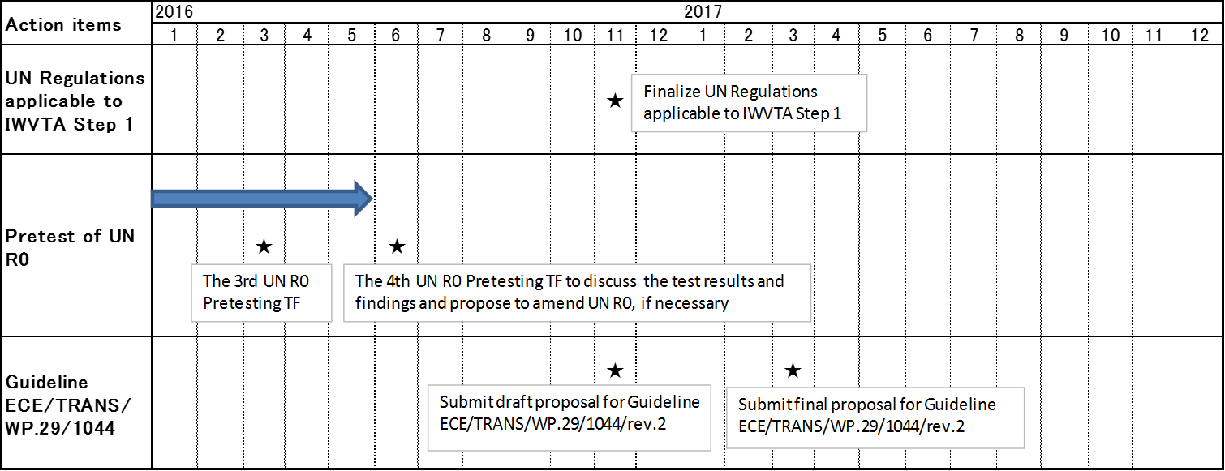

Point Of Contact (POC): Miguel A. Robledo, email: robledomm@inta.es

