Transmitted by the experts from The International Automotive Lighting and Light Signalling Expert Group (GTB | Informal document GRE-76-14-Rev.1  (76th GRE, 25-28 October 2016,  agenda item 7(h))

Revision to GRE/2016/29

(Proposal for Supplement 8 to the 01 series of amendments to Regulation No. 123 (Adaptive front lighting systems (AFS))

During preparatory meetings for the GRE 76th session it was found that the amendments proposed to Annex 3, table 2 had not been identified in BOLD text and a sentence in the justification had been omitted.
To clearly identify these editorial corrections the complete content of GRE/2016/29 is updated as shown below. Further, the decision taken during GRE-76 to remove the proposal to allow sub-classes of Class C to lower the cut-off position is also incorporated in this document that replaces GRE-76-14

- Proposal
Paragraph 5.7.3., amend to read:
"5.7.3. In the case of failure it must be possible to obtain automatically a passing beam or a state with respect to the photometric conditions which yields values not exceeding 1,300 cd in the zone III b as defined in Annex 3 to this Regulation and at least 3,400 cd in a point of "segment Emax I_{max} ", by such means as e.g. switching off, dimming, aiming downwards, and/or functional substitution;
When performing the tests to verify compliance with these requirements, the Technical Service responsible for approval tests shall refer to the instructions supplied by the applicant."
Paragraph 6.2.4., amend to read:
"6.2.4. When emitting a specified mode of the passing beam, the system shall meet the requirements in the respective section (C, V, E, W) of part A of Table 1 (photometric values) and in Table 2 Emax I_{max} and "cut-off" positions) of Annex 3 to this Regulation, as well as section 1 ("cut-off" requirements) of Annex 8 to this Regulation."
Paragraph 6.2.5.4., amend to read:
"6.2.5.4. If approval is sought for a category 1 bending mode, the system is designed so that, in the case of a failure affecting the lateral movement or modification of the illumination, it must be possible to obtain automatically either photometric conditions corresponding to paragraph 6.2.4. above or a state with respect to the photometric conditions which yields values not exceeding 1,300 cd in the zone IIIb, as defined in Annex 3 to this Regulation, and at least 3,400 cd in a point of "segment Emax I_{max} ";"
Annex 3, Figure 1, amend to show (change I_{max} is highlighted yellow):
"Figure 1

Angular positions of passing beam photometric requirements (indicated for right-hand traffic)
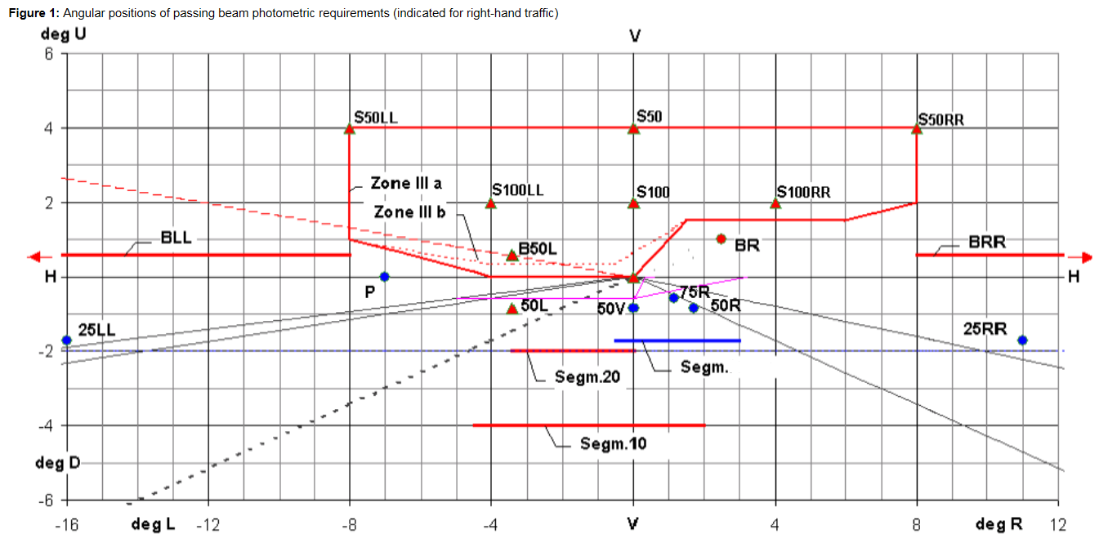"
Imax
Table 1, Part A, line 18, replace "E_{max}" with "I_{max}".
Table 1, Part B, line 18, replace "E_{max}" with "I_{max}".
Table 1, footnote 3, amend to read:
"³ Position Requirements according to the provisions of Table 2 below ("Segment E_{max} I_{max}") apply in addition.

Annex 3, Table 2, amend to read:
Table 2
"Passing beam elements angular position/extend, additional requirements
 | Angular position / extend in deg | Class C passing-beam |  | Class V passing-beam |  |  | Class E passing-beam |  |  | Class W passing-beam
No | beam part designation and requirement | horizontal | vertical | horizontal | vertical |  | horizontal |  | vertical | horizontal |  | vertical
2.1. | Angular position / extend in deg  for segment I_{max}  Emax shall not be positioned outside of the rectangle extending (above "segment Emax")  The maximum luminous intensity in "Segment I_{max}" as indicated in this table shall be within the limits as prescribed in Table 1, Line No. 18. | 0.5L  to 3R | 0.3D  to 1.72D |  | 0.3D  to 1.72D |  | 0.5L  to 3R |  | 0.1D  to 1.72D | 0.5L  to 3R |  | 0.3D  to 1.72D
2.2. | The "cut-off" and part(s) of shall:  (a) comply with the requirements of paragraph 1. of Annex 8 to this Regulation and
 | (b) be positioned with its "flat horizontal part" |  | at V = 0.57 D  not above 0.57D  not below 1.0D |  |  | not above 0.57D  not below 1.3D |  |  | not above 0.23D⁸ not below 0.57D |  | not above 0.23D  not below 0.57D
⁸ | Requirements according to the provisions indicated in Table 6 below apply in addition.
"

Annex 4, the introductory part, amend to read:
"Annex 4
Tests for stability of photometric performance of systems in operation – Tests on complete systems
Once the photometric values have been measured according to the prescriptions of this Regulation, in the point of Emax I_{max} for driving beam and in points HV, 50V and B50L (or R), whichever applies for passing beam, a complete system sample shall be tested for stability of photometric performance in operation.
…
(remainder of the text is unchanged)"
Paragraph 1.2.1.5., amend to read:
"1.2.1.5. Application of the test mixture to the test sample
The test mixture shall be uniformly applied to the entire light-emitting surface(s) of the test sample and then left to dry. This procedure shall be repeated until the illuminating value has dropped to 15-20 per cent of the values measured for each following point under the conditions described in this annex:
point Emax I_{max} in driving beam, under neutral state conditions,
50V for a class C passing beam, and each specified passing beam mode."
Annex 5, paragraph 2.4., amend to read:
"2.4. Measured and recorded photometric characteristics
The sampled headlamps shall be subjected to photometric measurements at the points provided for in the Regulation, the reading being limited:
To points Emax I_{max}, HV¹, HL and HR² in the case of a driving beam;
To points B50L, HV if applicable, 50V, 75R if applicable, and 25LL in the case of the passing beam(s) (see Figure 1 in Annex 3)."
Annex 6, paragraph 2.1.2.1., amend to read:
"2.1.2.1. Method
Photometric measurements shall be carried out on the samples before and after the test.
These measurements shall be made according to Annex 9 to this Regulation, at the following points:
B50L and 50V for the class C passing beam lighting;
Emax I_{max} for the driving beam of a system."
II. Justification
1. When the 01 series of amendments to Regulation No. 123 was introduced to convert the photometric requirements from illuminance E (lux) to luminous intensities I (cd), some changes from E_{max} to I_{max} were overlooked. This amendment introduces the necessary corrections.
2. Additionally the text in line 2.1 of table 2 of Annex 3 has been amended to make it clear that the maximum luminous intensity in “Segment Imax” has to be within the limits as declared in Table 1, Line18.

