Illustrations for definitions of audible warning devices
and audible warning systems

This document was prepared by the expert from the Russian Federation following the advice of the informal meeting of interested experts held in Moscow on June 10, 2016 in order to illustrate the definitions of audible warning devices and audible warning systems introduced in ECE/TRANS/WP.29/GRB/2016/4.

Reference to ECE/TRANS/WP.29/GRB/2016/4 | Illustration
2.2. "Audible warning system" means a combination of audible warning devices mounted on a common bracket operating simultaneously by the actuation of a single control.
2.4.1. "Pneumatic" means a principle of operation by an external compressed air source. | 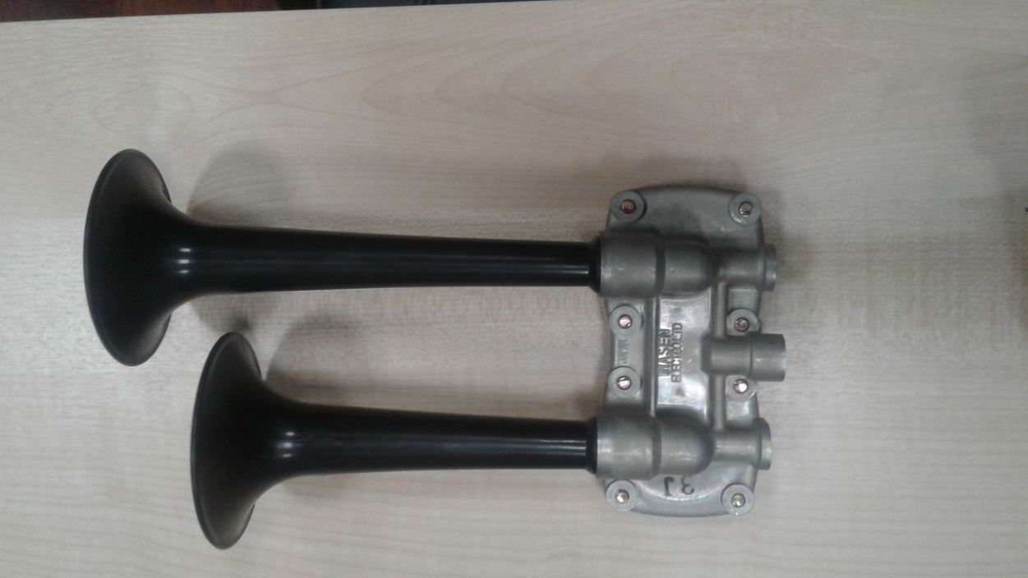
2.4.2. "Electro-pneumatic" means a principle of operation by a compressed air source which is controlled by electrical supply (direct or alternating current). | 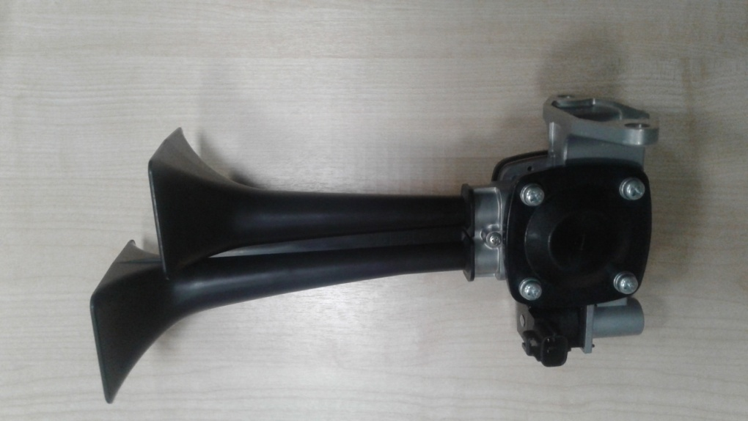
2.4.3. "Electro-magnetic with resonator disc" means a principle of operation by electro-magnetic force amplified by a resonator disc.
2.4.4. "Electro-magnetic with horn" means a principle of operation by electro-magnetic force amplified by a horn.

_______________

