|  |  |  |  |
| --- | --- | --- | --- |
|  | United Nations | ECE/TRANS/2016/2 | |
| _unlogo | **Economic and Social Council** | | Distr.: General  14 December 2015  Original: English |

**Economic Commission for Europe**

Inland Transport Committee

**Seventy-eighth session**

Geneva, 23–26 February 2016  
Item 4 (a) of the provisional agenda  
**Strategic questions of a horizontal policy nature:  
Status of accession to United Nations   
transport agreements and conventions   
under the purview of the Inland Transport Committee**

Status of accession to United Nations transport agreements and conventions administered by UNECE

Note by the secretariat

|  |
| --- |
| *Summary* |
| This document presents the status of accession by UNECE and non-UNECE member States to UN transport agreements and conventions administered by UNECE. |
| On 1 December 2015, the total number of Contracting Parties to the 58 United Nations (UN) legal instruments in the field of transport administered by UNECE was 1,709, with ten new Contracting Parties to eight legal instruments. The increase was slightly higher than in 2014. |
| The Committee may wish to invite countries, which have not yet done so, to accede to the UN conventions and other legal instruments in inland transport administered by the Committee and its subsidiary bodies. |
|  |

I. Overview

1. Figure 1 below shows the total number of Contracting Parties to United Nations legal instruments on inland transport under the purview of the Inland Transport Committee (ITC). On 1 December 2015, the total number of Contracting Parties to the 58 United Nations (UN) legal instruments in the field of transport administered by the United Nations Economic Commission for Europe (UNECE) was 1,709, with ten new Contracting Parties to eight legal instruments (see annex for details). Out of these 58 legal instruments, nine have not entered into force. The summary tables on the status of signatures, ratifications and accessions as of 1 December 2015 for all United Nations transport legal instruments are available at www.unece.org/trans/conventn/intro.html.

Figure 1

**Total number of Contracting Parties to international instruments on inland transport concluded under the auspices of the ITC**

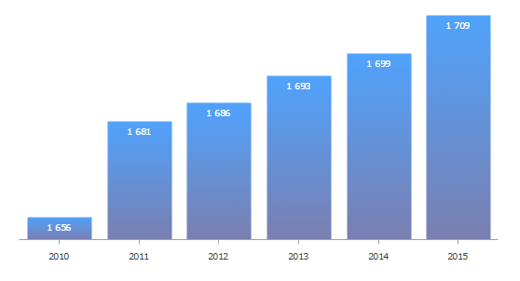

*Source*: UNECE

**II. Geographical distribution of Contracting Parties**

2. The total number of Contracting Parties to the 58 transport conventions is 1,709 (as of 1 December), of which 1,702 are States. Of these, 1,326 are UNECE Contracting Parties and 376 are non-UNECE Contracting Parties.

3. Of the 193 United Nations Member States, 147 States (75 per cent) are Contracting Parties to at least one legal instrument on inland transport (see figure 2).

4. Of the 147 United Nations Member States that are Contracting Parties, 91 (60 per cent) are non-UNECE member States.

5. Out of the 58 legal instruments under the purview of UNECE, 49 are in force. Non-UNECE member States are Contracting Parties to 29 transport conventions. This means that about 60 per cent of United Nations transport conventions serviced by UNECE and in force have a geographical coverage beyond the territory of the UNECE. On average, each UNECE member State is party to 23 legal instruments, while, on average, each non-UNECE Contracting Party is party to 13 legal instruments.

Figure 2

**UNECE and non-UNECE member States   
Contracting Parties to at least one United Nations transport convention**

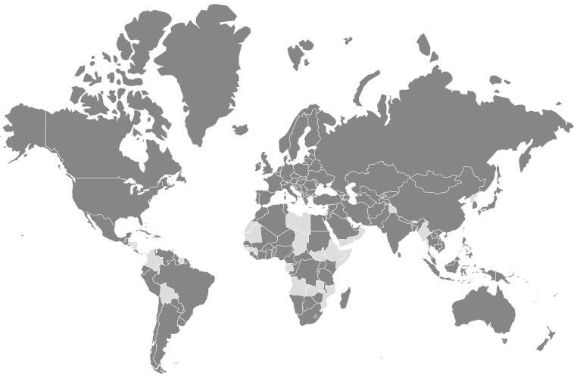

*Legend:* Dark grey: Contracting Parties - Light grey: non-Contracting Parties

*Source:* UNECE

6. The European Union is a Contracting Party to seven legal instruments. In the future it may be likely that other regional integration initiatives may seek to become Contracting Parties as well.

7. For the majority of transport conventions, the number of UNECE Contracting Parties is higher than that of non-UNECE Contracting Parties. The relationship is reversed for some transport conventions. For example, 60 out of the 96 Contracting Parties of the Convention on Road Traffic of 1949 are not UNECE member States. Similarly, for some border crossing facilitation conventions, more Contracting Parties are from outside of the UNECE region: 44 out of 79 Contracting Parties for the Convention concerning Customs Facilities for Touring of 1954 and 42 out of 74 Contracting Parties for its Protocol; and 44 out of 80 Contracting Parties for the Convention on the Temporary Importation of Private Road Vehicles of 1954.

8. There are still 48 United Nations Member States which are not Contracting Parties to any UN legal instruments on inland transport under the auspices of the ITC. These countries are: Angola, Belize, Bhutan, Bolivia (Plurinational State of), Brunei Darussalam, Cabo Verde, Chad, Colombia, Comoros, Democratic People's Republic of Korea, Djibouti, Dominica, Equatorial Guinea, Eritrea, Ethiopia, Gabon, Gambia, Grenada, Guinea, Guinea-Bissau, Honduras, Kiribati, Libya, Maldives, Marshall Islands, Mauritania, Micronesia (Federated States of), Mozambique, Myanmar, Nauru, Nicaragua, Oman, Palau, Panama, Saint Kitts and Nevis, Saint Lucia, Saint Vincent and the Grenadines, Samoa, Sao Tome and Principe, Somalia, South Sudan, Suriname, Swaziland, Timor-Leste, Tuvalu, Vanuatu, Yemen, Zambia.

9. The Committee may wish to consider this information and provide guidance to the Working Parties and the secretariat on ways to increase the number of new accessions to the legal instruments under its purview, in order to strengthen the international legal and regulatory framework for inland transport and thus promote more effectively sustainable mobility and transport.

**Annex**

**Accessions registered from 1 January – 1st December 2015**

| *Date* | *Contracting Party* | *Convention* |
| --- | --- | --- |
| 27/11/2015 | San Marino | Agreement concerning the Adoption of Uniform Technical Prescriptions for Wheeled Vehicles, Equipment and Parts which can be fitted and/or be used on Wheeled Vehicles and the Conditions for Reciprocal Recognition of Approvals Granted on the Basis of these Prescriptions, 1958 |
| 27/11/2015 | San Marino | Agreement concerning the Adoption of Uniform Conditions for Periodical Technical Inspections of Wheeled Vehicles and the Reciprocal Recognition of Such Inspections, of 13 November 1997 |
| 27/11/2015 | San Marino | Agreement concerning the establishing of Global Technical Regulations for Wheeled Vehicles, Equipment and Parts which can be fitted and/or be used on Wheeled Vehicles, 1998 |
| 27/10/2015 | Republic of Moldova | Protocol on Road Markings, additional to the European Agreement supplementing the Convention on Road Signs and Signals, 1973 |
| 27/10/2015 | Republic of Moldova | European Agreement supplementing the Convention on Road Signs and Signals, 1971 |
| 08/10/2015 | Republic of Moldova | Convention on Road Signs and Signals, 1968 |
| 21/07/2015 | Pakistan | Customs Convention on the International Transport of Goods under Cover of TIR Carnets (TIR Convention), of 14 November 1975 |
| 26/03/2015 | Georgia | Agreement concerning the Adoption of Uniform Technical Prescriptions for Wheeled Vehicles, Equipment and Parts which can be fitted and/or be used on Wheeled Vehicles and the Conditions for Reciprocal Recognition of Approvals Granted on the Basis of these Prescriptions, 1958 |
| 13/01/2015 | Saudi Arabia | Agreement on the International Carriage of Perishable Foodstuffs and on the Special Equipment to be Used for such Carriage (ATP), of 1 September 1970 |