|  |  |  |
| --- | --- | --- |
|  | **INF.25** | |
| **Economic Commission for Europe**  Inland Transport Committee  **Working Party on the Transport of Dangerous Goods**  **Joint Meeting of Experts on the Regulations annexed to the**  **European Agreement concerning the International Carriage**  **of Dangerous Goods by Inland Waterways (ADN)**  **Twenty-height session**  Geneva, 25-29 August 2016  Agenda item 5 (b)  **Proposals for amendments to the Regulations annexed to ADN:**  **Other proposals** | | English  **21 January 2016** |

Risk assessment for emissions from hot heavy fuel oil during barge loading – Revised Concawe Report

Transmitted by FuelsEurope

1. Reference is made to the ECE/TRANS/WP.15/AC.2/2016/26 working document regarding the proposal for an exemption from the requirement of 7.2.4.25.5 to return gas/air mixtures ashore during loading operations of heavy heating oil (UN No.3082) together with the INF paper 23 of the 26th session of the ADN Safety Committee.

2. At the 27th session of the ADN Safety Committee, a revised version of the CONCAWE report has been provided in the INF paper 20. This revised report was updated with clarification requested by the German expert agencies BAuA (Bundesanstalt für Arbeitsschutz und Arbeitsmedizin / Federal Institute for Occupational Safety and Health) and BfR (Bundesinstitut für Risikobewertung / Federal Institute for Risk Assessment).

3. In August 2015, the ADN Safety Committee requested all delegations still having doubts about the technical validity of the CONCAWE risk assessment report to consult FuelsEurope.

4. In this respect, FuelsEurope has been invited by the Dutch delegation to bring further explanations to their National Institute for Public Health and the Environment (RIVM). As a result of the discussions, the CONCAWE report has been updated

5. In order to assist the reading of this last revised report, changes are highlighted to capture the outcomes of discussions held with RIVM.

**Relevant documents:**

Risk assessment for emissions from hot heavy fuel oil during barge loading – Report 1/15R

CONCAWE - 1/15R January 2015 – Revised December 2015 (annexed)

ECE/TRANS/WP.15/AC.2/2016/26 working document

INF paper 20 of the 27th session of the AND Safety Committee

INF paper 23 of the 26th session of the ADN Safety Committee

|  |
| --- |
| Risk assessment for emissions from hot heavy fuel oil during barge loading |



report no. 1/15R



**The oil companies’ European association for Environment, Health and Safety in refining and distribution**



**Risk assessment for emissions from hot heavy fuel oil during barge loading**

Prepared for the Concawe Health Management Group by its HFO Working

Group:

A. Bartelloni

B. Birnbacher

P.J. Boogaard

M. Carter

B. Geudens

L. Gonzalez

C. Juery

D. Leuckx

F. Mengeot

J.H. Urbanus (Chair)

A. Rohde (Science Executive)

D. Morgott (Pennsport Consulting)

W. Koch (Fraunhofer ITEM)

C.M. Verspeek-Rip (WIL Research)

Reproduction permitted with due acknowledgement

© Concawe

Brussels

January 2015

Revised December 2015

ABSTRACT

A series of emissions, occupational exposures, and mutagenic hazard studies were conducted to assess the risk associated with the loading of commercial Heavy Fuel Oils onto barges on the inland waterways.  This report summarises the results from the laboratory investigations, exposure monitoring studies, and mathematical modelling exercise aimed at documenting the potential inhalation exposure, fractional release and intrinsic hazards of HFO vapours and aerosols under barge loading conditions.  Analytical methodologies were developed to quantify HFO vapour and aerosol air concentrations, and an industrial hygiene assessment and worker exposure monitoring were conducted during actual loading operations.  The results indicated that during the loading of hot commercial HFO on inland waterway barges:

* The emissions resulted in low workplace exposures, well below limit values set by the American Conference of Governmental lndustrial Hygienists
* There was no release of detectable amounts of benzo(a)pyrene
* There was no mutagenic risk to workers based on the mutagenicity assays conducted on fume condensates generated under similar operating conditions which was corroborated with low total concentrations of aromatic compounds and low overall fluorescence in the fumes
* There was no substantial contribution to air emissions relative to other types of petroleum hydrocarbon cargos.

Therefore, based on these findings, the risk for workers handling commercial grade HFOs, as well as the environmental risks, during a barge loading operation on inland waterways do not pose a health concern.  These studies did not indicate a need for additional control measures on the emissions of hot HFOs during barge loading beyond normal good operational industrial hygiene practices.

KEYWORDS

Occupational inhalation exposure, emission factor, PAH, total hydrocarbon, mutagenicity, naphthalene, heavy fuel oil, barge loading

INTERNET

This report is available as an Adobe pdf file on the Concawe website (www.concawe.org).

*NOTE*

*Considerable efforts have been made to assure the accuracy and reliability of the information contained in this publication. However, neither Concawe nor any company participating in Concawe can accept liability for any loss, damage or injury whatsoever resulting from the use of this information.*

*This report does not necessarily represent the views of any company participating in Concawe.*

**CONTENTS** Page

1. Introduction and objectives 1

2. Project outline 4

3. Materials and Methods 6

4. Results 14

5. Discussion 27

6. Conclusions 34

7. REFERENCES 35

summary

The emissions, exposures, and mutagenic hazards associated with the loading of heavy fuel oil (HFO) onto inland waterway barges were investigated in a series of studies initiated out of risk-related questions. The report summarizes the results from laboratory investigations, monitoring studies, and mathematical modelling exercises aimed at documenting the inhalation exposure, fractional release and intrinsic hazard of vapours and aerosols released when commercial grade UN 3082 HFOs are loaded onto an inland barge docked at a bulk storage terminal. The primary goal of these studies was to assess whether the inhalation of these hydrocarbons poses a health risk to operators who are responsible for the bulk loading onto barges. Since commercial grade HFOs are a combination of unblended C20–C98 refinery residues and a more volatile C9–C28 cutter stock used to improve handling, HFOs were assumed to have the potential for atmospheric release of some hydrocarbons. This concern for measurable release was based, in part, on the increased volatility that would be expected when HFOs are heated to their typical loading temperature of 70–90 °C. Until now, however, the nature and magnitude of these releases and any resulting worker exposures had not been widely reported.

Using a specially designed sampler capable of collecting hydrocarbon vapour and aerosols, personal exposure measurements were assessed for on-board (crew) and onshore refinery/terminal personnel responsible for operations during five barge loading events. The samples were analysed for both total hydrocarbons and a select number of indicator aromatic hydrocarbons (AHs) such as naphthalene and polycyclic aromatic hydrocarbons (PAHs) that included pyrene and benzo[a]pyrene. The level of hydrocarbon exposures from vapours and aerosols for on-board employees ranged from about 0.46–16 mg/m3, which was well below the occupational exposure limit of 100 mg/m3 set by the ACGIH (American Conference of Governmental Industrial Hygienists) for diesel fuel as an 8-hour TWA and considered applicable to the emissions of hot heavy fuel oil in this project. Personnel exposures to pyrene and benzo[a]pyrene vapour were below the limit of quantitation (mostly in the range of 0.01-0.07 µg/m3), whereas naphthalene vapour exposures up to 0.2 mg/m3 were observed with no exceedances of the German 8-hr time-weighted average exposure limit of 0.5 mg/m3 or 50 mg/m3 recognized in other European countries including France and The Netherlands. Most worker exposure samples for aerosol were at concentrations near or below the limit of quantitation of approximately 0.01 mg/m3. Measured exposure levels of onshore workers were lower than for those working on-board the barges.

Because the personal air samples did not provide sufficient material for further detailed analyses such as the boiling point distribution, fluorescence, and mutagenicity, fume condensates were generated in the laboratory from samples of three separate commercial grade HFOs collected at barge loading terminals. These condensates were used as surrogates to represent the emissions during barge loading. These condensates were generated at temperatures of 70, 80, and 90 °C to cover the range of temperatures that can typically exist during HFO loading**.** Measured loading temperatures on-board the barges ranged from 72 to 81 °C. Fluorescence measurements indicated that the condensates contained far less potentially carcinogenic 4–6 ring PAHs than the bulk material. Similarly, a comparison of the chemical analysis results of condensates and bulk HFO samples indicated that levels of PAHs of concern were much lower in the condensates. Mutagenicity was determined with a bacterial reversed mutation assay optimised to detect mutagens that may be present in petroleum substances. None of the condensates were mutagenic in this assay and the condensate generation temperature had no measurable influence on the test results.

The emissions of volatile hydrocarbons were estimated using three separate mathematical approaches developed by the USEPA, the UK Environment Agency, and Concawe after adjusting for the elevated vapour pressure and reduced density that would be expected at the 80 °C loading temperature. The resulting emission factor of 10–20 g/tonne was found to be equivalent to a total mass emission of 130–260 kg for a loading duration of 10 hr on a large barge capable of hauling a maximum of 13,000 tonnes of HFO. The fume emission factor during the loading of HFO fuels was found to be 8-fold lower than the factor associated with the barge loading of crude oil and 27-fold lower than the factor for the barge loading of gasoline.

The results of these studies indicated that during the loading of hot commercial HFO on inland waterway barges:

1. the emissions resulted in low workplace exposures, well below a limit value set by the ACGIH for employees working on-board the barge and even lower for those working onshore at the terminal;
2. there was no release of detectable amounts of benzo[a]pyrene;
3. there was no mutagenic risk for workers based on testing in a bacterial reversed mutation assay, optimised to detect mutagens that may be present in petroleum substances, on condensates generated from various HFO samples under conditions very similar to operating conditions; and
4. there was no substantial contribution to air emissions relative to other types of petroleum hydrocarbon cargos.

Based on the notion that human health risk is a function of both the intrinsic health hazard of a substance and the personal inhalation exposures a worker receives, the testing and analysis conducted as part of this programme indicate that both health hazards and exposures, and therefore health risks, for workers handling commercial grade HFOs during the surveyed barge loading operations did not pose a concern. The studies did not indicate a need for additional control measures on the emissions of hot HFOs during barge loading beyond normal good operational industrial hygiene practices.

# Introduction and objectives

Re-classification of heavy fuel oil (HFO) (UN 3082) as an environmentally hazardous substance in 2010 led to the introduction of the requirement that the gas/air mixture shall be returned to shore through a gas recovery or compensation pipe during loading operations. In response to a series of meetings held between UNECE’s ADN[1] Safety Committee and FuelsEurope regarding the potential hazards associated with heavy fuel oil (HFO) transport on inland European waterways, Concawe established a working group to investigate the exposures and health risks associated with the transfer of HFO onto inland barges (ECE, 2013). The resulting research programme was aimed at improving the understanding of hazards and exposures to emissions. Although HFO’s are known to be CMR (Carcinogenic, Mutagenic or Toxic for Reproduction), the fumes emitted during barge loading had not been not been studied in any detail until this time mainly because of its low volatility. In a previously published occupational exposure study the focus had been put on the dermal exposure route as the main route of concern (Christopher, et al. 2011).

A centrepiece of this research programme was an evaluation of occupational inhalation exposures relative to applicable standards. Other task associated with this research programme included:

1. A description of the family of products to ensure representativeness of test samples
2. Identification and procurement of representative test samples of HFOs that are transported via European inland waterways under UN 3082
3. Development of analytical methodologies to quantify HFO air concentrations during barge loading
4. An estimation of hydrocarbon emissions during barge loading operations
5. An industrial hygiene assessment of work conditions
6. The preparation of a risk assessment report on HFO emissions

The purpose of this report is to summarize the results from these studies and to examine their implications for human health. The focus of this investigation is on those HFOs sold commercially as fuels, including such products as vacuum gas oil, bunker C oil, fuel oil #6, marine fuel oil, and residual fuel oil. The exposure analysis specifically targets those substances with a UN 3082 designation, which implies a flash point greater than 60 °C (ECE, 2011). It does not include primary site-restricted HFOs used as an initial blending stock for preparing the final commercial product.

The primary difference between site-restricted HFOs and those used as fuels is the addition of a cutter stock to achieve the desired viscosity and to improve the fluidization necessary for transfer and combustion. All site-restricted HFOs and fuel products are stored and handled at elevated temperatures to improve their handling. The cutter stock used in a final product can originate from any of several refinery streams depending on availability. Gas oil, kerosene, and other middle distillate fractions represent some of the most commonly used alternatives.

The initial HFO blending stock includes the following site-restricted streams (Concawe, 1998):

* **Long residue**: the residue from the atmospheric distillation of crude oil.
* **Short residue**: the residue from the vacuum distillation of crude oil.
* **Thermal cracker or visbreaker residue**: the residue from thermal cracking processes designed to increase the yield of distillate components from atmospheric and vacuum residues.
* **Cat cracker slurry oil (clarified oil)**: a heavy fraction from a catalytic cracking operation, a process for the conversion of heavy hydrocarbon fractions into high quality gasoline components.
* **Vacuum gas oil**: a heavy gas oil fraction from the vacuum column.

The composition of HFOs varies widely and depends on refinery configuration, the crude oils being processed, and overall refinery demand for the residues from vacuum distillation and thermal and catalytic cracking processes (Concawe, 1998). A previous exposure study, focussing on dermal exposures, reported compositional data at ppm level (or µg/g) for a series of marker polycyclic aromatic hydrocarbons for blending stock and finished fuels that varied over 2 orders of magnitude (Christopher et al., 2011). Most of the constituents in an unblended HFO possess a high carbon number ranging from C20–C98 and are relatively non-volatile. Consequently, most of the constituents have a negligible impact on overall emissions to air (Concawe, 2012b, Kim et al., 2011). However, the addition of the cutter stock to improve handling can have a small but measurable influence on emissions because of its higher vapour pressure. Cutter stocks generally contain hydrocarbons in the C9–C28 range and their use percentage in a final product can vary depending on the specific viscosity needs of the customer (Garaniya et al., 2011). Given the diverse number sources for both the unblended HFO and the cutter stock, the commercial product is compositionally complex and virtually impossible to fully speciate.

Significant concentrations of highly toxic hydrogen sulphide (H2S) are known to accumulate in headspaces of tanks from decomposition of sulphur-containing compounds and safe handling advice is well established (Concawe, 1998). The hydrocarbon emissions encountered during barge loading may be associated with both the HFO product being loaded as well as any residual vapours arising from the previous cargo. Consequently, some variability is expected in the emissions depending on the volatility of the previous cargo, the length of time since the previous cargo was unloaded, and whether the tanks were degassed prior to reloading with an HFO. In addition, submerged versus splash loading can also have an impact on atmospheric release; however, in the case of the UN 3082 HFOs submerged loading is the only method employed. Submerged loading uses a delivery pipe that extends below the liquid surface to minimize agitation and vapour generation. The submerged loading of an HFO onto a tank barge takes place at a temperature of approximately 80 °C to decrease the viscosity and increase the handling ability of the product. The decreased turbulence that accompanies submerge loading at an elevated temperature will cause any released vapours to accumulate near the liquid surface as a vapour blanket. As a result, a majority of the hydrocarbon vapours may be released during the latter stages of the loading cycle when the head space (i.e. ullage) is less than 3–4.5 meters high.

An indication of the annual number of operations carried out in Europe was obtained by retrieving  information coming from the Europe Barge Inspection Scheme (EBIS) which is a system used by all chemical and oil industry company vetting departments. In Europe, there are 1290 tanker barges dedicated to the transport of liquid dangerous goods in bulk.  Each barge is EBIS inspected once a year.  Based on the EBIS inspection reports issued during the period June 2014-May 2015, 124 different barges were inspected while transporting/carrying UN3082 Fuel Oil product and hence some 10% of the European tanker barge fleet is used to transport HFO. The tonnage of these 124 barges ranged from 1000 to a maximum size of 13317T, with an average of 3900T, as per following distribution:

* 22 barges: Tonnage < 2000T
* 48 barges: Tonnage from 2000T to 4000T
* 34 barges : Tonnage from 4000 to 6000T
* 20 barges: Tonnage > 6000T

It is estimated that the barges carry out some 3000 loading operations annually.

ADN barge construction and cargo handling rules together with industry recommendations under ISGINTT (International Safety Guideline for Inland Waterway Tanker and Terminal) ensure that loading operations are done according to a standard process independent of the terminal or the barge and hence the emissions and exposures are not expected to be influenced by local variation in technical conditions, but only by product and environmental factors, and therefore to be relatively homogeneous.

# Project outline

The research programme was performed in stages using expertise from several different organisations. Each stage sought to accomplish a specific set of tasks that were aimed at obtaining a comprehensive picture of the exposures, emissions and hazards associated with volatile hydrocarbons emitted by commercial grade HFOs at a barge loading terminal. The adopted approach was developed and applied previously in health studies for emissions from hot bitumen and has been accepted by the International Agency for Research of Cancer (IARC) for carcinogenicity assessment of bitumen and by the European Chemicals Agency (ECHA) also for chronic toxicity and reproductive toxicity assessment of bitumens.

In essence the programme was performed in the following five phases:

1. Exposure sampling and analytical methods development
2. Vapour condensate generation and characterization
3. Workplace sampling and analysis
4. Mutagenicity testing
5. Emissions estimation

Each of these phases are outlined below and described in more detail in the following sections of this report.

## exposure sampling and Analytical methods development

A specialised exposure sampling approach was adopted that allowed workplace monitoring for both vapours and aerosols, as can be expected for emissions to ambient air from a hot product. The BIA (Berufsgenossenschaftliches Institut für Arbeitssicherheit) sampling device shown in **Figure 1** was selected. All sampling took place as inland barges were being loaded with a commercial grade HFO. Following sample collection the fume (vapour and mist) samples were analysed for total hydrocarbon content as well as naphthalene and two marker PAHs (pyrene, and benzo[a]pyrene) by gas chromatography.

## Vapour condensate generation and characterization

Vapour condensates were generated in the laboratory at a range of temperatures using HFOs that were representative of those used in commerce. The condensates were obtained using the apparatus depicted in **Figure 5** then analytically characterized by measuring boiling point distribution, total fluorescence, and AH content. Naphthalene and a group of 21 PAHs of varying ring size were individually quantitated by gas chromatography/mass spectrometry. These results were compared to those found for the bulk condensate to assess the types of hydrocarbons capable of being released.

## workplace sampling and analysis

Personal and area samples were collected during five barge loading operations at various locations. Both on-board and onshore personnel were monitored as the HFOs were loaded onto barges at temperatures between 72 and 81 °C. Area samples were collected in the vicinity of the exhausts used to expel any vapours from within the barge tanks. Background samples were collected onshore at a site upwind of the barge. Following processing within the laboratory, the extracted samples were analysed for total hydrocarbons and naphthalene, pyrene, and benzo[a]pyrene content as described above. A separate set of worker exposure samples served to characterise the boiling point distribution for comparison with the bulk product.

## hazard information refinement by mutagenicity testing

Full assessment of the reprotoxic and carcinogenic potential of emissions from hot HFO according to the the standard OECD guidelines is expected to require four to five years, based on the experience with previous carcinogenicity and current reproductive toxicity studies with bitumen fume condensates. The time requirement to conduct such studies was prohibitive for this route to be pursued under the provisions of the ADN convention. Therefore, a well-validated, short-term alternative is provided by mutagenicity testing which has the additional advantage of not requiring the use of experimental animals. Extensive research, fully published in the peer-reviewed literature, has indicated that standard approaches to mutagenicity testing, such as the methods issued by the OECD, do not work for petroleum substances and in fact run the risk of providing false-negative results. The petroleum industry has therefore developed a modification of the standard bacterial reversed mutation assay (Ames’ test) which is optimised to pick up mutagens that may be present in petroleum substances. This assay (the “modified Ames’ test”) was validated against more than hundred two-year rodent carcinogenicity tests (ASTM, 2010; Blackburn et al., 1986; Blackburn et al., 1996). This test was used to examine the genotoxicity of the HFO condensates. The assay was performed at nine plate concentrations of condensate using a single TA 98 strain of *Salmonella typhimurium.* After incubation, the number of revertant colonies was determined and a mutagenicity index was calculated from the slope of the response curve as described in ASTM 1687-10 (ASTM, 2010).

## EMISSIONS ESTIMATION

Several different mathematical approaches were used to calculate an emission factor for total hydrocarbon loss during barge loading of an HFO. Methods developed in the United States and Europe were used to calculate the emissions that would result when an HFO is loaded onto a barge at an elevated temperature. As such, the calculations were able to account for the increased volatility and decreased density that occurs when an HFO is heated to a loading temperature of 80 °C. The final emission factor was used to calculate the total hydrocarbon loss that would result assuming worst case loading conditions.

## integration of information to inform risk assessment

In the final evaluation of all information obtained from the project parts, information was suitably combined and interpreted. In particular, in order to inform the carcinogenicity and reproductive toxicity hazard assessment, not only the measured levels of the marker PAHs were compared to available occupational exposure standards, but in addition the total fluorescence readings of the bulk product and released vapour condensate were compared and the mutagenicity results of the various vapour condensate were taken into consideration. All these parameters pointed into the same direction, i.e. that there was no significant health hazard associated with the fumes released during barge loading.

# Materials and Methods

## Sampling method

The monitoring programme focused on personal exposure and area concentration measurements for employees working both on and off the barge during actual HFO loading operations. Five separate days of testing were scheduled on barges docked at three fuel terminals located on inland waterways in The Netherlands and Germany. HFO loading generally involved two employees, one located dockside and another aboard the ship. The loading temperature for the five operations ranged from 72–81 °C as shown in **Table 1**. Samples coded red and blue were taken at the same site within a 5-day period, and samples coded pink and green were taken from a single site during a period of several weeks. The sample coded yellow was collected at a third site.

Table 1. Conditions at the HFO barge loading terminals

|  |  |  |  |  |  |  |
| --- | --- | --- | --- | --- | --- | --- |
| **Survey**  **Code** | **Terminal**  **Number** | **Product loading**  **temperature (°C)** | **Barge size (T)** | **Loading duration (h)** | **Date** | **Local wind speed (m/s)** |
| Red | 1 | 78 | 4200 | 6.5 | 29.08.13 | 3-6 |
| Blue | 1 | 72 | 3900 | 4 | 04.09.13 | 2-3 |
| Pink | 2 | 81 | 13,000 | 16 | 21.11.13 | 3-4 |
| Green | 2 | 81 | 13,000 | 12 | 11.12.13 | 2-4 |
| Yellow | 3 | 79 | 1800 | 1.5 | 18.10.13 | 2-3 |

The employee aboard the ship was responsible for coupling and uncoupling the loading arm used to fill the tanks on the ship. The initial coupling of the loading arm takes place when all valves are in the closed position so there will be minimal opportunities for exposure. Uncoupling takes place after the lines and loading arm are cleared of residual product using nitrogen. The valves are then closed and the lines disconnected; but in some cases there will be a small amount of residual HFO in the lines that is collected in a drip pan. Coupling and uncoupling each required about 20–30 minutes of time, so the opportunity for exposure was limited in duration. Given the semi-volatile nature of HFOs and the tendency to form aerosols at the elevated temperatures required for barge loading, vapours and mists were both collected as part of the exposure programme (Breuer, 1999). A BIA sampling system was used to simultaneously collect vapours and mists. As shown in **Figure 1**, the system uses a special GSP cartridge (Gesamtstaubprobenahme-System) that holds a 37 mm glass fibre filter and 3 g of XAD-2 resin. The flow rate was set to a maximum of 2 L/min through the use of a critical orifice. Sampling pumps were calibrated before and after use to allow the calculation of the total air volume. A photograph of the sample pump and he BIA cassettes is shown in **Figure 2**. Full loading period samples were strived for, but were not always attained in every instance due to operator inactivity or sampling error (pump left running for one of the background samples).

Figure 1 A diagram of the BIA sampler for HFO mist and vapour



cartridge with 3 g

of XAD-2 resin

2.0 L/min

critical orifice

filter holder with a 37 mm

glass fiber or PTFE filter

Figure 2 Photographs of BIA cassette and sampling pump calibration device

B - Sampling pump calibration device

A - BIA Sampling cassette

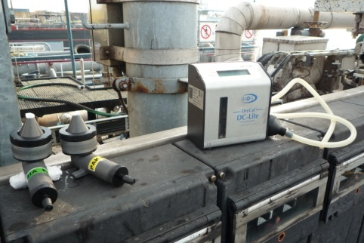

Separate samples were collected in parallel for the measurement of total hydrocarbon concentration (THC) and AH levels. Personal air samples were collected in the breathing zones of the on-board and onshore operators and an area sample located near an exhaust vent or hatch used to expel vapours as the tank was being filled. A background sample was also taken at an onshore location upwind of the loading site. The background sample concentrations were subtracted from the personal and area measurements to provide a robust assessment of exposures from the barge loading operation independent of any exposures resulting from emissions at the terminal storage facility. Background hydrocarbon levels ranged from non-quantifiable to 0.015 mg/m3 for the aerosol samples and non- quantifiable to 0.109 mg/m3 for the vapour samples. The pictures shown in **Figure 3** depict the placement of the BIA sampling cassettes for the collection of personal, area, and background samples; whereas **Figure 4** shows a heavy fuel oil barge docked at a loading terminal.

Figure 3 Photographs depicting the placement of samplers for THC and AH measurements

B - Area sampling

A - Personal sampling

C - Background sampling

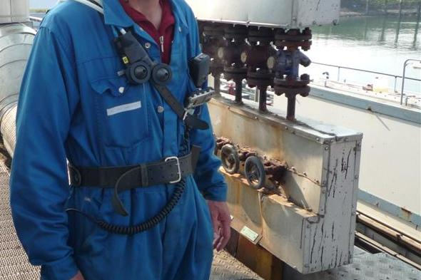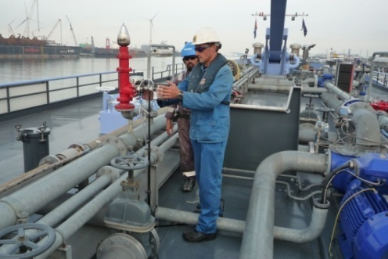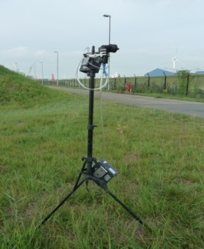

Figure 4 Photograph of a typical barge loading facility

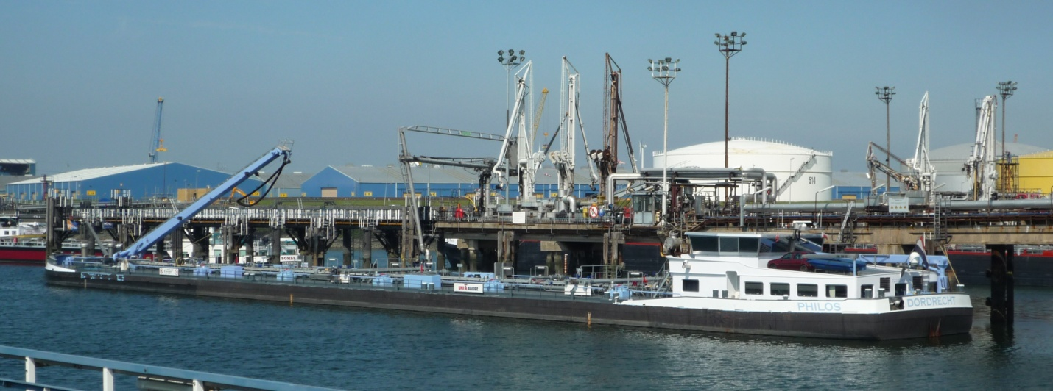

## 

## Condensates

To improve the reliability of inhalation exposure and hazard evaluations with complex petroleum substances, it has been customary to generate fume condensates that capture the volatile fraction that can be readily inhaled or emitted into the air (Kriech et al., 2007). This approach has been used successfully to obtain condensates of emissions from hot bitumen for further detailed analysis in occupational exposure determinations and toxicology assays (Pohlmann et al., 2001). The HFO research programme built off the successful application of these techniques and used a fume condensate to evaluate the nature and magnitude of volatile emissions, exposures, and hazards associated with barge loading. The generation of an HFO condensate provided a representative sample of the volatile emissions that would be expected to occur at the elevated temperatures required for a barge loading operation. A diagrammatic representation of the condensate generator is depicted in **Figure 5**. Condensates were generated at temperatures of 70, 80, and 90 °C. The highest temperature of 90 °C was greater than the temperature encountered during the field study for barge loading and was selected to obtain a worst case estimate of the emissions that could take place during the loading operation. After several analytical characterisations the condensates were used to determine mutagenic potential in a modified reverse mutation assay (ASTM 1687-10). Details concerning the generation and characterization of the condensates are contained within the report placed in **Appendix 1**.

The apparatus was operated by continuously feeding a litre of the bulk HFO sample through an oven that contained an evaporator coil. The flow rate of 300 mL/h was maintained using a peristaltic pump. A pre-heated nitrogen stream of 1 L/min was fed over the surface of an oil layer covering the bottom of the evaporator. Vapours captured by the nitrogen flow were then chilled down to 4 °C in a Peltier cooler, which caused the vaporized compounds to condense and drip into a collection flask.

Figure 5 Diagram of the HFO condensate generator

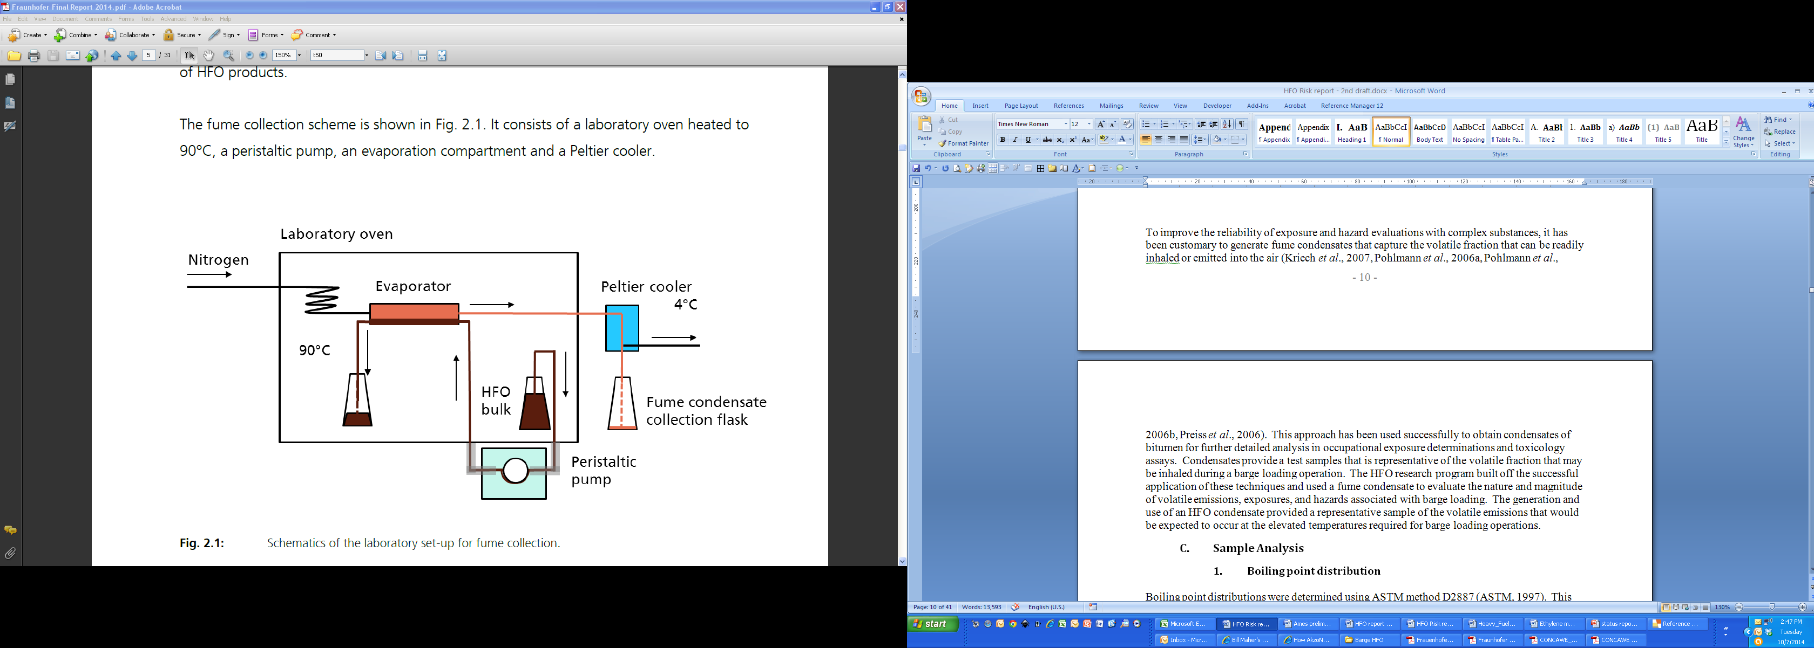

## Sample Analysis

The personal and areas samples collected in conjunction with this study were analysed for boiling point distribution, fluorescence, vapour and aerosol hydrocarbon levels, and vapour and aerosol AH. Detailed AH measurements were performed on bulk HFO samples and condensates. Full details of the analytical methodologies employed are provided in the full report which is attached as **Appendix 1**.

### Boiling point distribution

Boiling point distributions were determined using ASTM method D2887 (ASTM, 1997). This method is capable of providing a simulated distillation of petroleum fractions with boiling point range of 55.5 to 538 °C. A Hewlett-Packard 5890 Series II Plus gas chromatograph equipped with a flame ionization detector was used to determine the boiling point distributions of the condensate, filter, resin, and bulk HFO samples. A split/splitless injector was used in combination with an Agilent 30 m DB-5ms non-polar capillary column (0.32 mm i.d and 0.25 μm film thickness) and a helium carrier gas. The temperature programme included an initial 3 min phase at 40 °C followed by 9 °C/min change up to 120 °C and then an 11 °C/min change up to 320 °C.

The gas chromatograph was calibrated using an ASTM standard n-alkane mixture that was handled in the same manner as the samples. The standard ASTM calibration mixture contains C5–C44 straight chain alkanes at a known concentration. Measurements are accomplished by equating each alkane with a specific boiling point and quantifying the percent contribution of each hydrocarbon peak to the total integrated area under the chromatographic curve. **Table 2** gives the boiling points associated with each alkane found in the chromatogram.

Table 2 Boiling points for the alkanes used for calibration in the BP distribution assay

|  |  |  |  |  |  |
| --- | --- | --- | --- | --- | --- |
| **Alkane Carbon #** | **Boiling Point**  **(°C)** | **Boiling Point**  **(°F)** | **Alkane Carbon #** | **Boiling Point**  **(°C)** | **Boiling Point**  **(°F)** |
| 5 | 36 | 97 | 25 | 402 | 756 |
| 6 | 69 | 156 | 26 | 412 | 774 |
| 7 | 98 | 208 | 27 | 422 | 792 |
| 8 | 126 | 259 | 28 | 431 | 808 |
| 9 | 151 | 304 | 29 | 440 | 825 |
| 10 | 174 | 345 | 30 | 449 | 840 |
| 11 | 196 | 385 | 31 | 458 | 856 |
| 12 | 216 | 421 | 32 | 466 | 871 |
| 13 | 235 | 455 | 33 | 474 | 885 |
| 14 | 254 | 489 | 34 | 481 | 898 |
| 15 | 271 | 520 | 35 | 489 | 912 |
| 16 | 287 | 549 | 36 | 496 | 925 |
| 17 | 302 | 576 | 37 | 503 | 937 |
| 18 | 316 | 601 | 38 | 509 | 948 |
| 19 | 330 | 626 | 39 | 516 | 961 |
| 20 | 344 | 651 | 40 | 522 | 972 |
| 21 | 356 | 674 | 41 | 528 | 982 |
| 22 | 369 | 695 | 42 | 534 | 993 |
| 23 | 380 | 716 | 43 | 540 | 1004 |
| 24 | 391 | 736 | 44 | 545 | 1013 |

Bulk HFO samples and condensates were dissolved in dichloromethane prior to injection; whereas the workplace resin and filter samples were extracted with dichloromethane then combined and concentrated prior to analysis. The curve resulting from the boiling point analysis was used to determine a T50 value which is the temperature at which 50% of the available volatiles evaporated.

### Fluorescence

Ultraviolet fluorescence was employed to measure total 4–6 ring PAHs in the various samples (Kriech et al., 2002, Osborn et al., 2001). This method has been shown to detect both straight and alkylated PAHs at an excitation wavelength of 385 nm and an emission wavelength of 415 nm. In contrast, 2-3 ring PAHs have been shown to be minor fluorescent contributors at the wavelengths employed. Fluorescence intensity was measured using a 1 cm cuvette placed in Shimadzu RF-1501 spectrofluorometer. Bulk and condensate samples were dissolved in cyclohexane prior to analysis. Calibration was accomplished using known concentrations of 9,10‑diphenyl-anthracene (DPA) as reference standard. All results were expressed as DPA equivalents for the bulk samples (mg/kg DPAeq) and condensates (mg/L DPAeq).

### Total hydrocarbons

Total hydrocarbon (THC) measurements were based on BIA method 6305 (IFA, 1997). The method is based on a Fourier transform infrared spectroscopy determination of the absorption resulting from the stretching of aliphatic CH bonds at wavelengths between 2800 and 3000 cm-1. The method is non-specific and does not differentiate between different classes of hydrocarbons or different congeners within a class. Workplace filter and resin samples were analysed separately following extraction with tetrachloroethene. A Bruker Vector 22 Fourier transform infrared spectrometer was used for the analysis. The instrument was calibrated using mineral oil (Aldrich No. 16.140-3) since a specific reference standard does not exist for HFOs. Results are reported as mg/m3 of mineral oil equivalents. The limit of quantitation (LOQ) was 0.05 mg in extract; the corresponding exposure concentration was calculated based on the sampled air volume; results below the limit of quantitation are presented in the Tables as < calculated exposure concentration as per EN 32645.

### (Polycyclic) Aromatic Hydrocarbons

Two AH-specific methods were employed depending upon whether workplace samples or bulk/condensates were analysed. The methods differed with respect to the chromatographic conditions used, the types of AHs capable of being examined, and the extraction procedure. Both methods utilized an Agilent Technologies 6890 gas chromatograph with a 6783 B autosampler and a mass selective detector operator operated in the selective ion mode. A split/splitless injector was also used in combination with an Agilent 60 m DB-35ms capillary column (0.25 mm i.d and 0.25 μm film thickness) and helium as the carrier gas. The LOQ of the standard was 10 ng.

#### Bulk products and condensates

For bulk HFO samples and HFO condensates, the concentration of naphthalene and 21 individual PAHs were determined by the GC-MS method of Grimmer (Grimmer et al., 1997). These PAHs included members with ring numbers ranging from 3 to 6 and are listed in **Table 9**. The temperature programme used for chromatographic separation began with an initial temperature of 75 °C, which was increased 15 °C/min up to 200 °C, 5 °C/min up to 280 °C, 10 °C/min up to 300 °C, then finally 10 °C/min up to 340 °C. The bulk fuel oil samples were diluted in toluene and spiked with a deuterated form of each PAH prior to clean-up on a silica gel column.

The silica gel (0.063–0.200 mm) was first conditioned then suspended in cyclohexane and placed into glass columns. The diluted sampled was placed on the column and eluted with 320 ml of cyclohexane. Two fractions of 70 and 250 ml were collected and the first was discarded. The second fraction was reduced in volume to about 10 ml in a rotary evaporator then 2–3 ml of 2-propanol was added before finally concentrating the sample down to about 0.1–1.0 ml depending upon the PAH being analysed.

#### Workplace samples

The aerosol and vapour phase workplace samples were analysed for naphthalene, pyrene, and benzo[a]pyrene. These three AHs provide an indication of the distribution of 2‑ring, 4-ring, and 5-ring AHs in the workplace air. The measurement of pyrene, and benzo[a]pyrene provides an indication of those PAHs with a CMR (Carcinogenic, Mutagenic and Reprotox Substances) classification ranging from C2 (suspected to have CMR potential) for naphthalene to C1B (presumed to have CMR potential) for benzo[a]pyrene (CNRS, 2011).

The temperature programme used for chromatographic separation started at an initial temperature of 75 °C for 1.5 min which was increased 15 °C/min up to 200 °C, 5 °C/min up to 280 °C, then finally 10 °C/min up to 300 °C. The resin and filter samples were extracted with dichloromethane using an ultrasonic bath or reflux condenser respectively. Deuterated naphthalene, pyrene, and benzo[a]pyrene were added to the extracts as internal standards prior to injection and detection in the selective ion mode.

## Mutagenicity testing

The mutagenicity of nine HFO condensates was evaluated using a modified Ames assay that was optimized to yield highly sensitive indications of genotoxicity for water-insoluble petroleum products (ASTM, 2010). The assay employed *Salmonella typhimurium* strain TA 98 with the *his*D3052/R-factor mutation (R-factor being the plasmid pKM101 which increases error-prone DNA repair) and a series of additional mutations (*uvrB*, *rfa*, *gal*, *chl* and *bio*) since it is the most sensitive to PAH-induced mutations. An extraction with dimethyl sulfoxide (DMSO) was applied to concentrate the polar components present in the test sample (i.e. all aromatic and polyaromatic compounds and some cycloalkanes) and to obtain an aqueous compatible solution that could be applied directly to the agar plates. In addition, this modification of the Ames’ test applies hamster instead of rat liver S9 fraction and higher concentrations of NADPH as these modifications were found to increase the sensitivity to mutagenic constituents of petroleum substances significantly whereas the standard mutagenicity assays (i.e. the ‘normal’ Ames’ test, micronucleus tests, chromosomal aberration tests, mouse lymphoma assays) may provide false negative results or ambiguous outcomes (Blackburn et al., 1986; Blackburn et al., 1996). The HFO condensate and DMSO were mixed at a ratio of 1:5 for at least 30 minutes prior to the preparation of five dosing solutions that included the undiluted extract as the highest concentration. A fortified Aroclor 1254-induced hamster liver S-9 fraction was used for metabolic activation. A positive control (Reference Oil 1) was included in each assay, which was extracted with three volumes of DMSO before plate application. The values from the test sample were considered valid if the number revertant colonies from the positive control were at least three times higher than the number observed for the negative DMSO control (solvent control) and the positive control was within the historical control range. The solvent control and the positive control samples produced on average 44 ± 6 (SD) and 138 ± 22 (SD) revertant colonies per plate (n = 15), respectively. Each HFO sample was analysed in triplicate at nine dose levels ranging from 2.5–60 μg/plate. A mutagenicity index (MI) was calculated as the slope of the final dose response curve. If cytotoxicity occurred at higher dose levels, only the initial part of the dose response curve was used to calculate the MI. If the slope of the dose response curve was not statistically significantly different from zero, the MI was reported as zero. The results from the modified Ames assay were considered to be insignificant if the MI was less than 1. Full details of the test method are provided in the full report which is attached as **Appendix 3**.

## Emissions estimation

Several different approaches can be taken to estimate total hydrocarbon emissions from inland waterway barges. Empirical methods have been published that take advantage of observed relationships between the rate of emission and some physical or chemical characteristics of the petroleum product; however the results obtained using these approaches are unsatisfactory. Other mathematical approaches take advantage of procedures that have been developed by organizations such as the U.S. Environmental Protection Agency (USEPA), the UK Environment Agency (EA), and Concawe (Concawe, 2009, EA, 2007, USEPA, 2008). These three methods were adapted for use with HFOs handled at elevated temperatures by making adjustments for the vapour pressure increase and density decrease that would be encountered. A barge loading scenario was created that allowed use of the emission factors to calculate the mass of volatile hydrocarbons that would be released under worst case conditions. **Table 3** lists the default values used in this loading scenario. Further details on the methodological approach for the emission factor estimation study are provided in **Appendix 4**.

Table 3 Typical barge loading characteristics for a commercial HFO (UN 3082)

|  |  |
| --- | --- |
| **Parameter** | **Value** |
| Capacity of cargo typical barge | 3,000–6,000 metric tons - max up to 13,000 metric tons |
| Number of tanks on a typical barge | 10–18 tanks |
| Loading rate | 500–800 tons/hr - max up to 1,000 tons/hr |
| Loading duration | 6–10 hours (rate designed to minimize splash) |
| Tank hatches | Not opened |
| Vapour movement | Pushed back into pipes (collector) that run to a single vent that is more than 5 m away from permanent worksites |
| Size of vent on barge | 2 meters high by 15–25 cm in diameter |
| Location of other vents | Loading arm, loading side of stack (at end of loading, loading arm is sometimes emptied to barge, sometimes to buffer tank on shore with vent to atmosphere 4–6 meters high) |
| Visible vapour from the vents | None |
| Temperature of product at storage (max) | 80–90 °C (not well controlled) |
| Temperature during loading (typical) | 80 °C |
| Heating capability on barge | Some barges are equipped with heating |
| Temperature decrease during transport | 1–2 °C/day |
| Valve operation | 2 employees and 8-hour shifts: one crewman and another on land at loading facility. Land operator may supervise more than one barge |
| Exposure source | Crewman - exposed continuously from barge vent  Landsman - only potentially exposed for very short duration (at emptying and disconnecting loading arm) |
| Equipment | Crewman - standard PPE (overall, shoes, gloves, helmet, goggles, life jacket)  Landsman - standard PPE as noted above |
| H2S monitoring | Workers wear monitor with alarm; carry evacuation mask |

# Results

## Bulk Samples and Condensates

### Boiling point distribution

The boiling point distribution for the five bulk samples collected during the barge exposure survey at the three sites are shown in **Figure 6**. The results are quite similar for four of the five samples with the yellow sample showing a higher percentage of hydrocarbons boiling at temperatures below 425 °C. This difference was also apparent in the fume condensates with the yellow sample showing a noticeably greater amount of higher boiling hydrocarbons (see **Figure 7**). As expected, the T50 values for the condensates and bulk samples are very different. The largest difference of 173 °C was observed for the yellow samples where the condensate T50 was 402.1 °C and the bulk value was 228.9 °C. The difference observed with the yellow sample indicates that the volatility and opportunity for exposure would be lower with this HFO because the increased boiling point profile indicates a lower overall vapour pressure.

Figure 6 Boiling point distributions for the bulk HFO samples taken from the five barges under study

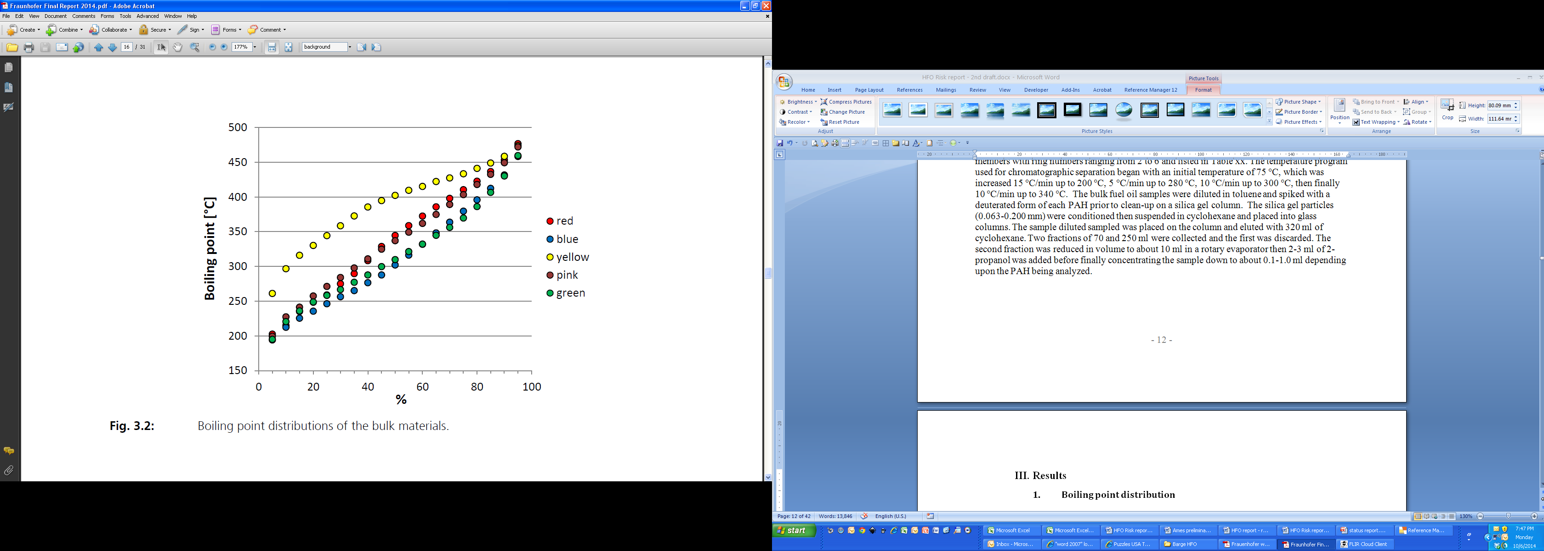

**Percent**

Figure 7 Boiling point distributions of fume condensates collected from the five bulk HFO fuel sample

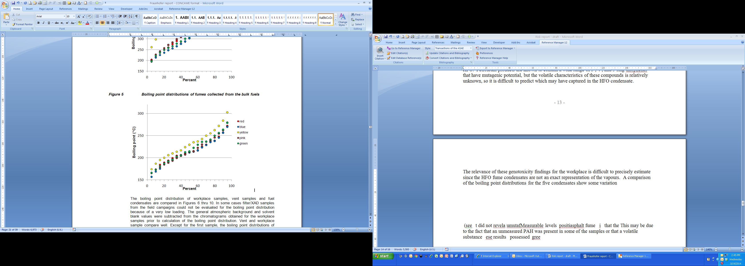

Further comparative analysis showed that the boiling point distributions of the condensate samples differed noticeably from the personal monitoring samples. Comparisons of the condensates with the personal monitoring samples were possible for 4 of the 5 HFOs examined (insufficient sample volume with the yellow sample), and, as shown in **Figure 8**, some differences can be observed. The boiling point distribution of the red workplace sample was very similar to the condensate except at the lowest and highest 10 % of the distribution. The condensate from the green, blue, and pink samples showed a shift towards higher boiling hydrocarbons relative to the workplace samples, which may have been due to the use of 90 °C as the condensate generation temperature. Unfortunately, a boiling point distribution profile was not available for the yellow personal monitoring sample so a comparison could not be made with the condensate profile. The comparisons for the remaining four samples show that the condensates came reasonably close to replicating the boiling point profile observed with the personal monitoring samples; however, the profiles were not perfectly aligned. Several of the condensates showed a 20–60 °C difference that was evident throughout most of the distribution except the highest 10%, where the worker samples contained a greater amount of higher boiling hydrocarbons than the condensate. These differences in the boiling point distribution profiles indicate that the condensates were not perfectly representative of the chemical characteristics of the vapour mixture that the employees were exposed to during the barge loading operation. However, since the condensates generally contained a greater percentage of those high boiling hydrocarbons of occupational concern, they provided a suitable worst case surrogate of the vapours that could be generated in the workplace environment.

Since the condensate was prepared at a temperature of 90 °C and the HFO temperature on the barges ranged from 72–81 °C, the difference in boiling point distribution for the condensate and personal samples may simply be the result of the volatility differences that would be expected.

Figure 8 Comparison of boiling point distributions for the bulk sample, fume condensate, worker personal ample and vent in four of the five barges examined

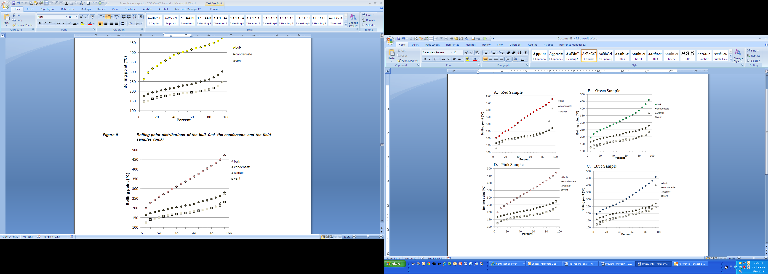

### 

### Fluorescence

Florescence measurements with the bulk samples and condensates are depicted in **Table 4** for the five HFOs handled during the barge loading operations. The fluorescence intensity of the condensates were 1358–5000 times lower than the bulk sample indicating that a majority of the 4–6 ring PAHs in the bulk sample did not volatilize and did not get captured in the condensate.

Table 4 Fluorescence intensity of bulk fuel samples and condensates

|  |  |  |  |
| --- | --- | --- | --- |
| **Code** | **Bulk**  **(mg/kg DPAeq)** | **Condensate (mg/L DPAeq)** | **Reduction factor** |
| Red | 25900 | 7.70 | 3364 |
| Blue | 23700 | 4.74 | 5000 |
| Yellow | 23500 | 17.3 | 1358 |
| Pink | 24200 | 7.17 | 3375 |
| Green | 27400 | 7.53 | 3639 |

## Personal and Area Samples

### Total Hydrocarbons (THC)

Results for the THC measurements yielded some very useful information on the magnitude of exposure for the on-board and onshore workers. The total hydrocarbon exposures of employees working onshore were considerably lower than those working on-board the barge. The surveyed loading durations ranged from 1.5 hours (partial loading) to 16 hours. In occupational hygiene practice it is customary to adjust personal exposure sample results to a reference period of 8 hours, however in this research the actually measured exposure levels during loading are reported, as this is considered more representative for worker exposures independently of the size of vessel being loaded. A comparison of the THC values for both vapours and aerosols presented in **Tables 5** and **6** reveals that the exposure concentrations ranged from about 0.46–16.01 mg/m3 for on-board workers and 0.15–<0.36 mg/m3 for those onshore. The average exposure of 6.13 mg/m3 for the on-board operators is approximately 20-fold higher than the 0.26 mg/m3 average exposure for those working onshore. These results are not surprising given the closer proximity of the on-board employees to emission sources and the higher hydrocarbon concentrations that are anticipated to be present on the barge. For all but a few of the samples the THC mist levels were below the limit of quantitation. THC background levels did not contribute appreciably to the overall exposures and were non-quantifiable for the aerosol samples and ranged from non-quantifiable to 0.109 mg/m3 for the vapour samples (**Appendix 1**).

Table 5 Total hydrocarbon exposures for on-board workers*

|  |  |  |  |  |  |
| --- | --- | --- | --- | --- | --- |
| **Site Code** | **Background**  **conc. (mg/m3)** | | **Exposure for on-board workers conc. (mg/m3)** | | |
| **Aerosol conc.** | **Vapour conc.** | **Aerosol conc.** | **Vapour**  **conc.** | **Total**  **conc.** |
| Red | <0.05 | <0.05 | <0.058 | 0.841 | 0.841 |
| Blue | <0.089 | < 0.089 | <0.123 | 16.01 | 16.01 |
| Yellow | <0.124 | <0.124 | <0.305 | 0.457 | 0.457 |
| Pink | <0.056 | 0.056 | <0.073 | 10.19 | 10.19 |
| Green | <0.024 | 0.109 | <0.067 | 3.16 | 3.16 |

* background measurements have been subtracted from the monitoring results

Table 6 Total hydrocarbon exposures for onshore workers*

|  |  |  |  |  |  |
| --- | --- | --- | --- | --- | --- |
| **Site Code** | **Background**  **conc. (mg/m3)** | | **Exposure for onshore workers conc. (mg/m3)** | | |
| **Aerosol conc.** | **Vapour conc.** | **Aerosol conc.** | **Vapour**  **conc.** | **Total**  **conc.** |
| Red** |  |  |  |  |  |
| Blue | <0.089 | < 0.089 | <0.111 | 0.239 | 0.239 |
| Yellow | <0.124 | <0.124 | <0.208 | 0.154 | 0.154 |
| Pink | <0.056 | 0.056 | <0.284 | <0.284 | <0.284 |
| Green | <0.024 | 0.109 | <0.357 | <0.357 | <0.357 |

* background measurements have been subtracted from the monitoring results

** invalid sample result due to sample pump underperformance

Occupational exposure limits (OEL) have not been established within Europe for total hydrocarbons; however, several provinces in Canada as well as the ACGIH have set a limit of 100 mg/m3 for vapour and aerosol hydrocarbons from No. 2 diesel fuels. Some countries have created an OEL for aliphatic hydrocarbons, but the value is greater than or equal to the value for diesel fuels and does not consider exposure to mists (GESTIS, 2014b). The exposure concentrations observed for workers on-board the barge were well below this occupational exposure limit of 100 mg/m3. A closer examination of the individual results reveals that the aerosol levels were very low which indicates that the loading operation proceeded at a reasonable rate that did not lead to excessive agitation or the generation of appreciable amounts of hydrocarbon-containing mist. A comparison of the worker aerosol levels with a recently created inhalation DNEL (Derived No Effect Level) of 0.12 mg/m3 for systemic effects(Concawe, 2012a) for an 8-hour occupational exposure was not possible due to all results being below the limit of quantitation (LOQ) which in some cases was higher than the DNEL; however, in the area samples close to the exhausts (**Table 7**) somewhat lower LOQs were achieved and no aerosol was quantified either. The corresponding acute inhalation DNEL for HFO aerosol has been set at 4700 mg/m3 for a 15 minute exposure period. A DNEL of 3.5 mg/m3 has also been established for steam cracked petroleum residues, which are site-restricted HFOs that have not been blended with a cutter stock (GESTIS, 2014a). As such, it is not strictly applicable to the exposure measurements collected in this study. Inhalation DNELs have not been established for the local acute or systemic effects of HFO vapour exposures.

Table 7 Total hydrocarbon concentrations in area sample near exhaust vents*

|  |  |  |  |  |  |  |  |
| --- | --- | --- | --- | --- | --- | --- | --- |
| **Site Code** | **Sample**  **volume**  **(m³)** | **Sample**  **time (min)** | **Background**  **conc. (mg/m3)** | | **Area sample**  **conc. (mg/m3)** | | |
| **Aerosol conc.** | **Vapour conc.** | **Aerosol conc.** | **Vapour**  **conc.** | **Total**  **conc.** |
| Red | 0.832 | 330 | <0.05 | <0.05 | <0.06 | 0.279 | 0.279 |
| Blue | 0.403 | 212 | <0.089 | < 0.089 | <0.124 | 78.81 | 78.81 |
| Yellow | 0.167 | 83 | <0.124 | <0.124 | <0.299 | 30.71 | 30.71 |
| Pink | 0.969 | 488 | <0.056 | 0.056 | <0.052 | 35.35 | 35.35 |
| Green | 1.131 | 565 | <0.024 | 0.109 | <0.044 | 20.93 | 20.93 |

* background measurements have been subtracted from the monitoring results

The results for the area sampling near the exhaust vents are shown in **Table 7**. The local air concentration of THC vapours and aerosols ranged from 0.28–78.81 mg/m3across the five barges. The lowest and highest concentrations were observed in the red and blue samples. A comparison of these sampling results with those from the personal exposure monitoring failed to reveal any direct relationship, which is not surprising since the placement of area sampling equipment varied considerably across the five barges. In addition, the wind direction relative to the location of the exhaust vent or hatch opening used to discharge the displaced vapours varied for each barge. Despite being located close to the hydrocarbon emission source, the area sampling yielded measurements that were within the 100 mg/m3 exposure limits for THC. As a result, a worker spending a majority of their time in the vicinity of the exhaust plume would not be exposed to THC levels in excess of the OEL. However, because these measurements were taken outdoors, it is important to consider factors such as wind speed and wind direction, which can have decided impact on the local vapour concentration. Measurements at the loading terminals revealed that the wind speed was relatively constant at about 2–6 m/sec for the monitoring results presented herein. These relatively low wind speeds indicate that the measurements are representative of a worst case scenario and that even lower levels would have been attained if windier conditions existed. Finally, it is noteworthy that the HFO temperatures for the five loading operations were relatively constant and ranged from 72–81 °C, so the sampling results are representative of typical working conditions.

### Aromatic hydrocarbon exposures

A second BIA sampling cassette was used for the analysis of naphthalene, pyrene, and benzo[a]pyrene. These three substances were selected because they are representative of the 2‑ring, 4-ring, and 5-ring aromatic hydrocarbons that can be found in HFO samples. An analysis of the aromatic hydrocarbon content in fume condensates showed that two of these substances could be found at measurable levels. As shown in **Table 8**, naphthalene and pyrene levels could be found but benzo[a]pyrene was below the detection limits. Because of its higher volatility, the level of naphthalene in the condensates was generally 10 to 20 times higher than in the bulk samples. The level of PAHs possessing 3- or 4-rings was decidedly lower in the condensates than in the bulk samples because of their lower volatility (see **Table 9**).

Table 8 Aromatic hydrocarbon concentration in HFO sample condensates

|  |  |  |  |  |  |
| --- | --- | --- | --- | --- | --- |
| **Aromatic Hydrocarbons** | **Condensate concentration (μg/g)** | | | | |
| **red** | **green** | **pink** | **blue** | **yellow** |
| naphthalene | 36547 | 20635 | 29095 | 23781 | 9688 |
| phenanthrene | 150 | 193 | 175 | 96.3 | 228 |
| anthracene | 13.5 | 21.1 | 18.2 | 9.2 | 19.8 |
| fluoranthene | 2.6 | 1.2 | 1.7 | 1.1 | 3.0 |
| pyrene | 9.2 | 5.6 | 7.0 | 5.1 | 11.2 |
| benzo[b]naphtha[2,1-d]thiophene | 0.68 | 0.32 | 0.44 | 0.41 | 2.8 |
| benzo[c]phenanthrene | <0.18 | <0.18 | <0.18 | <0.18 | <0.18 |
| benzo[ghi]fluoranthene | <0.18 | <0.18 | <0.18 | <0.18 | <0.18 |
| benzo[a]anthracene | 0.37 | <0.18 | 0.24 | 0.26 | 1.34 |
| cyclopenta[c,d]pyrene | <0.18 | <0.18 | <0.18 | <0.18 | <0.18 |
| triphenylene | 0.26 | <0.18 | <0.18 | 0.20 | 0.79 |
| chrysene | 0.43 | 0.19 | 0.28 | 0.28 | 1.9 |
| benzo[b]fluoranthene | <0.18 | <0.18 | <0.18 | <0.18 | <0.18 |
| benzo[k]fluoranthene | <0.18 | <0.18 | <0.18 | <0.18 | <0.18 |
| benzo[j]fluoranthene | <0.18 | <0.18 | <0.18 | <0.18 | <0.18 |
| benzo[e]pyrene | <0.18 | <0.18 | <0.18 | <0.18 | <0.18 |
| benzo[a]pyrene | <0.18 | <0.18 | <0.18 | <0.18 | <0.18 |
| dibenzo[a,h]anthracene | <1.0 | <1.0 | <1.0 | <1.0 | <1.0 |
| coronene | <1.0 | <1.0 | <1.0 | <1.0 | <1.0 |
| indeno[1,2,3-cd]pyrene | <1.0 | <1.0 | <1.0 | <1.0 | <1.0 |
| anthanthrene | <1.0 | <1.0 | <1.0 | <1.0 | <1.0 |
| benzo[ghi]perylene | <1.0 | <1.0 | <1.0 | <1.0 | <1.0 |

Table 9 Aromatic hydrocarbon concentration in bulk samples

|  |  |  |  |  |  |
| --- | --- | --- | --- | --- | --- |
| **Aromatic Hydrocarbons** | **Bulk sample concentration (μg/g)** | | | | |
| **red** | **green** | **pink** | **blue** | **yellow** |
| naphthalene | 2146 | 2466 | 149 | 1990 | 1422 |
| phenanthrene | 669 | 781 | 252 | 710 | 898 |
| anthracene | 83.5 | 97.3 | 23.5 | 83.5 | 102 |
| fluoranthene | 44.8 | 45.8 | 14.3 | 24.9 | 24.5 |
| pyrene | 343 | 348 | 61.9 | 209 | 194 |
| benzo[b]naphtha[2,1-d]thiophene | 177 | 110 | 125 | 28.7 | 25.3 |
| benzo[c]phenanthrene | 18.3 | 18.1 | 15.5 | <2.5 | 2.7 |
| benzo[ghi]fluoranthene | n.s. | n.s. | n.s. | <2.5 | <2.5 |
| benzo[a]anthracene | 147 | 130 | 129 | 13.1 | 13.8 |
| cyclopenta[c,d]pyrene | 7.6 | 7.6 | 6 | 2.9 | 2.6 |
| triphenylene | 52.6 | 59.6 | 54 | 6.1 | 7 |
| chrysene | 178 | 162 | 195 | 15.7 | 18.5 |
| benzo[b]fluoranthene | 35.6 | 35.5 | 39.6 | 3.3 | 4.2 |
| benzo[k]fluoranthene | 10.2 | 10.2 | 8.9 | <2.5 | <2.5 |
| benzo[j]fluoranthene | 13.9 | 12.2 | 14.3 | <2.5 | <2.5 |
| benzo[e]pyrene | 105 | 125 | 55.5 | 9 | 11 |
| benzo[a]pyrene | 101 | 96.3 | 62.5 | 6.9 | 8.7 |
| dibenzo[a,h]anthracene | 9.6 | 10.9 | 9.8 | <2.5 | <2.5 |
| coronene | 8.1 | 7.4 | 3.1 | 3 | <2.5 |
| indeno[1,2,3-cd]pyrene | 9.1 | 10.8 | 6.9 | <2.5 | <2.5 |
| anthanthrene | 25.8 | 24.7 | 13 | 2.5 | 3.1 |
| benzo[ghi]perylene | 91.3 | 77 | 18.9 | 15.7 | 10.2 |

n.s.- not specified, peak overlapping

The personal monitoring results for on-board and onshore workers are presented in **Tables 10** and **11** for the vapour samples. The measurements revealed that benz[a]pyrene was below quantitation levels in both the on-board and onshore samples and that pyrene could only be detect in 2 of 5 on-board personal samples at levels of 0.05 and 0.06 μg/m3. In the German reference document TRGS 910, a tolerance level of 700 ng/m3 and an acceptance level of 70 ng/m3 are presented for benz[a]pyrene; all but one of the concentrations calculated to correspond to the LOQ were below the acceptance level (**Tables 10, 11**) benz[a]pyrene). A specific OEL for pyrene does not exist but there is a limit for coal tar pitch volatiles, which has a TWA value of 0.2 mg/m3 for the sum total of anthracene, benzo[a]pyrene, phenanthrene, acridine, chrysene, and pyrene in the benzene soluble fraction. This value is recognized in the US, Singapore, South Korea, and New Zealand, but a comparable value is not available for Europe (GESTIS, 2014b). A somewhat smaller value of 0.14 mg/m3 has been promulgated in Ireland. Regardless of the basis for comparison, the pyrene exposures for on-board and onshore personnel were at least 2 orders of magnitude below the OELs of critical concern.

As expected from an examination of the condensate measurements, naphthalene levels were higher than for pyrene or benzo[a]pyrene. Workers on-board the barges displayed personal naphthalene exposure levels up to 0.20 mg/m3 (199 μg/m3). Numerous countries within the EU have established an exposure limit of 50–53 mg/m3 for naphthalene. Austria, France, Italy, Ireland, Sweden, Switzerland, and The Netherlands have established an 8-hr TWA limit of 50 mg/m3, which is the most applicable standard for evaluating occupational health risk (GESTIS, 2014b). German reference document TRGS 900 presents an OEL value of 0.5 mg/m3. Naphthalene aerosol was found at measurable levels in single personal sample for an on-board worker at a value of 0.004 μg/m3, with the remainder of the samples being below the quantitation limit (**Appendix 1**). The European Commission’s Scientific Committee on Occupational Exposure Limits (SCOEL) has deferred establishing an OEL for naphthalene until more information becomes available on its carcinogenic potential (EC, 2010). Based on more recent data, the Health Council of The Netherlands has decided that naphthalene is not classifiable as to its carcinogenic properties since, despite its being a rodent carcinogen, evidence strongly supports the notion that naphthalene is not carcinogenic to humans (Health Council of The Netherlands, 2012; Bailey et al., 2015). The average naphthalene exposure concentration for the five on-board operators was 65.18 μg/m3, which is more than 700-fold lower than an OEL of 50 mg/m3 and also well below the German OEL.

Table 10 Aromatic hydrocarbon vapour exposures for on-board workers*

|  |  |  |  |  |  |  |
| --- | --- | --- | --- | --- | --- | --- |
| **Site Code** | **Background**  **conc. (μg/m³)** | | | **Personal sample**  **conc. (μg/m³)** | | |
| **Naphthalene** | **Pyrene** | **Benzo[a]pyrene** | **Naphthalene** | **Pyrene** | **Benzo[a]pyrene** |
| Red | 0.12 | <0.008 | <0.008 | 20.6 | <0.012 | <0.012 |
| Blue | 2.3 | 0.01 | <0.018 | 199.3 | 0.05 | <0.021 |
| Yellow | 0.08 | <0.025 | <0.025 | 3.7 | <0.061 | <0.061 |
| Pink | 0.15 | <0.011 | <0.011 | 90.3 | 0.06 | <0.015 |
| Green | 0.95 | <0.007 | <0.007 | 12.0 | <0.013 | <0.013 |

* background measurements have been subtracted from the monitoring results

Table 11 Aromatic hydrocarbon vapour exposures for onshore workers*

|  |  |  |  |  |  |  |
| --- | --- | --- | --- | --- | --- | --- |
| **Site Code** | **Background**  **conc. (μg/m³)** | | | **Personal sample**  **conc. (μg/m³)** | | |
| **Naphthalene** | **Pyrene** | **Benzo[a]pyrene** | **Naphthalene** | **Pyrene** | **Benzo[a]pyrene** |
| Red | 0.12 | <0.008 | <0.008 | 5.9 | <0.009 | <0.009 |
| Blue | 2.3 | 0.01 | <0.018 | 2.9 | <0.022 | <0.022 |
| Yellow | 0.08 | <0.025 | <0.025 | 0.19 | <0.041 | <0.041 |
| Pink | 0.15 | <0.011 | <0.011 | 0.69 | <0.056 | <0.056 |
| Green | 0.95 | <0.007 | <0.007 | 1.2 | <0.074 | <0.074 |

* background measurements have been subtracted from the monitoring results

Although the area samples collected in the vicinity of the exhaust vent were higher than those seen for on-board and onshore personal samples, the main difference between the two sample types were restricted to naphthalene. As shown in **Table 12**, the concentrations of naphthalene, pyrene and benzo[a]pyrene in the area samples near exhaust vents were higher than those seen in the personal samples. The naphthalene vapour levels in the area samples rose to as high as 1.5 mg/m3, exceeding the German reference value for 8 hour exposures, in one barge loading operation (‘blue’), yet neither the bulk nor the condensate product showed an elevated naphthalene level (**Tables 8 and 9**). It is worth noting that the area samples were not representative of personal exposures but intended to be merely source-related samples and as such should not even feature as worst-case exposure samples, as there is no requirement for the crew to spend extended time periods close to the exhaust vents.

Table 12 Aromatic hydrocarbon vapour exposures in background and area samples near exhaust vents*

|  |  |  |  |  |  |  |  |  |
| --- | --- | --- | --- | --- | --- | --- | --- | --- |
| **Site Code** | **Sample volume (m³)** | **Sample time (min)** | **Background**  **conc. (μg/m³)** | | | **Area sample**  **conc. (μg/m³)** | | |
| **Naphthalene** | **Pyrene** | **Benzo[a]pyrene** | **Naphthalene** | **Pyrene** | **Benzo[a]pyrene** |
| Red | 0.660 | 330 | 0.12 | <0.008 | <0.008 | 3.4 | <0.015 | <0.015 |
| Blue | 0.413 | 212 | 2.3 | 0.01 | <0.018 | 1489 | 0.02 | n.a. |
| Yellow | 0.168 | 83 | 0.08 | <0.025 | <0.025 | 299 | <0.06 | <0.06 |
| Pink | 0.969 | 482 | 0.15 | <0.011 | <0.011 | 684 | 0.04 | <0.01 |
| Green | 1.123 | 565 | 0.95 | <0.007 | <0.007 | 260 | <0.009 | <0.009 |

* background measurements have been subtracted from the monitoring results

n.a. - not available

Whereas static aerosol sampling occasionally detected the presence of some mist, only 1 in 5 of the on-board samples and none of the onshore samples were above the quantitation limit for any of the three AHs examined (**Appendix 1**). Given the very low levels and the failure to consistently detect measurable aerosol levels, it can be concluded that misting is not occurring to any appreciable degree during the submerged loading of HFOs onto barges.

## Mutagenicity testing

The results from the first round of testing with condensates generated at 90 °C produced equivocal results with the mutagenicity index ranging from 0.02-9.0 for the five HFO samples. These unexpected findings were ultimately attributed to reproducibility problems with the assay due to false interpretation of the plate readings. Initially, the colonies on the plates were counted with an automated reader which was not properly calibrated for the high concentrations of hamster liver S9 fractions and interpreted the hamster liver preparation erroneously as microcolonies. Therefore, a new round of testing was performed in which the results of the automated plate reader were checked manually. The second round of testing was conducted using a set of three bulk HFO samples collected at the same three loading terminals involved in the exposure study. These new condensate samples were compositionally equivalent to those examined in the first round of testing with similar AH profiles and fluorescence intensities. Condensates were prepared from each bulk sample at temperatures of 70, 80, and 90 °C. The temperatures were selected to cover the range of temperatures that are normally encountered during barge loading. Details regarding the analytical characterization of the nine HFO condensates are presented in **Appendix 2**. This includes measurements of the boiling point distributions, AH content, and total fluorescence. An examination of the AH concentration ratio in the bulk HFO samples and condensate shows that the generation temperature did not appreciably impact the AH content in the condensates (see **Figure 9**).

Figure 9 Comparison of the AH ratio for bulk and condensate samples at the three recovery temperatures

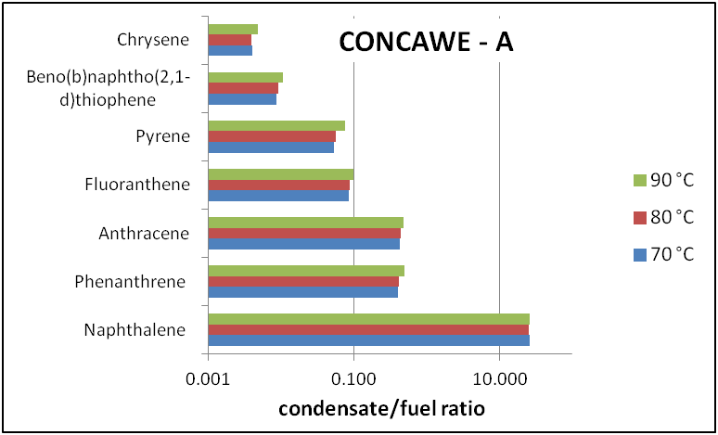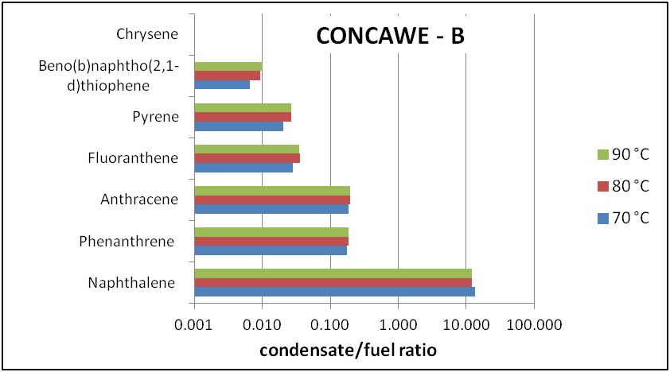

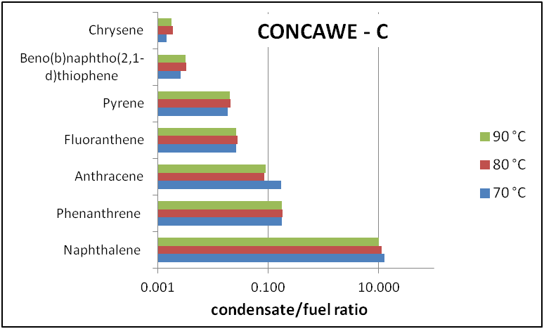

The results of the mutagenicity testing with the nine HFO condensates are presented at **Table 13**. The positive control samples were approximately 3 times higher than the solvent control, which indicated that the test conditions were suitable to yield valid results. In eight of the nine condensates a slight decrease was observed in the number of revertant colonies as the plate concentration increased. The resulting mutagenicity index was less than 1 in each case, indicating negligible mutagenic potential. These results are consistent with the observed decrease in fluorescence of the condensates relative to the bulk samples. The fluorescence of the condensates from samples A, B, and C was generally 2300 to 6500 times lower than the bulk preparation, indicating a sharp reduction the amount of 4- to 6-ring PAHs that were present. Furthermore, these results were corroborated by the results from the PAH analyses of the condensates which showed overall low concentrations of PAH with 4 to 7 rings.

Table 13 Mutagenic response from HFO condensates generated at three temperatures using a modified Ames test (ASTM 1687-10)

|  |  |  |  |  |  |  |  |  |  |
| --- | --- | --- | --- | --- | --- | --- | --- | --- | --- |
| **Dose**  **(μL/plate)** | **Mean ± Standard Deviation** | | | | | | | | |
| **Sample**  **A-01 (70 °C)** | **Sample**  **A-02 (80 °C)** | **Sample**  **A-03 (90 °C)** | **Sample**  **B-01 (70 °C)** | **Sample**  **B-02 (80 °C)** | **Sample**  **B-03 (90 °C)** | **Sample**  **C-01 (70 °C)\*** | **Sample**  **C-02 (80 °C)** | **Sample**  **C-03 (90 °C)** |
| positive control | 123 ± 19 | 123 ± 19 | 123 ± 9 | 130 ± 38 | 117 ± 42 | 160 ± 25 | 79 ± 15 | 76 ± 2 | 83 ± 14 |
| solvent control | 29 ± 8 | 29 ± 8 | 29 ± 8 | 41 ± 6 | 41 ± 7 | 44 ± 7 | 34 ± 5 | 36 ± 3 | 28 ± 6 |
| 2.5 | 39 ± 13 | 29 ± 7 | 48 ± 3 | 47 ± 11 | 54 ± 3 | 44 ± 10 | 43 ± 6 | 31 ± 3 | 41 ± 8 |
| 5 | 46 ± 7 | 31 ± 6 | * | 42 ± 17 | 42 ± 8 | 57 ± 3 | 42 ± 11 | 34 ± 8 | 31 ± 11 |
| 7.5 | 45 ± 10 | 34 ± 6 | 36 ± 5 | 57 ± 3 | 43 ± 3 | 57 ± 13 | 35 ± 7 | 33 ± 8 | 27 ± 8 |
| 10 | 51 ± 6 | 36 ± 8 | 184 ± 141 | 44 ± 2 | 49 ± 5 | 50 ± 5 | 38 ± 12 | 27 ± 7 | 29 ± 6 |
| 15 | 36 ± 17 | 40 ± 12 | 53 ± 33 | 50 ± 3 | 44 ± 6 | 52 ± 4 | 32 ± 6 | 16 ± 6 | 27 ± 5 |
| 30 | 48 ± 5 | 55 ± 34 | 53 ± 17 | 25 ± 2 | 23 ± 9 | 35 ± 4 | † | † | † |
| 45 | 45 ± 6 | 40 ± 4 | 42 ± 13 | † | † | 28 ± 4 | † | † | † |
| 52.5 | 37 ± 3 | 37 ± 10 | 39 ± 15 | † | † | 30 ± 9 | 57 ± 1 | † | † |
| 60 | 40 ± 8 | 22 ± 2 | 18 ± 4 | † | † | † | 23 ± 4 | † | 7 ± 4 |
| MI† | <0.1 | <0.1 | <0.1 | <0.1 | <0.1 | <0.1 | <0.1 | <0.1 | <0.1 |

* all threeplates infected

† microcolony formation

## Emission estimation

The emissions of hydrocarbons during the loading of HFO on inland barges were investigated using various approaches that have been advocated by competent authorities from the US and Europe. Empirical, mechanistic and mathematical methods were evaluated to determine their suitability for yielding reliable estimates that were applicable to HFOs meeting the UN 3082 fuel designation. The empirical approaches prove wholly unsuitable since they were unable to account for the differences in vapour pressure and density for HFOs being handled at elevated temperatures. The remaining methods showed some variability but were within an order of magnitude of one another. Two methods from Europe and one from the US were ultimately judged to provide the most reliable estimates, since they were able to compensate for the increased vapour pressure and decreased density of HFO at an assumed average loading temperature of 80 °C. The results in **Table 14** show that the USEPA method yielded the highest emission factors. The UK EA method and the Concawe method yielded factors that were approximately 2 to 4-fold lower, respectively.

Table 14 Comparison of HFO emission factors calculated by different approaches

|  |  |  |
| --- | --- | --- |
| **Method**  **(year)** | **Emission factor**  **(g/ton)** | **Comments** |
| USEPA  (2008) | 22.5 (15.7–29.2) | fully adjusted for elevated HFO loading temperature |
| Concawe  (2009) | 4.9 (2.6–6.6) | calculated from a generic formula using adjusted HFO vapour pressure |
| UK EA  (2007) | 8.9 | correction factors employed for temperature-dependent vapour pressure and density differences |

If adjustments are applied to the results from the Concawe and UK EA methods the results from the three methods merge even closer. The adjustment was based on an early Concawe study revealing that emission factor calculations for the barge loading of gasoline did not agree with Differential Absorption Lidar (DIAL) measurements (Concawe, 1995). A differential of 56% was found between the actual and estimated emission factors. Based on these findings, a 50% upward adjustment was made to those estimates that may have underestimated the true emissions. This yielded emission factor estimates ranging from 7.4 to 22.5 g/ton HFO. These are reasonably similar values given the differences in the mathematical approaches. The emission factor for volatile hydrocarbons during the barge loading of an HFO at a temperature of 80 °C is therefore estimated to be in the range of 10-20 g/ton, which is equivalent to a total mass emission of 130-260 kg for a loading duration of 10 hr on a barge capable of hauling a maximum of 13,000 tons of HFO.

# Discussion

## Exposure analysis

The preceding analysis shows that the release of volatile hydrocarbons from the loading on inland barges with a commercial HFO as surveyed in this project did not result in personal exposures that exceed the most relevant OEL of 100 mg/m3. Whereas, the use of cutter stocks containing lower molecular weight hydrocarbons was presumed to cause elevated emissions, these C9–C28 congeners were not released at particularly high levels. This may be due in part to the vapour pressure depression that occurs when they are blended into an HFO residuum from a refinery. Under these circumstances the vapour pressure of each component is essentially reduced as predicted by Raoult’s law. Unfortunately, the exact magnitude of the vapour pressure depression cannot be calculated due to the myriad of components in an HFO and the need to know the mole fraction of each component in the mixture. Measurement of personal exposures to total (vapour and aerosol) hydrocarbons did not result in any exposure measurements greater than 16 mg/m3. As shown in **Table 15**, the safety margin for total hydrocarbon exposures, not corrected for durations other than 8 hours, relative to an OEL of 100 mg/m3 ranged from 16 to 380.

Table 15 Comparison of personal monitoring measurements with applicable occupational exposure limits.

|  |  |  |  |  |
| --- | --- | --- | --- | --- |
| **Metric** | **Total hydrocarbon\*** | | **Naphthalene‡** | |
| **on-board barge** | **onshore** | **on-board barge** | **onshore** |
| avg. conc.(mg/m3) | 6.13 | 0.26 | 0.065 | 0.002 |
| 8-hr OEL (mg/m3) | 100 | 100 | 50/0.5 | 50/0.5 |
| safety margin | 16 | 380 | 770/7.7 | 25,000/250 |

* includes both vapour and aerosol measurements

‡ vapour measurements only

Although ADN specifies that the “gas/air mixture shall be returned to shore through a gas recovery or compensation pipe during loading operations”, the assumption was made that the emissions could in part exist as aerosol, and therefore a validated exposure monitoring system was adopted that could sample vapour and aerosol simultaneously. The measurement results however indicated that aerosol levels were so low as to be not-quantifiable with this system.

The main class of constituents of HFOs relevant to CMR effects are the aromatics. Concawe report 7/12 indicated a total aromatics content of 42.4% for a typical HFO component (Appendix 4 of CONCAWE, 2012b). It is generally not possible or meaningful to fully speciate this fraction at the molecular level, but it has become customary in health and environmental studies to characterise the aromatics fraction on the basis of analysis of a series of marker PAHs, such as the list proposed by the US Environmental Protection Agency or a slightly different list often used in Germany (Grimmer et al. 1997). Although these marker PAHs are not necessarily ideal representatives since the exact chemical composition of the aromatics fraction is not known, they can be reliably assessed and quantified using standard methods and will not only be relatively abundant due to their thermodynamic stability, but also have boiling points comparable to their alkylated congeners.

The levels of individual marker PAHs in the bulk product (see **Table 9**) in this study were in the same range as the levels reported in the dermal exposure study for 8 samples of heavy fuel oil or HFO blending components (Table 2 in Christopher et al, 2011), indicating that the surveyed loading operations can be considered representative of HFOs in commerce.

Benzo[a]pyrene poses the greatest toxicological hazard and has been listed has an IARC group 1 carcinogen that is capable of causing cancer in laboratory animals and humans. Benzo[a]pyrene vapour or aerosol was not quantified in a single personal or area measurement on-board or off board the barges, with the limit of quantitation generally below the German acceptance level of 70 ng/m3. In addition, benzo[a]pyrene vapour or aerosols levels were not found in any of the areas samples collected near the exhaust vents. Taken together, these data indicate that there is a negligible release and exposure to benzo[a]pyrene during the HFO barge loading operations. Likewise, aerosol transport to residential off-site locations beyond the terminal fence line was also judged to be doubtful.

Although pyrene is not considered to be carcinogenic and was categorised by IARC in group 3, which indicates inadequate evidence for inducing human or animal cancer (IARC, 2014), pyrene is considered a good and highly sensitive marker for exposure since, due to its thermodynamic stability, it is in most cases the most abundant PAH in PAH mixtures (Boogaard, 2011). Indeed pyrene was one of the more dominant PAHs in the bulk samples in this study (**Table 9**) and some detectable exposures were recorded for pyrene: quantifiable levels of pyrene were reported for 2of 10 personal vapour samples, but in none of 10 personal aerosol samples (**Appendix 1, Tables 3.15 and 3.16**). Since air quality guidelines have not been created for this PAH in Europe or North America, these levels cannot be compared to a reference value. There are several PAH-related occupational exposure limits that are applicable to pyrene. The most notable is for coal tar pitch volatiles, which includes several benzene-soluble PAHs in addition to pyrene. A comparison of the highest exposure levels for pyrene with the coal tar pitch OEL of 200 μg/m3 failed to show any evidence of overexposure or a cause for concern. A similar comparison for naphthalene levels is shown in **Table 15**. Naphthalene was found to be a rodent carcinogen, but the relevance of the available data for humans was questioned and, for that reason, the SCOEL did not derive an OEL for naphthalene in 2010 pending the availability of new data (EC, 2010). Evaluation of all available, including more recent data, strongly supports the view that naphthalene is not carcinogenic to humans (Bailey et al., 2015). The Health Council of The Netherlands reached a similar conclusion and classified naphthalene in category 3 (not classifiable as to its carcinogenicity to human) (Health Council of The Netherlands, 2012).

This study complements a previous occupational exposure study for HFO, which focussed on the dermal exposure route, which was thought to be the main exposure route of concern (Christopher et al., 2011). As in the present study, which focussed on inhalation exposures, the dermal exposures were generally found to be low.

## Mutagenicity testing

The HFO health and environmental research programme undertaken by Concawe included a hazard component despite the existence of an extensive toxicity database created in conjunction with due diligence activities and voluntary agreements (Concawe, 1998, McKee et al., 2014). Although the *in vitro* mutagenicity of HFO extracts has previously been determined for many refinery streams, the results are generally limited to site-restricted substances that have not been blended with a cutter stock to produce a commercial fuel. To better characterize the mutagenic potential of fuel-related HFOs, testing was undertaken with condensates prepared from the volatile fraction of three bulk samples collected at barge loading terminals. Condensates were prepared from each of these samples at temperatures of 70 °C, 80 °C, and 90 °C.

Modified Ames’ testing showed that all nine condensates produced a minimal change in the number of revertant colonies, yielding a mutagenicity index (MI) less than 0.1. By comparison, a commercial grade heavy fuel No. 6 sample yielded an MI of 24, which is consistent with the presence of high molecular weight (4 to 6 ring) PAHs in this type of sample (McKee et al., 2013). Furthermore, the cut-off value for mutagenicity of lubricant base oils is set at a MI value of 1.0 and for residual aromatic extracts at a MI value of 0.4 (ASTM, 2010; CONCAWE 2012c). Studies have shown that the mutagenicity of stock unblended HFOs in the modified Ames assay is quite variable depending on the source of the residuum. Analysis on separate samples of catalytically cracked clarified slurry oil show that that the MI was appreciably influenced by the percentage of PAHs with 4 to 7 rings (McKee et al., 2013).

Chemical analysis of the nine condensates used in this study showed that naphthalene was by far the most dominant aromatic hydrocarbon with lower amounts of 3- and 4-ring PAHs such phenanthrene, anthracene, and pyrene (see **Appendix 1**). Previous studies have shown that naphthalene is not genotoxic or mutagenic in the Ames assay (Brusick, 2008). Although naphthalene was shown to be a rodent carcinogen, recent insights strongly support the notion that naphthalene does not pose a human carcinogenic hazard (Baily et al., 2015; Health Council of The Netherlands, 2012). Although some 5- and 6-ring PAHs are considered to pose a human carcinogenic risk, the levels of 5- and 6-ring PAHs were below detection limits. Given the PAH distribution profile in the condensates, it can be concluded that the PAHs in the vapour phase do not pose a mutagenic risk and that workers working with HFOs at temperatures up to 90 °C are not in danger from the small amount of vapour being released.

## Emissions estimation

Contrary to the occupational exposure perspective with focus on AHs, environmental considerations are aimed at total hydrocarbons because of their potential to contribute to ground-level ozone formation and other air quality concerns. After adjusting for deviations in temperature, density, and methodological bias, a worst case total hydrocarbon emission factor of 10–20 g/ton was derived for the volatile hydrocarbons released during the barge loading of an HFO. The upper limit of this range is far below the values observed for other petroleum products such crude oil, gasoline, and petroleum distillates (see **Table 16**). Specific guideline or recommendation for VOC release during the loading or unloading of HFOs from inland waterway barges has not been issued by the European Union. In the absence of such a regulation, fuel distributors have taken extra precautions to ensure that releases are minimized during loading or unloading operation. This includes the use of submerged loading techniques to minimize agitation. Submerged loading employs a delivery pipe that extends below the liquid surface to minimize splatter and mist vapour generation. The initial rate of tank filling is also reduced to prevent excess splashing and agitation that leads to the release of vapours into the air space.

A comparison of the HFO emission factor with those for other petroleum products indicate that HFOs can be loaded onto barges without any concern of excessive emissions. As shown in **Table 16**, the worst case estimate of hydrocarbon emissions from HFO is 27-fold lower than the factor for gasoline and nearly 8-fold lower than crude oil. In addition, the USEPA endorsed emission factor for the submerge loading of an HFO onto a tank barge is 9.0 x 10-5 lb/1000 gal, which is equivalent to 0.01 g/ton of HFO shipped (USEPA, 2008). This estimate, however, assumes an average temperature during bulk loading of only 16°C (60 °F) which appears to be different from loading practices in the EU on inland waterways where the product is generally heated to improve handling.

To provide some assurance that the emission factors were not underestimated, the values were compared to factors that were roughly calculated from hydrocarbon emission measurements taken in the vicinity of the exhaust vent sites aboard the five barges. As shown in **Table 17**, these measurements yielded emission factors that generally ranged from about 0.02–0.08 g/ton, which is decidedly lower than the 10–20 g/ton estimated to be a worst case value, but reasonably close to the value of 0.01 g/ton adopted by the USEPA. Whereas the emission factors determined from the measurement data are not higher than the calculated estimates, the comparison needs be tempered with the knowledge that the measurements were not perfectly reflective of the concentrations in the exhaust stream. In many cases, the devices used for sample collection were merely located in the vicinity of an exhaust vent without any consideration of variable wind directions.

As a result, the area samples did not always record the hydrocarbon concentrations inside the exhaust plume rising through the vent. Despite these limitations, however, the samples provide a reasonable cross-check of the validity of the emission factor calculations. Overall, the estimated hydrocarbon emissions during the barge loading of an HFO show that the release factor is small and in line with the limited volatility of this product. The results further indicate that loading an HFO onto a 13,000 ton barge over a ten hour period of time would result in a total VOC mass release of 130-260 kg, which is relatively small compared to other sources. These findings are consistent with those of Environment Canada, who concluded that the evaporative fuel losses of VOCs from the storage and transport of HFOs is not a significant source of exposure or release at a production site (Environment Canada, 2013).

Table 16 Published emission factors for barge loading or degassing of fuels or hydrocarbons

|  |  |  |  |
| --- | --- | --- | --- |
| **Chemical**  **type** | **UN**  **code** | **Emission factor**  **(g VOC/ton)** | **Reference** |
| Gasoline | UN 1203 | 550 | OECD, 2009 |
| Crude  oil | UN 1267 | 137 | OECD, 2009 |
| Jet  naphtha | UN 1863 | 200 | OECD, 2009 |
| Petroleum distillates | UN 1268 | 200 | CE Delft, 2013 |
| Hydrocarbon liquids | UN 3295 | 380 | CE Delft, 2013 |
| Benzene | UN 1114 | 220 | CE Delft, 2013 |
| Flammable  liquids | UN 2398 | 240 | CE Delft, 2013 |

Table 17 Total hydrocarbon measurements in the vicinity of barge exhaust vent sites and the corresponding emission factors#†‡

|  |  |  |  |  |  |  |  |  |
| --- | --- | --- | --- | --- | --- | --- | --- | --- |
| **Site Code** | **Sample**  **volume**  **(m³)** | **Sample  time  (hr)** | **Conc. Total hydrocarbon**  **(mg/m³)** | **Total Hydrocarbon**  **mass**  **(mg)** | **Barge**  **loading time (hr)** | **Barge**  **load rate**  **(m3/hr)** | **Volume**  **displacement**  **(m3)** | **Emission factor**  **(mg/ton)** |
| Red* | 0.832 | 5.50 | 0.31 | 1424 | 5 | 922 | 4610 | 0.34 |
| Blue | 0.403 | 3.53 | 78.82 | 177347 | 3 | 750 | 2250 | 92.83 |
| Yellow | 0.167 | 1.38 | 30.75 | 43047 | 3.5 | 400 | 1400 | 12.15 |
| Pink | 0.969 | 8.13 | 35.36 | 424320 | 16 | 750 | 12000 | 17.97 |
| Green | 1.131 | 9.42 | 20.94 | 188433 | 12 | 750 | 9000 | 16.43 |

# emission factor calculations assume an HFO density of 1.0 ton/m3

† hydrocarbon levels in aerosol and vapour sample were quantitated separately and summed to arrive at a total

* aerosol level in the red sample was below the detection limit of 0.03 mg/m3 so the value imputed to be at the LOD

‡ emission factor = vent concentration x sample time x barge lode rate/load time x load rate

## Study strengths and Limitations

The research programme on the barge loading of HFOs is characterized by a number of key strengths that provide a solid basis for future decision making. Notable attributes include its comprehensive nature with personal exposures, atmospheric emissions, and health hazards independently examined and reported upon. The exposure monitoring programme included the use of sampling equipment that allowed the separate collection of aerosols and vapours so the contribution of each type of release could be assessed during the barge loading operations. In addition, state-of-the-science emissions estimation algorithms were developed that allowed the calculation of worst case atmospheric releases of total hydrocarbons during a barge loading scenario. The study also featured the generation of HFO condensates that allowed the mutagenic hazard of the volatile fraction to be determined in a modified Ames assay. Perhaps the greatest the strength of this programme was, however, the wide array of analytical techniques used to characterize, to the extent possible, the hydrocarbon composition of the various HFOs being examined.

Although the programme was well designed and executed, there are several uncertainties and limitations that need to be considered when interpreting the results. First, the number of HFO loading sites and personal samples collected during monitoring campaign was limited, although the compositional variation reported in the literature was also apparent for the HFOs included in the present study, as evidenced by the individual PAH levels in Table 9 which varied over more than an order of magnitude in some cases. This prevented a full statistical analysis of the results relative to applicable occupation exposure limits. This encumbrance was not viewed as a particularly serious problem; however, since observed personal exposure levels were uniformly low, showing little variability across the five operations surveyed. As a result, the inclusion of additional personal exposure samples would not have appreciably changed the magnitude of the exposure margin relative to the OELs. Second, the personal exposure monitoring was confined to the measurement of THC levels and a suite of three aromatic hydrocarbons deemed to be good markers of HFO exposures under actual barge loading conditions. Again, given the low exposure levels, a more refined speciation for individual hydrocarbons would not be expected to yield OEL safety margins that are different from those reported. Third, the BIA sampler employed in the study has been validated in wind speeds up to 4 m.s-1 (Kenny et al., 1997), but in one survey of the present study the outdoor wind speed exceeded that value. The type of aerosol expected however would consist of very small droplets due to condensation phenomena which are much less likely to be influenced by high wind speed than large droplets. Finally, the hazard analysis with the mist condensates was restricted to a determination of the mutagenic potential in a modified Ames assay. Although additional testing would have provided greater perspective on the range of possible hazards, the time required for a more complete evaluation would have been prohibitively long. However, the low mutagenicity indices of the fume condensates are corroborated by the low levels of PAH measured in the condensates aa well as by the low levels of fluorescence. In fact, the three independent measurements all indicate the low mutagenic hazard of the fume condensates.

# Conclusions

Measurements made in conjunction with this research programme show that naphthalene is the single most abundant aromatic hydrocarbon in the vapour blanket that is emitted during the tank filling process. The concentrations observed in area samples at or near the tank vent revealed maximum total hydrocarbon concentrations of 80 mg/m3 and maximum naphthalene values of 1.5 mg/m3 (see **Table 7** and **12**). Taken together, the exposure monitoring data indicated that the workplace controls currently in place to limit contact are sufficient to mitigate any hazards from barge loading of commercial HFOs. These controls together with institutional best practices guidelines for reducing emissions help ensure that unintentional releases and exposures do not occur.

The results of these studies indicated that during the loading of hot commercial HFO on inland waterway barges:

1. the emissions resulted only in low workplace exposures, well below limit values set by the ACGIH, for employees working on-board the barge and even lower for those working onshore at the terminal;
2. there was no release of detectable amounts of benzo[a]pyrene;
3. there was no mutagenic risk for employees based on testing in a modified Ames assay using a condensate generated under similar operating conditions; and
4. there was no substantial contribution to air emissions relative to other types of petroleum hydrocarbon cargos.

Overall, this analysis indicates that HFO emissions, exposures, and hazards during the surveyed barge loading operations of commercial HFOs, and considered representative for this operation in general, were not excessive or a source of environmental or human health concern. The studies did not indicate a need for additional control measures on the emissions of hot HFOs during barge loading beyond normal good operational practice.

# REFERENCES

1. ASTM (1997) Standard Test Method for Boiling Range Distribution of Petroleum Fractions by Gas Chromatography. D2887-97: American Society of Testing Materials, West Conshohocken, PA
2. ASTM (2010) Standard Test Method for Determining Carcinogenic Potential of Virgin Base Oils in Metalworking Fluids. E1687-10: American Society of Testing Materials, West Conshohocken, PA
3. Bailey, L. A., et al. (2015). "Hypothesis-based weight-of-evidence evaluation and risk assessment for naphthalene carcinogenesis." *Critical Reviews in Toxicology*
4. Blackburn, G. R., et al. (1986). Predicting carcinogenicity of petroleum distillation fractions using a modified Salmonella mutagenicity assay." *Cell Biol Toxicol* *2, 63-84*
5. Blackburn, G. R., et al. (1996). "Comparison of biological and chemical predictors of dermal carcinogenicity of petroleum oils." *Polycyclic aromatic compounds* *11*, 201-210
6. Boogaard, P.J. Biomonitoring of exposure to polycyclic aromatic hydrocarbons, in: Knudsen LE, Merlo DF (Eds), *Biomarkers and Human Biomonitoring*, Volume 1: Ongoing Programs and Exposures, 2011, Royal Society of Chemistry, Cambridge (ISBN: 9781849732413), UK, pp 338-359
7. Breuer, D. (1999) Measurement of vapour-aerosol mixtures. *J Environ Monitoring 1, 299-305*
8. Brusick, D. (2008) Critical assessment of the genetic toxicity of naphthalene. *Regulatory Toxicology and Pharmacology 51, S37-S42*
9. Christopher, Y. et al. (2011). An Assessment of Dermal Exposure to Heavy Fuel Oil (HFO) in Occupational Settings. *Annals of Occupational Hygiene 55, 319–328*
10. CNRS (2011) European Harmonized Classification and Labelling of Carconogenic, Mutagenic and Reproduction (CMR) Substances According to the Criteria of the CLP Regulation at the Date of the 22nd January 2011. CNRS, Prevention du Risque Chimique, Gif-sur-Yvette, France
11. CONCAWE (1998) Heavy fuel oils. Product Dossier No. 98/109. Brussels: CONCAWE
12. CONCAWE (2009) Air pollutant emission estimation methods for E-PRTR reporting by refineries, 2009 edition. Report No. 1/09. Brussels: CONCAWE
13. CONCAWE (2012a) International Uniform Chemical Information Database (IUCLID) for Heavy Fuel Oil Components. Brussels: CONCAWE
14. CONCAWE (2012b) REACH - Analytical characterisation of petroleum UVCB substances. Report No. 7/12. Brussels: CONCAWE
15. CONCAWE (2012c) Use of the modified Ames test as an indicator of the carcinogenicity of residual aromatic extracts. Report No. 12/12. Brussels: CONCAWE
16. EA (2007) Emission scenario document on transport and storage of chemicals. Bristol, United Kingdom: Environment Agency
17. EC (2010) Recommendations from the Scientific Committee on Occupational Exposure Limits for naphthalene. Brussels, Belgium: European Commission, Employment, Social Affairs, and Inclusion
18. ECE (2011) Carriage of fuel oil, heavy and fuel oil, residual. INF.25. Geneva, Switzerland: Economic Commission for Europe, Inland Transport Committee, Working Party on the Transport of Dangerous Goods
19. ECE (2013) CONCAWE/EUROPIA study on "HFO ADN Emissions and Exposure Assessment". INF.33. Geneva, Switzerland: Economic Commission for Europe, Inland Transport Committee, Working Party on the Transport of Dangerous Goods
20. Environment Canada (2013) Draft Screening Assessment Petroleum Sector Stream Approach, Fuel Oil, No. 4, Fuel Oil, No. 6, Fuel Oil, Residual. Ottawa, Ontario: Health Canada
21. Garaniya, V. et al (2011) Chemical characterization of heavy fuel oil for combustion modeling. Geneva, Switzerland
22. GESTIS (2014a) GESTIS DNEL Database. Sankt Augustin, Germany :Institute for Occupational Safety and Health of the German Social Accident Insurance [http://www.dguv.de/ifa/Gefahrstoffdatenbanken/GESTIS-DNEL-Datenbank/index.js](http://www.dguv.de/ifa/Gefahrstoffdatenbanken/GESTIS-DNEL-Datenbank/index.jsp)p
23. GESTIS (2014b) GESTIS International Limit Values for Chemical Agents. Sankt Augustin, Germany :Institute for Occupational Safety and Health of the German Social Accident Insurance

<http://limitvalue.ifa.dguv.de/Webform_gw.aspx>

1. Grimmer, G. et al (1997) Atmospheric emission of polycyclic aromatic hydrocarbons in sampling areas of the German environmental specimen bank. Method for the precise measurement of gaseous and particle-associated polycyclic aromatic hydrocarbons in the sub-nanogram range using deuterated internal standards. *Chemosphere 34, 2213-2226*
2. Health Council of The Netherlands (2012). Naphthalene - Evaluation of the carcinogenicity and genotoxicity. Report 2012/30, The Hague, December 7, 2012
3. IARC (2014) Agents Classified by the IARC Monographs, Volumes 1-109. Lyon: International Agency for Research on Cancer. <http://monographs.iarc.fr/ENG/Classification/ClassificationsGroupOrder.pdf>
4. IFA (1997) Measurement of Hazardous Substances - BGIA Arbeitsmappe [BGIA Working Folde], Method 6305: Determination of Exposure to Chemical and Biological Agents. Bielefeld, Germany: Institut fur Arbeitsschutz der Deutschen Gesetzlichen Unfallversicherung
5. Kim, E. et al (2011) Compositional characterization of petroleum heavy oils generated from vacuum distillation and catalytic cracking by positive-mode APPI FT-ICR mass spectrometry. *Mass Spectometry Letters 2, 41-44*
6. Kriech, A. J. et al (2002) Evaluation of worker exposure to asphalt paving fumes using traditional and nontraditional techniques. *Aiha Journal 63, 628-635*
7. Kriech, A. J. et al (2007) Generation of bitumen fumes using two fume generation protocols and comparison to worker industrial hygiene exposures. *Journal of Occupational and Environmental Hygiene 4, 6-19*
8. McKee, R. et al (2014) The toxicological effects of heavy fuel oil category substances. *International Journal of Toxicology 33, 95S-109S*
9. McKee, R. et al (2013) Genetic toxicity of high-boiling petroleum substances. *Regulatory Toxicology and Pharmacology 67, S75-S85*
10. Osborn, L. V. et al (2001) Luminescence spectroscopy as a screening tool for the potential carcinogenicity of asphalt fumes. J*ournal of Environmental Monitoring 3, 185-190*
11. Pohlmann, G. et al (2001) Collection of condensate from bitumen vapor for production of atmospheres in inhalation experiments with animals. Gefahrstoffe Reinhaltung der Luft 61:507-509
12. USEPA (2008) AP-42, Fifth Edition. Compilation of Air Pollution Emission Factors, Volume I, Stationary Point and Area Sources. Chapter 5: Petroleum Industry. U.S. Environmental Protection Agency, Office of Air Quality Planning and Standards, Research Triangle Park, NC

APPENDIX 1

**Final Report**

**HFO fume collection and analysis**

**Fraunhofer ITEM**

**Hannover, Germany**

APPENDIX 2

**Final Report**

**Phase 2: HFO fume collection and analysis at 70, 80 and 90°C**

**Fraunhofer ITEM**

**Hannover, Germany**

APPENDIX 3

Evaluation of the Mutagenic Activity of Fume Condensates of Heavy Fuel Oil in the Bacterial Reverse Mutation Test (modified according to ASTM E1687-10)

WIL Research Europe B.V.

‘s-Hertogenbosch, The Netherlands

APPENDIX 4

HFO Emissions during Barge Loading Operations on Inland Waterways – FINAL REPORT

David A. Morgott

Pennsport Consulting, LLC

Philadelphia, USA

|  |
| --- |
| Concawe  Boulevard du Souverain 165  B-1160 Brussels  Belgium  Tel: +32-2-566 91 60  Fax: +32-2-566 91 81  e-mail: info@concawe.org  website: <http://www.concawe.org>  \\epvm02\concawe$\General\Re CONCAWE Reports\ISBN Numbers\Barcodes\Barcode 978-2-87567-044-1.jpg |

1. Experts on the Regulations annexed to the European Agreement concerning the International Carriage of Dangerous Goods by Inland Waterways.