|  |
| --- |
| **UN/SCETDG/50/INF.29** |
|  |

|  |  |
| --- | --- |
| **Committee of Experts on the Transport of Dangerous Goods  and on the Globally Harmonized System of Classification and Labelling of Chemicals 18 November 2016** | |
| **Sub-Committee of Experts on the Transport of Dangerous Goods** |  |
| **Forty-ninth session** |  |
| Geneva, 28 November–6 December 2016  Item 2 (c) of the provisional agenda  **Recommendations made by the Sub-Committee  on its forty-seventh, forty-eighth and forty-ninth sessions  and pending issues: listing, classification and packing** |  |

Exemptions for polymerizing substances

Transmitted by the European Chemical Industry Council (CEFIC)

Introduction

1. In the last biennium, the Sub-Committee of experts on the Transport of Dangerous Goods had decided to introduce polymerizing substances in Division 4.1.
2. The definition of section 2.4.2.5.1 describes polymerizing substances as “substances which, without stabilization, are liable to undergo a strongly exothermic reaction resulting in the formation of larger molecules or resulting in the formation of polymers under conditions normally encountered in transport.“
3. However, the text does not contain any provisions about exemptions.
4. Industry believes it would be helpful to introduce some criteria for exemptions in analogy to self-reactive substances of Division 4.1 and organic peroxides of Division 5.2.
5. The proposal of these exemption was discussed during the meeting in June / July 2016 by the Members of the Sub-Committee. During the review of the paper there was the request to provide more details on the proposed exemptions, including data.
6. In this paper CEFIC has included some data that has already been obtained and some pictures of the packages that should be exempted (see Annex I). If this information is not sufficient to support the proposal, CEFIC asks for more detailed descriptions on what data would be needed to support such an exemption.
7. The proposal itself has not be changed, as CEFIC still believes that these are the correct criteria.
8. Regarding the request to test these product to determine the sensitiveness to the effect of intense heat under high confinement using the Koenen-Test, CEFIC thinks that this test cannot be applied, as the products would polymerize in the test apparatus and with that the test apparatus would no longer be usable.

Proposal

1. In the Model Regulations, insert a new section 2.4.2.5.3 to read: “Any substance shall be exempted from classification as a polymerizing substance of Division 4.1 provided that upon initiation of the polymerization from a temperature 5 K above the SAPT of the relevant package

(a) The temperature inside the package does not exceed 150 °C; and

(b) The temperature on the surface of the package does not exceed 100 °C, and

(c) There is no effect outside the package.

The assessment shall be based on evidence obtained either by experiment in a 1:1 scale on the package size used for transport or by a model derived from experimental kinetic data in consideration of the heat loss of the package.”

Justification

1. For self-reactive substances of Division 4.1, the following provisions apply according to 2.4.2.3.3.2 (g): “Any substance which, in laboratory testing, neither detonates in the cavitated state nor deflagrates at all and shows no effect when heated under confinement nor any explosive power shall be exempted from classification as a self-reactive substance … provided that the formulation is thermally stable … and any diluent meets the requirements of 2.4.2.3.5 …”.
2. Similar wording can be found in 2.5.3.3.2 (g) for organic peroxides of Division 5.2.
3. Polymerizing substances do not detonate nor do they deflagrate. They have no explosive power and show no effects when heated under confinement. Their only hazard is a thermal runaway reaction and a possible pressure-buildup.
4. Therefore, the remaining applicable criteria are a tolerable temperature rise and the integrity of the package. This is supported by the following test:
5. A one part epoxy adhesive classified as UN3240, Self-Reactive Solid Type F, Temperature Controlled, packaged in sheet form with 80 individual sheets with a net weight of 14.56 kg, exhibiting a heat of polymerization of 345J/g determined by DSC, was tested per the UN Manual of Tests and Criteria at 55ºC. The internal temperature of the package was monitored. The temperature of sample ascended for approximately 97 hours from the start of the test to 53ºC, and then continued to rise to >61ºC approximately 94 hours later. The sample reached a maximum temperature of 126.6ºC 102 hours after reaching 53ºC. After the temperature plateaued the test was terminated. The package exhibited swelling due to the product design which is intended to expand upon curing.



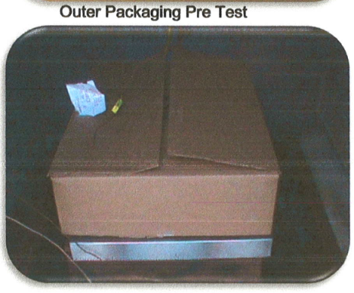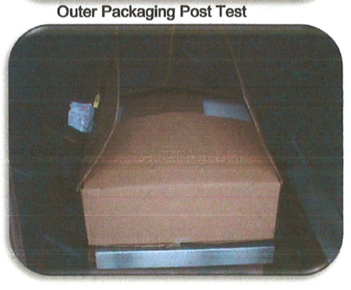

1. Prior to the test the package has been opened to place the thermocouples into the middle of the material. But although the package has been opened due to this, no product has could escape, as it is now polymerized. The package is not damaged by the heat that developed during the test. Therefore the 3 criteria that are proposed are fulfilled:

(a) The temperature inside the package does not exceed 150 °C; *(in this test it was 126°C)* and

(b) The temperature on the surface of the package does not exceed 100 °C, and

(c) There is no effect outside the package*, there is no effect like spillage outside the package and the package itself is not damaged.*

There was also a package tested with only 7 sheets of the above described product. The 7 sheet package configuration was also tested at 55C and that package passed the test. The package never exceeded a 6C rise in temperature. There was no change in the package after testing. Therefore it makes sense for these products, to test the package used for transport instead of a 50 kg package.