UN/SCETDG/50/INF.16
Committee of Experts on the Transport of Dangerous Goods
and on the Globally Harmonized System of Classification
and Labelling of Chemicals
Sub-Committee of Experts on the Transport of Dangerous Goods 10 November 2016

Fiftieth session
Geneva, 28 November-6 December 2016
Item 2 (d) of the provisional agenda
Recommendations made by the Sub-Committee
on its forty-seventh, forty-eighth and forty-ninth sessions
and pending issues: electric storage systems
Harmonization of rechargeable lithium metal polymer batteries
Transmitted by the European Association for Advanced Rechargeable Batteries (RECHARGE) and the Rechargeable Battery Association (PRBA)¹
Supporting safety data of RLMP batteries for the working paper ST/SG/AC.10/C.3/2016/68
1. This paper includes safety performance information on rechargeable lithium metal polymer (RLMP) cells. These data are compared to the data obtained with lithium-ion batteries (LIB) cells in the same testing conditions. It includes evaluation of flash point for various types of electrolyte, thermal stability for polymer-ceramic electrolyte separator, and accelerating rate calorimeter (ARC) for the pouch cells kept at SOC 100%. The collected information is additionally supporting safety evidence for RLMP cells and batteries as presented in the working paper ST/SG/AC.10/C.3/2016/68.
2. Lithium metal itself belongs to dangerous goods, which is classified with Class 4.3 (dangerous when wet) and UN1415. As described in ST/SG/AC.10/C.3/2016/68, the anode of the RLMP pouch cell contains lithium metal instead of graphite that is being used in lithium ion cells. Therefore, it is natural to consider that lithium cells and batteries equipped with lithium metal at their anodes tend to be dangerous, especially when submitted to abusive conditions, such as in the case of fire. Nevertheless, this paper gives evidence that RLMP cells are as safe as lithium ion cells, when their cell components are appropriately designed regarding both cell performance and safety.
3. For better understating of the ARC data, Annex I describes in detail the basic components of the RLMP pouch cell.
1) Anode and cathode: For a RLMP pouch cell of ca 1.5Ah capacity, multiple pieces of punched Li/Cu/Li electrode were used in the stacked cell, and then the total amount of lithium, including lithium as charged, is 1.05g. This amount corresponds to 13.1Wh (Li 1.05 g → 3.5Ah x 3.75V=13.1Wh) from calculation. Lithium metal can melt at 180°C, and it has auto ignition at 179°C. In order to reduce its affect in combustion, a non-flammable protective layer, which is coated onto lithium metal surfaces for suppressing dendrites as charging, has been applied. On the cathode side, the same materials as for LIB have been applied.
2) Electrolyte: It generally consists of Li salt and solvating medium of the salt.
- For the LIB cells, standard LiPF₆ salt and a combination of EC/PC/others including some additives have been used as the solvating medium. Their flash points tend to be lower 100°C, because they are liquid base.
- For the electrolyte to RLMP pouch cells, the polymer electrolyte is solid and is contained in the protective layer, in the polymer-ceramic composite separator, and even in the cathode for lithium ion conductivity. It’s flash point is at a temperature higher than 180°C, taking the thermal properties of lithium metal into consideration.
4. In Annex II, it is described how LIB and RLMP pouch cells were prepared and the process of self heating and thermal runaway measurement, including the maximum temperature in the combustion through the ARC test. Due to the limitation in the size of the equipment, the cell capacity was 1.5 Ah both for LIB and RLMP cells, instead of 2.5Ah cells, as tested for and presented in the earlier document UN/SCETDG/49/INF.32. Nevertheless, as the ARC equipment is highly thermally insulated by design, this difference do not induce any bias associated with the difference in size in this type of experiment.
5. In Annex III, the results of ARC tests for LIB and RLMP cells are described in Fig.6 and 7.
The results clearly indicates that:
- The RLMB cells are more robust than LIB when trying to ignite a thermal runaway by a heating method.
- Once the thermal runaway has been ignited, the heat production rate is similar for both type of cells, but the total heat produced by RLMB is less than that of LIB.
6. These results confirm that the hazards associated with the use of a lithium metal anode in a RLMP battery can be reduced to a lower level than the hazards of a lithium ion battery of similar size. This is achieved thanks to the design of the RLMP, based on the usage of a solid electrolyte without flammable solvents, and a protective layer on the lithium metal electrode.
Conclusion
7. This complementary set of data is supporting the conclusion of working paper ST/SG/AC.10/C.3/2016/33: thanks to his safety properties, the RLMP (Rechargeable lithium metal polymer) can be favourably compared with the lithium-ion batteries. The transport regulation of RLMP could be harmonized with the one applicable to lithium-ion batteries.

Annex I
Basic components of a RLMP pouch cell`
1) Anode and cathode
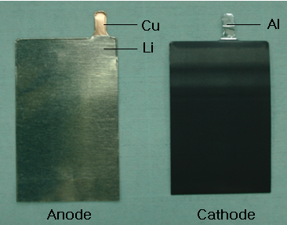

Fig.1 Appearance of single electrodes used at anode and cathode sites of a stacked cell where both sides of each electrode are coated. The lithium electrode contains a lithium film of 20um in thickness where its amount is 0.06g. In a RLMP pouch cell of being 1.5Ah in discharged state, its amount becomes 0.6g, and then adding lithium (1.5Ah x 0.3 = 0.45g) transferred by charging, and then it totally weighs 1.05g. On the other hand, the cathode information of the RLMP cell is similar to that of LIB cell chosen here for comparison.
2) Electrolyte
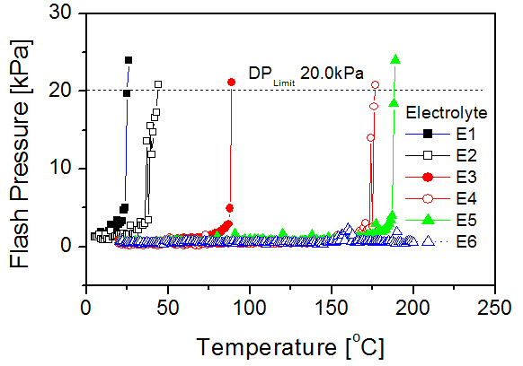

Fig.2 Plots of flash pressure for various electrolytes. The flash points were measured based on the method of ASTM D6450 using a commercial flash point meter (MINIFLASH FLP TOUCH, GRABNER INSTRUMENTS & AMETEK). The flash point for electrolyte in lithium ion cells tends to be below 100 ºC. For RLMP cells, however, their flash points must be higher than 100°C. When considering the melting point of lithium (180 ºC), the electrolyte might flash at temperatures at least above 180°C.
Annex II
Testing conditions for LIB and RLMP pouch cells
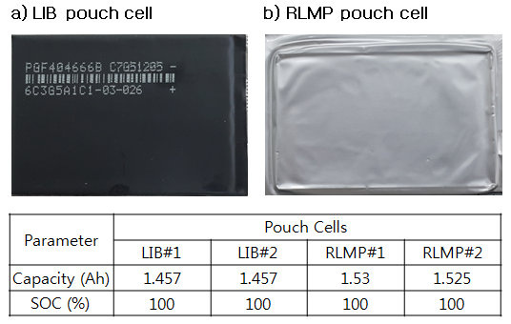
1) Preparation of cells before ARC tests

Fig.4 Appearance, capacity and SOC for LIB and RLMP pouch cells before ARC tests.
2) ARC test
ARC test principle: the cells are heated until the temperature where they self-generate heat (beginning of the thermal run-away) , then their maximum temperature increase is measured in adiabatic conditions ( the heating is stopped, and the system is thermally insulated).
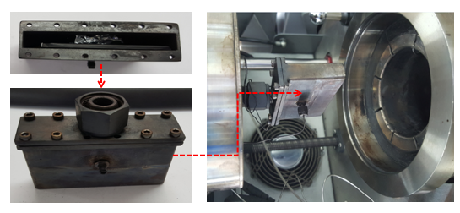
Fig.5 it shows a sequence of installing a cell in an ARC chamber. In the left side a tube is seen, including a pouch cell whose tabs were cut, and in the right side a picture is showing before the tube is put into the electric furnace of ARC equipment (TIAX). In order to raise objectivity in the ARC tests, all tasks including cell formation were executed at and through TÜVSÜD Korea (http://www.tuv-sud.kr/).

Annex III
ARC tests
Comparison of LIB and RLMP pouch cells
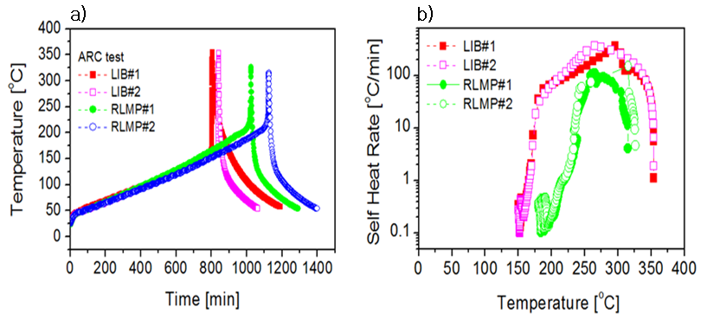

Fig.6 a) Plots of the temperature versus time for LIB and RLMP pouch cells, and b) plots of the self-heat rate versus temperature for the cells, which were measured by the ARC system operating in a heat-wait and search mode. As shown in a), the events of the RLMP pouch cells occurs at higher temperatures than the LIB ones, and those maximum temperatures are somewhat lower.
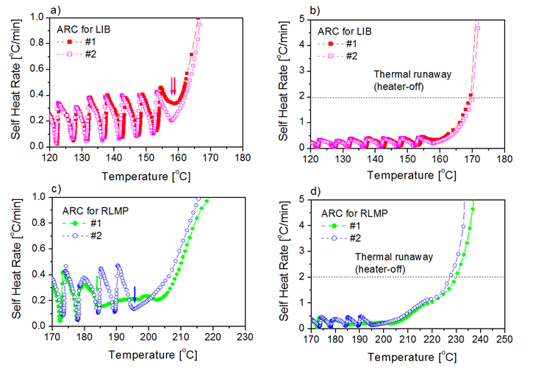
Fig.7 Detailed analysis of the plots shown in Fig. 6b: From a) and c), the repeated changes of the self heat rate are seen, which are signals responding to to the heating process (switching of a heat-wait and search mode in the ARC chamber). The arrows indicate the event points where the cells start making heating, called self heating temperatures. The self heating might occur due to some internal reactions among cell components that are thermally weakest. The points can be determined in the system when the process mode changes from Search to Adiabatic, in other words, here the point is determined on the time that the exothermic threshold gets higher than 0.05ºC/min in the Search stage. From b) and d), it is seen how the temperatures increase when thermal runaway happens. The dotted lines indicate the points, called thermal runaway temperatures. The points can be recorded by a mode change of Adiabatic to Heater-off. The mode change is programmed to occur when its self-heat rate reaches 2°C/min.
Table 1 Comparison of the temperatures of self-heating and thermal runaway for LIB and RLMP pouch cells.
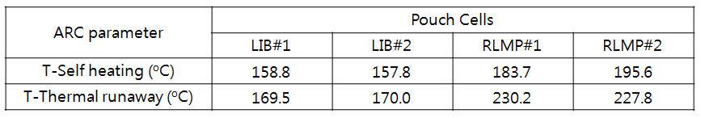

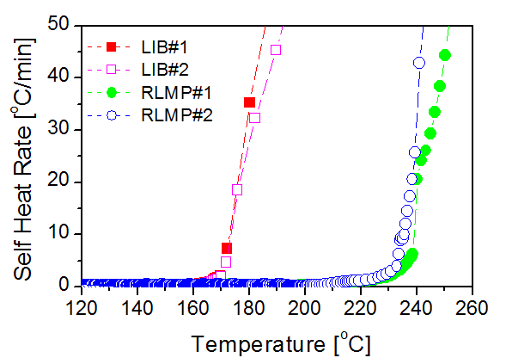

Fig.8 Plots of the self-heat rate for LIB and RLMP pouch cells after the thermal runaway occurs. The gradients look to be similar between them even though their thermal-runaway occurs at different temperatures.
The results clearly indicates that:
- The RLMB celles are more robust than LIB when trying to ignite a thermal runaway by a heating method.
- Once the thermal runaway has been ignited, the heat production rate is similar for both type of cells, but the total heat produced by RLMB is less than that of LIB.

