UN/SCETDG/49/INF.7(E)
Committee of Experts on the Transport of Dangerous Goods
and on the Globally Harmonized System of Classification
and Labelling of Chemicals
Sub-Committee of Experts on the Transport of Dangerous Goods 29 April 2016
Forty-ninth session
Geneva, 27 June – 6 July 2016
Item 6 (e) of the provisional agenda
Miscellaneous proposals for amendments to the Model Regulations on
the Transport of Dangerous Goods
Transportation of liquid fuel in flexible tanks
Transmitted by the International Dangerous Goods and Containers Association (IDGCA)
Introduction
- In the transport industry has been practiced transportation of certain types of liquid bulk cargoes in containers with flexible tanks with the capacity up to 24 000 litres. Recently are known cases when the above-mentioned transport units were used for the transportation of dangerous goods, in particular diesel fuel UN N° 1202 (see photo). This practice of dangerous goods transportation is not allowed by UN Model Regulations however some competent authorities (competent organizations) are permitting such type of carriage with referring to p. 4.1.3.8 and note to p. 4.1.3.8. in which wherein that “A large and robust article may include flexible fuel containment systems, military equipment, machinery or equipment containing dangerous goods above the limited quantity thresholds”. Therefore, insert is amounted to the flexible fuel system.
Proposal
- IDGCA consider that such practice of liquid fuel transportation (UN № 1202) is not permitted because it is unsafe and reference to p. 4.1.3.8 and note to p. 4.1.3.8 is not correct. However taking into account the current practice of liquid cargoes transportation in such transport units, we suggest to obtain expert opinion on the issue of prospects of the development of liquid cargoes transportation in combined transport units (container – insert) and to make recommendations to State administration and competent bodies (organizations).
- Revise p. 4.1.3.8 for the purpose of clarification of the requirements of this paragraph and give an explanation about what is meant by “flexible fuel containment system”.

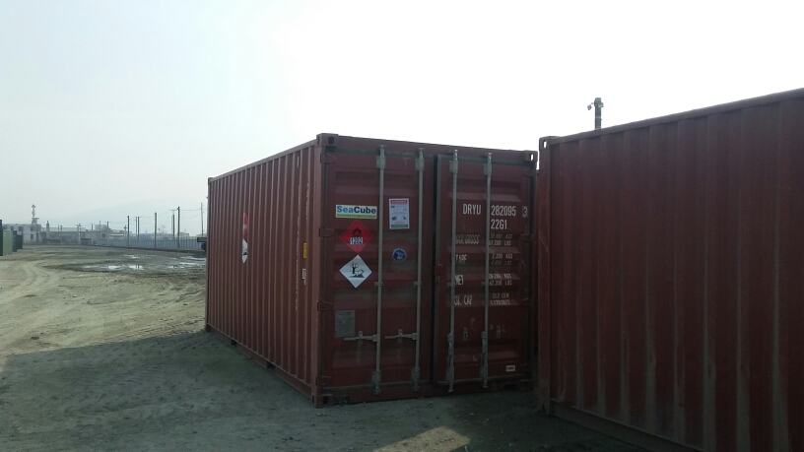
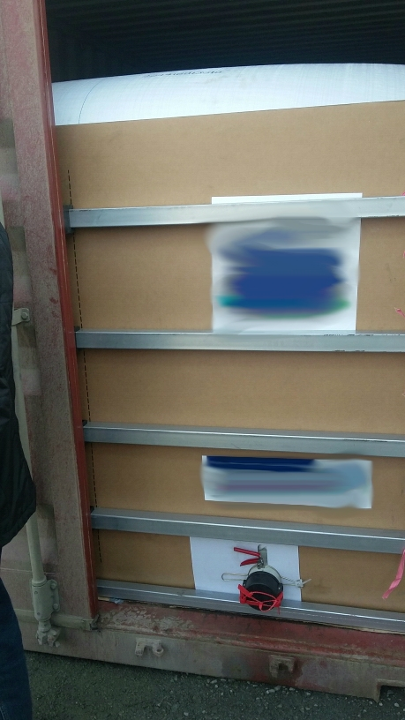
General cargo container
_______________
Container body
Bottom opening
Flexible tank

