Proposal for a Supplement to the 06 series of amendments to Regulation No. 16 (Safety-belts)
The modifications to the existing text of the Regulation are marked in bold for new or strikethrough for deleted characters.
I. Proposal
Paragraphs 8.3.4., amend to read:
8.3.4. Safety-belts or restraint systems incorporating retractors shall be so installed that the retractors are able to operate correctly and stow the strap efficiently. In case of belt adjusting devices as well as a flexible height adjusting devices this shall be checked in at least its highest and its lowest position.
Annex 17, Appendix 1, Paragraphs 2.7, amend to read:
"2.7. Ensure that the fixture is located with its centreline on the apparent centreline of the seating position ±25 mm with its centreline parallel with the centreline of the vehicle the vertical plane of symmetry of the seat”.
Annex 17, Appendix 1, Paragraphs 3.2, amend to read:
3.2. The lap portion of the belt shall touch the fixture on both sides at the rear of the lap belt path (see Figure 3). The seat belt webbing shall contact the curved edge on both sides of the fixture over at least [50 %] of its width.

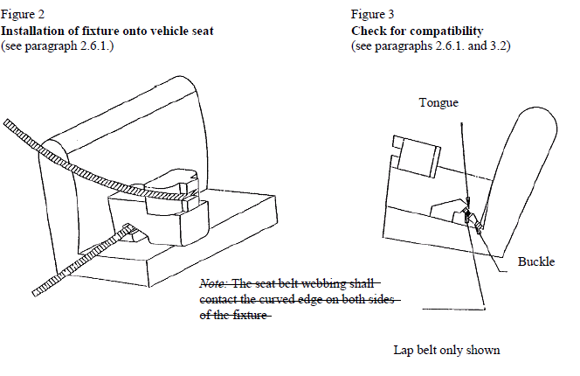

Annex 17, Appendix 3, Table 1, under “Key of letters to be inserted in the above table:”, amend to read:
L | = | Suitable for particular child restraints given on attached list. These restraints may be of the "specific vehicle", "restricted" or ,"semi-universal" or universal categories .

II. Justification
This proposal has to with four separate items that should be more clear:

- With regard to par. 8.3.4.: The possibility of having the benefit of a better belt routing at the shoulder section may not down-grade the automatically adjusting function of the retractor; certainly with the introduction of flexible shoulder adjusting devices for height (so-called generation belts) this must be checked in all circumstances.
- With regard to Annex 17, Appendix 1, par.2.7.: The present definition will cause non-naturalistic installation under certain circumstances. This has to do with the definition of seats as laid down in Reg.17. For example in Reg.17, par 2.3.1. you will find the following definition:
“2.3.1. "Forward-facing seat" means a seat which can be used whilst the vehicle is in motion and which faces towards the front of the vehicle in such a manner that the vertical plane of symmetry of the seat forms an angle of less than + 10° or - 10° with the vertical plane of symmetry of the vehicle;”
Focussing on the vertical plane of symmetry of the seat instead of the vehicle will deliver the naturalistic situation that one should check.
- With regard to Annex 17, Appendix 1, par.3.2.: Up to now the requirements for the belt path are divided over par.3.2 and Figure 2 and 3, and what’s more, the used wording could lead to misinterpretation. Therefore all text concerning requirements is now concentrated in par. 3.2. and on top of that what is meant by “shall contact” is described more accurate.
- With regard to Annex 17, Appendix 3, Table 1: If a certain seating position in a vehicle is not able to receive the gabarit (of Appendix 1) to get the “U” key letter meaning suitable for universal restraints, this does not necessarily mean that not any universal restraint will fit. Therefore the vehicle manufacturer should be able to mention here universal restraints that will fit anyway.

