|  |  |  |  |
| --- | --- | --- | --- |
|  | United Nations | ECE/TRANS/WP.29/GRRF/2015/27 | |
| Description: Description: _unlogo | **Economic and Social Council** | | Distr.: General  3 July 2015  Original: English |

**Economic Commission for Europe**

Inland Transport Committee

**World Forum for Harmonization of Vehicle Regulations**

**Working Party on Brakes and Running Gear**

**Eightieth session**

Geneva, 15-18 September 2015

Item 7(c) of the provisional agenda

**Tyres – Regulation No. 54**

Proposal for amendment to Regulation No. 54 (Tyres for Commercial Vehicles and their Trailers) and Regulation No. 117 (Tyres, Rolling Resistance, Rolling noise and Wet Grip)

Submitted by the experts from the European Tyre and Rim Technical Organisation[[1]](#footnote-2)\*

The text reproduced below was prepared by the experts from the European Tyre and Rim Technical Organisation (ETRTO) in order to amend the tyre marking requirements. The modifications to the existing text of the Regulation are marked in bold for new or strikethrough for deleted characters.

Part A – Amendment to UN Regulation No. 54

1. Proposal

*Paragraph 3.1.10.,* amend to read:

"3.1.10. An indication, by the "PSI" index, of the inflation pressure to be adopted for the load/speed endurance tests, as explained in Annex 7, Appendix 2. However, this indication, which it is permissible to restrict to one sidewall, shall not be mandatory, on any tyre submitted for approval, until two years after the date of entry into force of this Regulation**.** 5

**For tyres first approved after 1 January 2018, the inflation pressure for the dimension measurement and for the load/speed endurance test, pursuant to paragraph 4.1.12 of this Regulation,** **shall be indicated in kilopascals, replacing the "PSI" index**. "

*Annex 3,* replace:

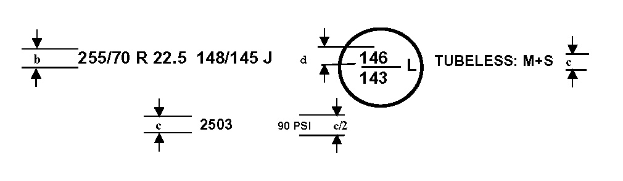"

*“*

*by:*

"

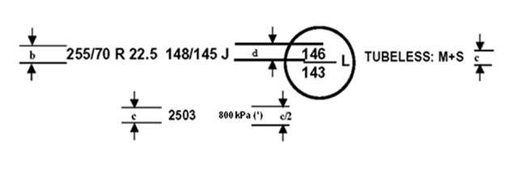

"

**(\*) PSI marking instead of kPa may be used for tyres first type approved before 1 January 2018.** "

*Paragraph 4.1.12.*, amend to read:

"4.1.12. The **inflation** ~~measuring~~ pressure **for the dimension** **measurement** **and for the load/speed endurance test** **pressure** and test pressure index;"

*Header of annex 6*, amend to read:

"Method of **dimension** **measurement for** measuring pneumatic tyres"

*Paragraph 1. of annex 6*, amend to read:

"1. The tyre is mounted on the measuring rim specified by the manufacturer pursuant to paragraph 4.1.11. of this Regulation and is inflated to **the** ~~a~~ pressure specified by the manufacturer pursuant to paragraph 4.1.12. of this Regulation."

*Paragraph 1.3. of annex 7*, amend to read:

"1.3. Inflate the tyre to the pressure corresponding to the pressure ~~index~~ specified by the manufacturer pursuant to paragraph 4.1.12. of this Regulation"

II. Justification

It is proposed to replace the PSI Index by indicating the inflation pressure in kilopascals ("kPa"). By this, it will become possible to mark the same pressure as in all major tyre standards and avoid confusion in case of tyres marked according to UN Regulation N°. 54 and, at the same time, according to FMVSS 119 or FMVSS 139.

Part B – Amendment to UN Regulation No. 117

I. Proposal

*Annex 3, paragraph 2.5.3.*, amend to read:

"2.5.3.Tyre inflation pressure

Each tyre fitted on the test vehicle shall have a test pressure Pt not higher than the reference pressure Pr and within the interval:

25

.

1

25

.

1

1

.

1

















⋅





















⋅

*r*

t

r

t

r

t

r

Q

Q

P

P

Q

Q

P

For Class C2 and Class C3 the reference pressure Pr is the **inflation** pressure corresponding to the pressure ~~index~~ marked on the sidewall. **If Pr is not marked on the sidewall, refer to the specified pressure in applicable tyre standards manuals corresponding to maximum load capacity for single applications.**

For Class C1 the reference pressure is Pr = 250 kPa for "standard" tyres and 290 kPa for "reinforced" or "extra load" tyres; the minimum test pressure shall be Pt = 150 kPa."

II. Justification

This proposal maintains coherency with the proposed amendment to UN Regulation No. 54 (Part A of this document)

1. \* In accordance with the programme of work of the Inland Transport Committee for 2012–2016 (ECE/TRANS/224, para. 94 and ECE/TRANS/2012/12, programme activity 02.4), the World Forum will develop, harmonize and update Regulations in order to enhance the performance of vehicles. The present document is submitted in conformity with that mandate. [↑](#footnote-ref-2)