UN/SCETDG/48/INF.37
Committee of Experts on the Transport of Dangerous Goods
and on the Globally Harmonized System of Classification
and Labelling of Chemicals
Sub-Committee of Experts on the Transport of Dangerous Goods 26 November 2015
Forty-eight session
Geneva, 30 November-9 December 2015
Item 4 (d) of the provisional agenda
Electric storage systems: miscellaneous
Response to ST/SG/AC.10/C.3/2015/52 and the meaning of “equipment” for the purposes of Special Provision 188 and Packing Instruction P903
Transmitted by the Rechargeable Battery Association (PRBA) and the European Association for Advanced Rechargeable Batteries (RECHARGE)
Introduction
1. The Informal Working Group (IWG) on Lithium Batteries that was held in Washington, DC on August 26-28, 2015 included an extensive discussion on the meaning of “equipment.” Therefore, we do not believe it would be prudent for the Sub-Committee to adopt a definition for equipment at this point as proposed in ST/SG/AC.10/C.3/2015/52.
2. The IWG on Lithium Batteries generally agreed that adding the following sentence to Special Provisions 188, 230 or creating a new stand-alone Special Provision would help to clarify the meaning of “equipment:”
For the purpose of this special provision, equipment are devices intended to be powered by or used in the operation associated with the lithium ion or lithium metal cells or batteries packaged with or installed in the devices. Examples of such equipment include, but are not limited to, notebook computers, tablets, cellular phones, e-readers, medical devices, power tools, flashlights, [battery chargers,] circuit boards and toys.
3. Because of the uncertainty over how “battery chargers” and/or “power packs” are regulated under the Model Regulations, the term “battery chargers” was placed in brackets for further consideration.
4. We also believe the definition proposed for “equipment” in ST/SG/AC.10/C.3/2015/52 would inadvertently eliminate the ability to ship batteries and chargers like those pictured on the following page as “UN3481, Lithium ion batteries packed with equipment.” The chargers in the pictures clearly are “equipment” and can only operate in association with the pictured battery. However, it does not appear the definition of “equipment” in ST/SG/AC.10/C.3/2015/52 would recognize these chargers as equipment because the lithium ion batteries do not “provide electrical power” for the chargers’ operation.
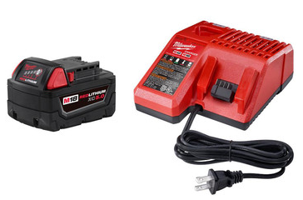
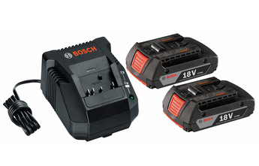

5. Examples of “Battery powered equipment” and “Battery powered vehicles” (UN3171) are provided in Special Provision 240. Therefore, providing examples as of “equipment” as agreed-to by the IWG on Lithium Batteries is consistent with the UN Model Regulations and will help to provide clarity for shippers of these devices.
6. In light of the ongoing discussions at the IWG on Lithium Batteries regarding the meaning of “equipment,” we believe it would be in the best interest of the Sub-Committee not to adopt a definition for “equipment” as proposed in ST/SG/AC.10/C.3/2015/52, but seek for a harmonized solution.

________________

