UN/SCETDG/47/INF.29

Committee of Experts on the Transport of Dangerous Goods
and on the Globally Harmonized System of Classification
and Labelling of Chemicals 12 June 2015
Sub-Committee of Experts on the Transport of Dangerous Goods
Forty-seventh session
Geneva, 22 – 26 June 2015
Item 2 (i) of the provisional agenda
Explosives and related matters: miscellaneous
Transport of energetic samples for further testing
Transmitted by the European Chemical Industry Council (CEFIC)
Introduction
1. Research and development in industry, public institutes and universities frequently have the need to transport substances for the purpose of testing, i.e. the determination of physical, chemical, biological, toxicological or ecotoxicological properties and behavior, fitness for use or application.
2. The substances usually consist of organic molecules which are active ingredients, building blocks or intermediates for pharmaceutical or agricultural chemicals.
3. Generally, the amounts per substance are small (frequently milligram scale), and reliable information about the proper classification is not available due to the lack of test data.
4. In many cases, the molecules of the substances carry functional groups listed in tables A6.1 and/or A6.2 in Annex 6 (Screening Procedures) of the UN Manual of Tests and Criteria, thus indicating explosive or self-reactive properties; however, they are not designed to be explosives of Class 1.
5. Whereas the transport of samples of self-reactive substances and organic peroxides is permitted under the provisions of 2.4.2.3.2.4 (b) and 2.5.3.2.5.1, respectively, substances considered to meet the criteria for Class 1 are prohibited for transport by 2.0.4.2 (b).
6. Thus, there is a need to find a proper solution for the transport of energetic samples for the purpose of testing in early stages of development, to define appropriate criteria for classification in cases of limited test data, and to specify the required packaging.
7. For practical purposes, industry suggests to develop a solution in three steps, i.e. to focus at first on very small samples (milligram scale), then medium size (gram scale) and finally lower kilogram scale (to cover the amounts required for test series 1 and 2 of the UN Manual of Tests and Criteria).
8. This informal paper serves as a thought starter and focuses on the first category of very small sample amounts.
9. The Sub-committee is requested to discuss this paper in the Explosives Working Group and to communicate a possible path forward to CEFIC.
Discussion
10. In a first stage of research, pharmaceutical companies frequently ship complete substance libraries for activity screenings to specialized institutes. For this purpose, substances may be arranged in so-called multi titer plates (i.e. array of several dozens or hundreds of samples) as primary packagings with about 1-10 mg of individual sample.
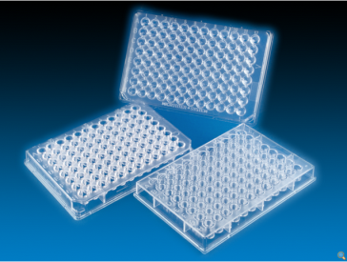


Figure 1: 96 and 384 type multi titer plate
11. The number of samples in this screening phase is quite large and may reach a magnitude of 10,000 to 100,000 per year and company.
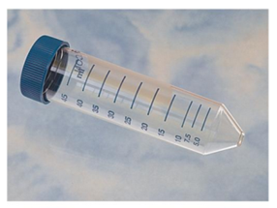
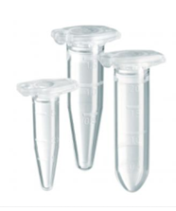
12. At a later stage, samples may be put into individual glass bottles or plastic containers as primary packagings with up to 150 mg sample.

Figure 2 Plastic vessels for individual substances

13. As secondary packagings, frequently plastic boxes (UN4H2), aluminium boxes (UN4B) or fibreboard boxes (UN4G) are applied. Figure 3 shows a possible arrangement.
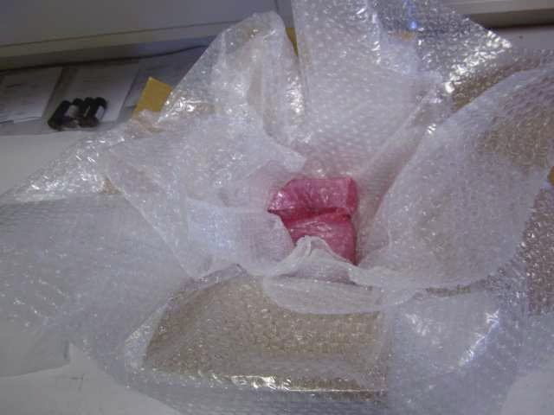
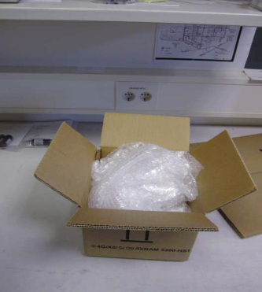
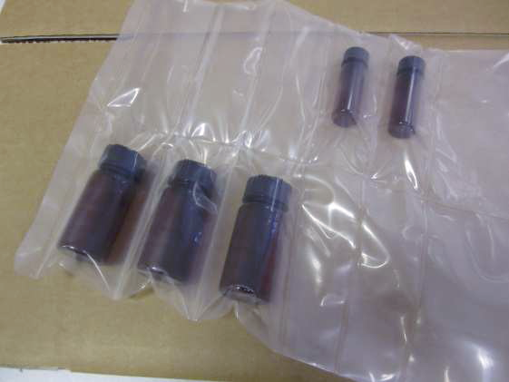
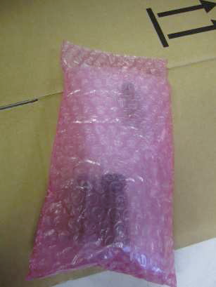
Figure 3 Placement of sample vessel in secondary package

14. The energy content of the samples was determined by screening DSC (heating rate 3K/min, closed crucible) for a representative set of substances in research (see diagram 1). Nearly all substances exhibit a decomposition energy of less than 3000 J/g, corresponding to the range of typical self-reactive substances and peroxides and clearly below the range of typical intentional explosives.
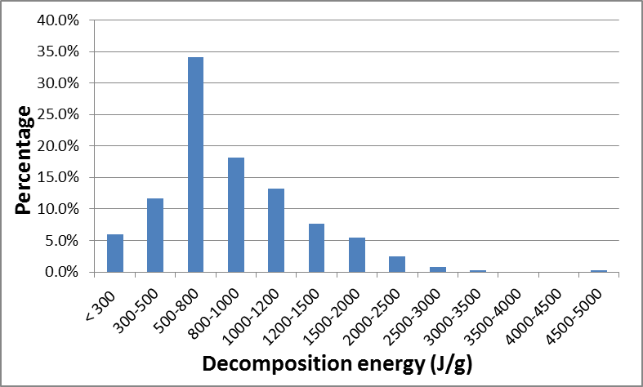
Diagram 1 Distribution of energy content (369 substances)
15. However, individual outliers do exist, and therefore an upper energy tolerable energy level of 2500 J/g is suggested for further consideration; higher energy levels would need individual treatment.
16. Another issue to be discussed is the decomposition onset: The investigation of a representative set of substances shows a distribution of the onset over a wide temperature range (see diagram 2) (DSC at 3 K/min, closed crucible).
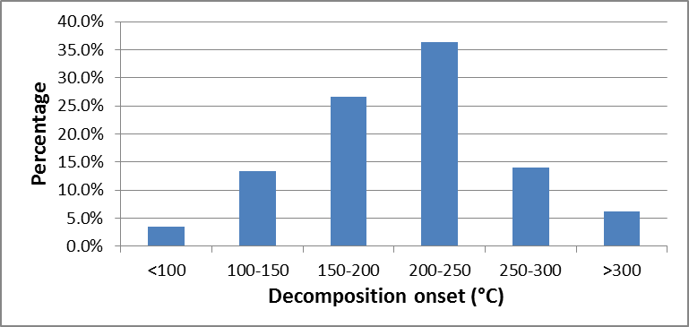
Diagram 2 Distribution of decomposition onset (372 substances)
17. This diagram allows some important conclusions: Since the onset as determined by a screening DSC gives only very rough estimates of thermal stability, an appropriate safety distance is required. Thus, the candidates for self-reactive substances should primarily be found for substances with an onset below 200 °C, and a small fraction might even require temperature control. The more stable substances (i.e. with an onset above 200 °C) are formally candidates for Class 1.
18. At this stage, however, neither can the SADT (test series H) be determined nor can test series 1 or 2 of the Class 1 Acceptance Procedure be performed, and a decision about a correct classification is simply not possible.
Preliminary test results
19. Since the critical detonation diameter for a sensitive commercial explosive is about 1 mm, it can be estimated that for decomposition energies of 2500 J/g or less, the critical diameter would increase to about 8 mm, thus about 150 mg of substance.
20. Currently, tests are being performed on highly energetic model substances at the German Federal Institute for Materials Research and Testing with different sample receptacles, amounts and layout. Some preliminary results are given in this paper:
21. Test were performed on Azodicarbonamide (solid, 1400 J/g) and a liquid organic peroxide (1900 J/g decomposition energy).
22. 5 g of the solid substance in a 50 ml glass bottle was put into a plastic bag which was placed into a 1,5 l HDPE bottle along with foam flakes. This bottle was put into a cardboard box filled with foam flakes (see figure 4); a similar arrangement was used for liquids.
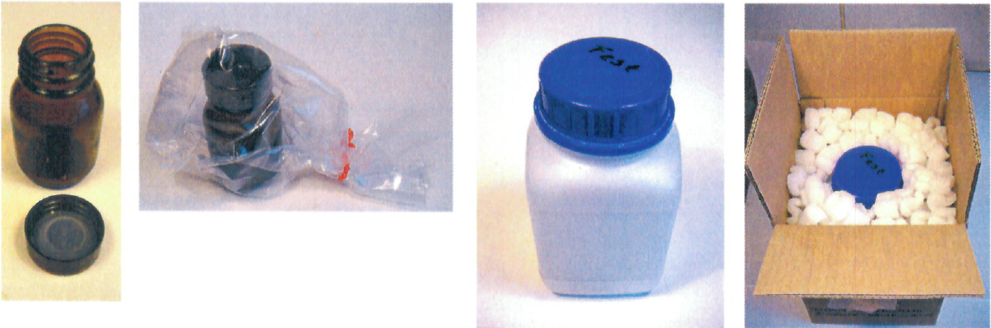
Figure 4 Packaging of solid sample for testing
23. The initiation of decomposition by a heating coil or a hot plate resulted only in minor damage (i.e. broken or melted lid); see figure 5 for results of liquid material.
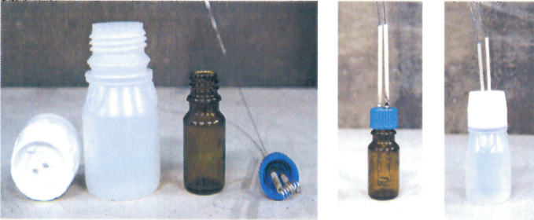
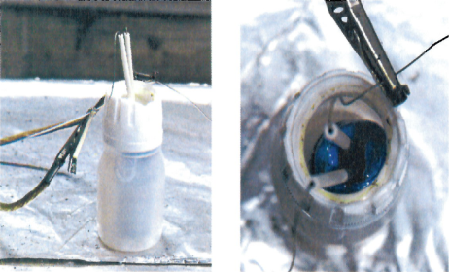
Before test
After test

Figure 5 Result of thermal decomposition test

24. From these results it can be concluded that thermal decomposition does not cause any severe effects for small amounts of energetic samples provided that proper packaging is applied; therefore, temperature control does not appear to be necessary in this case.
25. A drop test (1,8 m, different orientations) resulted only in a slight deformation of the corner of the cardboard box while the inner receptacles remained completely undamaged.
26. Currently, further tests are performed at the German Federal Institute for Materials Research and Testing, and the results will be communicated in a formal proposal for the December session.
Possible solution
The Sub-committee is invited to discuss possible solutions for the transport of energetic samples. For research and early stages of development, industry suggests the following path forward:
Range of application: energetic substances with functional groups according to tables A6.1 and/or A6.2 in appendix 6 of the UN Manual of Tests and Criteria, however, not intentional explosives
Energy limit: 2500 J/g or less
Amount for transport: up to 150 mg per sample per primary packaging, max. 20 g per package
Transport as self-reactive substance type C in analogy to 2.4.2.3.2.4 (b)
The text in 2.0.4.2 would have to be modified accordingly.
A paper with a proposal for a medium scale (gram range) will be prepared at a later time.

