|  |  |  |  |
| --- | --- | --- | --- |
|  | United Nations | ST/SG/AC.10/C.3/2015/36 | |
| _unlogo | **Secretariat** | | Distr.: General 1 September 2015  Original: English |

**Committee of Experts on the Transport of Dangerous Goods  
and on the Globally Harmonized System of Classification  
and Labelling of Chemicals**

**Sub-Committee of Experts on the Transport of Dangerous Goods**

**Forty-eighth session**

Geneva, 30 November – 9 December 2015

Item 3 of the provisional agenda

**Listing, classification and packing**

Additional criteria for polymerizing substances

Transmitted by the European Chemical Industry Council (CEFIC)[[1]](#footnote-2)

Introduction

1. In the last biennium, the Sub-Committee of Experts on the Transport of Dangerous Goods (TDG Sub-Committee) had decided to introduce polymerizing substances in Division 4.1.
2. In 2.4.2.5.1, the definition describes polymerizing substances as “substances which, without stabilization, are liable to undergo a strongly exothermic reaction resulting in the formation of larger molecules or resulting in the formation of polymers under conditions normally encountered in transport.“
3. However, given that the energy criterion of more than 300 J/g is met, in-depth chemical knowledge is required to understand and assess whether a substance is able to polymerize, rearrange or decompose (and, in the latter case, be a candidate for classification as a self-reactive substance), and to come to the correct conclusion about the classification.
4. During the last session, industry submitted informal document INF.27 (47th session) with some proposals to correctly identify substances that should be classified as polymerizing.
5. As a result of the discussion, the Sub-Committee was a priori in favour of drawing up screening procedures for the classification of polymerizing substances, as long as such procedures were reliable. The representative of CEFIC was thus invited to prepare an official proposal.
6. In this formal paper, CEFIC builds on the thoughts developed in aforementioned informal paper and elaborates additional arguments and reasoning.

Discussion

1. In informal document INF.27 it was shown that the ability to polymerize is generally linked to the existence of unsaturated (i.e. double or triple) bonds or strained rings in the molecule. The mere presence of such functional groups, however, does not necessarily establish that a substance will be able to polymerize; rather, the ability and tendency to undergo a chain reaction decreases rapidly with increasing size of the molecule due to energetic and kinetic reasons. Further, evidence was given that polymerisation cannot occur in the solid state.
2. In many cases, the molecular mass is taken to describe the size of a molecule. The advantage of this term is the ease of determination (i.e. the sum of the atomic masses in a molecule) and its common use.
3. However, a closer inspection of this parameter makes severe shortcomings for the intended purpose evident: Organic molecules are essentially built on a hydrocarbon (C, H) backbone with frequent incorporation of nitrogen (N) and oxygen (O). The mass contributions of the CH2 unit, nitrogen and oxygen atoms are nearly the same: 14, 14 and 16 g/mol, respectively. Other elements have much larger atomic masses, for example chlorine (35,5 g/mol) or bromine (79,9 g/mol). In other words: The contribution of one chlorine atom to the molecular mass corresponds to three carbon atoms, and one bromine atom even outweighs six carbon atoms.
4. An impressive example for this effect can be demonstrated for the ethene molecule (C2H4) where the hydrogen atoms are gradually substituted by bromine (see fig. 1): for the same carbon backbone and the same number of atoms, the molecular mass increases from about 28 (C2H4) to 344 (C2Br4), and the heat of polymerization drops almost inversely proportionally to the number of bromine atoms.

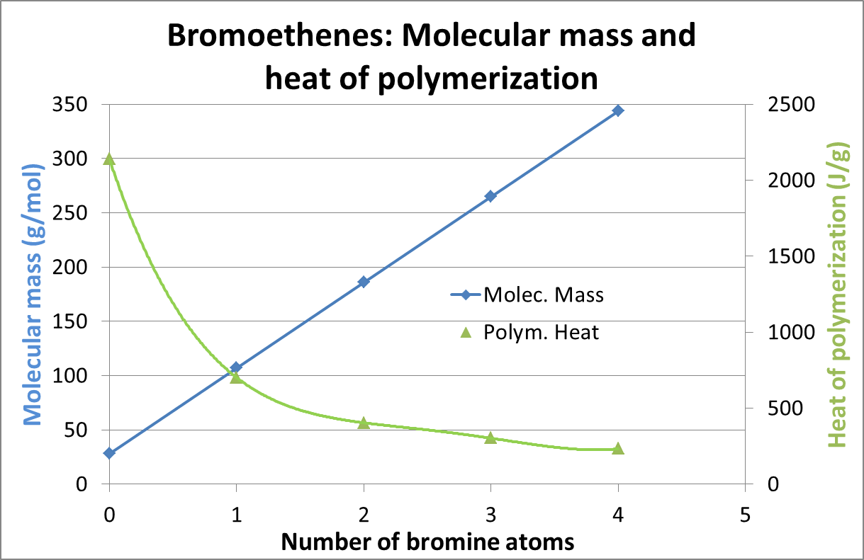

Figure 1: Mass effect of bromine substitution on ethene

1. A possible alternative might be to look at the “molecular volume”. The graphic below (figure 2) is a common way of displaying molecules: Whereas numerous parameters

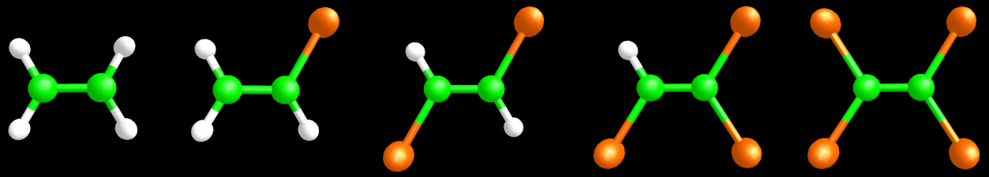

**Figure 2: Ethene and some of its bromine derivatives**

such as bond lengths, angles, dihedrals etc. can be derived from such a model, the determination of a molecular volume is a notoriously difficult task due to the fact that molecular orbitals are only probability functions for the abidance of electrons.

1. An intriguingly simple alternative approach is looking at the elements that form the “backbone” of the organic molecule, i.e. carbon and hydrogen (C, H), oxygen (O) and nitrogen (N). As already mentioned in section 9 of this paper, their contribution to the molecular mass is roughly 14 g/mol. In other words: Counting the contributions to the molar mass of these elements provides an excellent criterion for the size of the “backbone” of an organic molecule. For the sake of brevity, this figure is henceforth referred to as M(CHON).
2. The following examples illustrate the applicability of this approach: For ethane (C2H4), M(CHON) is 2\*12+4=28 g/mol, for dibromoethene (C2H2Br2) 26 g/mol, and for tetrabromoethene (C2Br4) 24 g/mol. The number has not changed very much since, indeed, the C-C backbone remains the same, and with increasing substitution of hydrogen by bromine, M(CHON) moves even to smaller numbers and thus to the safe side.
3. An increase in size of the “backbone”, on the other hand, is correctly mirrored by M(CHOH):

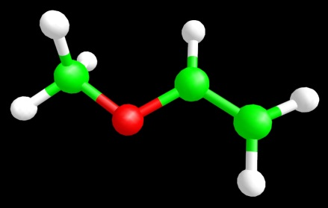

Methylvinylether

C3H6O

M(CHON) = 58

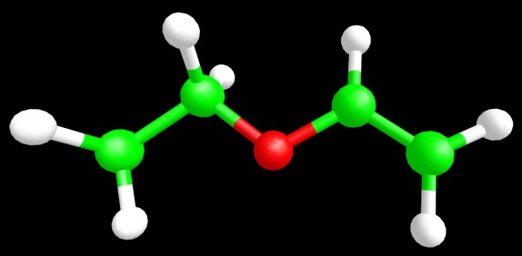

Ethylvinylether

C4H8O

M(CHON) = 72

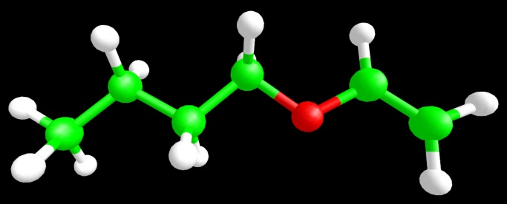

Butylvinylether

C6H12O

M(CHON) = 100

whereas for

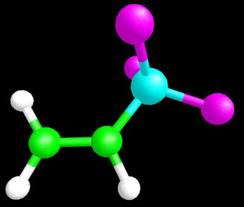

Vinyltrichlorosilane

C2H3SiCl3

M(CHON) = 27

the small vinyl group is correctly identified. This proves that M(CHON) is an appropriate criterion for the size of a polymerizable molecular backbone.

1. In informal document INF.27 (47th session) it was shown that the maximum energy of polymerization

* Decreases with increasing size of the molecule in terms of M(CHON),
* Approaches the 300 J/g border value for classification at a M(CHON) value of 150 g/mol.

1. Thus, scientifically sound evidence has been given that M(CHON) can be used as a robust criterion to identify possible polymerizing substances.

Proposal

1. In the UN Manual of Tests and Criteria, appendix 6 (Screening Procedures), insert a section 5.2 as follows:

5.2 Substances which may be polymerizing substances (Division 4.1)

The classification procedure for polymerizing substances need not be applied if:

(a) The chemical structure of the substance contains no double or triple bonds or strained rings;

(b) Or, the compounds contains double or triple bonds or strained rings, but the molecular mass M(CHON) counting only the elements C, H, O and N is more than 150;

(c) The compound is solid with a melting point above (50 °C).

1. Renumber the existing sections 5.2 to 5.3 and 5.3 to 5.4

Justification

1. This proposal for screening procedures helps to identify substances that fulfill the classification criteria and gives clear cutoff criteria, thus avoiding confusion and unnecessary testing.

1. In accordance with the programme of work of the Sub-Committee for 2015–2016 approved by the Committee at its seventh session (see ST/SG/AC.10/C.3/92, paragraph 95 and ST/SG/AC.10/42, para. 15). [↑](#footnote-ref-2)