 | United Nations | ECE/TRANS/WP.29/GRPE/2014/13
 | Economic and Social Council |  | Distr.: General  25 March 2014  Original: English
Economic Commission for Europe
Inland Transport Committee
World Forum for Harmonization of Vehicle Regulations
Working Party on Pollution and Energy
Sixty-ninth session
Geneva, 5-6 June 2014
Item 10 of the provisional agenda
Electric Vehicles and the Environment (EVE)
Proposal for an Electric Vehicle Regulatory Reference Guide
Submitted by the Chair of the informal working group on Electric Vehicles and the Environment *
The text reproduced below is submitted by the Chair of the informal working group on Electric Vehicles and the Environment (EVE) for consideration and endorsements by GRPE at it sixty-ninth session.
Contents
Paragraphs Page
1. Introduction 1-11 4
1.1. Overview of EVE IWG 2-6 4
1.1.1. Summary of EVE activities to date 6 5
1.2. Purpose of EV Reference Guide 7-10 6
1.2.1. Document aim, intended audience 8 6
1.2.2. Connection to WP.29, potential GTR development or adaptation
of existing GTRs 9-10 6
1.3. Outline of EV Reference Guide 11 7
1.3.1. Guide components, section logic 11 7
2. Reference Guide Design & Methodology 12 8
2.1. Design of the EV Reference Guide 12-13 8
2.1.1. Guide organization; rationale 12 8
2.1.2. Scope of guide 13 8
2.2. EV Regulatory Reference Guide Methodology 14-16 9
3. Summary of Findings 17-64 11
3.1. Electric Range 19-21 12
3.2. Energy Consumption/Efficiency 22-24 13
3.3. Electrified Vehicle Driver-User Information 25-26 14
3.4. Electrified Vehicle Recycling and Re-use 27-28 15
3.5. Vehicle Labeling 29-39 16
3.6. Battery Performance 40-41 18
3.7. Battery Durability 42-44 20
3.8. Battery Recycling 45-46 21
3.9. Battery Re-use (post-mobility) 47-51 22
3.10. On-board Charging System 52-54 24
3.11. Off-board Charging Standard Related to the Vehicle 55-57 26
3.12. Wireless Charging 58-59 27
3.13. Vehicle as Electricity Supply 60-62 28
3.14. Regulatory Incentives 63-64 30
4. Conclusions 65-78 31
4.1. High Activity Areas 66-67 31
4.2. Low Activity Areas 68-72 32
4.3. Gaps and Implications of the Analysis 73-78 34
4.3.1. Vehicle Attributes 73 34
4.3.2. Battery Attributes 74-76 35
4.3.3. Infrastructure Attributes 77 35
4.3.4. Market Deployment Attributes 78 35
5. Next Steps 79-88 36
5.1. Vehicle Range & Energy Consumption Testing 79-81 36
5.2. Method of Stating Energy Consumption 82-85 36
5.3. Battery Performance & Durability 86-87 37
5.4. Battery Recycling 88 38
6. Annex 89 38
6.1. Financial incentives 90 39
6.2. Consumer Awareness 91 39
6.3. Government Purchasing 92 39

1. Introduction
1. To remain consistent with terminology established by the Vehicle Propulsion System Definitions (VPSD) working group, VPSD EV definitions are used throughout this document; the cross-reference of VPSD definitions to popular EV terminology is shown in Table X. The abbreviation ‘EV’ as used in this text stands for ‘electrified vehicles’ and therefore includes all-configurations of hybrid electric vehicles (HEVs), in addition to pure electric vehicles (PEV); where the term ‘HEV’ is used in the text, it is assumed to apply to both NOVC-HEVs and OVC-HEVs. Finally, although fuel cell vehicles (FCV/FCHEV) are also considered as EV’s, they are excluded from this reference guide.

Table 1

EV definitions cross-reference chart
VPSD EV Definitions | Popular EV Definitions
NOVC-HEV  Non off-vehicle-chargeable hybrid electric vehicle | HEV  Hybrid electric vehicle
OVC-HEV  Off-vehicle-chargeable hybrid electric vehicle | PHEV  Plug-in hybrid electric vehicle
PEV  Pure electric vehicle | BEV  Battery electric vehicle
1.1. Overview of EVE IWG
2. The formal name of the United Nations Economic Commission for Europe (UNECE) international Electric Vehicle (EV) working group is the Electric Vehicles and the Environment Informal Working Group (EVE IWG). The working group is under the Working Party on Pollution and Energy (GRPE), which operates as a part of the World Forum for the Harmonization of Vehicle Regulations (WP.29) through the UNECE. The international EV working group was established in March 2012 to address environmental issues associated with electrified vehicles and a Terms of Reference (TOR) was developed; at this time a separate group focused on EV safety was also established. Participation in the working group is open to all UNECE Contracting Parties and interested non-governmental organizations, like electrified vehicle and battery manufacturers and suppliers. The working group leadership derives from 4 countries: the United States, Japan, China, and Canada. The role of each country in the leadership organization is depicted in Figure 1.

Figure 1

Leadership Organization Chart, EVE IWG
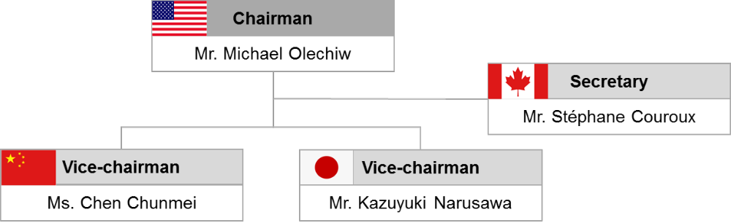
3. As a working group under WP.29, the EVE IWG has the following broad goals that are stipulated in the group’s TOR:
(a) Exchange information on current and future regulatory requirements for EVs in different markets
(b) Identify and seek to minimize the differences between regulatory requirements, with a view toward facilitating the development of vehicles to comply with such requirements
(c) In the event the EVE informal working group identifies the need to develop a UN GTR following a thorough review of the issues and potential areas for regulatory harmonization, a recommendation would be brought to the Working Party on Pollution and Energy (GRPE) and then to AC.3 for consideration regarding potential UN GTR activities.
4. The following specific objectives were established by the EVE IWG in the group’s TOR:
(a) Develop a priority list of topics to address the most timely and significant considerations before the EVE informal working group.
(b) Understand and document the current consideration of EVs under the work of other established informal working groups: Electric Vehicle Safety (EVS) IWG, Worldwide harmonized Light duty Test Procedure (WLTP) IWG, Heavy Duty Hybrid (HDH) IWG, Vehicle Propulsion System Definitions (VPSD) IWG, and Environmental and Propulsion Performance Requirements for light vehicles (L-EPPR) IWG.
(c) Establish a mechanism for sharing ongoing research and information on topics related to EVs and the environment.
(d) Develop a reference guide for regulatory activities already established or being considered by contracting parties.
5. Along with the above, the EVE IWG aims to stay abreast of developing concepts and implementation strategies with the aim of recommending the pursuit of future GTRs to appropriate groups and facilitating the introduction of EVs through regular dialogue and expert presentations. Also, EVE IWG activities are assessed for synergy and overlap with existing work already being conducted by other WP.29 informal working groups.
1.1.1. Summary of EVE activities to date
6. The goals and objectives noted above have been implemented through a series of EVE IWG meetings, where the following activities have taken place:
(a) Review and acceptance of group TOR;
(b) Roundtable discussions to establish working priorities and methodology;
(c) Various presentations relating to the EV questionnaire and Guide development:
(i) Development of the questionnaire document;
(ii) Summary and review of responses;
(iii) Presentation on completed questionnaires (4 presented to-date).
(d) Presentations aimed at information sharing:
(i) Presentations by representatives of related IWGs at meetings: EVS IWG, WLTP IWG, HDH IWG, VPSD IWG, and Environmental and Propulsion Performance Requirements of L-category vehicles (L-EPPR) IWG;
(ii) Presentations from industry, trade organizations, NGO’s, and technical experts (10 presented to-date);
(iii) Presentations of national frameworks by appropriate country representatives (4 presented to-date).
1.2. Purpose of EV Reference Guide
7. The development of the guide is appropriate in the context of the IWG EVE’s objectives, as reflected in the statement of the working group’s specific objectives outlined above.
1.2.1. Document aim, intended audience
8. The EV Reference Guide is intended to serve as a single point of reference relative to the worldwide, environmentally-related EV requirements landscape as it was at the time of this data collection (September 2013). The document captures, based on the information provided by Contracting Parties and other WP.29 members, the existence and extent of regulations relating to critical EV attributes including any standards that are available for voluntary compliance. Additionally, the guide highlights any on-going efforts to develop appropriate standards, regulations or other appropriate requirements. The primary intended audiences of the document are members of government and non-governmental regulatory bodies and agencies involved in the implementation and adoption of policy and regulations relating to electrified vehicles. The guide will identify differences in requirements (regulatory and voluntary) as well as highlight gaps in the requirements framework, allowing Contracting Parties to consider actions to minimize differences and narrow gaps. In addition, the guide will be part of the public domain and therefore be available as a source of information to other EV industry stakeholders such as original equipment manufacturers and suppliers of electrified vehicle components such as batteries, power electronics, and charging solutions.
1.2.2. Connection to WP.29, potential GTR development or adaptation of existing GTRs
9. The reference guide through its thorough overview of the EV requirements landscape permits the observation of issues and gaps that could potentially be addressed via the pursuit of UN Global Technical Regulations (GTRs) or other suitable efforts such as supplementing the work on existing GTRs or GTRs under development (WLTP, WHDC, WMTC), for topics within the scope of WP.29. The guide could also result in efforts by other groups (non-WP.29) to address topics that are outside the scope of WP.29. In the context of the former, the reference guide serves to highlight such opportunities that after thorough review by the IWG EVE including consideration of potential benefit and any overlap with efforts on-going in other informal working groups can be recommended to GRPE and subsequently to WP.29 for development and adoption. Actual development of GTRs or amendment of existing GTRs is not part of the current working group mandate and is therefore not part of the scope of the reference guide. Recommendations to develop GTRs or extend existing GTRs are however part of this reference guide.
10. In addition, this guide does not attempt to assign responsibility for future work but rather focuses on the important environmental attributes of electrified vehicles. Important environmental attributes are established in this guide as a reflection of input received from contracting party respondents. Where future work is noted, particularly within the WLTP or L-EPPR group, it is documented in attempt to inform future discussions of how responsibilities and mandates may be managed.
1.3. Outline of EV Reference Guide
1.3.1. Guide components, section logic
11. The layout of the reference guide focuses on an explanation of the document’s purpose, the methodology employed in its creation, a thorough overview of the findings, followed by conclusions, and recommendations in response to the results of the study. A chapter outline for the guide is given in Figure 2.

Figure 2

Chapter Outline, EV Reference Guide

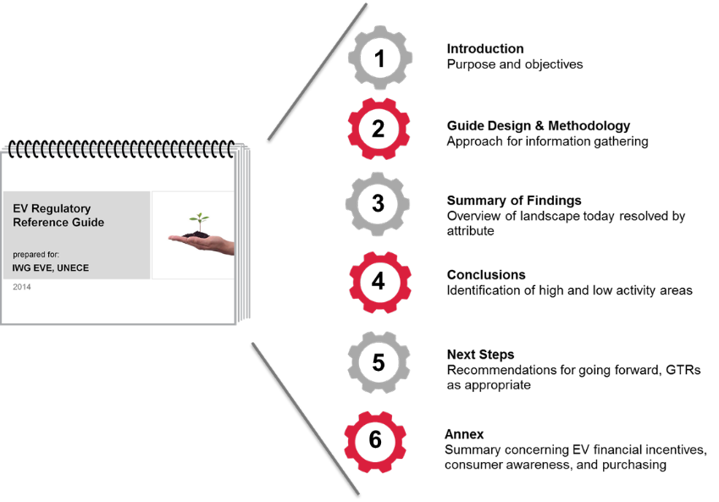
2. Reference Guide Design & Methodology
2.1. Design of the EV Reference Guide
2.1.1. Guide organization; rationale
12. The EV reference guide is organized according to so-called ‘attributes.’ An attribute is defined by the EVE IWG as a characteristic, activity or requirement related to EVs and the environment. This approach was pursued in an effort to minimize confusion related to the interpretation of wording, such as regulation, legislation, etc. Each attribute is defined. Definitions established in GTRs (2, 4, 10, 11), under development in other WP.29 working groups (EVS, VPSD, WLTP, HDH, L-EPPR), found in WP.29 documentation (R.E.3, S.R.1), and established by other organizations (ANSI, ISO, IA-HEV) were scanned for relevance to this work and were used where appropriate.
2.1.2. Scope of guide
13. Attributes related to EV safety were not included (i.e. crash testing; electrical safety standards for internal wiring, etc.) as these fall under the mandate of EVS IWG. Attributes are grouped by those related to vehicle, battery, charging infrastructure and market deployment support (Fig. 3). In order to remain within the scope of the WP.29 (vehicle-only related regulations), attributes related directly to the vehicle and battery were prioritized; charging infrastructure attributes related directly to the vehicle and market deployment support attributes were also included, but are of lower priority.

Figure 3

Groups and Corresponding Attributes, EV Reference Guide
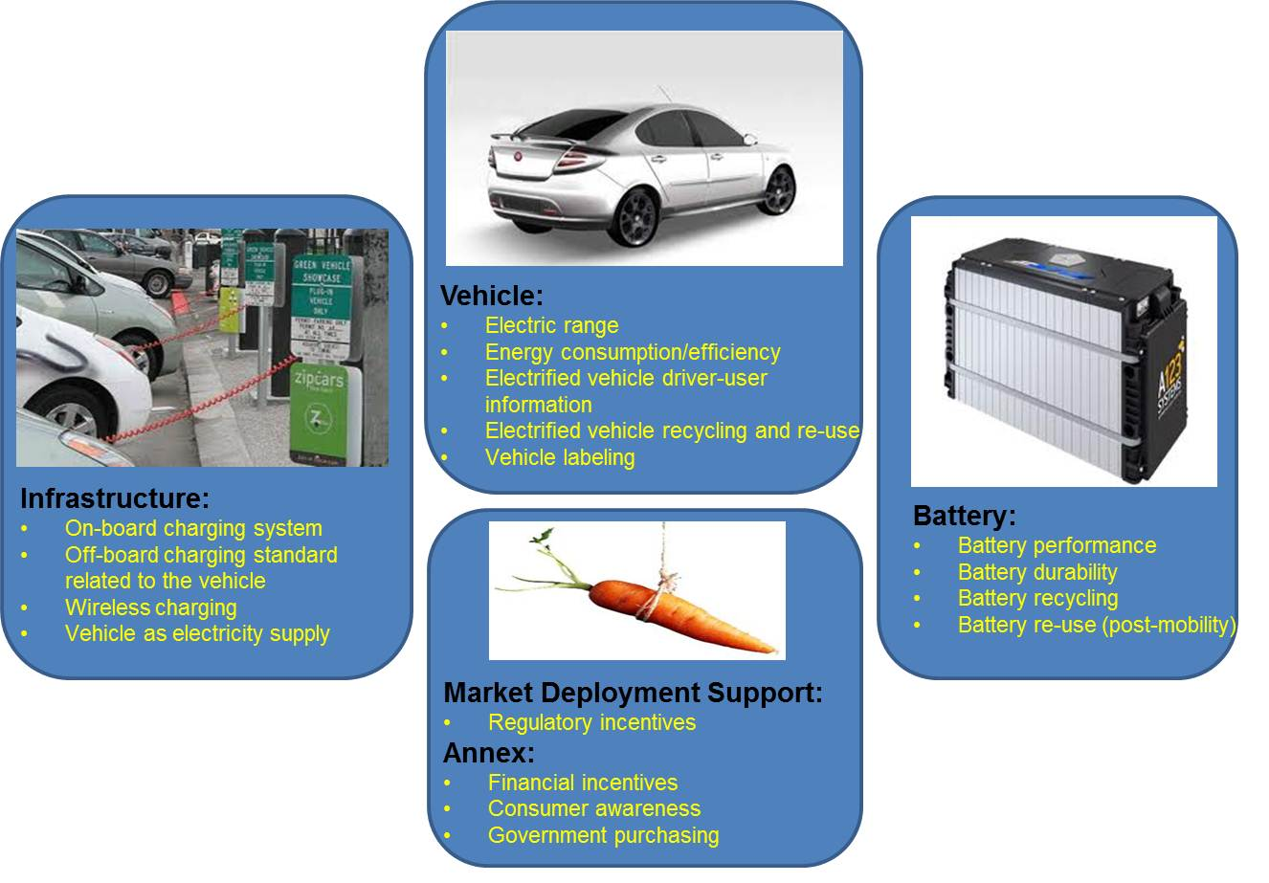
2.2. EV Regulatory Reference Guide Methodology
14. In order to gather input from Working Party on Pollution and Energy (GRPE) members, Contracting Parties, relevant working groups, and other stakeholders concerning global EV requirements (relevant to the environment), a survey-based approach was employed. A questionnaire was developed by the EVE IWG membership, and with the aid of a consultant, it was distributed to stakeholders listed above for their input. Figures 4 and 5 provide an overview of parties that completed the surveys.
15. In-line with the attribute-focused layout of the reference guide, the questionnaire was designed to revolve around these same attributes. Although each attribute is defined in the questionnaire, it was recognized that Contracting Parties may have slightly different definitions. In such circumstances, these parties were encouraged to contribute information for each attribute regardless of the exact definition.

Figure 4

Government Participants, EV Reference Guide Survey
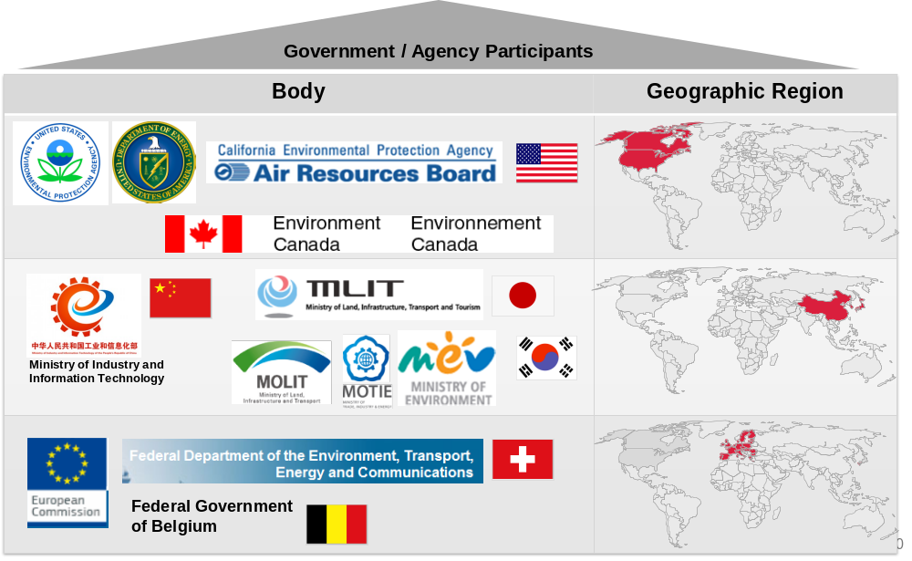

Figure 5

Other Stakeholder Participants, EV Regulatory Reference Guide Survey
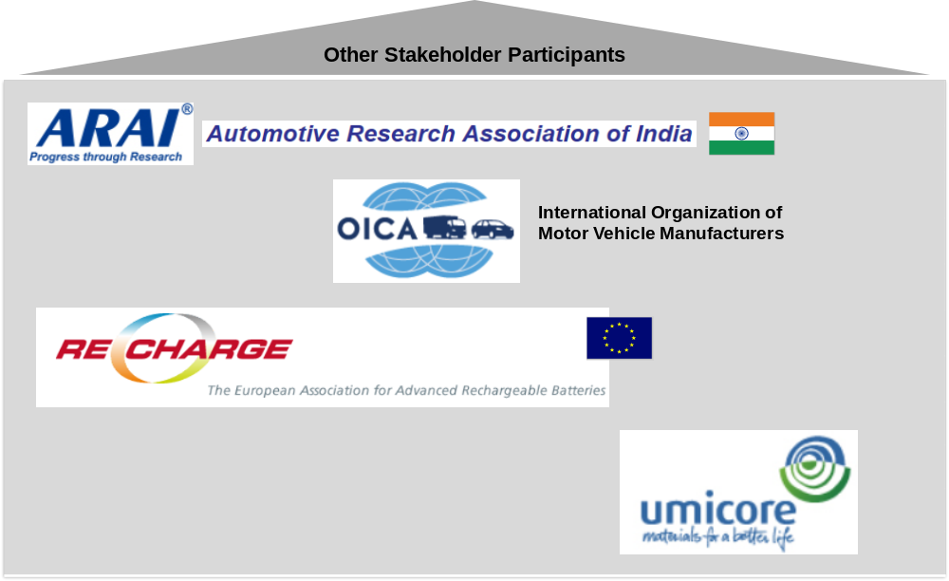
16. It was decided by the EVE IWG leadership that the government responses would form the foundation of the reference guide, while the other stakeholder responses would supplement this foundation. All parties were then invited to review and comment on draft versions of the reference guide. The latter allowed for a wide range of feedback and comments that were believed would lead to a more accurate and complete guide. In addition to the survey responses, relevant UN Regulations and on-going efforts to address electrified vehicle requirements through other WP.29 working groups are captured in the reference guide. Figure 6 summarizes the various sources that inform the content of the reference guide.

Figure 6

Information sources, EV reference guide

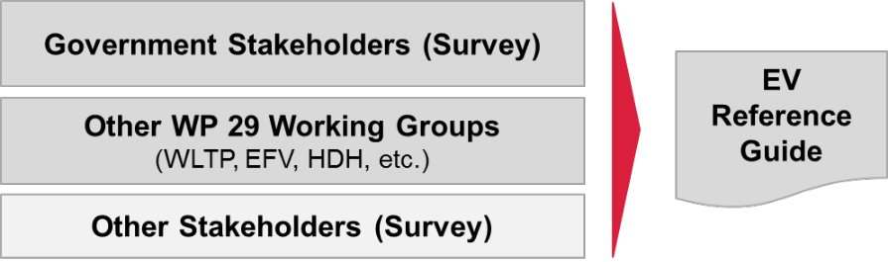
3. Summary of Findings
17. Findings are based primarily on the survey responses and corresponding follow up communications, with additional companion research as necessary to develop a more complete picture of the selected attributes.
The use of green, yellow, and red colours in Section 3 is to indicate visually for each party the presence (green) or absence (red) of regulation, or presence of voluntary regulation (yellow), for each EV attribute; the colours should not be interpreted as a judgement of whether or not a regulatory approach is best for each attribute.
Vehicle Attributes
18. Figure 7 provides a global overview of the requirements landscape from the standpoint of vehicle attributes. The following sections will discuss each attribute in detail.

Figure 7

Vehicle attributes, global snapshot
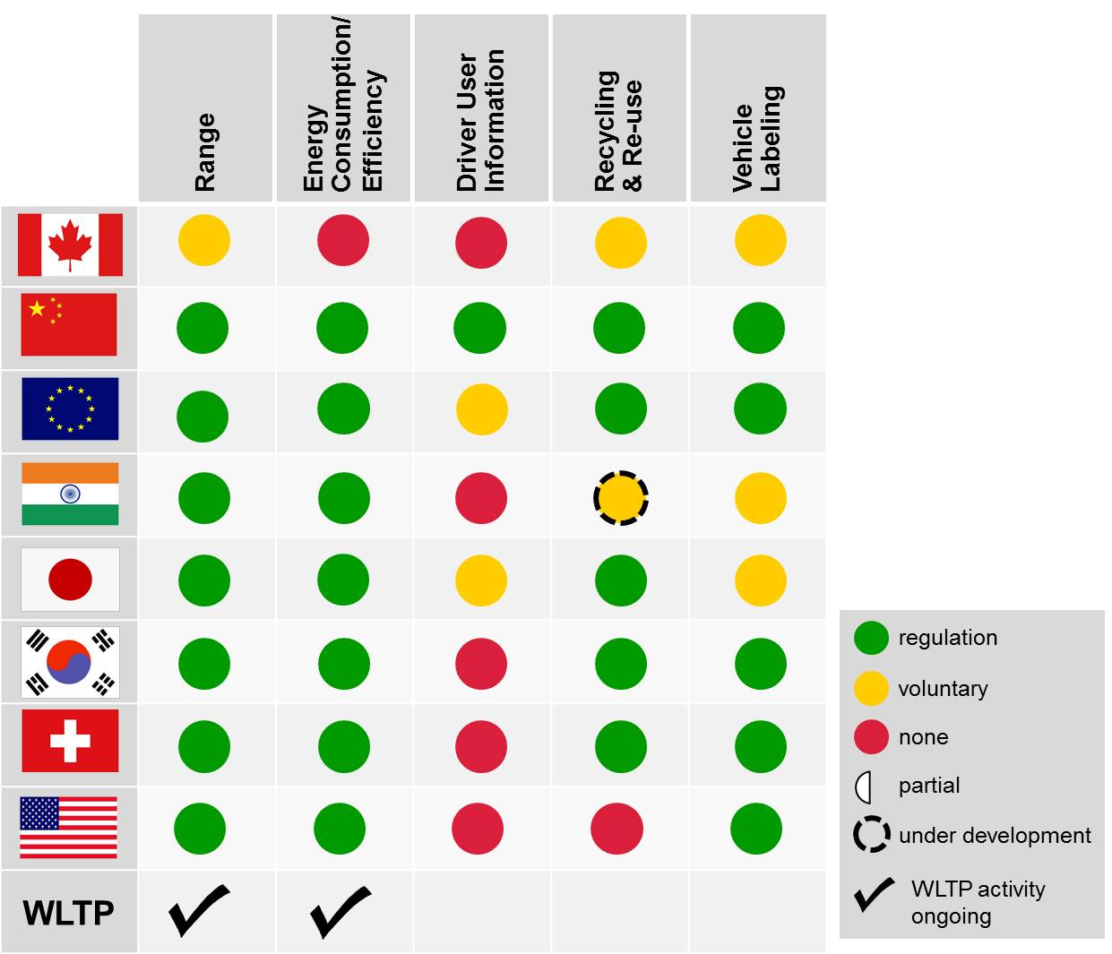
3.1. Electric Range
Attribute Definition: The maximum distance an electrified vehicle can travel using only battery power. In the case of off-vehicle-chargeable hybrid electric vehicles (OVC-HEV) also indicate the “total range”. Vehicle range determination can include a specific drive cycle, test procedures and vehicle preconditioning. Please specify “end of test condition” used. Please include these elements in your answer, if applicable.
Note: This attribute refers to the vehicle’s electric range and is not intended to consider any minimum range standard to be classified as an OVC-HEV.
19. Figure 8 provides a global picture of the responses received concerning electric vehicle range. This can also be observed from the first column in Figure 7.

Figure 8

Electric range requirements, world-wide view
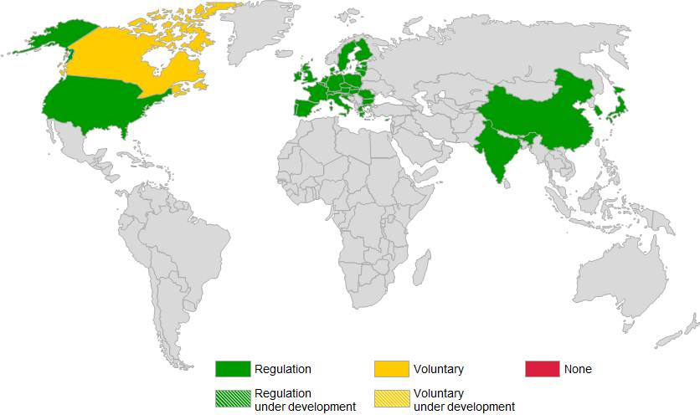
20. Electrified vehicle range is widely regulated. A memorandum of understanding is in place between the Government of Canada and industry for the purposes of vehicle labeling only, which involves range determination. China has a voluntary Chinese National Standard that is available for adherence to (GB/T 18386-2005), which is quoted in the regulation ‘Management Rules for New Energy Vehicle Production Enterprises and Product Access‘, and thus recognized as mandatory. The European Union and Switzerland determine range in accordance with UN Regulation No. 101 (UN-R 101), Annex 9 with respect to light duty motor vehicles and has custom-tailored these electric range requirements for L-category vehicles. India has adopted many aspects of UN-R 101, Annex 9 in its own test procedure (AIS 040). Japan specifies its own test procedure based on the JC08 dynamometer test cycle (TRIAS 99-011-01). South Korea employs a procedure similar to that of the US EPA/NHTSA (described below). The SAE J1634 recommended practice has been adopted as the test procedure for the US EPA/NHTSA. The California Air Resources Board (ARB) has its own range test procedure employed in determination of allowance credits in connection with its Zero Emission Vehicle (ZEV) Regulation.
21. The IWG-WLTP sub-group EV is working on a revision of EV test procedures that will affect the measurement of electrified vehicle range. This is being accomplished through a GTR, phase 1a of which will be adopted by WP29 in 2014 (ECE/TRANS/WP.29/2014/27e). Additionally, the UN L-EPPR IWG is working on expanding GTR No 2 with two- and three-wheeled vehicles in its scope, with respect to the energy efficiency type VII test procedures that includes among others the harmonized range determination of electrified vehicles.
3.2. Energy Consumption/Efficiency
Attribute Definition: Energy required to travel X km in standardized conditions. Energy consumption/efficiency determination can include a specific drive cycle, test procedures and vehicle preconditioning.
22. Figure 9 provides a global picture of the responses received concerning electric energy consumption/efficiency. This can also be observed from the second column in Figure 7.

Figure 9

Electrified vehicle energy consumption/efficiency requirements, world-wide view
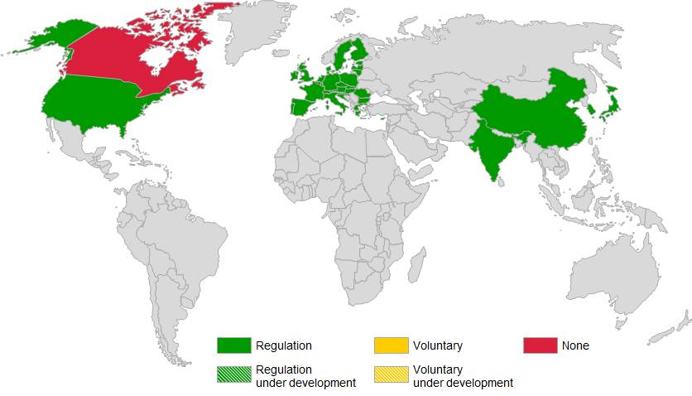
23. Canada does not presently have in place any requirements relating to electrified vehicle energy consumption/efficiency. There are voluntary Chinese National Standards pertaining to energy efficiency of EVs (GB/T 18386-2005) and HEVs (GB/T 19753-2005), which have been subsequently recognized as mandatory. The EU and Switzerland regulate EV energy consumption through the test procedure outlined in UN-R 101, Annex 7. India’s test requirements (AIS 039) draw extensively from UN-R 101, Annex 7. Japan specifies its own test procedure based on the JC08 dynamometer test cycle (TRIAS 99-011-01). South Korea has adopted the same requirements specified by the US EPA/NHTSA. The US EPA/NHTSA require that electrified vehicle energy consumption be determined in accordance to SAE J1634 (PEV), J1711 (NOVC-HEV and including OVC-HEV) and J2841 (- Utility Factor Definitions for OVC-HEV). California does not have separate requirements for energy consumption and is generally aligned with the preceding US Federal regulations.
24. The WLTP-EV sub-group is working on a standardized PEV/HEV test procedure that will impact the measurement of electrified vehicle energy consumption/efficiency. This is being accomplished through a GTR, phase 1a of which will be adopted by WP29 in 2014 (GRPE-66-02, Annex 8). The type VII test procedures on which the UN L-EPPR group is working also includes the harmonized determination of energy consumption for vehicles equipped with electrified propulsion units.
3.3. Electrified Vehicle Driver-User Information
Attribute Definition: The requirement for EVs to include standardized symbols for system warnings, charge systems, etc. For example, a symbol that would indicate to the driver that the gasoline engine is running in a OVC-HEV.
25. Figure 10 provides a global picture of the responses received concerning electrified vehicle driver-user information. This can also be observed from the third column in Figure 7.

Figure 10

Electrified vehicle driver-user information requirements, world-wide view
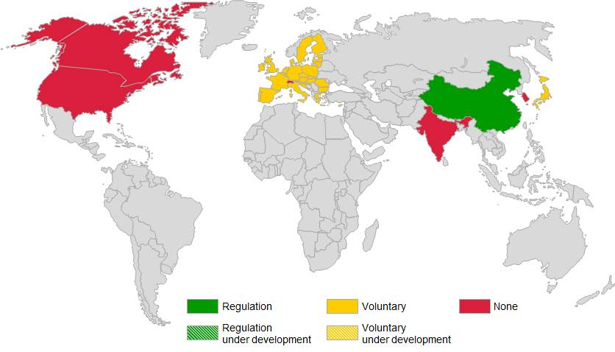

26. Driver-user information is an attribute that is largely lacking any formal regulation globally at the present time. China has a voluntary Chinese National Standard GB/T 4094.2-2005 that specifies EV-specific symbols relating to controls, indicators and tell-tales. This standard is quoted in regulation ‘Management Rules for New Energy Vehicle Production Enterprises and Product Access‘, and is thus now recognized as mandatory. Japan has voluntary standards for EV driver-user information (JEVS Z 804-1998).
3.4. Electrified Vehicle Recycling and Re-use
Attribute Definition: Requirements for recycling and/or reusing vehicle components and/or electric machine.
27. Figure 11 provides a global picture of the responses received concerning electrified vehicle recycling and re-use. This can also be observed from the fourth column in Figure 7. Canada employs a voluntary code of conduct to guide recyclers knows as the Canadian Auto Recyclers’ Environmental Code (CAREC). China has a mandatory Chinese National Standard that governs vehicle end-of-life recycling and dismantling (GB 22128-2008). The European Union regulates M1 and N1 type vehicle recycling through its Directive on End-of-Life Vehicles (2000/53/EC). Directive 2005/64/EC is a subsequent law that further stipulates the degree of recyclability, reusability and recoverability required for M1 and N1 vehicles prior to their approval for sale in the EU. India is in the process of formulating standards for vehicle recycling. It is assumed that these will initially be voluntary in nature. Japan governs vehicle recycling through Act No. 87 of the Ministry of Economy, Trade and Industry (Act on Recycling, etc. of End-of-Life Vehicles). South Korea stipulates requirements for vehicle recycling through Act No. 11913, managed by the Ministry of Environment. Swiss federal regulations for recycling are based on EC Directive 2000/53/EC mentioned previously. The US does not presently have any federal requirements that govern vehicle recycling.

Figure 11

Electrified vehicle recycling and re-use requirements, world-wide view
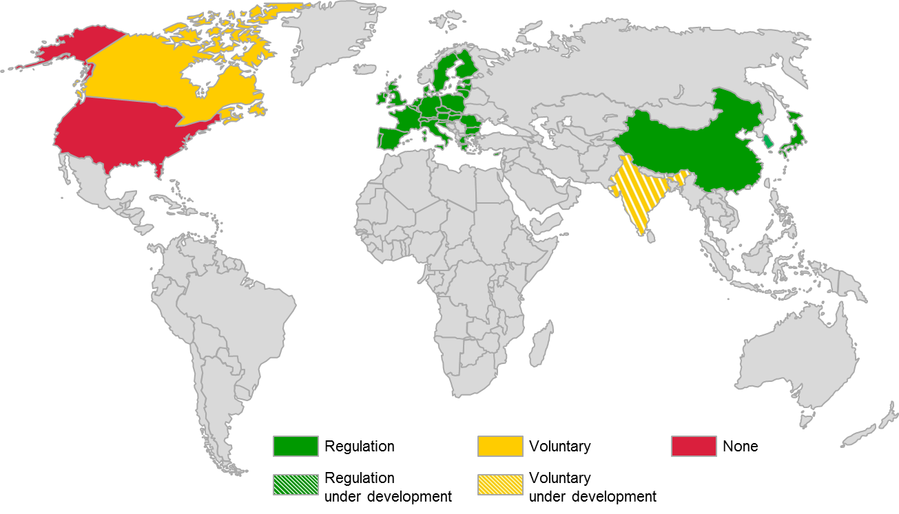

28. It should be noted that in addition to governing the recycling of vehicles, Japan and Korea have laws that require vehicle manufacturers to pro-actively emphasize recyclability in the design and manufacture of their products.
3.5. Vehicle Labeling
Attribute Definition: Requirements for vehicle labeling, including the drive cycle and test procedure used to obtain information for the label. Labels may indicate, but are not limited to, fuel efficiency, emissions, range, total battery capacity (kWh), cost, etc.
29. Figure 12 provides a global picture of the responses received concerning vehicle labeling requirements. This can also be observed from the fifth column in Figure 7.

Figure 12

Vehicle labeling requirements, world-wide view
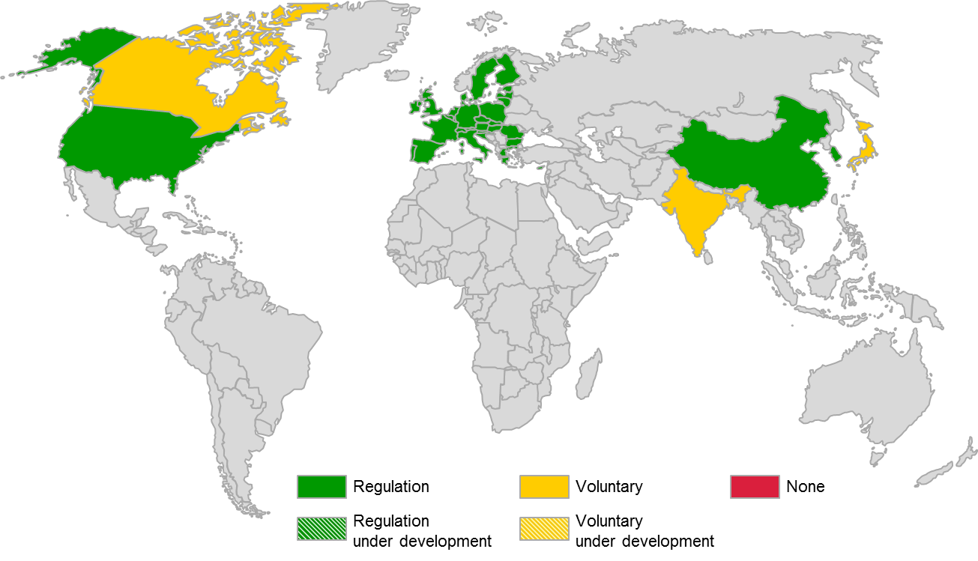
30. Vehicle labeling worldwide is predominantly in relation to fuel economy, with some countries also reporting additional characteristics such as CO₂ emissions and estimated fuel costs.
31. A memorandum of understanding is in place between the Government of Canada and industry for the purposes of vehicle labeling.
32. China’s light vehicle labeling requirements are captured in a mandatory National Standard (GB 22757-2008). The label features three fuel economy ratings covering urban, suburban driving conditions and a composite of the two referred to as ‘integrated operating condition.’ This label only applies to vehicles equipped with conventional internal combustion engine powertrains and will extend to electrified vehicles in the near future.
33. The EU employs a fuel economy label that provides fuel consumption, annual operating cost, and CO₂ emissions for light duty motor vehicles. In the EU this labeling scheme is not yet applicable to L-category vehicles but vehicle manufacturers are required to ensure that the CO₂ emission, fuel consumption, electric energy consumption and electric range data are provided to the buyer of the vehicle at the time of purchase of a new vehicle, in a format which they consider appropriate. CO₂ emissions are ranked using an alphabetized grade (A-G) system. Emissions of vehicles determine in turn, the level of Vehicle Circulation Tax imposed for usage of the vehicle.
34. India does not have regulations governing vehicle labeling, there are however two voluntary label formats available for adherence to by vehicle manufacturers. The two formats are from the Society of Indian Automobile Manufacturers (SIAM) and Bureau of Energy Efficiency (BEE) respectively with both mainly focused on a single average value for vehicle fuel consumption. Electrified vehicles are not addressed by either one of these labels.
35. Japan has voluntary fuel economy performance stickers that can be affixed to vehicles that meet or exceed fuel economy standards. These labels indicate that the vehicles bearing them are eligible for fiscal incentives only and do not provide any specifications or actual statement of fuel consumption. There is no label available for PEVs, OVC-HEVs, or vehicles featuring natural gas or clean diesel powertrains, despite these vehicles being included under the same fiscal incentive scheme.
36. South Korea introduced fuel economy labels according to the ‘Energy Use Rationalization Act’ in 1989, and improved the label scheme extensively with the new fuel economy adjusted by the 5-cycle formula to reflect real-world driving conditions as done in the US in 2011. The values on the label represent the performance of the vehicle in terms of the fuel economy values. Numerical grades between 1 and 5 are divided according to the fuel economy values: the number 1 denotes fuel economy > 16 km/L (‘best’), 2 denotes fuel economy of 15.9-13.8 km/L, 3 denotes fuel economy of 13.7-11.6 km/L, 4 denotes fuel economy of 11.5-9.4 km/L, and 5 denotes fuel economy of <9.3 km/L (‘worst’). All the vehicles with gross vehicle weight of 3.5 tons or less have to be given the grade except PEVs and compact cars with a displacement of 1,000cc or less.
37. Switzerland requires labels indicating fuel consumption, CO₂ emissions, and a letter grade between (A-G) denoting performance in fuel economy; A indicates the lowest consuming vehicle and G the highest, where the indication from A to G is segment specific by considering inter alia the vehicle curb weight.
38. The US EPA employs a series of ‘fuel economy and environment’ labels that address conventional gasoline/diesel powered vehicles, flex-fuel vehicles, CNG vehicles, OVC-HEVs (both series and blended), PEVs, and hydrogen FCVs; the label is not segment specific, in that it applies to all light duty vehicles. Labels include fuel economy information, as well as greenhouse gas and smog ratings based on a relative scale of 1 to 10. Alternative fuel and electrified vehicles feature gasoline equivalent MPG (so-called MPGe) ratings to facilitate comparison activity as well as a statement of range attainable on a single tank of fuel and/or a single full charge of the on-board battery pack.
Battery Attributes
Note: Usage of the term ‘battery’ in this text includes all Rechargeable Electric Energy Storage Systems (REESS) pertaining to electrified vehicles, which to-date are principally comprised of batteries and capacitors.

Figure 13

Battery attributes, global snapshot
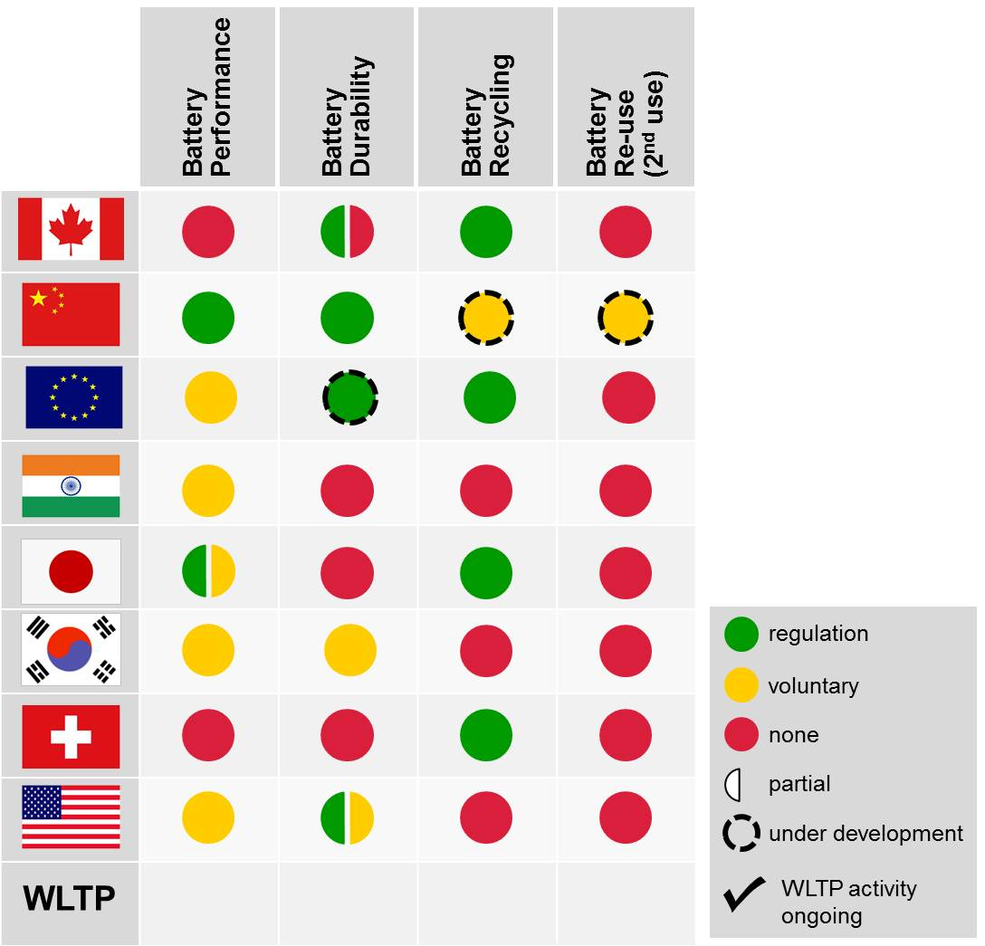
39. Figure 13 provides a global overview of requirements from the standpoint of battery attributes. The following sections will discuss each attribute in detail.
3.6. Battery Performance
Attribute Definition: Methods and conditions for testing and measuring battery power delivery capability, energy storage capacity, battery charge, etc.
40. Figure 14 provides a global picture of the responses received concerning battery performance requirements. This can also be observed from the first column in Figure 13.

Figure 14

Battery performance requirements, world-wide view
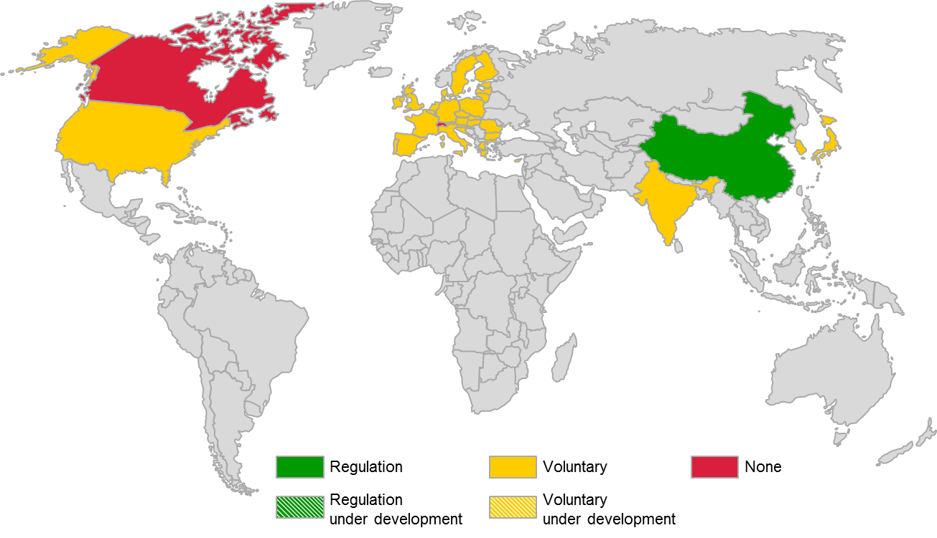

41. Canada does not presently have requirements in place that address battery performance. There are a number of voluntary standards quoted in regulation (hence becoming mandatory) relating to the performance of batteries for electrified road vehicles in China (QC/T743-2006 and others). The EU does have stipulations concerning specifications that must be furnished for electrified vehicle battery performance through UN-R 101, Annex 2. A test procedure however is not specified at this time. ISO 12405-1:2011 (high-power applications) and ISO 12405-2:2012 (high-energy applications) are available as optional test procedures for Lithium-ion traction battery performance. IEC 62660-1:2010 also represents an optional standard for battery performance testing. IEC 61982:2012 is an optional test procedure specifying performance and endurance tests for secondary batteries (except Lithium) for the propulsion of electrified road vehicles. India has a voluntary standard that specifies requirements and test procedures for lead acid batteries for use on battery powered road vehicles and other applications (BIS 13514-1992). Lithium-ion batteries are not addressed by the standard. Japan requires that manufacturers provide information concerning battery (and motor) capacity. South Korea has voluntary standards for testing traction battery performance. These standards (ISO 12405-1 and KS C IEC 62660-1) have been established according to the ‘Industrialization Standardization Act.’ Switzerland does not presently have in place any requirements pertaining to battery performance. There are presently no US Federal regulations that specify requirements for determining battery performance. There are however voluntary procedures for battery performance testing established by the United States Advanced Battery Consortium (USABC), a collaborative effort between the United States domestic automakers (GM, Ford, Chrysler). There is also an SAE recommended practice that is currently in formulation (J1798).
3.7. Battery Durability
Attribute Definition: Methods and conditions for determining average life cycle count, shock and vibration resistance, temperature, etc.
42. Figure 15 provides a global picture of the responses received concerning battery durability requirements. This can also be observed from the second column in Figure 13.

Figure 15

Battery durability requirements, world-wide view
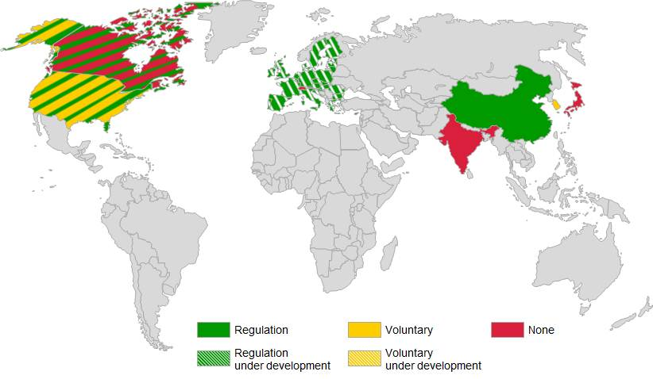
43. Canada has adopted into Federal law US requirements for HEVs, and does not presently have anything in place with regard to pure electric vehicles (PEVs). China has established voluntary guidelines quoted in regulation (hence becoming mandatory) for the determination of battery reliability and durability through the QC/T 743-2006 Automotive Industry Standard. The EU does not presently have battery durability requirements. Voluntary standards ISO 12405-1:2011, ISO 12405-2:2012 (International Standards Organization) and IEC 62660-2 (International Electrotechnical Commission) address durability testing of Lithium-ion batteries and are expected to be referenced in an upcoming effort by WLTP (see below). India and Japan do not presently have requirements relating to battery durability. South Korea has voluntary standards (KS C ISO 12405-1 and KS C IEC 62660-2) based on the previously mentioned international standards in accordance with its so-called ‘Industrialization Standardization Act.’ Switzerland does not presently have requirements relating to battery durability. The US EPA/NHTSA specify requirements that limit the deterioration of HEV batteries. The aim is to require that CO₂ emissions from the vehicle do not increase excessively over the useful life of the vehicle. Specifically, the regulation stipulates that CO₂ deterioration should not exceed 10% of a vehicle’s certified CO₂ value at full useful life. There is however at present no specified test procedure for determining compliance with this requirement. A similar requirement does not exist for pure electric vehicles since an increase in CO₂ emissions does not directly result from battery deterioration in these applications. The USABC has voluntary test procedures that can be followed for testing of rechargeable energy storage devices (REESS). There also exist voluntary SAE standards for battery module life cycle testing (J2288) and vibration testing (J2380). The California Air Resources Board (ARB) stipulates a durability requirement for HEVs that is required in order to earn credits under the California ZEV regulation. This requirement is enforced through a 10 year, 150,000 mile warranty of “zero-emission energy storage device used for traction power” that automakers must provide in conjunction with the sale of these vehicles.
44. Vehicle durability test requirements which could either generally or specifically include durability of components such as batteries are planned to be developed within the framework of the WLTP and subsequently adopted into EU law. This work is however not anticipated before phase 2 of WLTP which is currently not planned to commence before 2016.
3.8. Battery Recycling
Attribute Definition: Battery material recycling standards.
45. Figure 16 provides a global picture of the responses received concerning battery recycling requirements. This can also be observed from the third column in Figure 13.

Figure 16

Battery recycling requirements, world-wide view
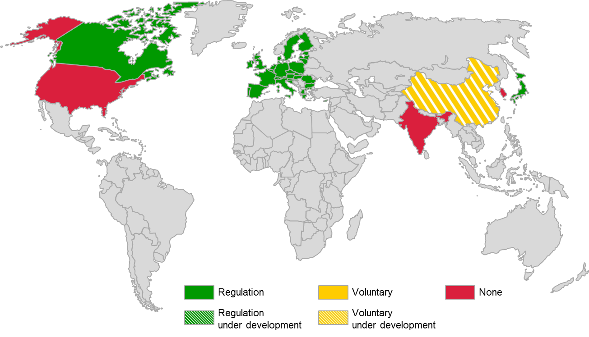
46. Canada does not have a single specific requirement for the recycling of batteries but indirectly mandates the proper recycling of batteries through underlying general recycling and disposal laws in various Acts; for example, the Canada Water Act, etc. Chinese standards relating to battery recycling do not exist at the present time, but are said to be under formulation. In the EU, battery recycling is addressed by the same legislation addressing vehicle recycling, which is Directive 2000/53/EC on end-of-life vehicles. Directive 2006/66/EC stipulates additional battery-specific requirements relating to maximum permissible quantities of hazardous elements in the batteries themselves as well required recycling, collection and disposal procedures. European Commission Regulation 493/2012 specifies the required methodology for achievement of the recycling efficiency defined in Annex III of batteries Directive 2006/66/EC. It should be noted however that the previously mentioned directives do not include battery recycling requirements specifically tailored to hybrid-electric and pure electric vehicles. Japan governs battery recycling through Act No. 87 of the Ministry of Economy, Trade and Industry (Act on Recycling, etc. of End-of-Life Vehicles). Switzerland governs battery recycling through its Chemical Risk Reduction Ordinance. India, South Korea, and the US do not presently have requirements governing battery recycling.
3.9. Battery Re-use (post-mobility)
Attribute Definition: Alternate uses for batteries after their useful life in vehicles.
47. Figure 17 provides a global picture of the responses received concerning battery re-use requirements. This can also be observed from the fourth column in Figure 13.

Figure 17

Battery re-use requirements, world-wide view
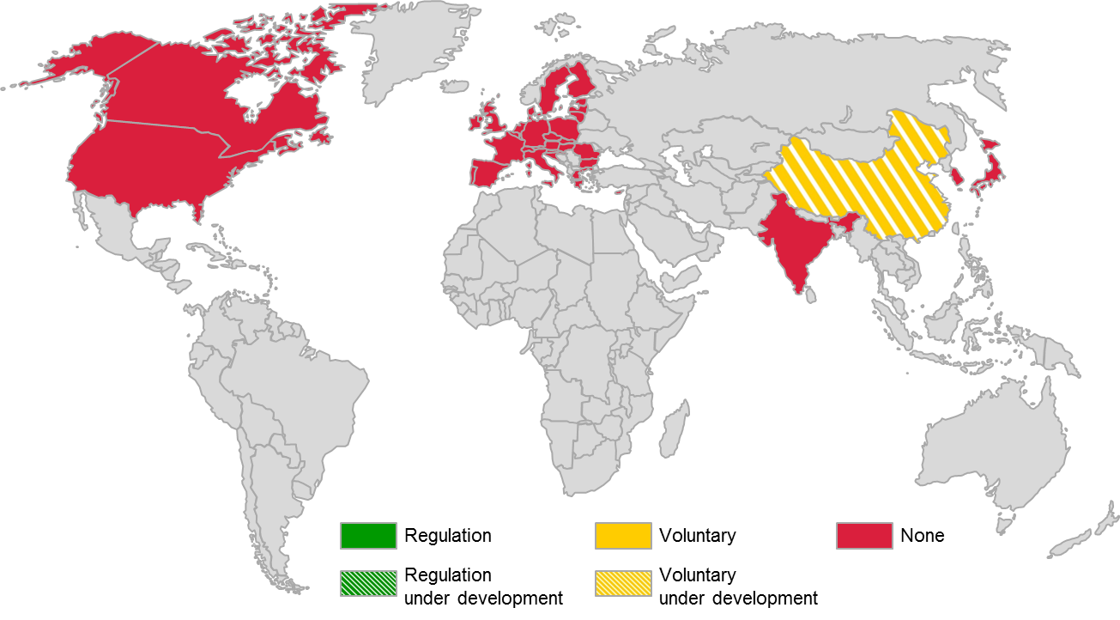
48. There are no standards or regulations pertaining to battery re-use currently in place world-wide. China is said to be in the process of formulating battery re-use standards. Existing EU legislation in the form of Directive 2005/64/EC provides a general framework for the reusability of vehicle components, systems and separate technical units, however there are no specific provisions for battery packs of electrified vehicles.
49. The latest developments (at the time of this writing, September 2013) at the UNECE level include the recently developed regulation on uniform provisions concerning the recyclability of motor vehicles. It has been based on the existing provisions of Directives 2000/53/EC (End-of-life vehicles) and 2005/64/EC (Recyclability, reusability and recovery of vehicles and components) and therefore does not include specific provisions for electrified vehicle battery re-use. Battery re-use or second-use as it is sometimes called is somewhat of a research topic at the moment. Some believe that re-purposing of these batteries could result in an EV ownership cost reduction which could subsequently spur EV adoption rates. Automakers such as BMW, Nissan, and General Motors in partnership with companies like ABB and Vattenfall are actively exploring possible second-use applications for retired EV battery packs. Applications being studied range from home or neighborhood back-up power systems, to more advanced grid power buffering strategies (smart grid). Figure 18 shows a microgrid backup system powered by 5 used Chevrolet Volt batteries, which was the result of a collaboration effort between ABB and General Motors. Automakers such as Renault, have introduced a new business model within the framework of battery pack re-usability. In this model, the battery pack is leased to the vehicle owner, while actual ownership of the battery pack is retained by the manufacturer. When these battery packs reach the end of their operational life, the automaker replaces them with new battery packs at a fraction of the cost of the actual battery. Through this approach, battery packs are either remanufactured as replacement battery packs or are utilized in second-use applications.

Figure 18

Microgrid battery backup technology, General Motors, ABB collaboration (Source: gas2.org)
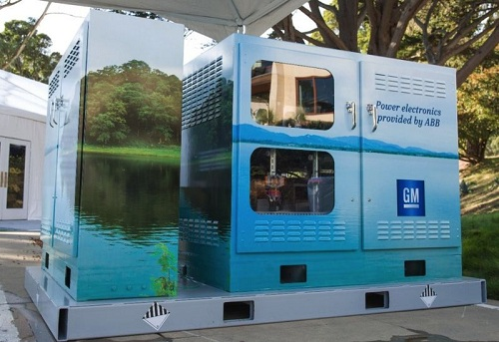
Infrastructure Attributes
Note: Infrastructure attributes are generally outside the scope of WP.29 and are therefore not addressed in the context of recommendations presented in this guide. An overview of the current state of requirements is however considered appropriate and is therefore included here.
50. Figure 19 provides a global overview of the requirements landscape from the standpoint of infrastructure attributes. The following sections will discuss each attribute in detail.

Figure 19

Infrastructure attributes, global snapshot
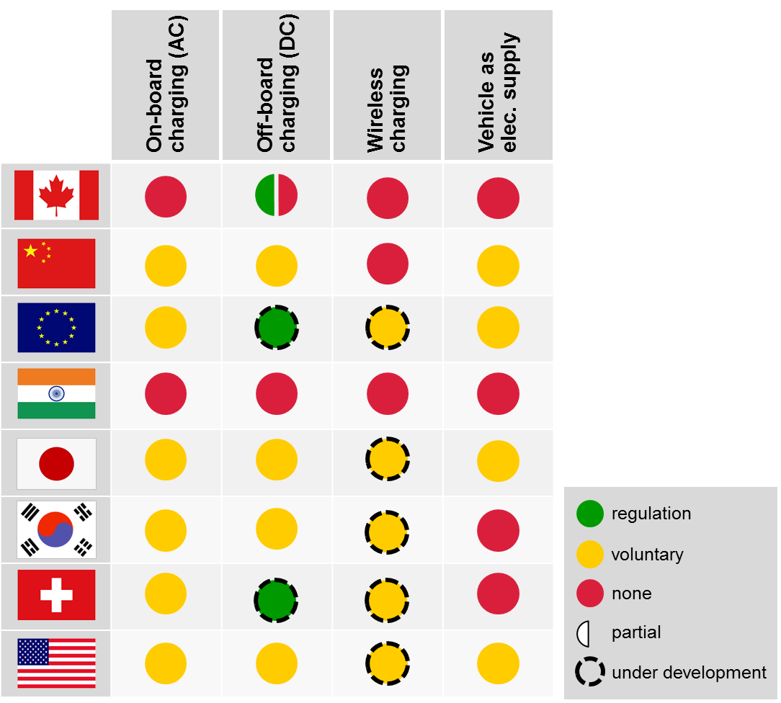

51. [Deleted].
3.10. On-board Charging System
Attribute Definition: Specifications and requirements for on-board charging system, including voltage, current, port for AC and/or DC power, etc.
52. Figure 20 provides a global picture of the responses received concerning on-board charging requirements. This can also be observed in the first column of Figure 19.

Figure 20

On-board charging system requirements, world-wide view
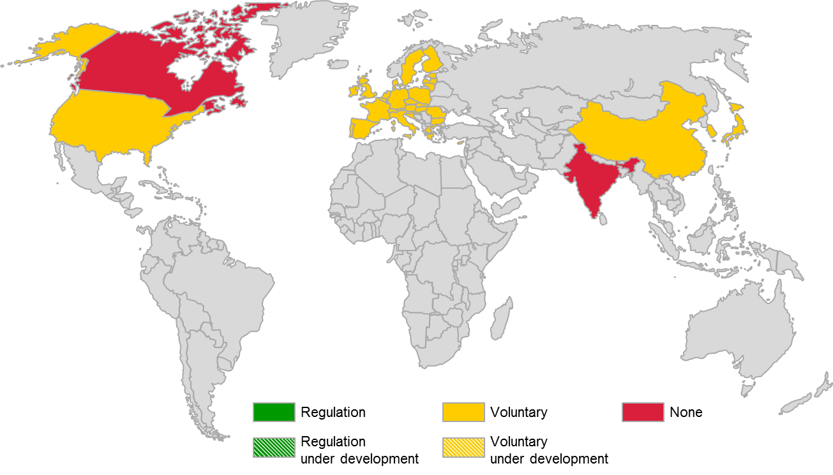
53. Globally, on-board charging is generally guided by IEC 61851 and IEC 62196 standards. The IEC 61851 standards specify the general requirements and functionality of conductive charging equipment, while the IEC 62196 standards specify connector requirements. IEC 61851-21 (ed.1.0) is currently under revision and will be split into IEC 61851-21-1 (EV on-board charger EMC requirements), and IEC 61851-21-2 (EMC requirements for off-board electric vehicle charging systems). IEC 61851-22 (ed.1.0) is scheduled to be withdrawn once the edition 3.0 of IEC 61851-1 is published. IEC 62196-2 is a standard for dimensional compatibility and interchangeability of coupling systems for AC conductive charging, and contains three types of coupling systems; Type-1 is compatible with SAE J1772 and widely used in the US and Japan for vehicle inlet/connector, Type 2 is used in Europe for both vehicle inlet/connector and plug/socket outlet and Type 3 is used in some countries in Europe for plug/socket outlet.
54. China has in place voluntary standards relating to on-board charging. These include Chinese National Standards (GB/T 20234.1-2011, GT/T 20234.2-2011), which are considered to be quoted in regulation, and an Automotive Industry Standard (QC/T 895 2011). The EU generally adheres to the definitions contained in these IEC standards on a voluntary basis (European Mennekes connector). This is also true for Japan (Type 1 connector / SAE J1772). South Korea in accordance with its so-called ‘Industrial Standardization Act’ has established voluntary on-board charging standards (KS C IEC 61851-1, KS C IEC 61851-22) based on the previously mentioned IEC standards. Switzerland, like the EU generally adheres to the IEC standards on a voluntary basis. The US also generally adheres to the mentioned IEC standards (Type 1 connector / SAE J1772). In California, ZEVs and OVC-HEVs must meet the requirements of SAE 1772 (AC connection) in order to qualify for ZEV credits. Canada and India do not presently have any requirements in place relating to on-board charging.
3.11. Off-board Charging Standard Related to the Vehicle
Attribute Definition: Specifications and requirements for off-board charging system, including port for DC power, battery communication interface/battery management system communication interface, etc.
55. Figure 21 provides a global picture of the responses received concerning off-board charging system requirements. This can also be observed in the second column of Figure 19.

Figure 21

Off-board charging system requirements, world-wide view
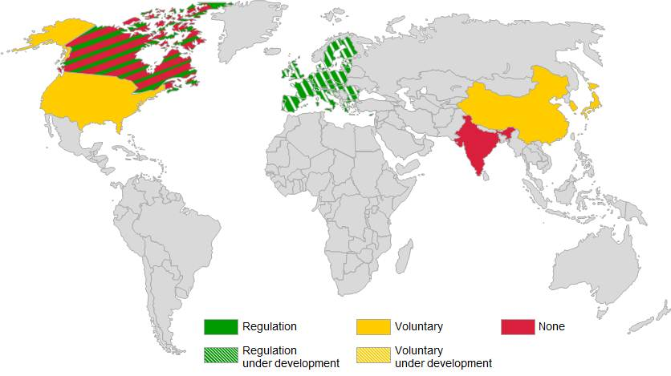
56. Globally, off-board charging is generally guided by IEC 61851 and IEC 62196 standards. The IEC 61851 standards specify the general requirements and functionality of conductive charging equipment, while the IEC 62196 standards specify connector requirements. IEC 61851-23 (DC charging stations), IEC 61851-24 (control communications) and IEC 62196-3 (vehicle couplers) will define specific requirements for conductive charging with a DC connection and are expected to be published in early 2014.
57. Canada does not have federal requirements for off-board charging, as this issue is under provincial jurisdiction. As with most electrical installations, chargers must comply with Canadian Standards Association (CSA) standards for electric appliances and the Canadian Electric Code. China maintains several voluntary standards in relation to off-board charging. These include Chinese National Standards (GB/T 20234.1-2011, GB/T 20234.3-2011, GB/T 27930-2011), which are considered to be quoted in regulation, and Energy Industry Standards (NB/T 33001-2010). The EU is in-line to adopt the a new EU Directive referencing the new IEC standard IEC 62196-3 on vehicle connectors, as well as existing standard IEC standard IEC 62196-2. Member States of the EU will be required to transpose the requirements into their national laws, regulations and standards within 2 years of adoption and this is likely to be complete by 2017. Japan has voluntary standards through the CHAdeMO connector system (JARI JEVSG105 and IEC 62196-3). South Korea in accordance with its so-called ‘Industrial Standardization Act’ has established voluntary standards (KS C IEC 61851-1 and KS C IEC 61851-23) relating to off-board charging. Switzerland, like the EU is also in-line to adopt the upcoming IEC standards mentioned previously. The US has voluntary standards for off-board DC charging through SAE J1772 (up to DC Level 2). India does do not presently have any requirements in place relating to off-board charging. Figure 22 summarizes the various IEC standards governing conductive charging and the anticipated timing of their release.

Figure 22

IEC standards governing conductive charging
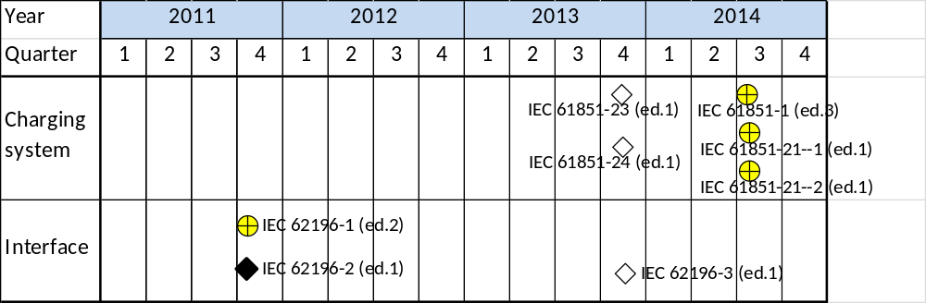
3.12. Wireless Charging
Attribute Definition: Requirements and standards for wireless charging.
58. Figure 23 provides a global picture of the responses received concerning wireless charging requirements. This can also be observed in the third column of Figure 19.

Figure 23

Wireless charging system requirements, world-wide view
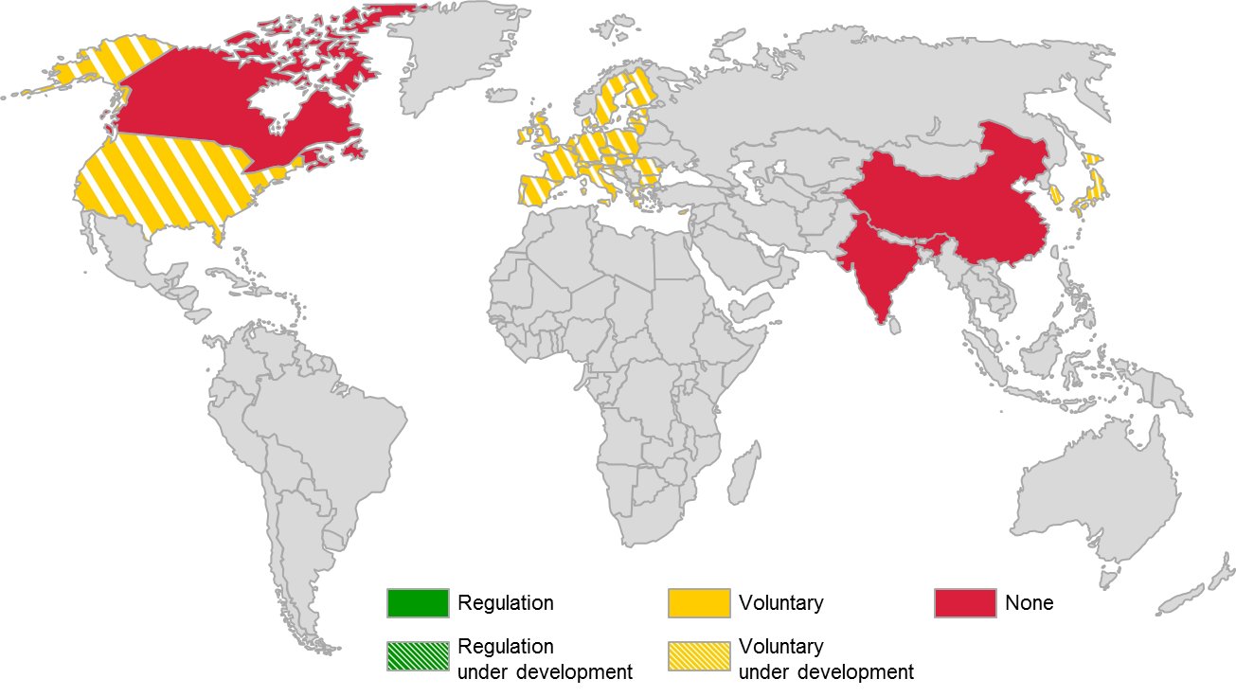
59. There are neither legislated nor voluntary requirements for wireless charging anywhere in the world at the present time, while existing regulations on radio-communication or broadcasting may apply to such systems. Within IEC, a new international standard addressing general requirements for wireless charging is being developed (IEC 61980-1). Technical specifications for charge control communication (IEC/TS 61980-2) and specific requirements for magnetic coupling (IEC/TS 61980-3) are also in development. These standards and specifications are expected to be published in Q2, 2014. The EU is expected to adopt these on a voluntary basis. China has planned to develop the voluntary standards on wireless-charging in the near future. Japan is said to have voluntary standards in development through Association of Radio Industries and Businesses (ARIB). Korea also is said to have voluntary standards in development, with charging frequencies of 20 kHz and 60 kHz already being allocated for wireless charging purposes. Switzerland, like the EU is expected to adopt the upcoming IEC standard and technical specifications on a voluntary basis. In the US, there is an SAE standard that is currently in formulation (efforts commenced in 2010) that will eventually lead to a published, voluntary recommended practice (J2954). Canada and India do not have anything in place in regards to wireless charging at the present time. It is however expected that these countries will eventually adopt in some fashion the upcoming IEC or SAE standards governing wireless charging.
3.13. Vehicle as Electricity Supply
Attribute Definition: Vehicle-related specifications and requirements for transferring electricity from EVs to the grid.
60. Figure 24 provides a global picture of the responses received concerning vehicle as electricity supply requirements. This can also be observed in the fourth column of Figure 19.

Figure 24

Vehicle as electricity supply requirements, world-wide view
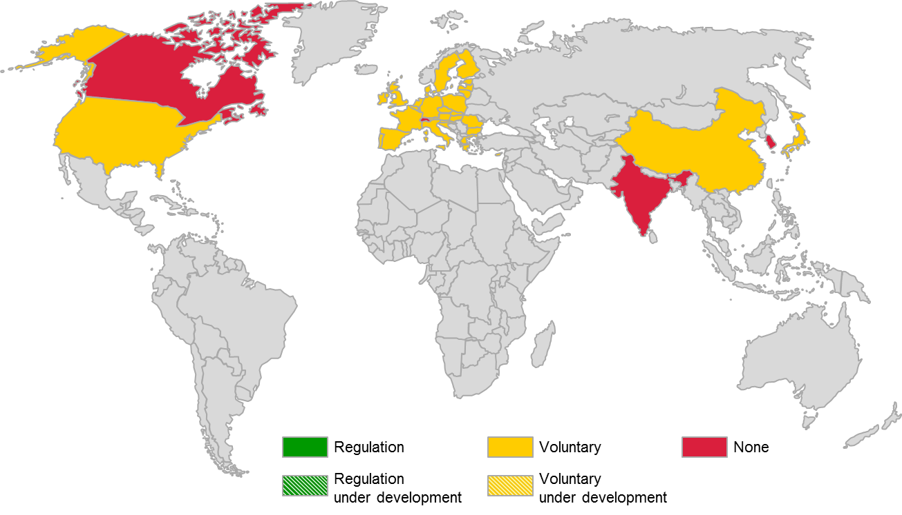
61. There are no legislated regulations in place anywhere in the world that govern the requirements of a vehicle functioning as an electricity supply. China does not have any national or professional standards in place, but has several so-called enterprise standards that stipulate basic requirements relating to bi-directional charging equipment (Q/GDW 397-2009, Q/GDW 398-2009, Q/GDW 399-2009). In the EU, initial portions of an 8 part ISO/IEC standard (ISO/IEC 15118) are currently available while the remaining portions are in formulation. Japan is said to have enterprise standards that stipulate basic requirements relating to bi-directional charging equipment (Electric Vehicle Power Supply Association Guideline EVPS-001/002/003/004 2013). In the US, initial voluntary standards are available in the form of SAE recommended practices J2836, J2847, and J2931 which are continuing to be developed and extended to more fully address the necessary requirements. The maturity level of the ISO/IEC standards and their SAE counterparts are generally similar, with a substantial amount of remaining effort required to finalize them for their intended purpose. It should be noted that the preceding efforts relate primarily to the development of the appropriate grid communication interface. None of them are yet addressing the actual functionality of the vehicle as an electricity supply. The only modest exception is Japan where requirements that allow an electrified vehicle to be used as an electricity supply in emergency cases are said to already be available. Canada, India, South Korea and Switzerland do not yet have any requirements in place relating to this attribute, but are expected to eventually adopt in some fashion the ISO/IEC or SAE standards that are presently in development.
Market Deployment
62. Figure 25 provides a global overview of the regulatory landscape from the standpoint of market deployment attributes. Regulatory incentives will be discussed in detail in this section. The remaining attributes are outside the scope of WP. 29 and will be summarized in the Annex.

Figure 25

Market deployment attributes, global snapshot
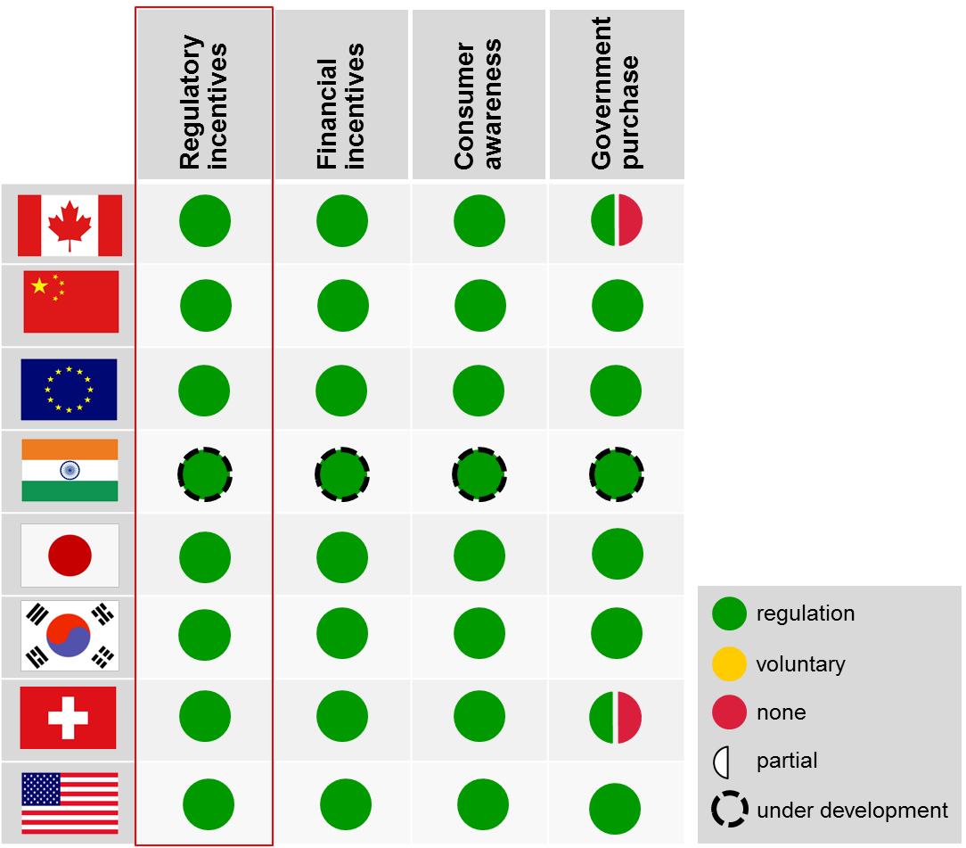
3.14. Regulatory Incentives
Attribute Definition: Legal requirements that contain an incentive for deployment of electrified vehicles. The term ‘legal requirements’ is broad and can refer to any regulation, legislation, code, and/or standard that is rooted in law
63. Figure 26 provides a global picture of the responses received concerning regulatory incentives. This can also be observed in the first column of Figure 25. It can be seen that in general, regulatory incentives are widely available throughout the world. Canada’s current greenhouse gas emission regulations for new cars and trucks aim to reduce GHG emissions from vehicles by establishing mandatory GHG emission standards in alignment with U.S. standards (see below). The regulations include additional flexibilities for advanced technologies, like hybrid and electrified vehicles, which encourage vehicle manufacturers to adopt low GHG emission technology. China has established a Corporate Average Fuel Consumption (CAFC) law which specifies standards, methods and regulatory incentives for PEVs, FCVs, and OVC-HEVs with electric driving ranges greater than 50km as well as for so-called low fuel consumption vehicles (lower than 2.8L/100km). The corresponding rules pertaining to credits and penalties are under development.

Figure 26

Regulatory incentives, world-wide view
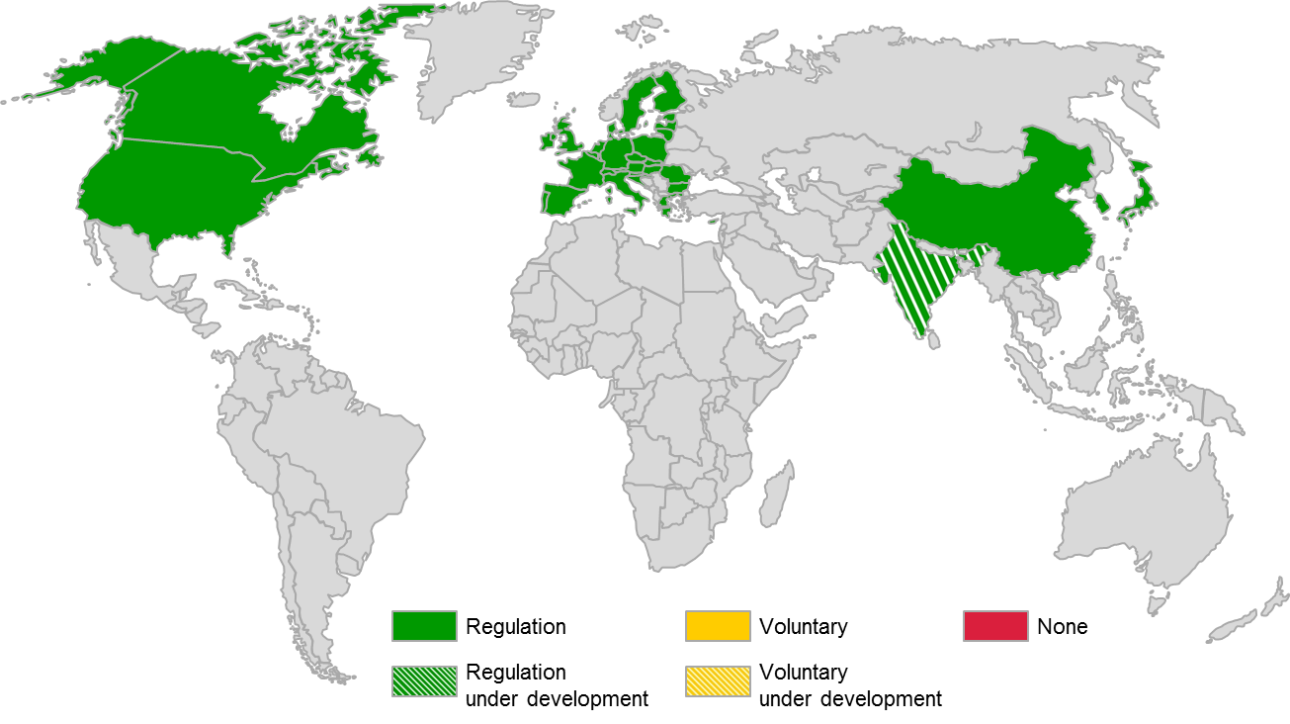
64. In the EU, regulation 443/2009/EC establishes fleet-wide CO₂ targets that include electrified vehicles. Specifically, super-credits are available to manufacturers for any of their vehicles that emit less than 50g/km of CO₂ in the years 2013 to 2015 and 2020 to 2022 to encourage more of the cleanest vehicles into the European market. India is said to have regulatory incentives under formulation as part of the ‘National Mission for Electric Mobility’ being undertaken by the Government of India. Japan is said to award credits to manufacturers for the sale of PEVs and OVC-HEVs, in accordance with its 2020 fuel economy standard. Switzerland has adopted the previously cited EU regulations into Swiss law. South Korea regards pure electric vehicles as zero CO₂ vehicles and awards super credits to vehicles emitting less than 50g/km of CO₂, in accordance with its national light-duty vehicle fuel economy and greenhouse gas regulations. In the US, EPA/NHTSA provides a zero tailpipe emission score and bonus credits to electrified vehicles up to a specific cap under the national light duty vehicle GHG emissions regulations. The California zero emission vehicle (ZEV) mandate requires sales percentages of plug-in and fuel cell passenger vehicles to 2025. Credits are based on vehicle type (pure ZEV or plug-in hybrid) and ZEV range. Pure battery electric, fuel cell electric and plug-in hybrids are eligible for credits. California also has a passenger vehicle fleet average GHG standard that is coordinated with the federal GHG standards, and electrified vehicles can earn credits towards the GHG fleet average standards. The California program has also been adopted by several other states. High Occupancy Vehicle/High Occupancy Toll lane exemptions are provided to HEVs by many US states to encourage adoption of the technology. The following states presently offer these exemptions: Arizona, California, Colorado, Florida, Georgia, Hawaii, Maryland, North Carolina, New Jersey, New York, Tennessee, Utah, and Virginia.
4. Conclusions
65. It should be noted that conclusions offered here are based primarily on responses provided by participants in the EV reference guide questionnaire coupled with reasonable additional diligence in terms of companion research and follow on communications with participants and other relevant parties where appropriate. It should also be noted that the entire reference guide including this section has been progressively refined through the draft review process with EVE IWG leadership and members.
4.1. High Activity Areas

Figure 27 :

Activity chart, electrified vehicle requirements
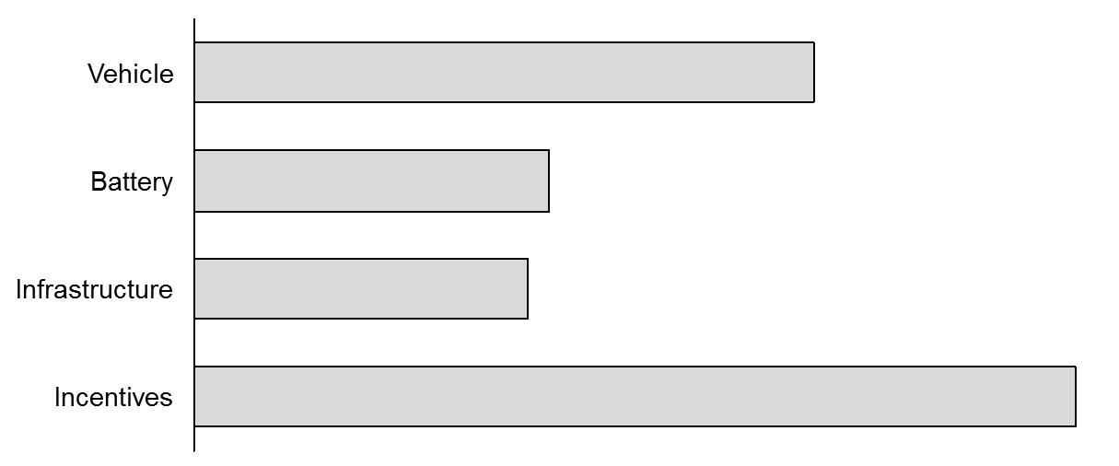
66. Figure 27 provides an overview of the overall level of activity by attribute, for electrified vehicle requirements. This chart and the ones that follow (Figs. 28-31) employ a simple scoring system where responses of no requirements are assigned a numerical value of 0, voluntary requirements are assigned a value of 1, and legislated requirements are assigned a value of 2. There is no scoring difference between requirements that already exist and that are being developed. For Figure 27, the total for each category has been divided by the number of attributes in that category, providing a representative average value for each category. In general the presence of requirements in the surveyed countries was high with respect to vehicle-level attributes, with the exception of driver-user information which was largely absent across the countries (China and Japan are the exceptions). This is illustrated in Figure 28.

Figure 28

Activity chart, vehicle attributes
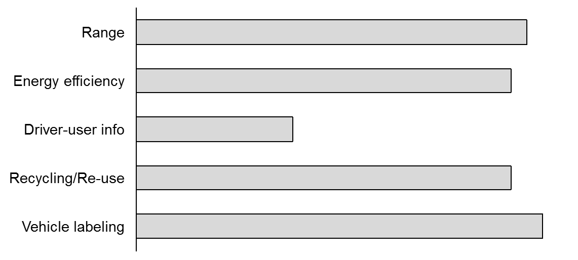
67. From a market deployment standpoint, the area of regulatory incentives was also found to be at a high state of activity, with 8/8 of the countries/regions surveyed having either incentives already in place, or plans to deploy them in the future (Fig. 29).

Figure 29

Activity chart, market deployment attributes
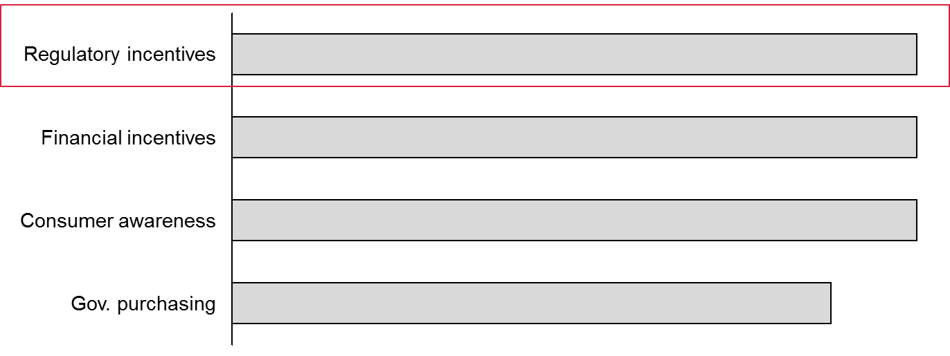
4.2. Low Activity Areas
68. In general, requirements pertaining to battery-level attributes were low on the activity spectrum (Fig. 27). Figure 30 illustrates the activity level of each sub-attribute. Battery re-use in particular is at present largely without any requirements whatsoever. The exception is China which is said to be in the process of formulating appropriate standards relating to battery post-mobility use.

Figure 30

Activity chart, battery attributes
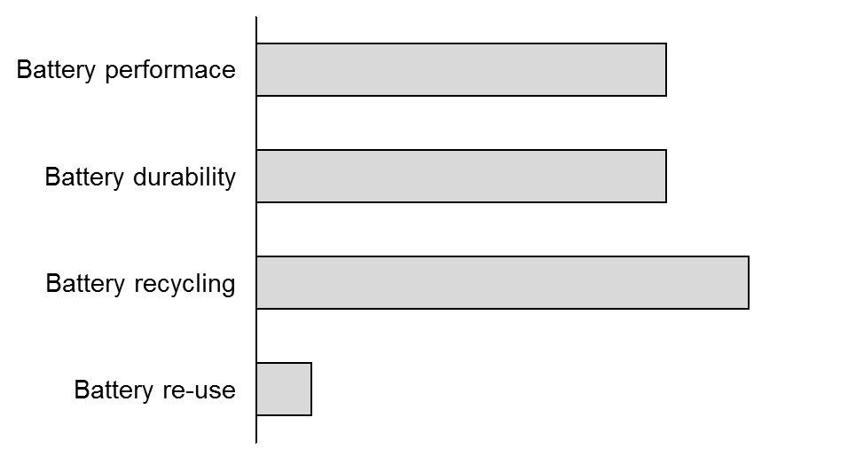
69. Battery durability is somewhat unaddressed by present standards, the exceptions being China and partial coverage (HEVs) by US and Canadian laws. The activity level is expected to increase globally. These requirements may not only address battery lifecycle determination, but also the impact of partially deteriorated batteries on CO₂ emissions / fuel economy.
70. Battery recycling is partially addressed, but through largely country-specific protocols and with therefore little standardization from a global perspective. These requirements are also generally non-battery-specific and tend to take the form of general end-of-life vehicle recycling guidelines. The exception is the EC which stipulates battery-specific requirements pertaining to permissible quantities of hazardous materials as well as specific required recycling procedures.
71. Battery performance is partially addressed, and by a range of largely voluntary standards established by international organizations (ISO, IEC) and other organizations such as SAE. There is therefore lack of standardization in regards to the required procedures and hence outcome of battery performance testing.
72. Infrastructure attributes are also generally low in terms of their level of activity (Fig. 27), and tend to be dominated by voluntary standards. Figure 31 illustrates the activity level of each sub-attribute. A number of these attributes such as off-board charging, wireless charging, and vehicle as an electricity supply can be regarded as developing topics in the EV domain. Given this, despite the relatively low score, requirements to properly address these attributes are being actively and methodically pursued, in most cases through international standards (ISO, IEC) and through the efforts of other organizations like SAE.

Figure 31

Activity chart, infrastructure attributes
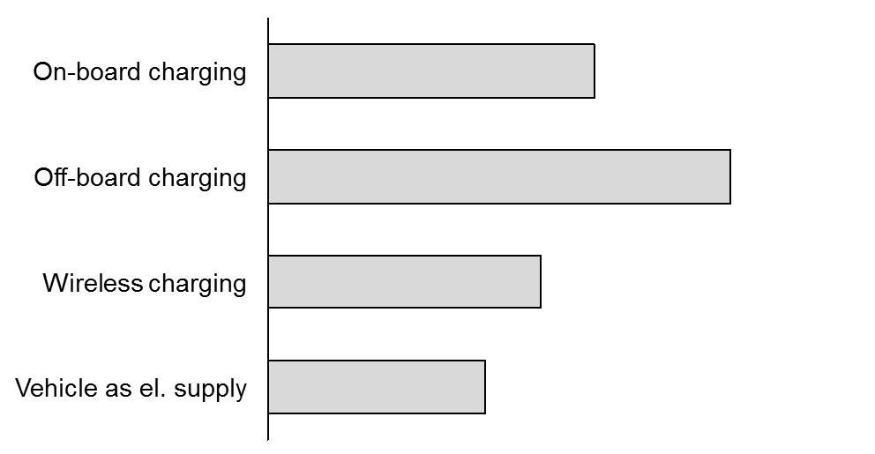
4.3. Gaps and Implications of the Analysis
4.3.1. Vehicle Attributes
73. Vehicle-level attributes despite their high global activity level, do feature some gaps. The fact that vehicle-level attributes such as range and energy efficiency are among key consumer buying criteria highlights the need for uniformity in their determination. Further, against a backdrop of increasing globalization and a largely international market for import and export of vehicles, it is essential that this uniformity be as global in nature as possible, so that consumers can expect some reasonable degree of commonality in critical vehicle performance attributes both across vehicle concepts and world-wide. Energy efficiency and range are also critical input parameters to other key events such as CO₂/fuel economy standards compliance determination, new vehicle type approvals, and vehicle labeling (principal method for consumer gathering of purchasing information mentioned previously). Vehicle range and fuel economy is generally determined in accordance to SAE procedures in the US and South Korea. European Union member countries employ procedures stipulated in current UN-R 101, with India borrowing key aspects of the regulation in its own procedure. Japan and China specify their own procedures. The challenge here is lack of global uniformity in regards to drive cycle and test procedures for determination of key vehicle performance criteria. This disconnect was identified by the UNECE and is the subject of Phase 1 of a GTR being developed under the framework of WLTP working group. The latter features the development of a so-called Worldwide Harmonized Light Duty Test Cycle (WLTC). Besides uniformity in the drive cycle itself, standardization of test procedures is critical. One key aspect of this is ambient temperature which has been shown to significantly impact range and efficiency of electrified vehicles. Phase 2 of the GTR is expected to include provisions to address the impact of both low ambient temperatures as well as high altitude conditions on range and energy efficiency; however, the workplan for WLTP Phase II is still under development and will likely start in 2015/16. A gap still exists in accounting for the use of accessories, in particular air conditioning, cabin heating, and vehicle exterior lighting. The L-EPPR IWG is also working on supplementing GTR No 2 with energy efficiency requirements. There are currently a range of practices concerning the operation of these auxiliary systems. For instance, South Korea requires the heater to be operated at its maximum setting during cold testing, and US standards capture A/C operation by default through its 5-cycle testing procedure. Besides these differences, there is also a general lack of provisions corresponding to advanced thermal management systems such as heat pumps or infra-red heating. The efficiency impact of such comfort systems compared to resistive heating may influence vehicle range and efficiency substantially. Active battery management systems employed by different OEMs / battery pack manufacturers as well as driver selectable operating modes (sport, eco etc. ) are also aspects that are generally not yet fully addressed. Vehicle labeling, while widely practiced globally (high activity), sometimes excludes electrified vehicles (EU, US and South Korea are the exceptions) representing another significant gap.
4.3.2. Battery Attributes
74. Battery performance determination is largely non-standard, with a mix of voluntary standards (USABC, SAE, ISO, IEC) and some country-specific ones existing or in development (China, Japan). Considering that battery performance is a crucial factor effecting CO₂ emissions, fuel economy, range, and therefore the ultimate value proposition of an electrified vehicle to a customer, this disparity in requirements represents a gap. The battery is also the most expensive component in an EV which adds emphasis to the importance of accurately determining its performance.
75. Battery recycling by virtue of its widely differing requirements globally can be considered to be gapped as well. Overall there are a limited number of requirements relating to battery recycling globally at the present time.
76. Battery re-use post mobility represents a wide gap that will be challenging to govern given the highly variable nature of battery wear and inherent differences in chemistry, construction, and power management. Given that batteries dominate the cost of electrified vehicles and are typically deemed unusable from a mobility standpoint after degrading to between 70 and 80% of fully-chargeable capacity, there is a compelling reason to take a serious look at re-using these batteries in other applications. In order to ensure the success of battery re-use, guidelines and regulations that govern the implementation, as well as ensure the reliability durability of such systems are crucial. This is likely to be challenging given that used batteries can be subject to a wide range of usage behaviors that can in turn influence the consistency of their performance over time. There may also be a need for additional regulation/legislation in this field to prevent misuse or abuse of rechargeable batteries offered for second use. In addition, the question of the application of the extended producer responsibility is raised in the case of the end of life management of these batteries after their second use.
4.3.3. Infrastructure Attributes
77. Infrastructure attributes are generally on the path towards well specified, thorough requirements. This effort is being led by a roadmap of ISO/IEC standards that govern the system interface and communication protocols, and a generally well harmonized set of standards that govern the charging and coupling interface. The gap here is one that is temporary, and progressively closing.
4.3.4. Market Deployment Attributes
78. There are no gaps that exist in the context of regulatory incentives.
5. Next Steps
5.1. Vehicle Range & Energy Consumption Testing
79. It is recognized that electrified vehicle range is affected substantively by vehicle speed and driving behaviour, ambient temperature, and the operation of climate control systems. Properly accounting for cabin heating is crucial, not only to ensure that consumers are provided with realistic estimates of electric-mode vehicle driving range, but so that EVs equipped with advanced, efficient HVAC systems are able to prove their effectiveness and justify any potential cost differential between them and more conventional resistive heating systems. Similarly, assessing vehicle performance at elevated ambient temperatures with air conditioning in operation should be of regulatory concern.
80. It is recommended that general provisions be considered in efforts to develop test procedures in the existing GTRs or a future GTR pertaining to range and energy efficiency of electrified vehicles, for example:
Requirements flexible enough to accommodate current and anticipated technologies such as:
(a) resistive heating element and heat pump systems
(b) infra-red panels and foot wells
(c) heated seats, heated steering wheel
(d) etc.
81. In conjunction with the development of appropriate test procedures or GTR, consideration of additional research to quantify the impact of climate and auxiliary system operation on range and energy efficiency is recommended. Such research could potentially improve the understanding of the sensitivity of the vehicle attributes (range and energy efficiency) to climatic factors, and a range of auxiliary systems and their corresponding methods of operation and control. It is understood that Phase 2 of the GTR being pursued by the WLTP working group aims to address low temperature ambient conditions, but to-date there is no mandate from WP.29. Should the preceding recommendations go beyond the scope of those efforts, further consideration should be given as to how these requirements can be addressed in coordination with WLTP.
5.2. Method of Stating Energy Consumption
82. Besides a uniform test procedure for measuring energy consumption, commonality in stating the outcome of the corresponding measurement (i.e. MPG, L/100km, or kWh/100km, etc.) can be an equally important environmental issue. A standardized method for calculating and stating energy consumption and the associated GHG emissions for electrified vehicles is therefore recommended for consideration. The development of such an assessment method is important as the expected increase in use of electric vehicles will lead to displaced emissions from the vehicle to electricity grids; depending on the GHG accounting methods used, the impact of electric vehicles on a region’s emissions profile may be underestimated if only considered for transportation. However, the development of such a method is very challenging. It requires expertise in the composition of regional electrical grids as well as knowledge of the energy consumed for both electricity generation and distribution and conventional fuel production and distribution. In addition, vehicle energy sources and their associated GHG emissions are geographically highly variable. For this reason it is recommended that a method be developed rather than attempt to establish a common value.
83. Specifically this metric could consider the following:
(a) Vehicle energy source upstream emissions;
(b) Applicability to fleet average calculations;
(c) Specific energy sources used by the vehicle and operating conditions can vary by region and are not managed by the vehicle manufacturer;
(d) Easily understood by the consumer;
(e) Of interest to the consumer in the context of comparing products;
(f) Flexible enough to cover a wide range of propulsion system technologies;
(g) Adopted widely across vehicle manufacturers;
(h) Adopted widely across the world.
84. Other considerations for electrified vehicle energy consumption include geographical and seasonal variation in liquid fuel lower heating values, and the relative efficiency associated with the upstream production of fuels and other energy carriers. The latter can vary depending on the method of power generation and source of raw input energy (heavy fuel, gas, biofuel, wind, solar, hydro etc.). These considerations also merit further research and discussion.
85. At the time of drafting this Guide, there was agreement between contracting parties that this recommendation is an important issue that needs to be addressed. However, there was disagreement on how and who should address this issue; some contracting parties (Japan and the European Union) feel strongly this work is not appropriate for GRPE, while others (China, USA, Canada) feel this work could be completed by GRPE. It is recommended that the foundation for future work be further explored and addressed by WP.29/AC.3.
5.3. Battery Performance & Durability
86. UN-R 101 specifies test procedures for measurement of energy consumption and range of electrified vehicles in Annex 7. Annex 2 specifies required battery performance information that should be reported, but a specific battery performance test procedure is lacking. An SAE recommended practice is in progress (J1798), while there are a number of ISO and IEC standards, as well as Chinese standards in place. India has standards pertaining to lead-acid batteries while South Korea and China have voluntary standards for testing of traction battery performance. Based on this mixed state of largely voluntary standards, it is recommended that a uniform propulsion battery test procedure be considered. It is recommended that for Lithium-ion batteries, currently available international standards be used as references in this work, in particular ISO 12405-1 and 12405-2 which appear to be the most elaborate standards to have been released to-date.
87. There is also a need to understand and document the degradation in attainable range and vehicle energy efficiency (and hence CO₂ emissions) over the operating lifecycle of the vehicle. For example, the United States is currently assessing methods to assess the CO₂ performance of OVC-HEVs for full useful life. The current requirements only apply at the time of certification or when the vehicle is new. This is principally a function of battery durability. It is recommended that the development of future test protocols in existing GTRs or a separate GTR attempt to capture this deterioration in performance at key points during the battery life-cycle. It is further recommended that the outcome from any such deterioration testing be used to influence the reporting of vehicle range and energy efficiency. For example, there may be an opportunity to report two sets of range and energy efficiency values, representative of performance when new, and at a later stage of vehicle operation (full useful life) respectively. It is understood that Phase 2 of the GTR being pursued by the WLTP working group aims to address durability, but to-date there is no mandate from WP.29. Should the preceding recommendations go beyond the scope of those efforts, further consideration should be given as to how these requirements can be addressed.
5.4. Battery Recycling
Note: Usage of the term ‘battery’ in this text includes all Rechargeable Electric Energy Storage Systems (REESS) pertaining to electrified vehicles, which to-date are principally comprised of batteries and capacitors.
88. Global battery recycling requirements are presently either lacking completely or where they exist, differ substantially in practice and/or depth of coverage. The European Union has adopted Directives 2000/53/EC on the end-of-life vehicles and 2005/64/EC on the recyclability, reusability and recovery of automotive vehicles and parts. These two directives provide some basic requirements with respect to vehicle batteries, however they do not have specific requirements or provisions for battery packs of pure electric and hybrid electric vehicles. This represents a gap, but one that is likely to be challenging to close on a global basis due to the complex nature of both practices, and attitudes towards recycling worldwide. Given that battery recycling is not within the mandate of WP.29, no formal recommendations are provided here. However, WP.29 recently adopted a new UN Regulation on uniform provisions concerning the recyclability of motor vehicles; as this UN Regulation is based on the existing two EU directives, it exhibits the same limitations present with Directives 2000/53/EC and 2005/64/EC. It is recommended to consider the following concerns in developing a gtr to address battery recyclability. Having well thought and standardized requirements in this area is likely to make actual recycling requirements easier to specify and more effective in the long term. In developing such requirements, it will be necessary to look closely at current battery manufacturing practices, while accounting for differences in materials and chemical composition from manufacturer to manufacturer. Any cascading impact such recyclability requirements may have on the performance or durability of batteries will also need to be evaluated with care. Such requirements may also reveal the necessary consideration of change in the upstream engineering of battery products to ensure recyclability. This may require parallel consideration of any cost consequences that result from such re-engineering for recyclability. Incremental battery pack cost in exchange for an added degree of recyclability is unlikely to be acceptable at the present price point per KWh, so this is likely to be a strong factor that limits the extent of recyclability requirements and should be carefully considered.
6. Annex
89. Figure 33 summarizes the responses concerning market mobilization requirements besides regulatory requirements, which were already captured in section 3.14. Specifically addressed are financial incentives, consumer awareness efforts, and government purchase requirements.
6.1. Financial incentives
Attribute Definition: Financial support provided by the government to vehicle manufacturers, businesses, organizations, and/or consumers for the purchase of an electrified vehicle. Ensure to describe the terms of the financial support, specifying (if appropriate) where an incentive is applied, i.e. manufacturers, sales, infrastructure, etc.
90. As evidenced in Figure 29, financial incentives are the most widely supported market deployment attribute across the countries and regions surveyed. These types of incentives are generally available in some form in all countries with the exception of India, which is said to be formulating incentives at present. The incentives are a wide mix of purchase subsidies (all countries except India and Switzerland), and reductions or exemptions in taxes and charges associated with owning and operating vehicles (license fees, registration fees, ownership fees, import taxes). Numerous countries also offer infrastructure subsidies (all except India and Switzerland), generally offered as rebates or income tax reductions for costs associated with the installation of charging stations. Column 1 of Figure 33 provides specific details of the programs by country.
6.2. Consumer Awareness
Attribute Definition: Education and outreach activities supported by the government to increase awareness about electrified vehicles.
91. Consumer awareness is also generally well supported throughout the countries surveyed. The US and Canada are active in increasing consumer awareness and understanding of EV technology options with multiple, extensive web-based resources, fact sheets, calculators, and purchasing guides offered. All other countries also have campaigns in place to create consumer awareness. Column 2 of Figure 33 provides specific details of the programs by country.
6.3. Government Purchasing
Attribute Definition: Requirements and/or financial incentives within government operations incentivizing the purchase and use of electrified vehicles.
92. Government purchase requirements are also in place in many of the countries surveyed (all except India). The Chinese government stipulates percentages of PEVs, OVC-HEVs, and FCV’s that government and public institutions are required to maintain as part of their fleets. The US is notable in its efforts to require the adoption of alternative fuel vehicles both on a Federal and state-wide basis. The US has stipulated targets both for fleet adoption percentages as well as overall fuel consumption reductions. South Korea also stipulates an adoption percentage of low pollution vehicles required for new vehicle purchases made by government and public institutions. Specifically, South Korean government administration and public institution new vehicle purchases are required to include 30% or greater so-called ‘high efficient vehicles’ (hybrid electric vehicles, compact cars under 1,000cc, low-pollution vehicles). Most other countries have more general policies in place encouraging the adoption of fuel efficient vehicles. Column 3 of Figure 32 provides specific details of the programs by country.

Figure 32

Summary of other market mobilization programs
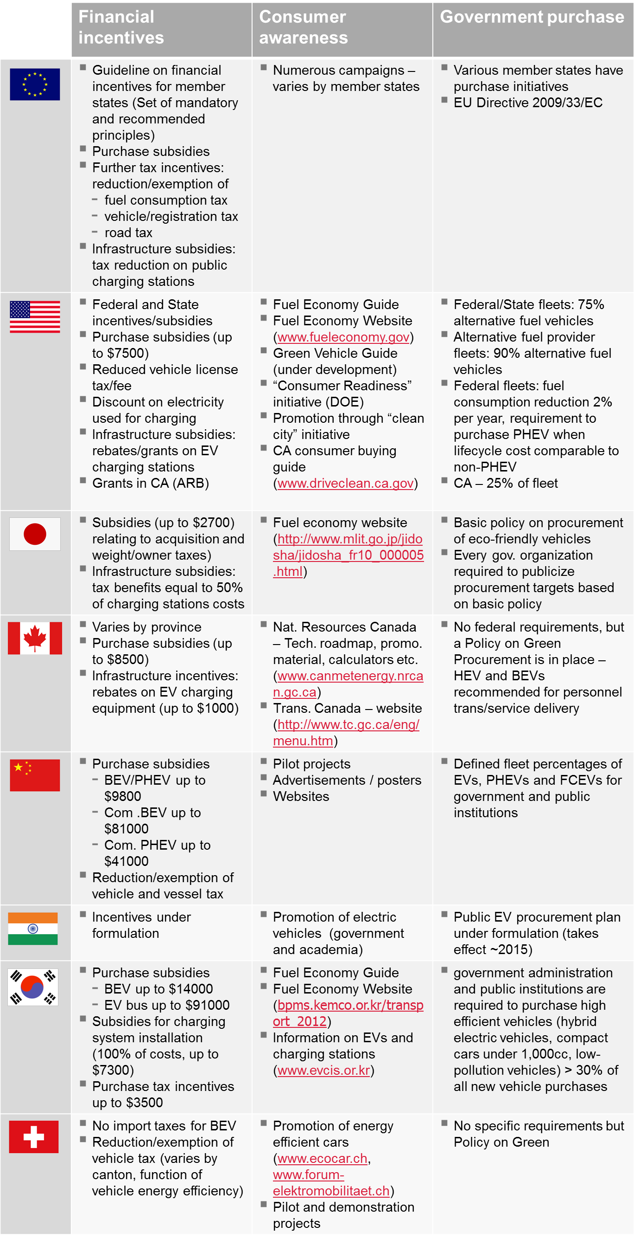

* * In accordance with the programme of work of the Inland Transport Committee for 2012–2016 (ECE/TRANS/224, para. 94 and ECE/TRANS/2012/12, programme activity 02.4), the World Forum will develop, harmonize and update Regulations in order to enhance the performance of vehicles. The present document is submitted in conformity with that mandate.
? IWG EVE Final Terms of Reference, Informal Document EVE-02-23.
? Proposal ECE/Trans/WP.29/2012/36.
? L-category is the family name for light vehicles such as powered cycles, two- and three wheel mopeds, motorcycles with and without sidecar, tricycles and quadricycles.
? Series OVC-HEV – electric motor only traction is possible; Blended OVC-HEV – electric motor and combustion engine must operate together most of the time (exception is at low speeds).

