 | United Nations | ECE/TRANS/WP.15/AC.1/2014/8
 | Economic and Social Council |  | Distr.: General  20 December 2013  Original: English
Economic Commission for Europe
Inland Transport Committee
Working Party on the Transport of Dangerous Goods
Joint Meeting of the RID Committee of Experts and the
Working Party on the Transport of Dangerous Goods
Geneva, 17-21 March 2014
Item 5(b) of the provisional agenda
Proposals for amendments to RID/ADR/ADN: new proposals
Exempting the carriage of construction, agricultural and forestry machinery from special provision 363
Proposal transmitted by the European Association of Road Milling Enterprises (VESF),
Summary
Executive summary: Amendment of the exemption provision for the carriage of self-propelled construction, agricultural and forestry machinery in RID/ADR 1.1.3.3 or in a new special provision 6xx, as a follow-up to informal document INF.16 of the Joint Meeting in September 2013.
Action to be taken: (a) Include a new paragraph in 1.1.3.3 on the exemption of self-propelling construction, agricultural and forestry machinery and add a further explanation of the term; or
(b) Include a new special provision 6xx to exempt the carriage of self-propelling construction, agricultural and forestry machinery from the provisions of RID/ADR.
Related documents: Informal document INF.16 of the last session of the Joint Meeting (Geneva, 17 to 27 September 2013)

1. Special provision 363 defines the requirements for UN numbers 1202 and 1203 concerning the marking of means of containment that are a part of equipment or machinery. In doing so, no clear dividing line has been drawn between vehicles or other means of transport which, when carried as a load, are exempt from the provisions of RID/ADR in accordance with RID 1.1.3.3/ADR 1.1.3.3 (b).
2. Self-propelled construction, agricultural and forestry machines have fuel tanks of different sizes in their interior structure which are used for propulsion and operation of their equipment. At present, it is not clear from RID 1.1.3.3/ADR 1.1.3.3 (b) and special provision 363 that these self-propelled construction, agricultural and forestry machines come under the carriage of exempted "equipment and machines".
3. The persons involved in transport know that self-propelled construction, agricultural and forestry machines have tanks containing fuels. This differentiates them from compressors and generators, where it is not obvious that they contain fuel during carriage.
4. Therefore, to make it clear for users, the carriage of self-propelled construction, agricultural and forestry machines should be explicitly exempt from the requirements of special provision 363 in the regulations. There are two possible ways of achieving this aim:
Proposal I: Include a paragraph (c) in ADR 1.1.3.3/RID accordingly
Proposal II: Include a new special provision 6xx
Proposal I
5. Include a new paragraph (c) in ADR 1.1.3.3 as follows:
"(c) fuel contained in the tanks of self-propelled construction, agricultural and forestry machinery which is carried as a load, when it is destined for its propulsion or the operation of any of its equipment. The fuel may be carried in fixed fuel tanks connected directly to the vehicle engine and/or equipment and which meet the legal requirements. These machines shall be loaded upright and secured against falling.
NOTE: For the definition of self-propelled construction, agricultural and forestry machinery, see Directive 97/68/EC, Article 2 (non-road mobile machinery).".
The RID text should be amended accordingly.
Proposal II
6. Include a new special provision 6xx in Chapter 3.3 as follows:
"6xx Fuel contained in the tanks of self-propelled construction, agricultural and forestry machinery in accordance with Directive 97/68/EC, Article 2 (non-road mobile machinery), which is carried as a load, shall not be subject to the requirements of special provision 363 and the other requirements of RID/ADR, when the fuel is destined for its propulsion or the operation of any of its equipment. The fuel may be carried in fixed fuel tanks connected directly to the vehicle engine and/or equipment and which meet the legal requirements. These machines shall be loaded upright and secured against falling.
NOTE: For the definition of self-propelled construction, agricultural and forestry machinery, see Directive 97/68/EC, Article 2 (non-road mobile machinery)."
Justification
Safety: The design of the fuel tanks complies with harmonised european safety standards, as does the design of the entire machine, meaning that the tanks can be regarded as safe. As far as VESF is aware, no fuel tank has been damaged in the comparatively few accidents that have happened during the carriage of such machines (load lost or slipped, left the road, rear-end collisions). In addition, there are cases known in which cars or lorries have collided with road construction machines in operation (including on motorways). While in some of these cases the machines themselves were severely damaged, their fuel tanks remained intact.
Feasibility: Self-propelled construction, agricultural and forestry machines are described by the term "non-road mobile machinery", which is based on the definition in Article 2 of Directive 97/68/EC for "non-road mobile machinery". This term denotes the entirety of a machine that is within the definition framework of EC Machinery Directive 2006/42/EC (in particular Annex I, Section 3), specified in greater detail by the harmonised standards published in the Official Journal of the European Communities such as EN 474, EN 500, EN 280, EN ISO 4254 or EN ISO 11850, and further characterised in that:
- It is equipped with an energy source that is fed directly by liquid energy carriers (combustion engine operated by diesel fuel (UN 1202) or petrol (UN 1203)); and
- The energy source is not used exclusively to provide energy to the working equipment of said machine within the parameters of its intended use in the sense of EC Machinery Directive 2006/42/EC but is additionally used to provide energy to a traction drive for locomotion of the machine under its own power; or
- The traction drive for the machine’s locomotion is itself, wholly or in part, an element of the intended use in the sense of EC Machinery Directive 2006/42/EC.
The aforementioned machines are usually equipped with an inherently safe design of the means of containment (fuel tank) in accordance with the requirements of Directive 2006/42/EC.
Examples of machines involved

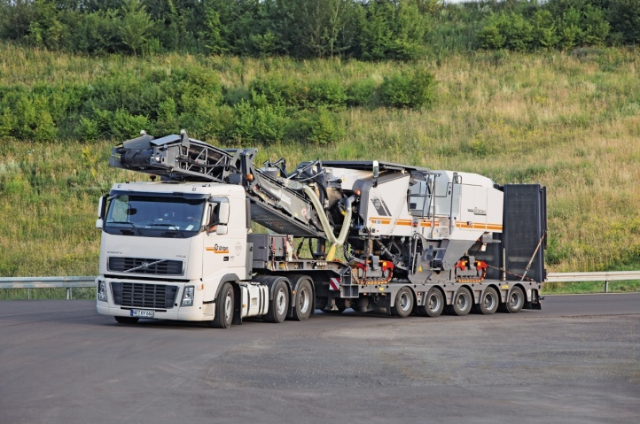 | Large milling machine on transport vehicle
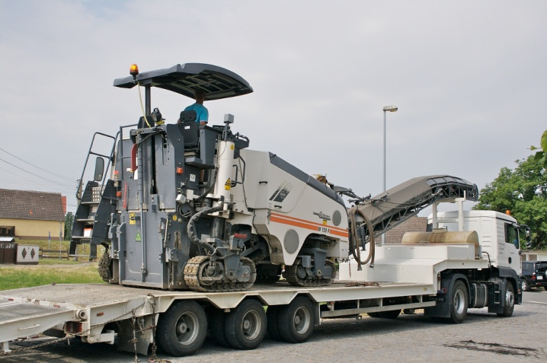 | Small milling machine on transport vehicle
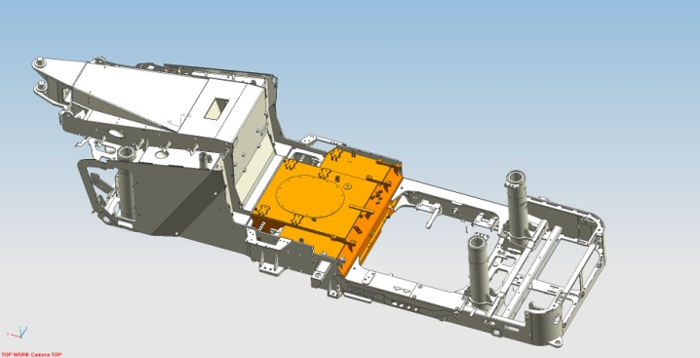 | Chassis of a typical large milling machine with tank (shown in orange)
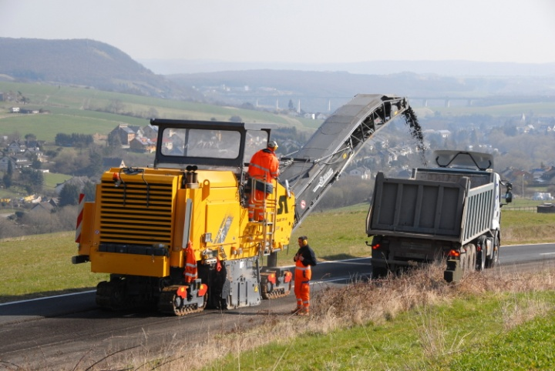 | Large milling machine in operation
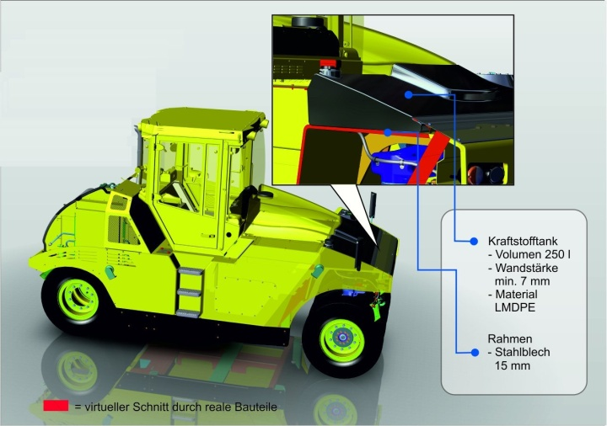 | Inherently safe design of the fuel tank in a pneumatic-tyred roller
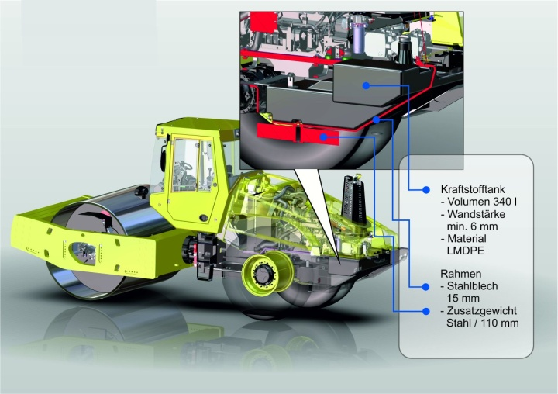 | Inherently safe design of the fuel tank in a single drum compactor
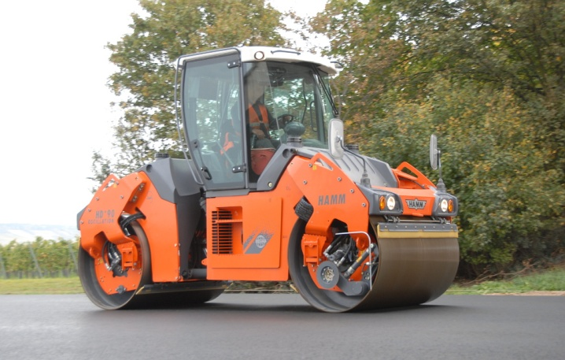 | Tandem roller in operation
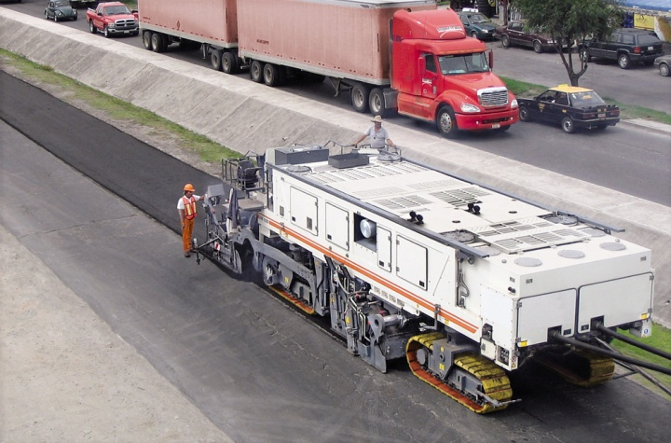 | Cold recycler in operation
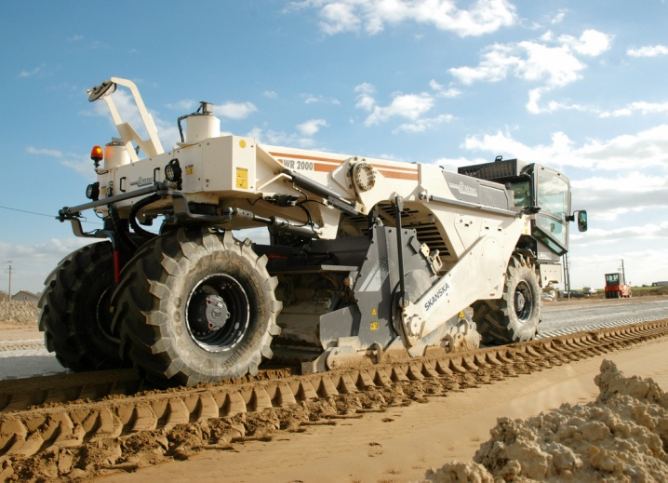 | Cold recycler/soil stabilizer in operation
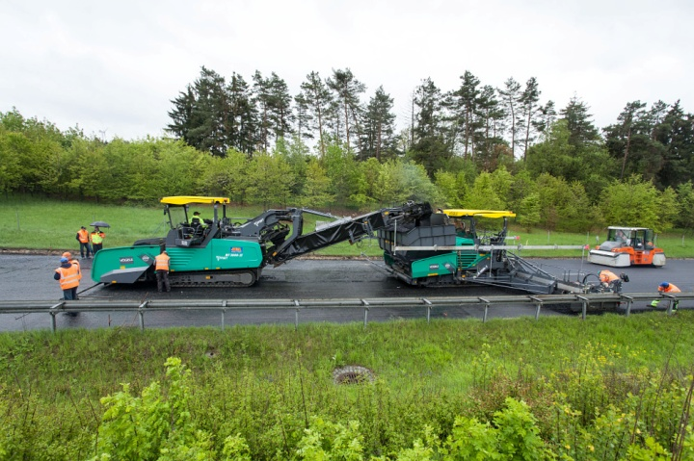 | Feeder, asphalt paver and pneumatic-tyred roller in operation
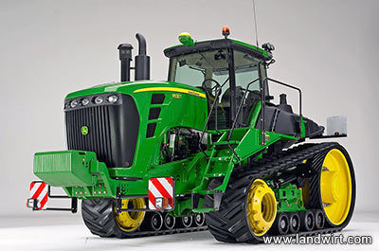 | Forestry machine
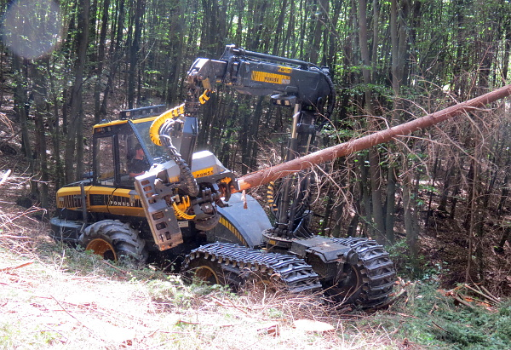 | Forestry machine in operation
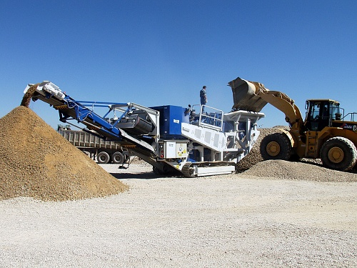 | Mobile crusher in operation
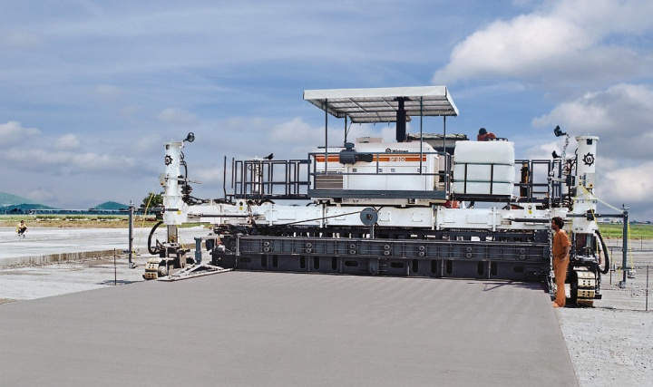 | Slipform paver in operation

__________

In accordance with the programme of work of the Inland Transport Committee for 2012–2016 (ECE/TRANS/224, para. 94, ECE/TRANS/2012/12, programme activity 02.7 (A1c)).
Circulated by the Intergovernmental Organisation for International Carriage by Rail (OTIF) under the symbol OTIF/RID/RC/2014/8.

