UN/SCEGHS/27/INF.12
Committee of Experts on the Transport of Dangerous Goods
and on the Globally Harmonized System of Classification
and Labelling of Chemicals
Sub-Committee of Experts on the Globally Harmonized
System of Classification and Labelling of Chemicals 19 June 2014
Twenty–seventh session
Geneva, 2 – 4 July 2014
Item 4 (d) of the provisional agenda
Hazard communication issues: miscellaneous
Large pictograms on portable tanks and MEGC’s while in transport
Transmitted by the Dangerous Goods Advisory Council (DGAC)
Introduction
1. The Sub-Committee will recall that, at its 26th session, DGAC provided a formal document (ST/SG/AC.10/C.4/2013/10) which proposed to prohibit the display of GHS pictograms not required for the transport of dangerous goods on portable tanks and multi-element gas containers (MEGC’s). The GHS already prohibits these pictograms from appearing on freight containers (for example for ocean transport), road vehicles or railway wagons or tanks. DGAC proposed adding portable tanks and MEGC’s to this prohibition, however some delegates viewed that portable tanks should expressly have this form of hazard communication in supply and use. As a result of this feedback, DGAC is submitting a proposal of narrowed scope which is applicable only to transport. The intent is to harmonize requirements as necessary for international transport and to avoid unintended consequences to supply and use regulations.
Discussion
2. Industry has been receiving portable tanks with GHS pictograms not required for transport displayed adjacent to and of the same size as the placards required for the transport of dangerous goods. When an example was previously presented, the Sub-Committee agreed that this was not appropriate, but questioned the need for action. This was based on whether this practice was occurring frequently, and also whether it was already prohibited, as GHS section 1.4.10.5.4.1 specifies the required elements which constitute a label, and a pictogram alone is not a label. DGAC submits further examples to show that this situation is not infrequent. DGAC can find no prohibition in GHS against the use of a pictogram alone where a label is not required, and we find this scenario to be outside the scope of GHS section 1.4.10.5.4.1. Therefore, while we sympathize that this practice is not the intent of GHS, we do not believe it is prohibited. Accordingly, this proposal from DGAC serves a valid purpose to ensure harmonization for the display of GHS pictograms on portable tanks and MEGC’s while in transport. Here are some examples:

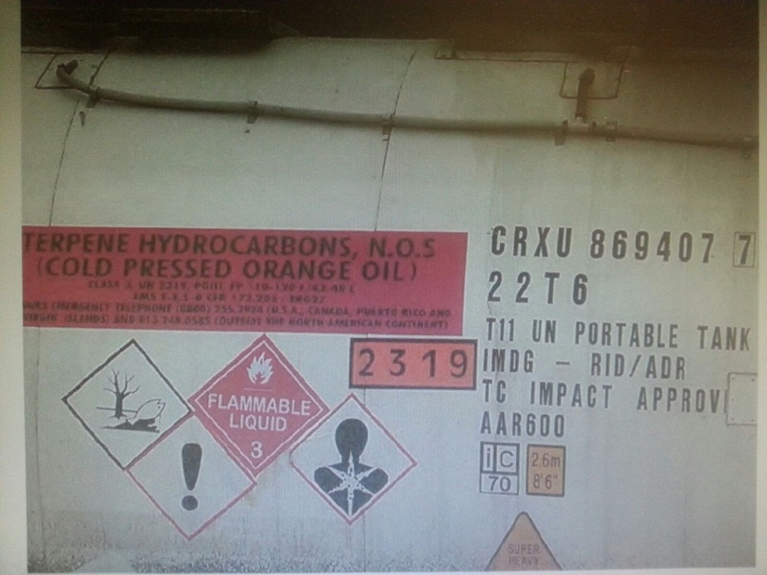

Example 1
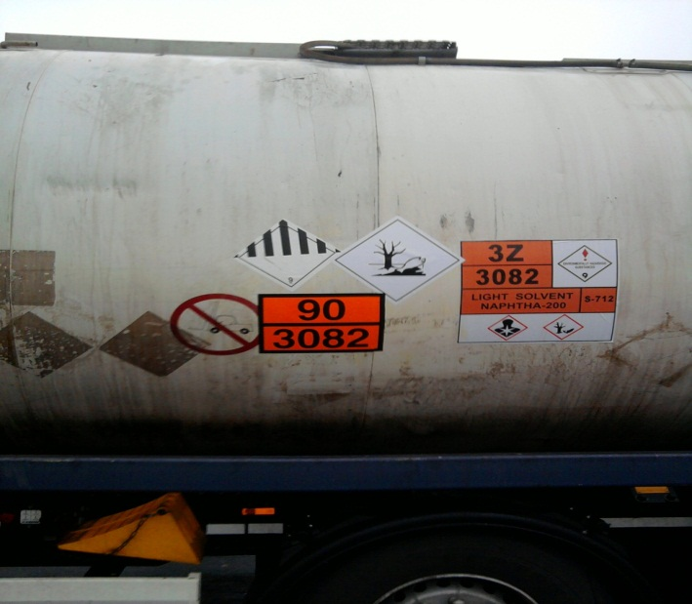

Example 2
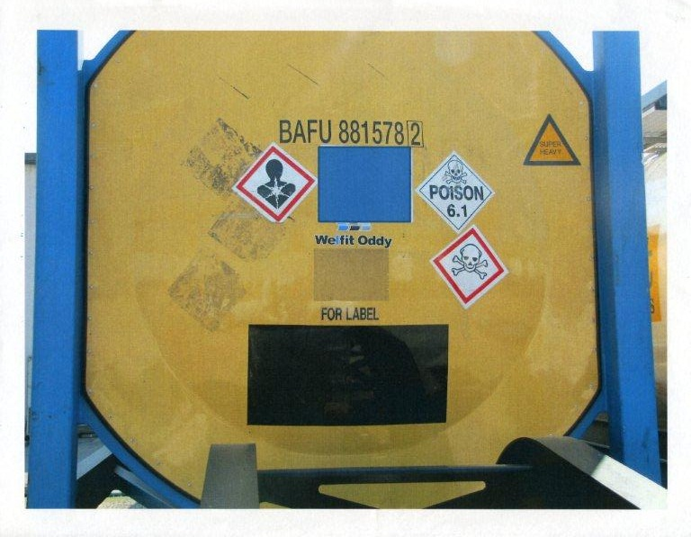
Example 3 (shown previously in INF.8, GHS 25th session)
3. Like portable tanks, MEGC’s have been identified as a conveyance for which a clarification in the GHS would be beneficial. Hereafter in this proposal, a reference to portable tanks in this discussion should be read to include MEGC’s.
4. In section 1.4.10.5, the GHS states: “The GHS pictograms not required for transport of dangerous goods should not be displayed on freight containers, road vehicles or railway tanks.” (Note that the word “shall” does not often appear in the GHS, and the word “should” is used for important requirements throughout GHS.) Unlike the conveyances mentioned in 1.4.10.5, portable tanks are not exempted from labelling. The EU, the USA and other countries require this labelling in supply and use, but not in transport. However GHS does not exclude portable tanks from the requirements for pictograms. Therefore, a clarification in GHS addressing these pictograms on portable tanks and MEGC’s while in transport would align with a significant portion of the GHS implementation in the world.
5. It is DGAC’s intent to harmonize transport regulations, and our proposal has been amended to avoid impact to supply and use. In transport it is imperative for efficient commerce that requirements for labelling, marking and placarding of packages and conveyances (for example trucks, freight containers and portable tanks) applied at the origin be harmonized with the requirements of the country of destination, all transit countries and modal jurisdictions (ocean and air regulations). Not only must the regulations be harmonized, but they also must be very clear to avoid the adoption of varying local regulations (for example, ports) and industry policies based on unclear requirements. Inconsistent application of GHS pictograms on portable tanks, which may be voluntary or imposed by national regulations, will impede commerce and must be addressed.
6. In addition, the use of large pictograms could cause confusion on the part of emergency responders that could lead to inappropriate response. As noted by the Secretariat in the report on the work of the Sub-Committee of Experts on the Transport of Dangerous Goods on its 43rd session (INF.17, GHS 25th session), the labelling (placarding) system for transport was designed to be easily recognized from a distance (paragraph 13 of the Consignment Procedures of the UN Recommendations for the Transport of Dangerous Goods). Emergency response to transport incidents is guided by the acute physical hazards involved, not by chronic hazards important in supply and use. Delegates have asked whether this is a matter of training. DGAC believes that emergency responders should be trained in GHS. However the point here is the marginal ability to read the pertinent hazard communication in an emergency incident. Emergency responders often first view an incident through smoke or a fire or toxic clouds using binoculars. In such a situation it may be difficult to see the pictograms for the acute hazards, and additional non-emergency information should not distract an observer from necessary information.
7. DGAC would like to maintain an option to apply a conforming GHS label (including all required label elements) on or near the outlet. This is a practical means of compliance that can satisfy supply and use hazard communication requirements, and which in some regions can be left on during transport. This provides an efficient means of cross-sector compliance where a market has only one or a few languages. However, due to the large number of languages existing in some markets, and globally, it is inappropriate to require text on portable tanks which may require replication in multiple languages during transport through a large number of transit countries, compounded by varying or undetermined routing.
8. To facilitate understanding of the requirements, a new example is proposed for Annex 7. The example shows the label at or on the outlet, and limits the GHS pictogram size to half the size or less of the transport placard. DGAC is open to discussion on the precise nature of the size limitation, and therefore places it in square brackets.
Proposal
9. Modified text in Section 1.4.10.5 (new text is underlined)
“1.4.10.5 Allocation of label elements
1.4.10.5.1 Information required for packages covered by the UN Model Regulations on the Transport of Dangerous Goods
(a) Where a UN Model Regulations on the Transport of Dangerous Goods pictogram appears on a label, a GHS pictogram for the same hazard should not appear;
(b) The GHS pictograms not required for the transport of dangerous goods should not be displayed on freight containers, road vehicles or railway wagons/tanks;
(c) While in transport, the GHS pictograms should not be displayed on portable tanks or multi-element gas containers. Display on portable tanks or multi-element gas containers is permissible if displayed on or near the outlet, and as part of a complete GHS label as defined in Section 1.4.10.5.2. In this case, GHS pictograms should not exceed [half] the size of TDG transport pictograms, as illustrated in example 8 of Annex 7.”
10. New example 8 in Annex 7
“Example 8: Additional guidance when transport and other GHS information appear on portable tanks and multi-element gas containers:
- Where transport and GHS information appear on a portable tank, consideration must be given to ensure that the label elements are placed in a manner that addresses the needs of the different sectors;
- Transport pictograms must convey information immediately in an emergency situation. They must be able to be seen from a distance, as well as in conditions that are smoky or otherwise partially obscure the pictogram;
- While in transport, the GHS pictograms should not be displayed on portable tanks or multi-element gas containers. However, it is permissible to include non-transport pictograms as part of a complete GHS label as specified in Section 1.4.10.5.2 and 1.4.10.5.3 if displayed on or near the outlet or unloading connection. In the case of a multi-element gas containers, the label may be displayed in a prominent position on the outside panels/doors of the housing for the unloading connections. The size of the non-transport pictograms should not exceed [half] that of the transport related pictograms, but should be clear and comprehensible for employers and workers using the chemicals stored in the portable tanks or MEGCs.
Following are examples of how such a label may appear:
Portable tank (tank Container, multi-modal Tank) displaying GHS and transport information for a flammable liquid, and multi-element gas container displaying GHS and transport information for a non-flammable gas with oxidizer subsidiary risk:
