Annex 3
Working Group on Explosives (23 – 26 June 2014)
Changes for the Manual of Tests and Criteria (5th Revised Edition)
Note: Source of proposed change is indicated by italicized text with turquoise highlight
Section 1.1.2 – add the following sentence at end of the paragraph:
Examples which may be listed within various test procedures are for illustrative purposes and are provided for guidance only.
Source: ST/SG/AC.10/C.3/2014/37, para. 3, as amended by the working group
Section 10.4 – amend Figure 10.3 as indicated below:
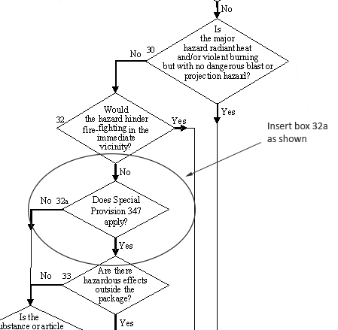
Source: ST/SG/AC.10/C.3/2014/4, para. 8 and Annex
Section 10.4.3.4 – amend as indicated below:
10.4.3.4 Test types 6 (a), 6 (b), 6 (c) and 6 (d) are normally performed in alphabetical order. However, it is not always necessary to follow this order or to conduct tests of all types.

(a) Test type 6 (a) may be waived if explosive articles are carried without packaging or when the package contains only one article (see also section 10.4.3.4.(d)).

(b) Test type 6 (b) may be waived if in each type 6 (a) test (see also section 10.4.3.4.(d)):

(i) The exterior of the package is undamaged by internal detonation and/or ignition; or

(ii) The contents of the package fail to explode, or explode so feebly as would exclude propagation of the explosive effect from one package to another in test type 6(b).

(c) Test type 6 (c) may be waived if, in a type 6 (b) test, there is practically instantaneous explosion of virtually the total contents of the stack. In such cases the product is assigned to Division 1.1.

(d) Test type 6(d) is a test used to determine whether a 1.4S classification is appropriate and is only used if special provision 347 of Chapter 3.3 of the Model Regulations applies. . When testing articles to which special provision 347 applies, test type 6(d) may be performed first. If the results of test type 6(d) indicate that a 1.4S classification is appropriate, then test types 6(a) and 6(b) may be waived.

Source: ST/SG/AC.10/C.3/2014/4, Annex 2, as amended by the working group
Section 10.5 – amend Figure 10.8 as indicated below:
Source: ST/SG/AC.10/C.3/2014/4, para. 8 and Annex
Section 11.1.1 – amend as indicated below:
11.1.1 The question "Is it an explosive substance?" (box 4 of Figure 10.2) is answered on the basis of the results of three types of test to assess possible explosive effects. The question in box 4 is answered "yes" if a "+" is obtained in any of the three types of test.
Source: UN/SCETDG/45/INF.4
Section 11.3.2 – amend as indicated below:
11.3.2 If a mixture can separate out during transport, the test should be performed with the initiator in contact with the potentially most explosive part, if known.
Source: UN/SCETDG/45/INF.4
Section 11.3.5 – amend as indicated below:
11.3.5 For organic substances and mixtures of organic substances with a decomposition energy of 800 J/g or more, test 1 (a) need not be performed if the outcome of the ballistic mortar Mk.IIId test (F.1), or the ballistic mortar test (F.2) or the BAM Trauzl test (F.3) with initiation by a standard No. 8 detonator (see Appendix 1) is "No". In this case, the result of test 1 (a) is deemed to be "-". If the outcome of the F.1 or F.2 or F.3 test is “Low” or "Not low", the result of test 1 (a) shall be deemed "+". In this case, a "-" can only be obtained by performing test 1 (a).
Source: UN/SCETDG/45/INF.4
Section 11.4.1.2.1 – amend as indicated below:
11.4.1.2.1 Solids

The apparatus for solids is shown in Figure 11.4.1.1. The test sample is contained in aseamlesscarbon steel tube with an external diameter of 48 ± 2 mm, a wall thickness of 4 mm and a length of 400 ± 5 mm. If the test substance may react with the steel, the inside of the tube may be coated with fluorocarbon resin. The bottom of the tube is closed with a plastic sheet pulled tightly (so that it plastically deforms) over the bottom of the tube and held tightly in place. The plastic sheet shall be compatible with the substance under test. The booster charge consists of 160 g RDX/wax (95/5) or PETN/TNT that has a minimum of 50% PETN in the mixture, 50 ± 1 mm in diameter with a density of 1 600 ± 50 kg/m³. The charges may be pressed in one or more pieces, as long as the total charge is within the specifications, and the PETN/TNT charge is cast. A mild steel witness plate, 150 ± 10 mm square and 3 mm thick, may be mounted at the upper end of the steel tube and separated from it by spacers 1.6 ± 0.2 mm thick.
Source: ST/SG/AC.10/C.3/2014/6, para. 6 as amended by the working group
UN/SCETDG/45/INF.4, as amended by the working group
Section 11.4.1.3.1 – amend as indicated below:
11.4.1.3.1 The sample is loaded to the top of the steel tube. Solid samples are loaded to the density attained by tapping the tube until further settling becomes imperceptible. The sample mass is determined and, if solid, the apparent density calculated using the measured internal volume of the tube.
Source: UN/SCETDG/45/INF.4
Section 11.4.1.4 – amend as indicated below:
11.4.1.4 Test criteria and method of assessing results

The test results are assessed on the basis of the type of fragmentation of the tube or on whether a hole is punched through the witness plate. The test giving the most severe assessment should be used for classification. The test result is considered "+" and the substance to propagate detonation if:

- The tube is fragmented completely; or

- A hole is punched through the witness plate.

Any other result is considered "—" and the substance is not able to propagate a detonation.
Source: UN/SCETDG/45/INF.4, as amended by the working group
Section 11.6.1.2.2 – amend as indicated below:
11.6.1.2.2 The end of the pressure vessel furthest from the side-arm is closed with a firing plug which is fitted with two electrodes, one insulated from, and the other earthed to, the plug body. The other end of the pressure vessel is closed by an aluminium bursting disc 0.2 mm thick (bursting pressure approximately 2 200 kPa) held in place with a retaining plug which has a 20 mm bore. A soft lead washer or a washer of a suitable deformable material (for example, polyoxymethylene) is used with both plugs to ensure a good seal. A support stand (Figure 11.6.1.2) holds the assembly in the correct attitude during use. This comprises a mild steel base plate measuring 235 mm × 184 mm × 6 mm and a 185 mm length of square hollow section (S.H.S.) 70 × 70 × 4 mm.
Source: ST/SG/AC.10/C.3/2014/6, para. 7
Section 12.3.2 – amend as indicated below:
12.3.2 If a mixture can separate out during transport, the test should be performed with the initiator in contact with the potentially most explosive part, if known.
Source: UN/SCETDG/45/INF.4
Section 12.3.4 – amend as indicated below:
12.3.4 For organic substances and mixtures of organic substances with a decomposition energy of 800 J/g or more, test 2 (a) need not be performed if the outcome of the ballistic mortar Mk.IIId test (F.1), or the ballistic mortar test (F.2) or the BAM Trauzl test (F.3) with initiation by a standard No. 8 detonator (see Appendix 1) is "No". In this case, the result of test 2 (a) is deemed to be "-". If the outcome of the F.1 or F.2 or F.3 test is “Low” or "Not low", the result of test 2 (a) shall be deemed "+". In this case, a "-" can only be obtained by performing test 2 (a).
Source: UN/SCETDG/45/INF.4
Section 12.4.1.2 – amend as indicated below:
12.4.1.2 Apparatus and materials

The apparatus is shown in Figure 12.4.1.1. The test sample is contained in aseamlesscarbon steel tube with an external diameter of 48 ± 2 mm, a wall thickness of 4 mm and a length of 400 ± 5 mm. If the test substance may react with the steel, the inside of the tube may be coated with fluorocarbon resin. The bottom of the tube is closed with a plastic sheet pulled tightly (so that it plastically deforms) over the bottom of the tube and held tightly in place. The plastic sheet shall be compatible with the substance under test. The booster charge consists of 160 g RDX/wax (95/5) or PETN/TNT that has a minimum of 50% PETN in the mixture, 50 ± 1 mm in diameter with a density of 1 600 ± 50 kg/m³. The charges may be pressed in one or more pieces, as long as the total charge is within the specifications, and the PETN/TNT charge is cast. A polymethyl methacrylate (PMMA) spacer is required of diameter 50 ± 1 mm and length 50 ± 1 mm. A mild steel witness plate, 150 ± 10 mm square and 3 mm thick, may be mounted at the upper end of the steel tube and separated from it by spacers 1.6 ± 0.2 mm thick.
Source: ST/SG/AC.10/C.3/2014/6, para. 8 as amended by the working group
UN/SCETDG/45/INF.4, as amended by the working group
Section 12.4.1.3.1 – amend as indicated below:
12.4.1.3.1 The sample is loaded to the top of the steel tube. Solid samples are loaded to the density attained by tapping the tube until further settling becomes imperceptible. The sample mass is determined and, if solid, the apparent density calculated using the measured internal volume of the tube.
Source: UN/SCETDG/45/INF.4
Section 12.4.1.4 – amend as indicated below:
12.4.1.4 Test criteria and method of assessing results

The test results are assessed on the basis of the type of fragmentation of the tube or whether the witness plate is holed. The test giving the most severe assessment should be used for classification. The test result is considered "+" and the substance to be sensitive to shock if:

(a) The tube is fragmented completely; or

(b) The witness plate is holed.

Any other result is considered "—" and the substance is considered to be not sensitive to detonative shock.
Source: UN/SCETDG/45/INF.4, as amended by the working group
Section 12.6.1.2.2 – amend as indicated below:
12.6.1.2.2 The end of the pressure vessel furthest from the side-arm is closed with a firing plug which is fitted with two electrodes, one insulated from and the other earthed to, the plug body. The other end of the pressure vessel is closed by an aluminium bursting disc 0.2 mm thick (bursting pressure approximately 2 200 kPa) held in place with a retaining plug which has a 20 mm bore. A soft lead washer or a washer of a suitable deformable material (for example, polyoxymethylene) is used with both plugs to ensure a good seal. A support stand (Figure 12.6.1.2) holds the assembly in the correct attitude during use. This comprises a mild steel base plate measuring 235 mm × 184 mm × 6 mm and a 185 mm length of square hollow section (S.H.S.) 70 × 70 × 4 mm.
Source: ST/SG/AC.10/C.3/2014/6, para. 9
Section 13.2 – add new entries to Table 13.1 as indicated below:
Table 13.1: TEST METHODS FOR TEST SERIES 3

Test code | Name of Test | Section
3 (a) (i)  3 (a) (ii)  3 (a) (iii)  3 (a) (iv)  3 (a) (v)  3 (a) (vi)  3 (a) (vii)  3 (b) (i)  3 (b) (ii)  3 (b) (iii)  3 (b) (iii)  3 (c) (i)  3 (c) (ii)  3 (d) | Bureau of Explosives impact machine  BAM Fallhammerª  Rotter test  30 kg Fallhammer test  Modified type 12 impact tool  Impact sensitivity test  Modified Bureau of Mines impact machine test  BAM friction apparatusª  Rotary friction test  Friction sensitivity test  ABL friction machine test  Thermal stability test at 75 °Cª  SBAT thermal stability test at 75 °C  Small-scale burning testª | 13.4.1  13.4.2  13.4.3  13.4.4  13.4.5  13.4.6  13.4.7  13.5.1  13.5.2  13.5.3  13.5.4  13.6.1  13.6.2  13.7.1

Source: ST/SG/AC.10/C.3/2014/48, …2014/51, and …2014/52, as amended by the working group
Section 13.4.7 – add new section 13.4.7 as indicated below:
13.4.7 Test 3 (a) (vii): Modified Bureau of Mines impact machine test
13.4.7.1 Introduction
This test is used to measure the sensitiveness of the substance to drop-mass impact and to determine if the substance is too dangerous to transport in the form tested. The test substance is subjected to a vertical impact force through an intermediate hammer via a drop mass. It is applicable to solid, semisolid, liquid, and powder substances.
13.4.7.2 Apparatus and materials
13.4.7.2.1 The general design of the MBOM impact test apparatus is given in Figure 13.4.7.1. The following components are required:
A mechanism containing a drop mass of 2.0 kg (4.4 lbs.), two drop mass guide rails, a drop mass holding, lifting, and dropping mechanism, and a 1.02 kg (2.25 lbs.) intermediate hammer containing a 1.27 cm (0.5 in) diameter steel insert with a surface roughness of 1.27 – 1.78 µm (50 – 70 µin) that is resting on a sample placed on an steel anvil (impact surface 3.81 cm (1.5 in) diameter) with a surface roughness of 1.27 – 1.78 µm (50-70 µin). Details of the target area are given in Figure 13.4.7.2.
13.4.7.3 Procedure
13.4.7.3.1 Solid sample placement
As a rule substances are tested in the form in which they are received. Wetted substances should be tested with the minimum quantity of wetting agent required for transport. Depending on the physical form, the substances should then be subjected to the following procedures:
(a) Powders are to be tested on the anvil in a monolayer; i.e., the thickness of the granular material. Place enough granules on the anvil to cover an area in excess of the 1.29 cm² (0.2 in²) area of the insert.
(b) Solid propellants are tested in the form of thin, uniform slices. The slices are usually square, having a minimum edge length of 1.587 cm (0.625 in) and a thickness of 0.084 ± 0.01 cm (0.033 ± 0.004 in). This thickness is easily obtainable with the use of a microtome cutting tool.
The intermediate hammer is raised. The test substance is placed centrally on the anvil. The intermediate hammer is then carefully lowered onto the substance on the anvil.
13.4.7.3.2 Liquids and semisolids sample placement
Depending on the physical form, the substances should then be subjected to the following procedures:
- Liquids are tested with a controlled thickness and a fixed gap of 0.05 cm (0.02 in) above the liquid level using a spring between the hammer collar and the guide collar (adjustable tension). The thickness of the liquid sample is controlled by putting a piece of 0.015 cm (0.006 in) thick tape (compatible with the substance) with a 1.587 cm (0.625 in) diameter hole in it on the anvil. The intermediate hammer is raised. The hole in the tape is centrally positioned on the anvil such that the intermediate hammer insert does not touch the tape. A 0.05 cm (0.02 in) feeler gauge is used to set the proper gap above the liquid. The tape hole is filled with the liquid substance and levelled-off using a straight-edge ensuring that no air gaps are present in the sample. The intermediate hammer is then carefully lowered to 0.05 cm (0.02 in) above the substance on the anvil.
- Semisolids (slurries, gels, etc.) are prepared and tested in much the same way as liquid samples; however, the sample thickness is governed by the largest particle size. If the largest particle size is greater than the 0.015 cm (0.006 in) thickness then a monolayer sample is spread on the anvil in a monolayer; i.e., the thickness of the granular material. If the cohesive properties of the semisolid are not practical for a 0.015 cm (0.006 in) thickness, then the minimum attainable thickness is used. Place enough granules on the anvil to cover an area in excess of the 1.29 cm² (0.2 in²) area of the intermediate hammer insert.
13.4.7.3.3 Machine operation
The drop mass is raised to the desired height (17 cm (6.7 in) for solids and semisolids and 11 cm (4.3 in) for liquids) and released to drop onto the intermediate hammer. Observations are made on whether a “reaction” occurs as evidenced by audible report or production of smoke, fire, charring or visible light as observed by human senses. The type of reaction that occurs is documented. The surfaces are cleaned with a cloth or light abrasive pad to remove any residual material from the anvil or intermediate hammer insert. The anvil and intermediate hammer insert are inspected for scratches, scoring, divots, or other damage which may affect the surface roughness. If damaged these items should be replaced before use on the next trial. Six trials are performed for each test sample.
13.4.7.4 Maintenance and calibration
Moving parts should be inspected to ensure that they are freely moving and that friction between them is minimal. The distance between the drop mass and the intermediate hammer that is resting on the anvil should be verified. The contact area between the intermediate hammer insert and anvil should be uniform. The test machine should be periodically cleaned and calibrated according to a schedule based on the amount of usage. At a minimum, the machine should be calibrated on an annual basis.
13.4.7.5 Test criteria and method of assessing results
13.4.7.5.1 Solids
The test result is considered “+” if a reaction (see 13.4.7.3.3) is observed in at least 1 out of 6 trials at a drop height of 17 cm and the substance is considered too dangerous for transport in the form in which it was tested. Otherwise, the result is considered “–”. Borderline cases may be resolved using the Bruceton method (see Appendix 2).
13.4.7.5.2 Liquids
The test result is considered “+” if a reaction (see 13.4.7.3.3) is observed in at least 1 out of 6 trials at a drop height of 11 cm and the substance is considered too dangerous for transport in the form in which it was tested. Otherwise, the result is considered “–”. Borderline cases may be resolved using the Bruceton method (see Appendix 2).
13.4.7.6 Examples of results
Substances¹ | Result
RDX (dry) | +
PBXN-8 | –
Nitrocellulose/DNT (90/10) | –
PETN (dry) | +
Nitroglycerin | +

¹Data acquired at relative humidity of 10-30% and temperature of 60-75 °F
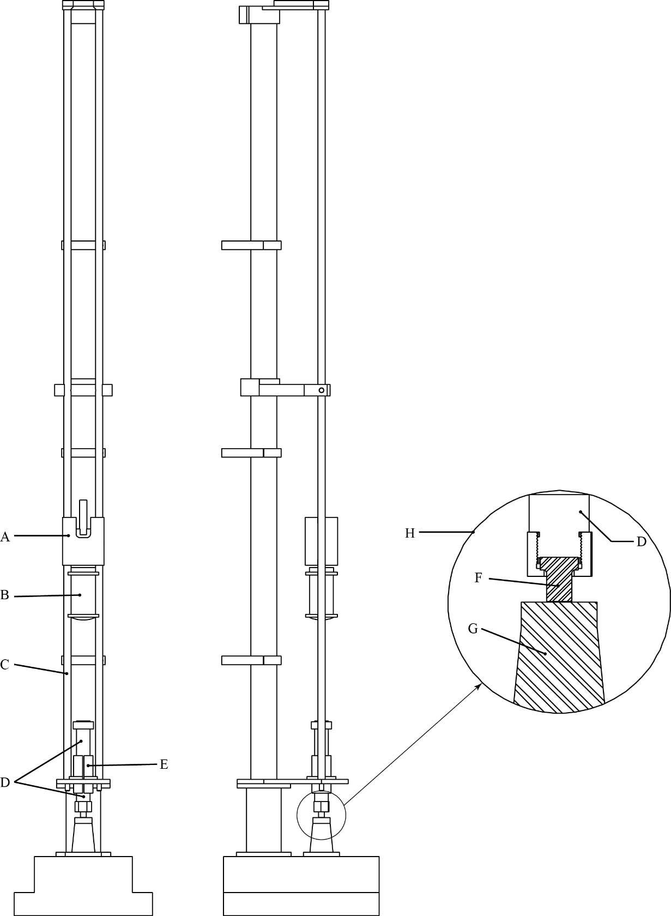
(A) | Drop mass lifting, holding, and dropping device | (B) | Drop mass
(C) | Drop mass guild rails | (D) | Intermediate hammer
(E) | Intermediate hammer guide | (F) | Intermediate hammer insert
(G) | Anvil | (H) | Magnified view of target area

Figure 13.4.7.1: MBOM Impact machine

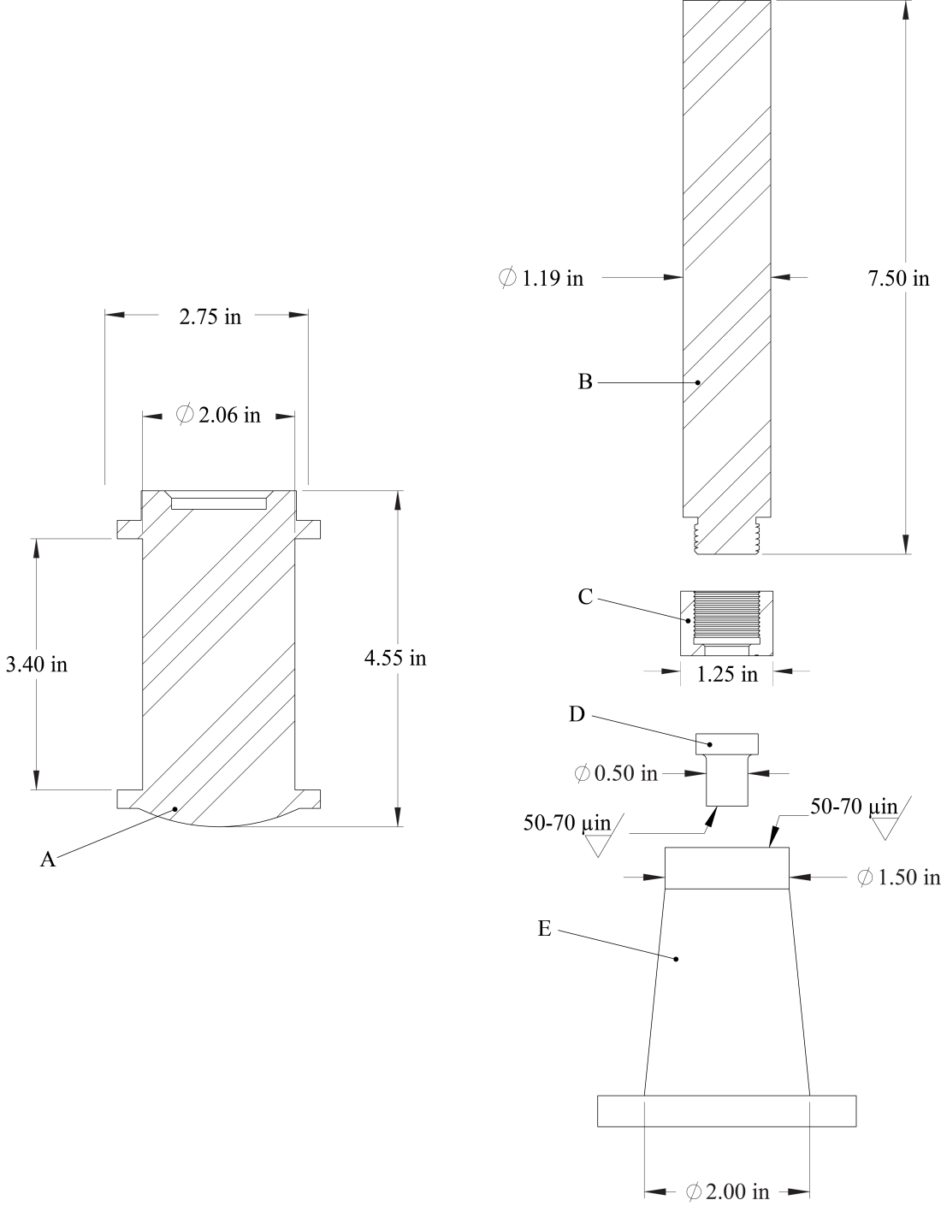

(A) | Drop mass
(B) | Intermediate hammer
(C) | Intermediate hammer insert retaining nut
(D) | Intermediate hammer insert
(E) | Anvil

Figure 13.4.7.2: MBOM Impact machine drop mass and target area detail”
Source: ST/SG/AC.10/C.3/2014/51, para. 4
Section 13.5.4 – add new section 13.5.4 as indicated below:
13.5.4 Test 3 (b) (iii): ABL friction machine test
13.5.4.1 Introduction
This test is used to measure the sensitiveness of the substance to friction stimuli and to determine if the substance is too dangerous to transport in the form tested. The test substance is subjected to a vertical compression force under a non-rotating wheel, while the substance is moved in a horizontal direction on a sliding anvil. It is applicable to solid, semisolid, and powder substances.
13.5.4.2 Apparatus and materials
13.5.4.2.1 The following apparatus and materials are required:
(a) A mechanism capable of applying a force hydraulically through a non-rotating steel wheel to a sample placed on steel anvil. Both the wheel and anvil have a surface roughness of 1.27 – 1.78 µm (50-70 µin) and a Rockwell C hardness of 55 – 62.
(b) A pendulum system that is capable of being positioned and released at an angle that will impart a predetermined velocity to the sliding anvil. A travel distance of approximately 2.54 cm (1 in) perpendicular to the applied force on the wheel is achieved with this system.
13.5.4.3 Procedure
13.5.4.3.1 As a rule substances are tested in the form in which they are received. Wetted substances should be tested with the minimum quantity of wetting agent required for transport. Depending on the physical form, the substances should then be subjected to the following procedures:
(a) Powders are to be tested on the anvil in a monolayer; i.e., the thickness of the granular material, if possible. Place enough granules on the anvil to approximately cover an area 1.27 cm (0.5 in) long by 0.635 cm (0.25 in) wide starting about 0.635 cm (0.25 in) behind the initial contact point of the wheel with the anvil such that the wheel will be in total contact with the sample when lowered onto it.
(b) Solid propellants are tested in the form of thin, uniform slices with a thickness of 0.084 + 0.01 cm (0.033 ± 0.004 in). This thickness is easily obtainable with the use of a microtome cutting tool.
(c) Semisolids will be smoothed with a spatula to a thin layer with uniform thickness approximately 0.015 cm (0.006 in).
With the friction wheel raised, the test substance is placed on the anvil below the wheel such that the wheel will be in total contact with the sample when lowered onto it. The friction wheel is then carefully lowered onto the substance on the anvil and the desired normal force is applied to the wheel [249 N (56 lb_{f}) at 2.44 m/s (8 ft/s) or 445 N (100 lb_{f}) at 1.2 m/s (4 ft/s)]. The pendulum is raised to the desired angle to achieve the appropriate test velocity and released. Observations are made on whether a “reaction” occurs as evidenced by audible report or production of smoke, fire, charring or visible light as observed by human senses. The type of reaction that occurs is documented. The force on the wheel is removed and any excess test substance is cleaned from the area. The wheel is indexed and shifted across the anvil in order to ensure that fresh surfaces are used for each trial.
13.5.4.4 Maintenance and calibration
The maximum speed of the anvil should be calibrated to 2.44 m/s (8 ft/s) and 1.2 m/s (4 ft/s). The downward force on the wheel should be verified. The test machine should be periodically cleaned and calibrated according to a schedule based on the amount of usage. At a minimum, the machine should be calibrated on an annual basis.
13.5.4.5 Test criteria and method of assessing results
The test result is considered “+” if the lowest friction load at which at least one reaction occurs in six trials is 249 N (56 lb_{f}) at 2.44 m/s (8 ft/s) or 445 N (100 lb_{f}) at 1.2 m/s (4 ft/s) or less and the substance is considered too dangerous for transport in the form in which it was tested. Otherwise, the result is considered “–”.
13.5.4.6 Examples of results
Substances¹ | Result
RDX (class 5) | –
RDX (class 7) | –
PBXN-8 | –
PBXN-10 | –
Aluminum/TNT (80/20 Mixture) | –
PETN (dry)² | +

¹ Data acquired at 2.44 m/s, relative humidity of 10-30%, and temperature of 60-75 °F unless noted otherwise.
² Data acquired at 2.44 m/s and 1.2 m/s
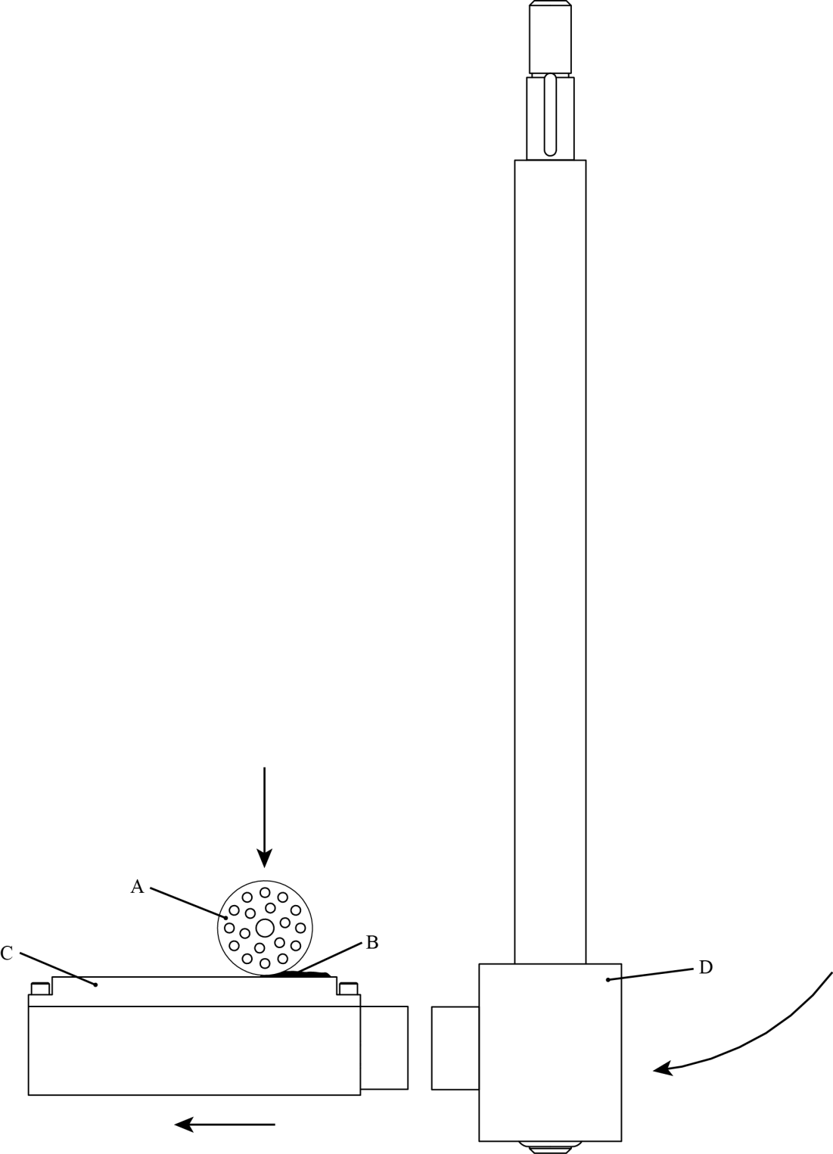

(A) | Non-rotating wheel | (B) | Sample
(C) | Anvil | (D) | Pendulum

Figure 13.5.4.1: ABL Friction machine

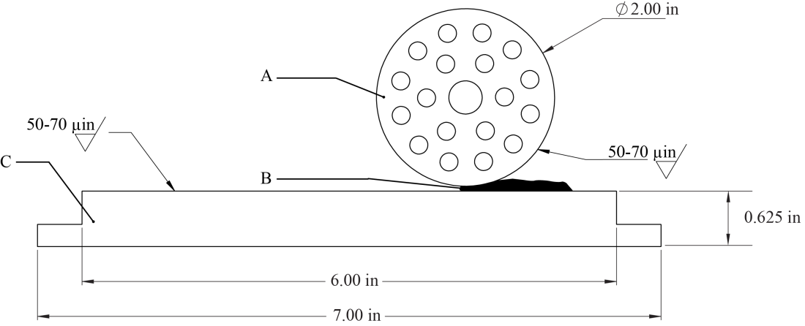

(A) | Non-rotating wheel 5.08 cm (2.0 in) diameter maximum × 3.175 cm (0.125 in)
(B) | Sample under test
(C) | Anvil 17.78 cm (7.0 in) × 5.715 cm (2.25 in) × 1.588 cm (0.625 in) maximum

Figure 13.4.7.2: ABL Friction machine wheel and anvil detail

Source: ST/SG/AC.10/C.3/2014/48, para. 5, as amended by the working group
Section 13.6.4 – add new section 13.6.4 as indicated below:
13.6.2 Test 3(c)(ii): SBAT thermal stability test at 75 °C
13.6.2.1 Introduction
This test is used to measure the stability of the substance when subjected to elevated thermal conditions to determine if the substance is too dangerous for transport.
13.6.2.2 Apparatus and materials
13.6.2.2.1 The following apparatus is required:
(a) Glass sample tubes of 13 x 100 mm inside a larger tube of 25 x 100 mm. Each 13 x100 mm tube is surrounded by insulation and placed into the larger tube. Each larger glass tube has insulation surrounding it further isolating it thermally from the metal oven block. The glass sample tube can be sealed to prevent the escape of gases.
(b) A well-insulated multiport metal block that can be heated with resistance heaters to a temperature of at least 260 °C. The heating of the block must be automated or reliably controlled so that the desired temperature can be maintained within ± 0.5 °C. The heated block should have independent protection against excessively heating the block in the event of a primary control system failure. Each port in the metal block should have a diameter of 2 inches and a depth of 4 inches.
(c) The temperature decay time constant, τ, for the configuration outlined in (a) and (b) should be at least 10 minutes. The decay constant, τ, is found by heating 5 grams of an inert material (e.g. dried silica, alumina, or silicone) in the sample tube (13 x 100 mm test tube) to a temperature 50 °C or more higher than the constant temperature of the SBAT. The heated sample tube is placed into the SBAT apparatus (into the larger glass tube with internal and external insulation as previously described). The sample will cool to the constant temperature of the oven. While cooling, the sample temperature is recorded. The decaying temperature will be exponential in shape and is fit to the following equation:
where T is the inert reference temperature that varies with time, T_{a} is the constant oven temperature, T_{i} is the initial reference temperature, t is time and τ is the temperature decay time constant.
(d) An inert material (e.g. dried silica, alumina or silicone) to be used as a reference which is also placed into insulated glass tubes (13 x 100 mm inside the larger 25 x 100 mm tube) with the same insulation configuration as the sample.
(e) Thermocouples with a data recording system to record the temperature of the reference and sample(s) as well as thermocouple(s) to measure and control the oven temperature.
13.6.2.3 Procedure
13.6.2.3.1 Five grams of the sample or an amount that fills the tube to 75 mm height, whichever is less, is placed inside one of the sample tubes. A second sample tube is filled with the same amount of sample. One of the filled sample tubes is not sealed whereas the second filled sample tube is sealed with a screw cap or other method. For the sample tube that is sealed, the thermocouple is attached to the sidewall of the sample tube. For the open sample tube, the thermocouple can be attached to the side of the tube or inserted into the sample.
13.6.2.3.2 Each sample tube is then surrounded with insulation and placed into the larger 25 x 100 mm tube which is also insulated from the side walls of the SBAT oven ports. The approximately 5 gram reference sample must also be present in one of the SBAT ports with the same insulation configuration as the sample. The samples are heated to 75 – 77 °C and maintained at that temperature for 48 hours. Sample and reference temperatures are recorded throughout the test.
13.6.2.3.3 Once the test has been completed, additional test data may be obtained by linearly increasing the temperature of the apparatus to determine the thermal profile of the sample (measuring endotherms and exotherms, as evidenced by departures of the sample from the temperature of the inert reference).
13.6.2.4 Test criteria and method of assessing results
13.6.2.4.1 The result from a test is considered “+” if either the sealed or unsealed sample shows more than a 1.5 °C temperature rise during the 48 hour test period indicating self-heating.
13.6.2.4.2 If the test result is “+”, the substance should be considered too thermally unstable for transport.
13.6.2.5 Examples of results
Substances | Temperature Rise | Result
PETN | Less than 1.5 °C | –
RDX | Less than 1.5 °C | –
TNT | Less than 1.5 °C | –
Composition B, reclaimed | Less than 1.5 °C | –
Double base smokeless powder, 40% NG | Less than 1.5 °C | –
Black powder | Less than 1.5 °C | –
Barium styphnate | Less than 1.5 °C | –
Rocket motor propellant (60-70% AP, 5-16% Al, 12-30% binder) | Less than 1.5 °C | –
Catalyst containing copper acetylide | Greater than 1.5 °C | +

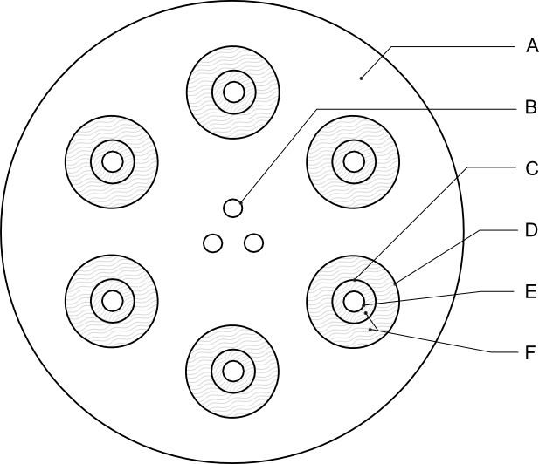

(A) | Metal block | (B) | Cartridge heaters
(C) | Glassware | (D) | Sample port
(E) | Glass sample container | (F) | Insulation
Figure 13.6.2.1: SBAT Heating Block

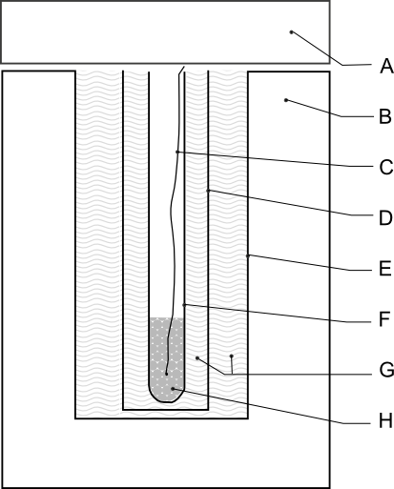

(A) | Insulative cap or blanket | (B) | Metal block
(C) | Thermocouple | (D) | Glassware
(E) | Sample port | (F) | Glass sample container
(G) | Insulation | (H) | Sample
Figure 13.6.2.1: SBAT Port
Source: ST/SG/AC.10/C.3/2014/52, para. 10
Section 16.2.2 – amend as indicated below:
16.2.2 Test types 6 (a), 6 (b), 6 (c) and 6 (d) are normally performed in alphabetical order. However, it is not always necessary to follow this order or to conduct tests of all types.

(a) Test type 6 (a) may be waived if explosive articles are carried without packaging or when the package contains only one article (see also section 16.2.2.(d)).

(b) Test type 6 (b) may be waived if in each type 6 (a) test (see also section 16.2.2.(d)):

(i) The exterior of the package is undamaged by internal detonation and/or ignition; or

(ii) The contents of the package fail to explode, or explode so feebly as would exclude propagation of the explosive effect from one package to another in test type 6(b).

(c) Test type 6 (c) may be waived if, in a type 6 (b) test, there is practically instantaneous explosion of virtually the total contents of the stack. In such cases the product is assigned to Division 1.1.

(d) Test type 6(d) is a test used to determine whether a 1.4S classification is appropriate and is only used if special provision 347 of Chapter 3.3 of the Model Regulations applies. . When testing articles to which special provision 347 applies, test type 6(d) may be performed first. If the results of test type 6(d) indicate that a 1.4S classification is appropriate, then test types 6(a) and 6(b) may be waived.

Source: ST/SG/AC.10/C.3/2014/4, Annex 2, as amended by the working group
Section 16.4.1.2 – amend as indicated below:
16.4.1.2 Apparatus and materials

The following items are required:
(a) A detonator to initiate the substance or article or an igniter just sufficient to ensure ignition of the substance or article (see 16.4.1.3.2 and 16.4.1.3.3);

(b) Suitable confining materials (see 16.4.1.3.4); and
(c) A sheet of 3 mm thick mild steel to act as a witness plate.

Blast measuring equipment may be used.
Source: ST/SG/AC.10/C.3/2014/4, Annex 2, as amended by the working group
Section 16.5.1.2 – amend as indicated below:
16.5.1.2 Apparatus and materials

The following items are required:
(a) A detonator to initiate the substance or article or an igniter just sufficient to ensure ignition of the substance or article (see 16.5.1.4 and 16.5.1.5);

(b) Suitable confining materials (see 16.5.1.3); and
(c) A sheet of 3 mm thick mild steel to act as a witness plate.

Blast measuring equipment may be used.
Source: ST/SG/AC.10/C.3/2014/4, Annex 2, as amended by the working group
Section 16.6.1.1 – amend as indicated below:
16.6.1.1 Introduction

This is a test performed on packages of an explosive substance or explosive articles, or unpackaged explosive articles, to determine whether there is a mass explosion or a hazard from dangerous projections, radiant heat and/or violent burning when involved in a fire.
Source: ST/SG/AC.10/C.3/2014/4, Annex 2, as amended by the working group
Section 16.6.1.2 – amend as indicated below:
(a) – (b): no changes proposed
(c) A metal grid to support the products above the fuel and allow adequate heating. If a wooden crib fire is used, the grid should be 1.0 m above the ground and if a liquid hydrocarbon pool fire is used then the grid should be 0.5 m above the fuel surface at the onset of the test;
(d) – (h): no changes proposed
Blast gauges, radiometers and associated recording equipment may also be used. Further equipment may be needed when following the procedure in 16.6.1.3.9.
Source: ST/SG/AC.10/C.3/2014/4, Annex 2, as amended by the working group (change to para (c)).
Ad-hoc working group document (additional text inserted at end of section)
Section 16.6.1.3 – add new sub-section 16.6.1.3.9 as indicated below:
16.6.1.3.9 For candidates to cartridges, small arms (UN0012), this test can be augmented or replaced by the specialised measurement of the energy of projections as described in Appendix 9. This applies to circumstances where the dominant hazard is a projection hazard, for example as known from previous testing of similar explosive articles.
Source: Ad-hoc working group document
Section 16.6.1.4.6 – amend as indicated below:
16.6.1.4.6 If none of the events occur which would require the product to be assigned to Division 1.1, 1.2, 1.3 or 1.4 other than Compatibility Group S, the thermal, blast, or projection effects would not significantly hinder fire-fighting or other emergency response efforts in the immediate vicinity, and if hazardous effects are confined within the package, then the product is assigned to Division 1.4 Compatibility Group S. For candidates to Cartridges, small arms (UN0012), evidence of projections with a kinetic energy not exceeding 8 J as determined by the test procedure in Appendix 9 may be used to assign the product to Compatibility Group S.
Source: Ad-hoc working group document
Section 16.7.1.2 – amend as indicated below:
16.7.1.2 Apparatus and materials

The following items are required:
(a) A detonator to initiate the substance or article or an igniter just sufficient to ensure ignition of the substance or article (see 16.7.1.3.2) and

(b) A sheet of 3 mm thick mild steel to act as a witness plate.
Video equipment may be used.
Source: ST/SG/AC.10/C.3/2014/4, Annex 2, as amended by the working group
Section 16.7.1.4(b) – amend as indicated below:
(b) A flash or flame that ignites an adjacent material such as a sheet of 80 ± 3 g/m² paper at a distance of 25 cm from the package;
Source: ST/SG/AC.10/C.3/2014/4, Annex2
Section 21.1.2 – amend as indicated below:
21.1.2 The question "Does it propagate a detonation?" (box 1 of Figure 20.1) is answered on the basis of the results of one of the test methods in Table 21.1. If a liquid is being considered for transport in tank-containers or IBCs with a capacity exceeding 450 litres, a cavitated version of a Series A test should be performed (see Appendix 3).
Source: UN/SCETDG/45/INF.4
Table 21.1 – amend as indicated below:
Table 21.1: TEST METHODS FOR TEST SERIES A

Test code | Name of test | Section
A.1  A.5  A.6 | BAM 50/60 steel tube test  UN gap test  UN detonation testª | 21.4.1  21.4.3  21.4.4

ª Recommended test

All tests are considered to be equivalent and only one test method has to be used.
Source: UN/SCETDG/45/INF.4
Section 21.3.2 – amend as indicated below:
21.3.2 If a mixture can separate out during transport, the test should be performed with the initiator in contact with the potentially most explosive part, if known.
Source: UN/SCETDG/45/INF.4
Section 21.4.3.2 – amend as indicated below:
21.4.3.2 Apparatus and materials
The apparatus is shown in Figure 21.4.3.1. The test sample is contained in an annealed, seamless, carbon steel tube with an external diameter of 48 ± 2 mm, a wall thickness of 4 mm and a length of 400 ± 5 mm. If the test substance may react with the steel, the inside of the tube may be coated with fluorocarbon resin. The bottom of the tube is closed with a plastic sheet pulled tightly (so that it plastically deforms) over the bottom of the tube and held tighly in place The plastic sheet shall be compatible with the substance under test. The booster charge consists of 160 g RDX/wax (95/5) or PETN/TNT that has a minimum of 50% PETN in the mixture, 50 ± 1 mm in diameter with a density of 1 600 ± 50 kg/m³. The charges may be pressed in one or more pieces, as long as the total charge is within the specifications, and the PETN/TNT charge is cast. A mild steel witness plate, 150 ± 10 mm square and 3 mm thick, may be mounted at the upper end of the steel tube and separated from it by spacers 1.6 ± 0.2 mm thick.
Source: UN/SCETDG/45/INF.4
Section 21.4.3.3.1 – amend as indicated below:
21.4.3.3.1 The sample is loaded to the top of the steel tube. Solid samples are loaded to the density attained by tapping the tube until further settling becomes imperceptible. The sample mass is determined and, if solid, the apparent density calculated using the measured internal volume of the tube.
Source: UN/SCETDG/45/INF.4
Section 21.4.4.2 – amend as indicated below:
21.4.4.2 Apparatus and materials

The apparatus is shown in Figure 21.4.4.1 and is identical for solids and liquids. The test sample is contained in an annealed, seamless, carbon steel tube with an external diameter of 60 ± 1 mm, a wall thickness of 5 ± 1 mm and a length of 500 ± 5 mm. If the test substance may react with the steel, the inside of the tube may be coated with fluorocarbon resin. The bottom of the tube is closed with a plastic sheet held tightly in place. The plastic sheet shall be compatible with the substance under test. The booster charge is a 200 g RDX/wax (95/5) or PETN/TNT that has a minimum of 50% PETN in the mixture, 60 ± 1 mm in diameter with a density of 1 600 ± 50 kg/m³. The charges may be pressed in one or more pieces as long as the total charge is within the specifications and the PETN/TNT charge is cast. The tube may be instrumented, e.g. by a continuous wire velocity probe, to measure the velocity of propagation in the substance. Additional information on the explosive behaviour of the test sample can be gained by the use of a witness plate, as shown in Figure 21.4.4.1. The mild steel witness plate, 150 mm square and 3 mm thick, may be mounted at the upper end of the tube and separated from it by spacers 1.6 ± 0.2 mm thick.
Source: UN/SCETDG/45/INF.4
Section 21.4.4.3 – amend as indicated below:
21.4.4.3 Procedure

The sample is loaded to the top of the steel tube. Solid samples are loaded to the density attained by tapping the tube until further settling becomes imperceptible. The sample mass is determined and, if solid, the apparent density calculated. The tube is placed in a vertical position and the booster charge is placed in direct contact with the sheet which seals the bottom of the tube. The detonator is fixed in place against the booster charge and initiated. Two tests should be performed unless detonation of the substance is observed
Source: UN/SCETDG/45/INF.4
Section 23.2.1 – amend as indicated below:
23.2.1 The question "Can it propagate a deflagration?" (boxes 3, 4 and 5 of Figure 20.1) is answered on the basis of the results of one, or if necessary both, of the test methods in Table 23.1.
Source: UN/SCETDG/45/INF.4
Table 23.1 – amend as indicated below:
Table 23.1: TEST METHODS FOR TEST SERIES C
Test code | Name of test | Section
C.1  C.2 | Time/pressure testª  Deflagration testª | 23.4.1  23.4.2
ª Recommended test.
Source: UN/SCETDG/45/INF.4
Section 23.4.1.2 – amend as indicated below:
23.4.1.2 Apparatus and materials

23.4.1.2.1 The time/pressure apparatus (Figure 23.4.1.1) consists of a cylindrical steel pressure vessel 89 mm in length and 60 mm in external diameter. Two flats are machined on opposite sides (reducing the cross-section of the vessel to 50 mm) to facilitate holding whilst fitting the firing plug and vent plug. The vessel, which has a bore of 20 mm diameter, is internally rebated at either end to a depth of 19 mm and threaded to accept 1" British Standard Pipe (BSP). A pressure take-off, in the form of a side-arm, is screwed into the curved face of the pressure vessel 35 mm from one end and at 90° to the machined flats. The socket for this is bored to a depth of 12 mm and threaded to accept the 1/2" BSP thread on the end of the side-arm. A washer is fitted to ensure a gas-tight seal. The side-arm extends 59 mm beyond the pressure vessel body and has a bore of 6 mm. The end of the side-arm is rebated and threaded to accept a diaphragm type pressure transducer. Any pressure-measuring device may be used provided that it is not affected by the hot gases or decomposition products and is capable of responding to rates of pressure rise of 690 to 2 070 kPa in not more than 5 ms.

23.4.1.2.2 The end of the pressure vessel furthest from the side-arm is closed with a firing plug which is fitted with two electrodes, one insulated from and the other earthed to the plug body. The other end of
the pressure vessel is closed by an aluminium bursting disc 0.2 mm thick (bursting pressure approximately 2 200 kPa) held in place with a retaining plug which has a 20 mm bore. A suitable deformable washer or rubber ring is used with both plugs to ensure a good seal. A support stand (Figure 23.4.1.2) holds the assembly in the correct attitude during use. This comprises a mild steel base plate measuring 235 mm × 184 mm × 6 mm and a 185 mm length of square hollow section (S.H.S.) 70 × 70 × 4 mm.

23.4.1.2.3 No changes.

23.4.1.2.4 No changes.

23.4.1.2.5 No changes.

23.4.1.2.6 The procedure for the preparation of the ignition assembly for solids starts with separation of the brass foil contacts of an electric fusehead from its insulator, (see Figure 23.4.1.3). The exposed portion of insulation is then cut off. The fusehead is then fixed onto the terminals of the firing plug by means of the brass contacts such that the tip of the fusehead is 13 mm above the surface of the firing plug. An approximately 13 mm square piece of primed cambric is pierced through the centre and positioned over the attached fusehead around which it is then folded and secured with fine cotton thread.

23.4.1.2.7 For liquids samples, a single piece of thin PVC sheathing, or equivalent, is used to cover the primed cambric in such a way that the primed cambric is not in contact with the liquid sample. The leads of the resistance wire are then fixed onto the terminals of the firing plug such that the tip of the primed cambric is above the surface of the firing plug.
Source: UN/SCETDG/45/INF.4
Section 23.4.1.3.1 – amend as indicated below:
23.4.1.3.1 The apparatus assembled, complete with pressure transducer but without the aluminium bursting disc in position, is supported firing plug end down. 5.0 g³ of the substance is introduced into the apparatus so as to be in contact with the ignition system. Normally no tamping is carried out when filling the apparatus unless it is necessary to use light tamping in order to get the 5.0 g charge into the vessel. If, even with light tamping, it is impossible to get all the 5.0 g of sample in, then the charge is fired after filling the vessel to capacity. Note should be taken of the charge weight used. The washer or rubber ring and aluminium bursting disc are placed in position and the retaining plug is screwed in tightly. The charged vessel is transferred to the firing support stand, bursting disc uppermost, which should be contained in a suitable, armoured fume cupboard or firing cell. A power source is connected to the external terminals of the firing plug and the charge is fired. The signal produced by the pressure transducer is recorded on a suitable data acquisition system which allows both evaluation and a permanent record of the time/pressure profile to be achieved.

³ If preliminary safety-in-handling tests (e.g. heating in a flame) or burning tests (e.g. a series 3 type (d) test) indicate that a rapid reaction is likely to occur, then the sample size should be reduced to 0.5 g until the severity of the confined reaction is known. If it is necessary to use a 0.5 g sample size, the sample size is gradually increased until either a "Yes, rapidly" result is obtained or the test is performed with a 5.0 g sample.
Source: UN/SCETDG/45/INF.4
Figure 23.4.1.1 – amend the caption as indicated below:

(A) Pressure vessel body (B) Bursting disc retaining plug
(C) Firing plug (D) Deformable washer
(E) Bursting disc (F) Side arm
(G) Pressure transducer thread (H) Washer
(J) Insulated Electrode (K) Earthed electrode
(L) Insulation (M) Steel cone
(N) Washer distorting groove

Figure 23.4.1.1: APPARATUS

Source: UN/SCETDG/45/INF.4
Section 23.4.2.2.1 – amend as indicated below:
23.4.2.2.1 The test is performed with a Dewar vessel (see Figure 23.4.2.1) which is provided with vertical observation windows on opposite sides. The windows are not necessary when using thermocouples to measure the deflagration rate. A timer with an accuracy of 1 second is used to measure the deflagration rate.
Source: UN/SCETDG/45/INF.4
Section 23.4.2.2.2 – amend as indicated below:
23.4.2.2.2 The Dewar vessel has a volume of about 300 cm³, an internal diameter of 48 ± 1 mm, an external diameter of 60 mm and a length between 180 and 200 mm. The half-time of cooling with water or other suitable material filled to a height of 20 mm below the rim (i.e. 265 cm³) of Dewar vessel, closed by a tight fitting cork, should be longer than 5 hours. Horizontal graduation marks are drawn at 50 and 100 mm from the top of the Dewar vessel. The time it takes for the decomposition front to propagate from the 50 mm mark to the 100 mm mark yields the deflagration rate. A glass thermometer with an accuracy of 0.1 °C is used to measure the temperature of the test substance prior to ignition. Alternatively, the deflagration rate and sample temperature may be determined by using two thermocouples at distances of 50 mm and 100 mm from the top of the Dewar vessel.
Source: UN/SCETDG/45/INF.4
Section 23.4.2.3.2 – amend as indicated below:
23.4.2.3.2 The Dewar vessel and the substance are brought to the emergency temperature as defined in the Model Regulations. If the substance is sufficiently stable as to require no emergency temperature, a test temperature of 50 °C is used. The Dewar vessel is filled to a height of 20 mm below the rim with the substance. Granular substances are filled into the Dewar vessel in such a way that the bulk density of the substance will be comparable with that in transport and there are no lumps.
Source: UN/SCETDG/45/INF.4
Section 23.4.2.3.3 – amend as indicated below:
23.4.2.3.3 Pasty materials are introduced into the Dewar vessel in such a way that no air pockets will be present in the sample to be tested. The height of filling shall be about 20 mm below the rim of the Dewar vessel. The mass and the temperature of the substance are recorded. The Dewar vessel is placed in the test-cell or fume-chamber behind a shield, after which the substance is heated at the top by means of a gas burner. At the moment when ignition is observed or, alternatively, if no ignition occurs within five minutes, the gas burner is removed and extinguished. The period of time that is required for the reaction zone to pass the distance between the two marks is measured with the timer. If the reaction stops before reaching the lower mark, the substance is considered to be non-deflagrative. The test is performed in duplicate and the shortest time interval is used for the calculation of the deflagration rate. Alternatively, the rate may be determined by locating thermocouples down the centre of the Dewar at distances 50 mm and 100 mm from the top of the Dewar vessel. The thermocouple outputs are monitored continuously. The passage of the reaction front causes a steep increase in output. The time between the increases in output is determined.
Source: UN/SCETDG/45/INF.4
Section 23.4.2.5 – amend the entry for “Dicetyl peroxydicarbonate” as indicated below:
Substance | Sample mass (g) | Temperature (°C) | Propagation rate (mm/s) | Result
Dicetyl peroxydicarbonate | 159 | 35 | No ignition | No
Source: UN/SCETDG/45/INF.4
Section 25.4.1.2.1 – amend as indicated below:
25.4.1.2.1 The apparatus consists of a non-reusable steel tube, with its re-usable closing device, installed in a heating and protective device. The tube is deep drawn from sheet steel conforming to specification DC04 (EN 10027-1), or equivalent A620 (AISI/SAE/ASTM), or equivalent SPCEN (JIS G 3141). The dimensions are given in Figure 25.4.1.1. The open end of the tube is flanged. The closing plate with an orifice, through which the gases from the decomposition of the test substance escape, is made from heat-resisting chrome steel. For classification the following diameter holes shall be used: 1.0 - 1.5 - 2.0 - 2.5 - 3.0 - 5.0 - 8.0 - 12.0 - 20.0 mm. In addition, other diameters can be used for hazard assessment. The dimensions of the threaded collar and the nut (closing device) are given in Figure 25.4.1.1.
Source: UN/SCETDG/45/INF.4
Section 25.4.1.2.2 – amend as indicated below:
25.4.1.2.2 Heating is provided by propane, from an industrial cylinder fitted with pressure regulator, via a flow meter and distributed by a manifold to the four burners. Other fuel gases may be used provided the specified heating rate is obtained. The gas pressure is regulated to give a heating rate of 3.3 ± 0.3 K/s when measured by the calibration procedure. Calibration involves heating a tube (fitted with a 1.5 mm orifice plate) filled with 27 cm³ of dibutyl phthalate or equivalent. The time taken for the temperature of the liquid (measured with a 1 mm diameter thermocouple centrally placed 43 mm below the rim of the tube) to rise from 135 °C to 285 °C is recorded and the heating rate calculated.
Source: UN/SCETDG/45/INF.4,as amended by the working group
Section 25.4.1.3.1 – amend as indicated below:
25.4.1.3.1

The tube is filled to a height of 60 mm from the bottom of the tube. Cast solids should be cast to the internal dimensions of the steel tube with a height of 60 mm and then placed inside the tube. Powders are filled in approximately three equal increments with tamping1 to 80 N force between each increment. Liquids and gels are loaded into the tube to a height of 60 mm taking particular care with gels to prevent the formation of voids. Determine the total mass used to fill the tube to this level and use this amount of solid for each trial filling being performed. The threaded collar is slipped onto the tube from below, the appropriate orifice plate is inserted and the nut tightened by hand after applying some molybdenum disulphide based lubricant. It is essential to check that none of the substance is trapped between the flange and the plate, or in the threads.
Source: UN/SCETDG/45/INF.4
Section 25.4.1.3.5 – amend as indicated below:
25.4.1.3.5 The series of trials is started with a single trial using an orifice plate with a certain diameter. If, in this trial, the result "explosion" is observed, the series is continued with single trials at increasing diameters until only negative results in three tests are obtained at the same level. If in the first trial "no explosion" occurs, the series is continued with single trials using plates with the decreasing diameters and finally 1.0 mm until, at one of these diameters, the result "explosion" is obtained. Subsequently, trials are carried out at increasing diameters, until only negative results in three tests are obtained at the same diameter. The limiting diameter of a substance is the largest diameter of the orifice at which the result "explosion" is obtained. If no "explosion" is obtained with a diameter of 1.0 mm, the limiting diameter is recorded as being less than 1.0 mm.
Source: UN/SCETDG/45/INF.4
Figure 25.4.1.1 – replace the drawing and amend the caption as indicated below:
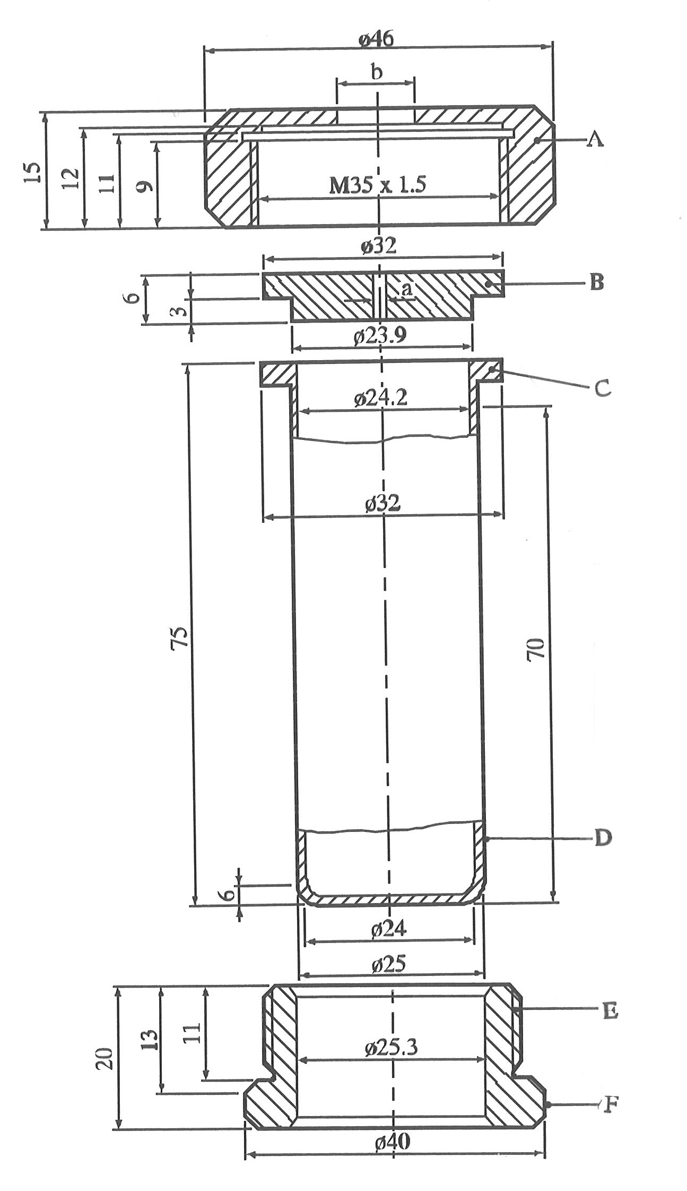

(A) Nut (b = 10.0 or 20.0 mm) with flats for size 41 spanner
(B) Orifice plate (a = 1.0 to 20.0 mm diameter)
(C) Flange
(D) Tube
(E) Threaded collar
(F) Flats for size 36 spanner

Source: UN/SCETDG/45/INF.4
Section 25.4.2.2.1 – amend as indicated below:
25.4.2.2.1 Description of the pressure vessel
Figure 25.4.2.1 shows the apparatus used. The vessel is made of stainless steel, type AISI 316. 8 aperture discs are used, the diameters of the orifices being: 1.0 - 2.0 - 3.5 - 6.0 - 9.0 - 12.0 - 16.0 and 24.0 mm. In addition other diameters may be used for hazard assessment. These discs have a thickness of 2.0 mm ± 0.2 mm. The bursting discs are 38 mm diameter aluminium discs rated to burst at 620 ± 60 kPa at 22 °C (see Figure 25.4.2.2).
Source: UN/SCETDG/45/INF.4
Section 25.4.2.2.2 – amend as indicated below:
25.4.2.2.2 Heating device
The pressure vessel is heated by technical-grade butane taken from a cylinder fitted with a pressure regulator. A Teclu burner is used. Other gases may be used, with a suitable burner, provided that a heating rate of 3.5 ± 0.3 K/s is obtained. The heating rate should be checked by heating 10 g of dibutyl phthalate or equivalent in the pressure vessel and measuring its temperature. The time taken for the temperature of the oil to rise from 50 °C to 200 °C is recorded and the heating rate calculated.
Source: UN/SCETDG/45/INF.4
Section 25.4.2.3.1 – amend as indicated below:
25.4.2.3.1 For a normal test, 10.0 g of the substance should be placed in the vessel. The bottom of the vessel should be evenly covered with the substance. The bursting disc, the selected orifice plate and retaining ring are then put in place. The wing nuts are tightened by hand and the box nut with a spanner. The bursting disc is covered by enough water to keep it at a low temperature. The pressure vessel is placed on a tripod (with an inside ring diameter of 67 mm) which may be placed inside a protective cylinder. The ring at the middle of the vessel rests on the tripod.
Source: UN/SCETDG/45/INF.4
Section 25.4.2.3.3 – amend as indicated below:
25.4.2.3.3 The series of trials is started with a single trial using an orifice plate with a certain diameter. If there is no rupture of the disc with this orifice, experiments are performed with single trial using plates with decreasing diameters until rupture of the disc occurs. In cases where no disc rupture is observed with an orifice of 1.0 mm, the next test with an orifice of 1.0 mm is carried out with 50.0 g of the substance instead of 10.0 g. If still no rupture of the disc is observed the experiment is repeated until three successive experiments without rupture are obtained. In the event of rupture of the disc, the experiments are repeated at the next higher level (10 g instead of 50 g or next higher diameter of the orifice) until the level is found at which there are no ruptures in three successive experiments.
Source: UN/SCETDG/45/INF.4
Section 25.4.2.4.2 – amend as indicated below:
25.4.2.4.2 The test criteria are as follows:

"Violent": - Rupture of the disc with an orifice of 9.0 mm or greater and a sample mass of 10.0 g.

"Medium": - No rupture of the disc with an orifice of 9.0 mm but rupture of the disc with an orifice of 3.5 mm or larger but smaller than 9.0 mm and a sample mass of 10.0 g.

"Low": - No rupture of the disc with an orifice of 3.5 mm and a sample mass of 10.0 g but rupture of the disc with an orifice of 1.0 mm or or larger but smaller than 3.5 mm and a sample mass of 10.0 g or rupture of the disc with an orifice of 1.0 mm and a sample mass of 50.0 g.

"No": - No rupture of the disc with an orifice of 1.0 mm and a sample mass of 50.0
Source: UN/SCETDG/45/INF.4
Appendices – add Appendix 9 as indicated below:
Appendix 9

Ballistic Projection Energy Test for Cartridges, Small Arms (UN0012)

1. Introduction

This test is conducted with candidates for Cartridges, small arms (UN 0012) with individual cartridges and is used to determine the maximum possible energy of a projection that could be generated upon functioning in transport. The test takes worst-case conditions into account, since no packaging attenuates the energy of the projectile and the cartridge is supported by a fixed anvil block. It is not necessary to reverse the test set-up to a situation where the cartridge is propelled, because experimentation shows that energy transfer from the propellant to the bullet is equal or more than that to the case.

2. Apparatus and materials

The following items are required:

(a) A suitable actuator to initiate ammunition and

(b) A ballistic pendulum with an interception device for the projectile for determining the energy, or a high-speed camera and a background with a scale to determine the velocity of the projectile.

3. Procedure

The test is performed on single cartridges. The cartridge is actuated as designed by means of the primer cap and a firing pin. The cartridge, actuator and measuring device are arranged along the flight path in such a way that angle errors are minimized. The test is performed three times.

4. Test criteria and method of assessing the results

The energy of the projectile is calculated either from the maximum displacement of the ballistic pendulum or from the velocity (v) determined by the high-speed camera taking the mass (m) of the projectile into account. The value of energy (E) can be calculated from the equation:

E = ½mv²

If the energy of the projectile does not exceed 8 J in any of the test runs, the article, in the appropriate packaging in accordance with Chapter 3.2 of the Model Regulations, may be assigned to Cartridges, small arms (UN0012).
Source: Ad-hoc working group document (additional text inserted at end of section)

1 For reasons of safety, e.g. the substance is friction sensitive, the substance need not be tamped. In cases where the physical form of the sample can be changed by compression or compression of the sample is not related to the transport conditions, e.g. for fibrous materials, more representative filling procedures may be used.

