Proposal for amendments to ECE/TRANS/WP.29/GRE/2013/13
(Supplement 25 to the 01 series of amendments to
Regulation No. 6 (direction indicators))
The text reproduced below was prepared by the expert from OICA, to propose amendments to document GRE/2013/13 submitted by the experts from France and Germany. The modifications to the document GRE/2013/13 are highlighted in red, and marked in bold for new or strikethrough for deleted characters.
I. Proposal
Paragraph 2.2.4., amend to read:
"2.2.4. For a direction indicator lamp of categories 1, 1a, 1b, 2a and 2b, information regarding the signal according to paragraph 5.6. and 6.4.2. 6.2.2. below.
Insert new paragraphs 5.6. and 5.6.1., to read:
"5.6. For direction indicators of the categories 1, 1a, 1b, 2a or 2b, intentionally changing the sequentially progressive luminous intensity during a flash inside the maximum apparent surface is allowed, if all photometric and colorimetric requirements as well as the following conditions are met:
(a) the minimum intensity as specified for the specific category shall be achieved at least from [160] not later than 200 ms onwards after the flash has started;
(b) the variation shall propagate in an outward horizontal orientation outwards only, until all light sources of the lamp are lit switched on [during the time needed to reach the minimum intensity];
Horizontal orientation of a sequential progressive luminous intensity direction indicator means the ratio of the length of path of the movement in horizontal direction to that in vertical direction on the apparent surface [should not exceed] the value of [1:1]."
(c) the variation is oriented from inside the vehicle in direction of the outer side of the vehicle;
(c d) once lit, all the light sources of the lamp shall remain lit until all light sources of the lamp shall be are switched off simultaneously at the end of the flash;
(d e) the test shall be carried out in flashing mode.5.6.1. A note shall be made in paragraph 9 of the communication form in Annex 2 to this Regulation."
Annex 2, item 9 amend to read:
"9. Concise description:
…
Variable luminous intensity ................yes/no 2/
Changing Sequential progressive luminous intensity (see paragraph 5.6. to this Regulation).......... yes/no 2/"
II. Justification
1. Time to achieve the minimum intensity (§5.6 (a)):
200ms is proposed because it is the warm up time for a P21W.
If the minimum intensity is achieved faster than/equal to the performance of a filament light source when switched ON, the safety is insured.
The requirement of 160ms mandates a technology. The aim of the regulation is to be performance oriented.
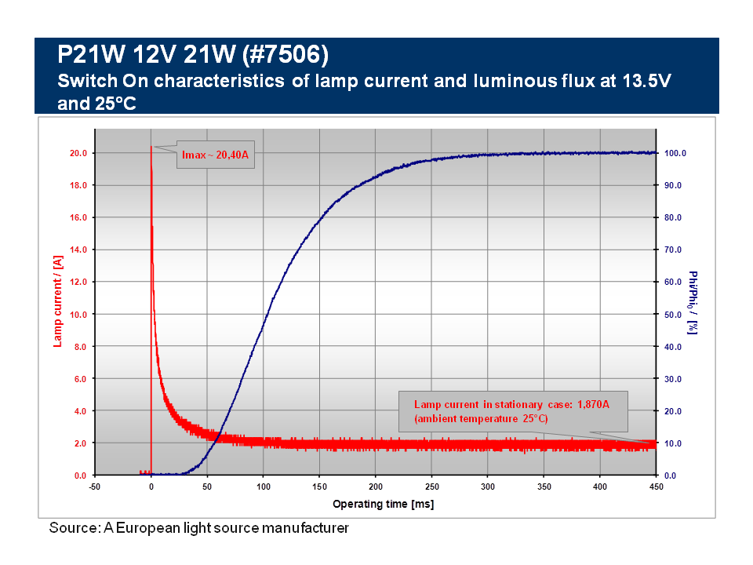
2. Movement of propagation (§5.6 (b)):
To add more clarity, it is proposed to use the same definition of "horizontal orientation" as in Regulation No. 48 (document ECE/TRANS/WP29/GRE/2013/14).
The ratio 1:1 is proposed because this is the limit between the horizontal and the vertical and, according to the shape of the body (curve, bump, convex, etc.), there is no visual impact and no safety issue between the ratio 1:1 or 10:6
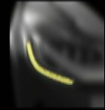 | 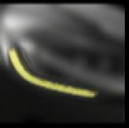
Ratio 1:1 | Ratio 10:6
3. Deletion of the §5.6 (c ):
The sentence expresses the same idea as "orientation outwards only" of § 5.6 (b).
4. Annex 2, item 9:
The terms "sequential progressive" seams more appropriate and more precise.
_______________

