 | United Nations | ECE/TRANS/WP.29/GRE/2013/59
 | Economic and Social Council |  | Distr.: General  7 August 2013  Original: English
Economic Commission for Europe
Inland Transport Committee
World Forum for Harmonization of Vehicle Regulations
Working Party on Lighting and Light-Signalling
Seventieth session
Geneva, 21-23 October 2013
Item 11 of the provisional agenda
Regulation No. 65 (Special warning lamps)
Proposal for Supplement 10 to Regulation No. 65 (Special warning lamps)
Submitted by the expert from Germany*
The text reproduced below was prepared by the expert from Germany in order to make the Conformity of Production (CoP) of the Regulations more precise. The modifications to the existing text of the Regulation are marked in bold characters.
I. Proposal
Paragraph 9., amend to read:
"9. Conformity of Production
9.1. The Conformity of Production procedures shall comply with those set out in the Agreement, Appendix 2 (E/ECE/TRANS/505/Rev.2), with the following requirements:
9.1.1. Special warning lamps approved under this Regulation shall be so manufactured as to conform to the type approved by meeting the requirements set forth in paragraphs 5., 6. and 7. above.
9.1.2. In order to verify that the requirements of paragraph 9.1.1. are met, suitable controls of the production shall be carried out.
9.1.3. The holder of the approval shall in particular:
9.1.3.1. Ensure the existence of procedures for the effective control of the quality of products;
9.1.3.2. Have access to the control equipment necessary for checking the conformity to each approved type;
9.1.3.3. Ensure that data of test results are recorded and that related documents shall remain available for a period to be determined in accordance with the administrative service;
9.1.3.4. Analyze the results of each type of test in order to verify and ensure the stability of the product characteristics making allowance for variation of an industrial production;
9.1.3.5. Ensure that for each type of product at least the tests prescribed in Annex 7 to this Regulation are carried out;
9.1.3.6. Ensure that any collecting of samples giving evidence of non-conformity with the type of test considered shall give rise to another sampling and another test. All the necessary steps shall be taken to re-establish the conformity of the corresponding production.
9.1.4. The competent authority which has granted type approval may at any time verify the conformity control methods applicable to each production unit.
9.1.4.1. In every inspection, the test books and production survey records shall be presented to the visiting inspector.
9.1.4.2. The inspector may take samples at random to be tested in the manufacturer's laboratory. The minimum number of samples may be determined in the light of results of the manufacturer's own checks.
9.1.4.3. When the quality level appears unsatisfactory or when it seems necessary to verify the validity of the tests carried out in the application of paragraph 9.1.4.2. above, the inspector shall select samples, to be sent to the technical service which has conducted the type approval tests, using the criteria of Annex 8.
9.1.4.4. The competent authority may carry out any test prescribed in this Regulation. These tests will be on samples selected at random without causing distortion of the manufacturer's delivery commitments and in accordance with the criteria of Annex 8.
9.1.4.5. The competent authority shall strive to obtain a frequency of inspection of once every two years. However, this is at the discretion of the competent authority and their confidence in the arrangements for ensuring effective control of the conformity of production. In the case where negative results are recorded, the competent authority shall ensure that all necessary steps are taken to re-establish the conformity of production as rapidly as possible.
9.2. Special warning lamps with apparent defects are disregarded.
9.3. The reference mark is disregarded."
Annex 8,
Paragraphs 2. to 4., shall be deleted.
Figure 1, shall be deleted.
Insert new paragraphs 2. to 6., to read:
"2. First sampling
In the first sampling four special warning lamps are selected at random. The first sample of two is marked A, the second sample of two is marked B.
2.1. The conformity of mass-produced special warning lamps shall not be contested if the deviation of any specimen of samples A and B (all four lamps) is not more than 20 per cent.
In the case that the deviation of both lamps of sample A is not more than 0 per cent the measurement can be closed.
2.2. The conformity of mass-produced special warning lamps shall be contested if the deviation of at least one specimen of samples A or B is more than 20 per cent.
The manufacturer shall be requested to bring their production in line with the requirements (alignment), and a repeated sampling according to paragraph 3. below shall be carried out within two months' time after the notification The samples A and B shall be retained by the Technical Service until the entire COP process is finished.
3. First repeated sampling
A sample of four special warning lamps is selected at random from stock manufactured after alignment.
The first sample of two is marked C, the second sample of two is marked D.
3.1. The conformity of mass-produced special warning lamps shall not be contested if the deviation of any specimen of samples C and D (all four special warning lamps) is not more than 20 per cent.
In the case that the deviation of both special warning lamps of sample C is not more than 0 per cent, the measurement can be closed.
3.2. The conformity of mass-produced special warning lamps shall be contested if the deviation of at least:
3.2.1 One specimen of samples C or D is more than 20 per cent but the deviation of all specimens of these samples is not more than 30 per cent.
The manufacturer shall be requested again to bring their production in line with the requirements (alignment).
A second repeated sampling according to paragraph 4. below shall be carried out within two months' time after the notification. The samples C and D shall be retained by the Technical Service until the entire COP process is finished.
3.2.2 One specimen of samples C or D is more than 30 per cent.
In this case the approval shall be withdrawn and paragraph 5 below shall be applied.
4. Second repeated sample
A sample of four special warning lamps is selected at random from stock manufactured after alignment.
The first sample of two is marked E, the second sample of two is marked F.
4.1. The conformity of mass-produced special warning lamps shall not be contested if the deviation of any specimen of samples E and F (all four special warning lamps) is not more than 20 per cent.
In the case that the deviation of both special warning lamps of sample E is not more than 0 per cent, the measurement can be closed.
4.2. The conformity of mass-produced special warning lamps shall be contested if the deviation of at least one specimen of samples E or F is more than 20 per cent.
In this case the approval shall be withdrawn and paragraph 5 below shall be applied.
5. Approval withdrawn
Approval shall be withdrawn according to paragraph 10. of this Regulation.
6. Rain test
One of the special warning lamps of sample A after sampling procedure in paragraph 2. of this annex shall be tested according to the procedure described in Annex 4 of this Regulation.
The special warning lamp shall be considered as acceptable if the test has passed.
However, if the test on sample A is not complied with, the two special warning lamps of sample B shall be subjected to the same procedure and both shall pass the test"
II. Justification
1. The present set of proposals for amendments to the CoP provisions in a number of Regulations on lighting and light-signalling is based on documents ECE/TRANS/WP.29/GRE/2013/21 to ECE/TRANS/WP.29/GRE/2013/37, which were adopted at the sixty-ninth GRE session.
2. By the fact, that GTB has finalized the amendments for the UN Regulations Nos. 27 and 65, the expert from Germany has prepared revised proposals for the relevant parts for CoP also for these Regulations, to have the chance, if accepted, to prepare a final consolidated version in one document for each of these two Regulations for WP.29.
3. The proposals clarify in the relevant paragraphs of the above-mentioned Regulations, that the specimens taken at random may deviate unfavourably by not more than 20 per cent from the prescribed (required) values.
4. In the relevant annexes on "Minimum requirements for conformity of production control procedures" of the light-signalling Regulations, tables equivalent to the lighting Regulations were incorporated, which show the equivalent deviation in candela for small values (e.g. geometric visibility).
5. The relevant annexes on "Minimum requirements for sampling by an inspector" were completely restructured and simplified. All former examples which caused confusion were deleted.
6. COP is now described in a clear stepwise process (with limited steps), which gives the manufacturer the chance in the first step - in the case of deviations of more than 20% - to align his production process. Also the COP process could be completed earlier, when the first two samples are in the full specifications.
7. With the additional requirements up to the third step, the withdrawal of approval is clearly required, when after the second repetition of this process the manufacturer was not in the position to align his production process in the correct way.
8. The attached drawing shows this stepwise process.
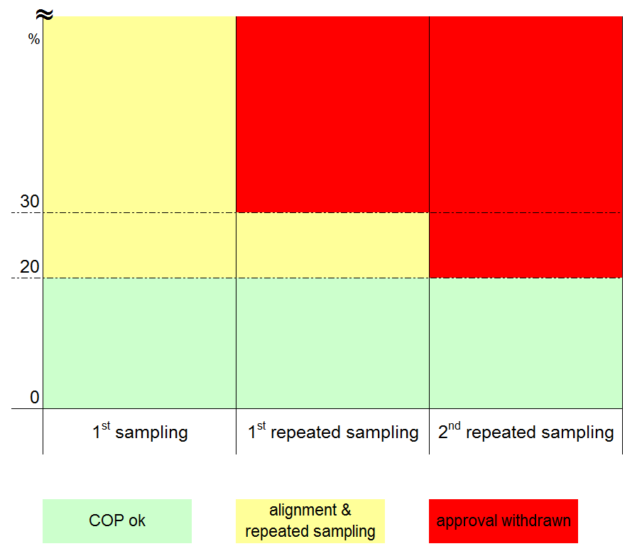
9. The Figure 1 may therefore be deleted, because this Figure has brought more confusion than clarification - and with the new simply description it is no longer necessary.

* In accordance with the programme of work of the Inland Transport Committee for 2010–2014 (ECE/TRANS/208, para. 106 and ECE/TRANS/2010/8, programme activity 02.4), the World Forum will develop, harmonize and update Regulations in order to enhance the performance of vehicles. The present document is submitted in conformity with that mandate.

