 | United Nations | ECE/TRANS/WP.15/AC.1/2013/6
 | Economic and Social Council |  | Distr.: General  20 December 2012  Original: English
Economic Commission for Europe
Inland Transport Committee
Working Party on the Transport of Dangerous Goods
Joint Meeting of the RID Committee of Experts and the
Working Party on the Transport of Dangerous Goods
Bern, 18–22 March 2013
Item 5(b) of the provisional agenda
Proposals for amendments to RID/ADR/ADN:
new proposals
Periodic inspection of LPG road and rail tankers - Alternatives to the hydraulic test
Transmitted by the European Liquid Petroleum Gases Association (AEGPL) ,
Summary
Executive summary: This proposal justifies alternatives to the hydraulic test that can be used on LPG road and rail tankers at the 6 yearly periodic inspections. It is not intended to replace the internal visual inspection.
Action to be taken: Amend 6.8.2.4.2 of RID/ADR.
Introduction
1. The current text of the RID/ADR paragraph 6.8.2.4.2 requires that every 6 years an LPG tanker is required to undergo a hydraulic test:
Shells and their equipment shall undergo periodic inspections no later than every
six years. | five years.
These periodic inspections shall include:
- An external and internal examination;
- A leakproofness test in accordance with 6.8.2.4.3 of the shell with its equipment and check of the satisfactory operation of all the equipment;
- As a general rule, a hydraulic pressure test¹⁰ (for the test pressure for the shells and compartments if applicable, see 6.8.2.4.1).
Proposal
2. Add an additional footnote that reads: “When approved by the competent authority the hydraulic test may be replaced by other suitable Non-destructive tests as detailed in appropriate standards. For example, magnetic particle examination in accordance with EN ISO 17638 and ultrasonic testing in accordance with EN ISO 17640.”.
Justification
3. Hydraulic testing became popular in the nineteenth century as the only method for ensuring the integrity of pressure vessels (mainly steam boilers), long before any other (technological) methods became available. Following the initial construction or repair of a fixed tank (pressure vessel) it is still a basic requirement to hydraulic test. Hydraulic testing can be undertaken at periodic inspection, but other methods of non destructive testing will provide an equivalent level of safety.
4. The United Kingdom originally started to supplement the hydraulic testing of fixed tanks by Magnetic Particle and Ultrasonic testing in the 1980s. Initially the Magnetic Particle inspection was limited to detect cracking, in the tank shell, over the horns of the saddle backing plates. It was found that at the Periodic Inspection the Magnetic Particle examination of welds and Ultrasonic thickness checks (of the shell) were identifying defects that were not being detected by a hydraulic test. The hydraulic test could be replaced by a combination of Magnetic Particle and Ultrasonic Examination methods. The Competent Authorities subsequently approved the substitution of suitable non-destructive testing (NDT) methods in place of the hydraulic test (for non ADR tanks) and in 1984 issued an approved Code of Practice.
5. According to the figures published by the Trade association for the LPG industry in the United Kingdom (UKLPG) there are approximately 600 LPG tankers in operation in the United Kingdom. If it is assumed that during their working life they will normally go through their periodic inspection at 6, 12 and 18 years (with a total working life of 24 years) each year there will be an average of 25 new tankers and 75 periodic inspections.
6. Annually (since 1984), approximately 60 (of the 75) United Kingdom’s LPG tankers have been periodically inspected by using appropriate non-destructive test (NDT) methods in place of the hydraulic test (the other 15 have been hydraulically tested at the request of the Competent authority or as part of the operators inspection policy). During that time there has been no record of any failure of an LPG fixed tank (on a tanker). Defects that have been found that would not have been identified by a hydraulic test or visual examination.
7. In 1995 a United States’rail tanker suffered a catastrophic failure only a short time after being re-qualified by a hydraulic test. The subsequent investigations found that the hydraulic test and visual examination had not identified the defects that caused the failure and that the hydraulic test had actually propagated some cracks.
8. Since 1998 the United States Department of Transportation has required that suitable NDT is used for the requalification of tank cars (rail tankers) and this is mandated by the docked federal regulation ‘HM-201’.
9. According to the United States Department of Transportation (DOT), “HM-201 is a federal regulation governing the qualification of DOT & AAR tank cars. It eliminates the hydrostatic tank test previously used and uses non-destructive testing which provides a better method of detecting defects and ensures tank car safety.”
10. They (DOT) also have an ongoing program of research and study on developing the probability of detection curves for several NDT methods, which can be found at
http://www.fra.dot.gov/downloads/Research/ord0910.pdf
11. RID/ADR already permit alternatives to the hydraulic pressure test for some pressure receptacles – see 6.2.1.6.1 Notes 2 and 3 and the Note under 6.2.3.5.1.
NDT
12. Both surface breaking and non surface breaking cracks can be detected by NDT that would not be found or detected test by a visual examination or a hydraulic test.
EN ISO 17638:2009 “Non-destructive testing of welds. Magnetic particle testing.”
13. Magnetic particle testing will detect imperfections in welds in ferromagnetic materials, including the heat affected zones. The techniques are suitable for most welding processes and joint configurations.
EN ISO 17640:2010 “Non-destructive testing of welds. Ultrasonic testing - Techniques, testing levels, and assessment.”
14. Ultrasonic testing is suitable for fusion-welded joints in metallic materials of thickness greater than or equal to 8.0 mm which exhibit low ultrasonic attenuation (especially due to scatter) at object temperatures from 0 ºC to 60 ºC. It is primarily intended for use on full penetration welded joints where both the welded and parent materials are ferritic.
15. Suitable NDT can identify surface breaking defect 3 mm long x 1 mm deep and non surface breaking defect 3 mm long x 2 mm deep. Defects of this size would not cause failure during a hydraulic test or would be identified by normal visual examination.
Recent Experience
16. As an example a LPG fixed tank (manufactured in 1995) recently passed a hydraulic test (in 2011) which was undertaken before any other tests were conducted. The subsequent visual and magnetic particle inspections of some of the nozzle welds found cracks between 25 – 90 mm long in three welds.
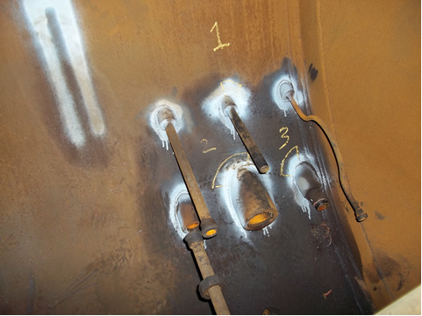

17. Following the initial indications of cracking light grinding of the surface was undertaken to ensure that it was not just weld overlap, however it was confirmed that all three were hairline cracks (the white background paint and black indicator has now made these very visible to the naked eye).

Nozzle 1 houses the temperature gauge blind pocket and has a 25 mm long crack as indicated below:

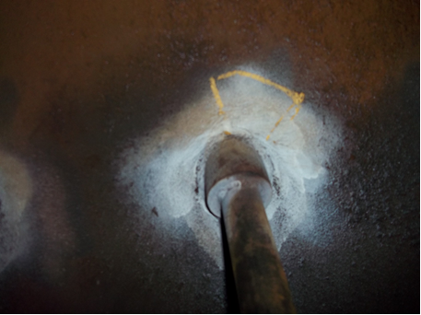

Nozzle 2 is the tanker filling connection (is connected to internal fill pipework) and has a 90 mm long crack as indicated below:

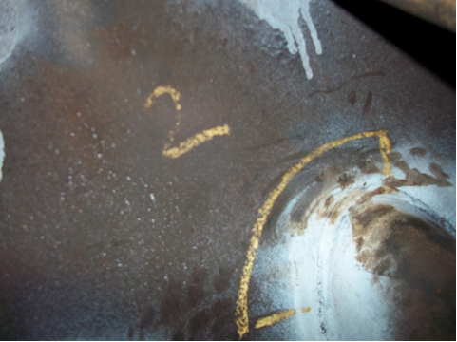

Nozzle 3 is the tanker vapour balance connection (and again is connected to internal pipework) and has a 50 mm long crack as indicated below:

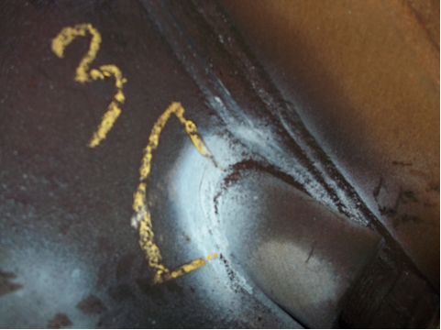

18. It is known that fixed tanks can pass/have passed hydraulic tests even though they have serious defects, which are not detected by a hydraulic test.
19. The magnetic particle examination of a weld (undertaken in 1995 as part of a company’s procedure when it purchasing a used fixed tank, that was constructed in 1973 by a very reputable tank manufacturer) around part of the main outlet connection nozzle identified that the internal root weld was missing and it just had a cap weld.

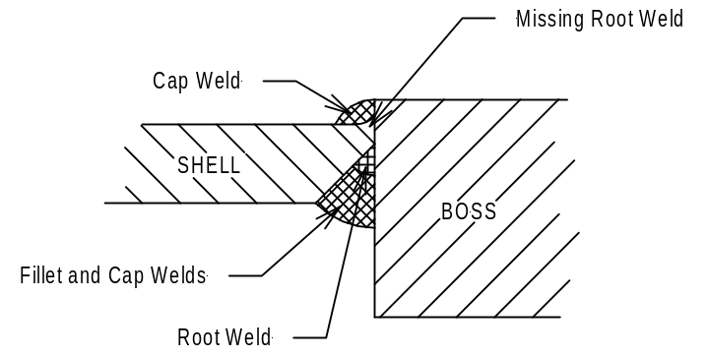

This missing weld gave an indication, during the magnetic particle inspection, that an internal crack was present along the length of the missing weld.
This fixed tank had previously passed four hydraulic tests - in 1973 (when it was first constructed), 1979, 1985 and 1991.
Environmental considerations
20. In addition to the possible contamination of components and the acceleration of oxidization of the internal surfaces of the vessel, using water as a hydraulic test medium can generate large quantities of waste water that must be treated by a suitably licensed disposal company and cannot be discharged to the ground or water drainage systems.
Another example of where NDT has replaced hydraulic testing
21. Steam Boilers: For many years it was a requirement in the United Kingdom that all steam boilers were hydraulically tested every 10 years. This legal requirement was repealed some years ago and most boilers (that have not undergone hot work repairs) are now re-qualified by using NDT techniques.

? In accordance with the programme of work of the Inland Transport Committee for 2010–2014 (ECE/TRANS/208, para. 106, ECE/TRANS/2010/8, programme activity 02.7 (c)).
? Circulated by the Intergovernmental Organisation for International Carriage by Rail (OTIF) under the symbol OTIF/RID/RC/2013/6.
1 0 In special cases and with the agreement of the expert approved by the competent authority, the hydraulic pressure test may be replaced by a pressure test using another liquid or gas, where such an operation does not present any danger.

