6.4.2. Mechanical Integrity
This test applies only to the REESS intended to be installed in vehicles of category M1 and N1.
At the manufacturer’s choice the test may be performed as, either
(a) vehicle based tests in accordance with paragraph 6.4.2.1 of this Regulation or
(b) component based tests in accordance with paragraph 6.4.2.2 of this Regulation.

6.4.2.1 Vehicle based test
At the manufacturer’s choice, the test may be performed as either
(a) vehicle based dynamic tests in accordance with paragraph 6.4.2.1.1 of this Regulation, or
(b) vehicle based static tests in accordance with paragraph 6.4.2.1.2 of this Regulation, or
(c) any combination of (a) and (b) above, for different direction of vehicle travel.

When the REESS is mounted in a position which is between a line from the rear edge of the motor vehicle perpendicular to center line of the vehicle and 300 mm forward and parallel to this line, this shall be agreed by the manufacturer together with the Technical Service.

The approval of a REESS tested under this paragraph shall be limited to the specific vehicle type.

6.4.2.1.1 Vehicle based dynamic test
Compliance with the requirements of the acceptance criteria of Paragraph 6.4.2.3.below may be demonstrated by REESS(s) installed in vehicles that have been subjected to a vehicle crash test in accordance with UNECE regulations ECE R12 Annex 3 or ECE R94 Annex 3 for frontal impact, and ECE R95 Annex 4 for side impact. The ambient temperature and the SOC shall be in accordance with the said Regulation.

6.4.2.1.2 Vehicle specific based static test
The test shall be conducted in accordance with Annex 8D of this Regulation.

The crush force replacing the prescribed force specified in paragraph 3.2.1 of Annex 8 D shall be determined by the vehicle manufacturer using test data obtained from either actual or simulated data according to ECE-R12 Annex 3 or ECE R94 Annex 3 in the direction of travel and according to ECE R95 Annex 4 in the direction horizontally perpendicular to the direction of travel. These forces shall be agreed in discussion with the Technical Service.

The manufacturer may define the relevant parts of the vehicle structure used for the mechanical protection of the REESS components. The test shall be conducted with the REESS mounted to this vehicle structure in a way which is representative of its mounting in the vehicle.

6.4.2.2 Component based test
The test shall be conducted in accordance with Annex 8D of this Regulation.
REESS approved according to this paragraph shall be mounted at a position where the horizontal distance parallel to the centre line of the vehicle from the foremost edge to the front edge of the motor vehicle is more than 420 mm and at a position where the horizontal distance parallel to the centre line of the vehicle from the rearmost edge to the rear edge of the motor vehicle is more than 300 mm. The mounting restrictions shall be documented in Annex 6 - Part 2. (approval form has to be amended)

For REESS which mounting location in the vehicle is restricted to and described as follows:
- not more than 400 mm ahead from the driver seat R point of the vehicle and
- not more than 400 mm to the rear from the rearmost seat R point of the vehicle or more than 600 mm away from the rearmost rear edge of the vehicle and
- at a position within more than 200 mm from the longitudinal chassis frame

See also Annex 8D for explanatory Figure 8

A contact force of 10 kN shall be applied.

The contact force which has to be applied has to be agreed

6.4.2.3 Acceptance criteria
During and after the test there shall be no evidence of:
- fire
- explosion
(c1) electrolyte leakage if tested according to 6.4.2.1 in the period from the impact until 30 minutes after no electrolyte from the REESS shall spill into the passenger compartment and no more than 7 per cent of electrolyte shall spill from the REESS except open type traction batteries outside the passenger compartment. For open type traction batteries no more than 7 per cent with a maximum of 5.0 liters shall spill outside the passenger compartment
(c2) electrolyte leakage if tested according to 6.4.2.2

The isolation resistance of the Tested-Device shall ensure at least 100 Ω/Volt for the whole REESS measured in accordance with Annex 4A, or the protection degree IPXXB shall be fulfilled for the Tested-Device.

Tested according 6.4.2.2 the evidence of electrolyte leakage shall be verified by visual inspection without disassembling any part of the Tested-Device.

To confirm compliance to c1) of this paragraph appropriate coating shall be applied, if necessary, to the physical protection in order to confirm any electrolyte leakage from the REESS after the impact test. Unless the manufacturer provides means to differentiate between the leakage of different liquids, all liquid leakage shall be considered as the electrolyte.

Annex 8D

Mechanical integrity

1. PURPOSE
The purpose of this test is to verify the safety performance of the REESS under contact loads which may occur during vehicle crash situation.

2. INSTALLATIONS
2.1 This test shall be conducted either with the complete REESS or with related subsystems of the REESS including the cells and their electrical connections. If the electronic management unit for the REESS is not integrated, such control unit may not be installed on the device under test by the discretion of the manufacturer.

2.2 The Tested-Device shall be connected to the test fixture as recommended by the manufacturer.

3. PROCEDURES
3.1. General test conditions
The following condition shall apply to the test:
- the test shall be conducted under a standard ambient temperature of 20 ± 10 °C.
- at the beginning of the test, the SOC shall be adjusted to a value in the upper 50% of the normal operating state of charge range.
- at the beginning of the test, all protection devices which effect the function of the Tested-Device and which are relevant for the outcome of the test shall be operational.

3.2. Crush test
3.2.0. Crush Plate
Figure 7: Dimension of the crush plate:
600 mm x 600 mm or smaller

3.2.1. Crush force
The Tested-Device shall be crushed between a resistance and a crush plate as described in figure 7 with a force of at least 100 kN, but not exceeding 105 kN with an onset time less than 3 minutes and a hold time of at least 100 ms and not exceeding 10s.
A higher crush force, a longer onset time, a longer hold time, also in combination, may be applied at the request of the manufacturer.
The application of the force shall be decided by the manufacturer together with the technical service in recommendation with regard to direction of travel and horizontally perpendicular to the direction of travel of the RESS.
After the release of the load, the Tested-Device shall be observed for 1 h at the ambient temperature conditions of the test environment. The test ends after the observing time.

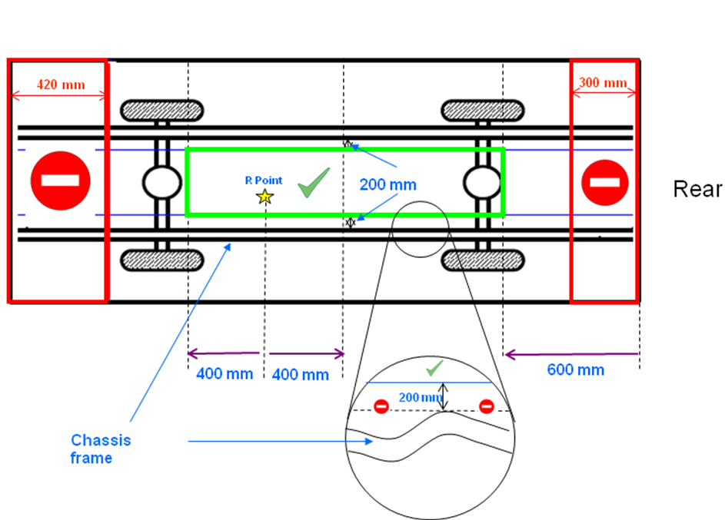

Figure 8 Explanation of battery safety zone
Annex 6 - Part 2

ESSENTIAL CHARACTERISTICS OF REESS

3. REESS
3.1. Trade name and mark of the REESS:
3.2. Indication of all types of cells:
3.2.1 The cell chemistry:
[3.2.2 Physical dimensions: ]
3.3. Description or drawing(s) or picture(s) of REESS explaining:
3.3.1 Structure:
3.3.2 Configuration (number of cells, mode of connection, etc.):
3.3.3 Dimensions:
3.3.4.4 Enclosures:
3.4 Electrical specification
3.4.1 Nominal voltage (V):
3.4.2 Working voltage (V):
3.4.3. Capacity (Ah):
3.4.4 Maximum current (A):
3.5. Gas combination rate (in per cent):
3.6 Description or drawing(s) or picture(s) of the installation of the REESS in the vehicle (including mounting restrictions according to paragraph 6.4.2.2.):
3.6.1 Physical support:
3.7 Type of thermal management:
3.8 Electronic control:
3.9. Category of vehicles which the REESS can be installed:

Definition.

(ECE-R95)

