 | United Nations | ECE/TRANS/WP.29/GRSP/2012/20
 | Economic and Social Council |  | Distr.: General  25 September 2012  Original: English
Economic Commission for Europe
Inland Transport Committee
World Forum for Harmonization of Vehicle Regulations
Working Party on Passive Safety
Fifty-second session
Geneva, 11–14 December 2012
Item 11 of the provisional agenda
Regulation No. 16 (Safety-belts)
Proposal for Supplement 3 to the 06 series of amendments
Submitted by the expert from the European Association of Automobile Suppliers *
The text reproduced below was prepared by the expert from the European Association of Automobile Suppliers (CLEPA) to amend requirements on emergency locking retractors. It is based on document without a symbol (GRSP-51-09) distributed during the fifty-first session of the Working Party on Passive Safety (GRSP) (see ECE/TRANS/WP.29/GRSP/51, para. 23). The modifications to the current text of the UN Regulation are marked in bold for new or strikethrough for deleted characters.
I. Proposal
Paragraph 6.2.5.3.2., amend to read:
"6.2.5.3.2. When tested in accordance with paragraph 7.6.2., an emergency locking retractor … direction of unreeling is not less than [3.0] g."
II. Justification
A. Reference, paragraph 6.2.5.3.2.
(Note: updates from GRSP-51-09 are in bold characters)
1. Safety-belts are broadly accepted as one of the major contributors to road safety. Buckling up is seen as an obligatory process after entering a vehicle by most of the car users, not only due to enforcement, but also due attitude. Wearing and handling comfort play an important role in increasing such a positive perception.
2. Most of the actually installed safety-belt systems represent emergency locking retractors. In the case of multiple sensitivity, strap sensitivity must not lock at an acceleration of less than 0.8 g and shall lock up at an acceleration of 2.0 g when measured in the direction of the extraction of the strap.
3. Devices with a strap sensitivity threshold in the area towards 0.8 g result in frequent locking phenomena already during pulling out the strap while buckling up. To prevent car user criticism and effects of refusing to wear the safety-belt at all, strap sensitivities are usually defined in an area close to 2.0 g. Anyhow this is not preventing the locking phenomena during buckling up entirely.
4. It is proposed to further increase the strap sensitivity to a range of up to [3.0]g to allow the installation of a user friendlier safety-belt system.
5. A similar step was already adopted in GRSP by an increase from 1.5g to 2.0g during its tenth session in 1991 based on TRANS/SC.1/WP.29/GRSP/R.60.
6. The upper threshold for webbing sensitivity was already adjusted from 1.2g to 1.5g due to a similar argumentation on practical use in the vehicle in the 1980s.
7. With today’s technology developed under the modified provisions of paragraph 6.2.5.3.4. allowing a reduced retracting force of the strap of 0.1 daN, respectively 0.05 daN with a tension-reduction device in operation, the practicability of the strap extraction while buckling is often confronted with a similar sticking phenomena.
8. In the normal use case, locking of a retractor is dominantly initiated by vehicle sensitivity. Strap sensitivity can be seen as a redundant mechanism to enable the locking function even with failing vehicle sensitivity in severe frontal crash modes.
9. Numerous studies with switched off vehicle sensitivity have shown that the proposed increase of strap sensitivity is not negatively affecting the performance of safety belts in severe frontal impacts.
B. Investigation in numerical simulation on a synthetic Euro New Car Assessment Programme (EuroNCAP) sled pulse with variation of strap sensitivity.
10. Vehicle sensitivity or strap sensitivity are switched off each to understand its solely influence to the belt forces. The seen onset of shoulder belt force shows no difference due to different chosen levels of strap sensitivities (WS). The diagram incorporates additionally for reference purpose the upper shoulder belt force with a vehicle sensitivity of 1.0 g (CS).
Diagram 1
Upper Shoulder Belt Force versus Time with Strap Sensitivities (WS 1.0 g up to 3.0 g)
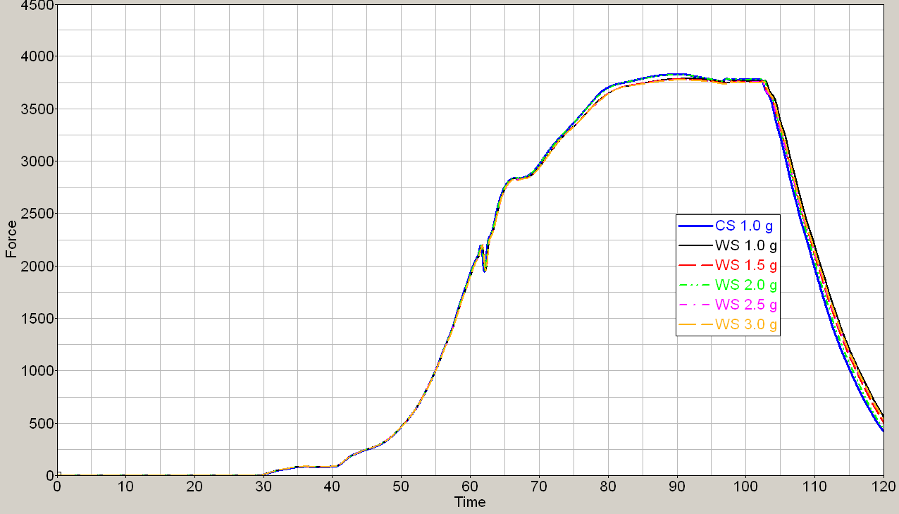

Diagram 2
Belt movement measure above the Retractor
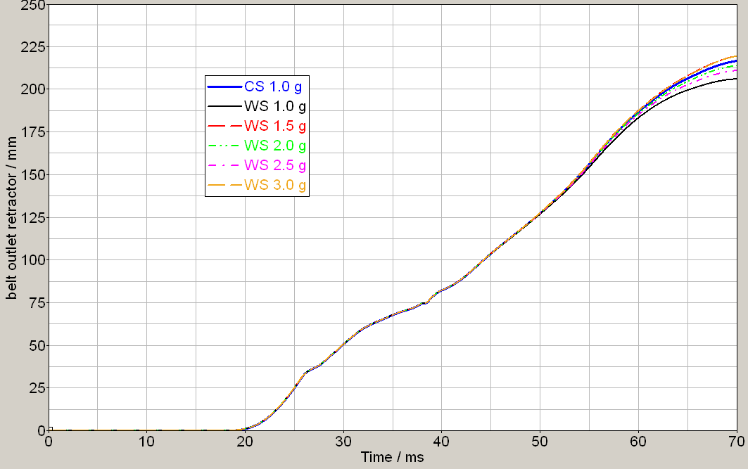

11. The consequent appearing belt movement analysed above the retractor housing, which represents the belt spending for the occupant kinematics and finally maximum forward displacement is shown in the diagram 2. The variation visible after 55 ms is affected by the restraint system (air bag deployment, air bag to internal parts contact, etc.). It can be demonstrated that different sensor layouts, in this case up to a webbing sensitivity of 3.0g do not show any evidence for a change in the occupant kinematics.
C. Investigation with UN Regulation No. 16 sled tests with variation of strap sensitivity.
12. Another study performed on UN Regulation No. 16 sled was set up to demonstrate potential differences between sensor layout 2.0g and 3.5g. To eliminate any kind of influence coming from the vehicle sensitivity, these elements were detached from the retractor.
13. Diagram 3 shows the shoulder belt forces versus time, specifically with a webbing sensitivity of 2.0g and 3.5g. There is no relevant difference visible.
14. The same counts for the forward displacements of the Nederlands Instituut voor Toegepaste Geowetenschappen (TNO) - 10 dummies, which are shown in Diagram 4. The kinematics with both sensitivities can be described as equal.
Diagram 3
Shoulder Belt Force versus Time with Strap Sensitivity 2.0g and 3.5g
Diagram 4
Forward Displacement TNO-10 on ECE-R 16 sled with Strap Sensitivity 2.0g and 3.5g

* * In accordance with the programme of work of the Inland Transport Committee for 2010–2014 (ECE/TRANS/208, para. 106 and ECE/TRANS/2010/8, programme activity 02.4), the World Forum will develop, harmonize and update Regulations in order to enhance the performance of vehicles. The present document is submitted in conformity with that mandate.

