 | United Nations | ECE/TRANS/WP.29/GRE/2013/6
 | Economic and Social Council |  | Distr.: General  28 January 2013  Original: English
Economic Commission for Europe
Inland Transport Committee
World Forum for Harmonization of Vehicle Regulations
Working Party on Lighting and Light-Signalling
Sixty-ninth session
Geneva, 8-11 April 2013
Item 3 of the provisional agenda
Regulation No. 37 (Filament lamps)
Proposal for Supplement 42 to the 03 series of amendments of Regulation No. 37
Submitted by the expert from the International Automotive Lighting and Light Signalling Expert Group (GTB)*
The text reproduced below was prepared by the expert from the International Automotive Lighting and Light Signalling Expert Group (GTB) to introduce light source categories WT(Y)21W and WT(Y)21/7W. The modifications to the existing text of the Regulation are marked in bold for new or strikethrough for deleted characters.

I. PROPOSAL

Annex 1, the list of categories of filament lamps, grouped and their sheet numbers, amend to read:

"
Group 2
Only for use in signalling lamps, cornering lamps, reversing lamps and rear registration plate lamps:
 | Category |  | Sheet number(s)
 | ...
 | WR21/5W |  | WR21/5W/1 | (W21/5W/2 to 3)
 | WT21W |  | WT21W/1 to 2
 | WT21/7W |  | WT21/7W/1 to 3
 | WTY21W |  | WT21W/1 to 2
 | WTY21/7W |  | WT21/7W/1 to 3
 | WY5W | ^{*6} | WY5W/1
 | ...
"

The list of sheets for filament lamps and their sequence, amend to read:

"
Sheet number(s)
…
WR21/5W/1
WT21W/1 to 2
WT21/7W/1 to 3
WY2.3W/1
…
"

Insert new sheets WT21W/1 to 2 and WT21/7W/1 to 3 between sheet WR21/5W/1 and sheet WY2.3W/1, to read: (see next pages):

Category WT21W AND WTY21W Sheet WT21W/1
The drawings are intended only to illustrate the essential dimensions (in mm) of the filament lamp
Reference Plane
Reference Axis
f
β
ø 20.5 Max
44 Max.
e
4/
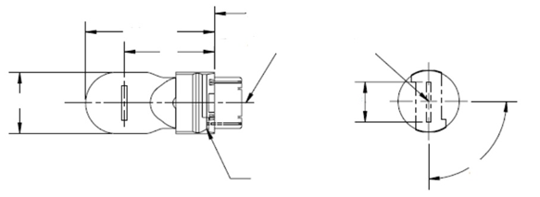
Reference Key

Dimensions in mm |  |  |  |  | Filament lamps of normal production |  |  |  |  | Standard filament lamp  5/
 |  |  |  |  | min. |  | nom. |  | max. | Standard filament lamp  5/
e |  |  | 12V |  |  |  | 27.9 ^{3/} |  |  | 27.9 ± 0.3
 |  |  | 24V |  | 26.9 |  | 27.9 |  | 28.9
f |  |  |  |  |  |  |  |  | 7.5 | 7.5 + 0/ - 2
Lateral deviation^{2/} |  |  | 12V |  |  |  |  |  | ^{3/} | 0.0 ± 0.4
 |  |  | 24V |  |  |  |  |  | 1.5
β |  |  |  |  | 75°^{3/} |  | 90° |  | 105°^{3/} | 90° ± 5°
Cap: | WT21W: [WUX2.5x16d]  WTY21W:[WUY2.5x16d] |  |  | in accordance with IEC Publication 60061 |  |  |  |  |  | (sheet 7004-[….]-1)  (sheet 7004-[….]-1)
Electrical and photometric characteristics
Rated values |  | Volts |  |  |  | 12 |  | 24 |  | 12
 |  | Watts |  |  |  | 21 |  |  |  | 21
Test voltage |  | Volts |  |  |  | 13.5 |  | 28.0 |  | 13.5
Objective values |  | Watts |  |  |  | 26.5 max. |  | 29.7 max. |  | 26.5 max.
 |  | Luminous flux | WT21W |  |  | 460 ± 15 %
 |  | Luminous flux | WTY21W |  |  | 280 ± 20 %
Reference luminous flux at approximately 13.5 V: |  |  |  |  |  |  |  |  |  | White: 460 lm  Amber: 280 lm
^{1/} The reference axis is defined with respect to the reference keys and is perpendicular to the reference plane.
^{2/} Maximum lateral deviation of the major (high wattage) filament centre from two mutually perpendicular planes both containing the reference axis and one containing the axis through the reference keys.
^{3/} To be checked by means of a "Box-System", sheets WT21W/2.
^{4/} The light emitted from filament lamps of normal production shall be white for category WT21W and amber for category WTY21W (see also note 5).
^{5/} The light emitted from standard filament lamps shall be white for category WT21W and white or amber for category WTY21W.

Category WT21W AND WTY21W Sheet WT21W/2
Screen projection requirements
This test is used to determine, by checking whether the filament is correctly positioned relative to the reference axis and reference plane and has an axis perpendicular, within ± 15°, to the plane through the centres of the keys and the reference axis, whether a filament lamp complies with the requirements.
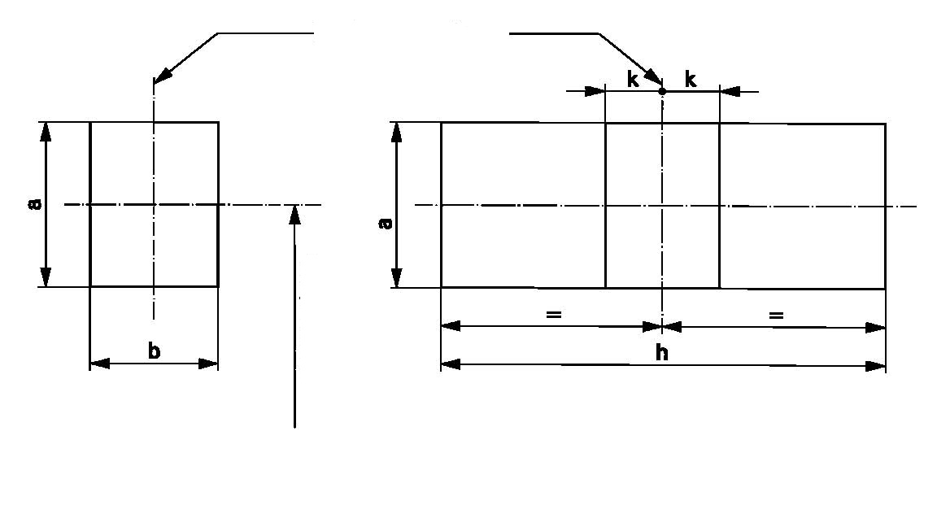
ReferenceabhkDimension3.53.09.51.0
Reference Axis
27.9 to
Reference Plane
Side Elevation
Front Elevation
Test procedures and requirements.
- The filament lamp is placed in a holder capable of being rotated about its axis and having either a calibrated scale or fixed stops corresponding to the angular displacement tolerance limits. The holder is then so rotated that an end view of the filament is seen on the screen on to which the image of the filament is projected. The end view of the filament shall be obtained within the angular displacements tolerance limits.
- Side elevation
The filament lamp placed with the cap down, the reference axis vertical and the filament seen end-on, the projection of the filament shall lie entirely within a rectangle of height "a" and width "b", having its centre at the theoretical position of the centre of the filament.
- Front elevation
The filament lamp placed with the cap down and the reference axis vertical, the filament lamp being viewed in a direction at right angles to the filament axis:

3.1. The projection of the filament shall lie entirely within a rectangle of height "a" and width "h", having its centre at the theoretical position of the centre of the filament.
3.2. The centre of the filament shall not be offset by more than distance "k" from the reference axis.
Category WT21/7W AND WTY21/7W Sheet WT21/7W/1
The drawings are intended only to illustrate the essential dimensions (in mm) of the filament lamp

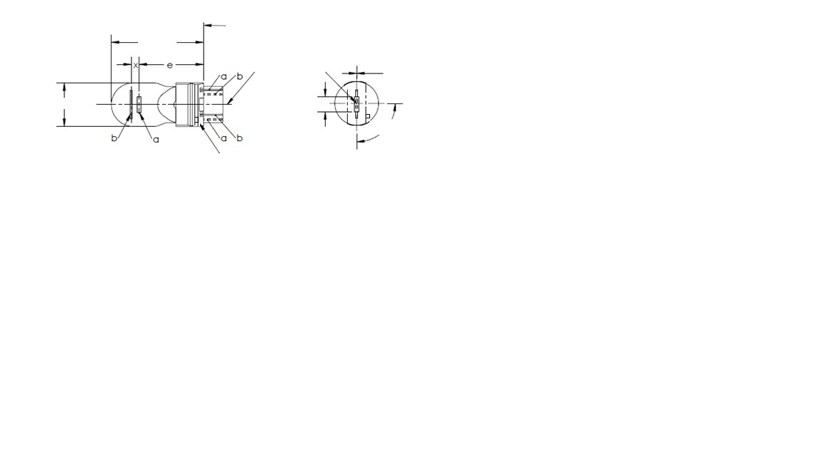
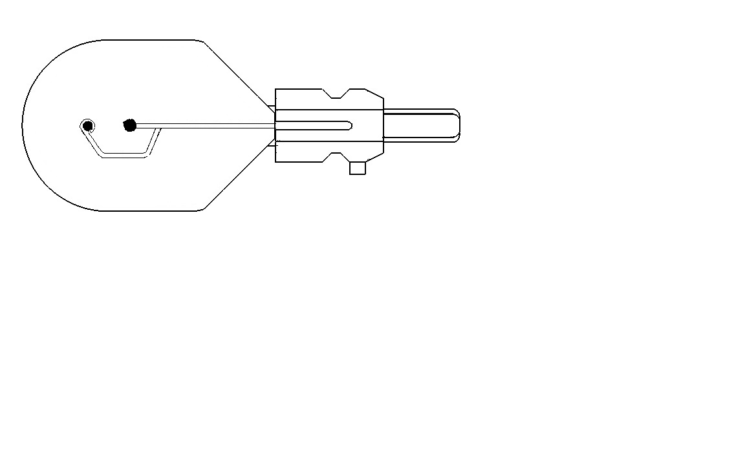
ø 20.5 Max.
6/
Support /5

Reference Key /5

Reference Plane
Reference Axis
f
44 Max.
β
y
a = major (high wattage) filament
b = minor (low wattage) filament

Dimensions in mm |  |  | Filament lamps of normal production 6/ |  |  |  |  |  | Standard filament lamp  7/
 |  |  | min. |  | nom. |  |  | max.
E |  |  |  |  | 27.9 ^{3/} |  |  |  | 27.9 ± 0.3
F |  |  |  |  |  |  |  | 7.5 | 7.5 + 0/ - 2
Lateral deviation^{2/} |  |  |  |  |  |  |  | ^{3/} | 0.0 ± 0.4
x ^{4/} |  |  |  |  | 5.1 ^{3/} |  |  |  | 5.1 ± 0.5
y ^{4/} |  |  |  |  | 0.0 ^{3/} |  |  |  | 0.0 ± 0.5
β |  |  | 75° ^{3/} |  | 90° |  |  | 105° ^{3/} | 90° ± 5°
Cap: | WT21/7W: [WZX2.5x16q]  WTY21/7W: [WZY2.5x16q] |  |  | in accordance with IEC Publication 60061 |  |  |  |  |  | (sheet 7004-[….]-1)  (sheet 7004-[….]-1)
Electrical and photometric characteristics
Rated values |  | Volts | 12 |  |  |  |  |  | 12
 |  | Watts | 21 |  |  |  | 7 |  | 21 |  | 7
Test voltage |  | Volts | 13.5 |  |  |  |  |  | 13.5
Objective values |  | Watts | 26.5 max. |  |  | 8.5 max. |  |  | 26.5 max. |  | 8.5 max.
 |  | Luminous flux | 440 ± 15 % |  |  | 35 ± 20 %
 |  | Luminous flux | 280 ± 20 % |  |  | 22 ± 20 %
Reference luminous flux at approximately 13.5 V: |  |  |  |  |  | White: 440 and 35 lm  Amber: 280 and 22 lm

For the notes see sheet WT21/7W/2.
Category WT21/7W AND WTY21/7W Sheet WT21/7W/2

^{1/} The reference axis is defined with respect to the reference keys and is perpendicular to the reference plane.
^{2/} Maximum lateral deviation of the major (high wattage) filament centre from two mutually perpendicular planes both containing the reference axis and one containing the axis through the reference keys.
^{3/} To be checked by means of a "Box-System", sheets WT21/7W/2 and 3.
^{4/} "x" and 'y" denote the offset of the axis of the minor (low wattage) filament with respect to the axis of the major (high wattage) filament.
^{5/} If the minor filament is positioned using an asymmetric support similar to the one shown then the reference key and support structure must be located on the same side of the filament lamp.
^{6/} The light emitted from filament lamps of normal production shall be white for category WT21/7W and amber for category WTY21/7W (see also note 7).
^{7/} The light emitted from standard filament lamps shall be white for category WT21/7W and white or amber for category WTY21/7W.

Screen projection requirements
This test is used to determine, by checking whether:
- the major (high wattage) filament is correctly positioned relative to the reference axis and reference plane and has an axis perpendicular, within ± 15°, to the plane through the centres of the keys and the reference axis; and whether:
- the minor (low wattage) filament is correctly positioned relative to the major (high wattage) filament, whether a filament lamp complies with the requirements.

Test procedure and requirements.
- The filament lamp is placed in a holder capable of being rotated about its axis and having either a calibrated scale or fixed stops corresponding to the angular displacement tolerance limits. The holder is then so rotated that an end view of the major filament is seen on the screen on which the image of the filament is projected. The end view of that filament shall be obtained within the angular displacement tolerance limits.
- Side elevation
The filament lamp placed with the cap down, the reference axis vertical, the reference key to the right and the major filament seen end-on:

2.1. The projection of the major filament shall lie entirely within a rectangle of height "a" and width "b", having its centre at the theoretical position of the centre of the filament;
2.2. The projection of the minor filament shall lie entirely within a rectangle of width "c" and height "d" having its centre at a distance "u" above the theoretical position of the centre of the major filament.
3. Front elevation
The filament lamp being placed with the cap down and the reference axis vertical, the filament lamp being viewed in a direction at right angles to axis of the major filament:

3.1. The projection of the major filament shall lie entirely within a rectangle of height "a" and width "h", centred on the theoretical position of the centre of the filament;
3.2. The centre of the major filament shall not be offset by more than distance "k" from the reference axis;
3.3. The centre of the minor filament axis shall not be offset from the reference axis by more than ± 2 mm (± 0.4 mm for standard filament lamps).

Category WT21/7W AND WTY21/7W Sheet WT21/7W/3

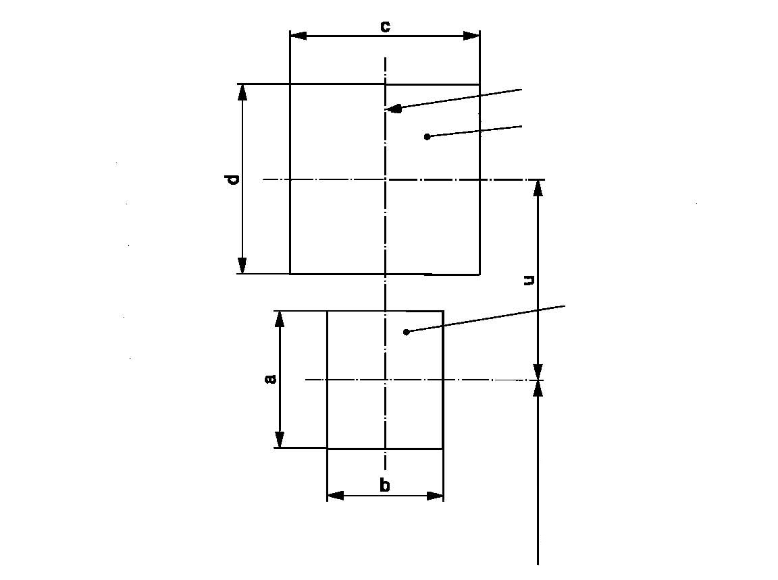
Reference Axis
low-wattage filament
high-wattage filament
27.9 to reference plane
Side Elevation

Reference | a | b | c | d | u
Dimensions | 3.5 | 3.0 | 4.8 |  | 5.1

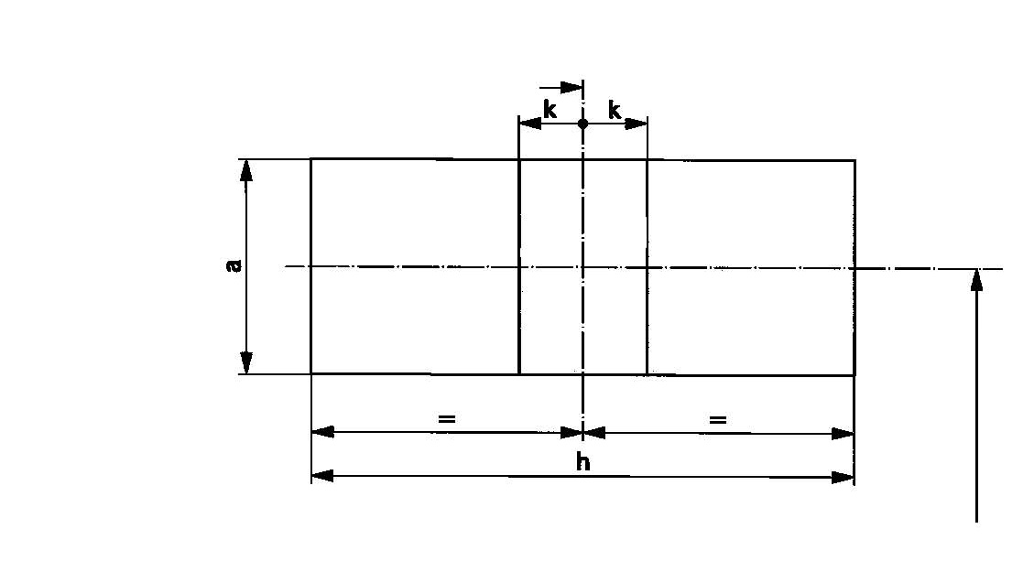
Reference Axis
27.9 to reference
plane
Front Elevation

Reference | a | h | k
Dimensions | 3.5 | 9.5 | 1.0
II. Justification
1. Over the past several years, the market has been shifting into two distinct areas for signal and marking lighting applications. One area being advanced LED technology, which provides custom solutions and advanced styling features; however, in some cases this technology is cost prohibitive. The second area is placing increasing demands on traditional signal and marking solutions to fill the need for economical solutions, with greater performance. As a result, the market has requested a smaller packaged signal/marking filament lamp which can help gain the optical efficiency with the benefits of a tight tolerance plastic base.
2. The WT21 filament lamps are intended to provide the following advantages:
(a) Better reflector efficiency and greater styling flexibility by using a smaller bulb outer diameter and improved base/cap geometry;
(b) Proven reliability for shock and vibration by using the similar mount design as P27/7W with larger coil separation;
(c) Proven plastic base/connector interface design similar to P27/7W combined with small bulb technology.
3. For the single filament categories, a 24V version is also specified.
4. The fundamental structure of this filament lamp is the same as P27/7W except for the non-interchangeable structure of the cap, diameter of the cap, diameter of the light source capsule and length of the light source.
5. A proposal for the cap and holder has been sent to IEC.

* * In accordance with the programme of work of the Inland Transport Committee for 2010–2014 (ECE/TRANS/208, para. 106, ECE/TRANS/2010/8, programme activity 02.4), the World Forum will develop, harmonize and update Regulations in order to enhance the performance of vehicles. The present document is submitted in conformity with that mandate.

