 | United Nations | ECE/TRANS/WP.29/GRE/2013/26
 | Economic and Social Council |  | Distr.: General  28 January 2013  Original: English
Economic Commission for Europe
Inland Transport Committee
World Forum for Harmonization of Vehicle Regulations
Working Party on Lighting and Light Signalling (GRE)
Sixty-Ninth session
Geneva, 8-11 April 2013
Item 5(d) of the provisional agenda
Regulations Nos. 3, 4, 6, 7, 19, 23, 38, 65, 69, 70, 77, 87, 91, 98, 112, 113, and 119
Proposal for Supplement 20 to the 00 series of amendments to Regulation No. 23 (reversing lights)
Submitted by the expert from Germany*
The text reproduced below was prepared by the expert from Germany updating the Conformity of Production requirements (CoP). The modifications to the current text of the Regulation are marked in bold for new or strikethrough for deleted characters.

I. Proposal
Paragraph 9.1., amend to read:
"9.1. Lamps shall be so manufactured as to conform to the type approved under this Regulation.
The compliance with the requirements set forth in paragraphs 6 and 8 above shall be verified as follows:"
Paragraph 9.2. (former), renumber as paragraph 9.1.1.
Paragraph 9.3. (former), renumber as paragraph 9.1.2.
Paragraph 9.4. (former), renumber as paragraph 9.2.
Annex 5, paragraph 1.2 amend to read
"1.2. With respect to photometric performance, the conformity of mass-produced lamps shall not be contested if, when testing according to paragraph 7 of this Regulation, the photometric performances as set forth in paragraph 6 of this Regulation of any lamp chosen at random:"
Annex 5, paragraph 1.2.1. amend to read:
"1.2.1. according to the requirements in paragraph 1.2.1. of Annex 4 to this Regulation are met."
Annex 5, paragraph.2. to 5. amend to read:
"2. First sampling
In the first sampling four lamps are selected at random. The first sample of two is marked A, the second sample of two is marked B.
2.1. The conformity of mass-produced lamps shall not be contested if the deviation of any specimen of samples A and B (all four lamps) is not more than 20 per cent.
In the case, that the deviation of both lamps of sample A is not more than 0 per cent the measurement can be closed.
2.2. The conformity of mass-produced lamps shall be contested if the deviation of at least one specimen of samples A or B is more than 20 per cent.
The manufacturer shall be requested to bring his production in line with the requirements (alignment) and a repeated sampling according to paragraph 3. below shall be carried out within two months' time after the notification. The samples A and B shall be retained by the Technical Service until the entire CoP process is finished.
3. First repeated sampling
A sample of four lamps is selected at random from stock manufactured after alignment.
The first sample of two is marked C, the second sample of two is marked D.
3.1. The conformity of mass-produced lamps shall not be contested if the deviation of any specimen of samples C and D (all four lamps) is not more than 20 per cent.
In the case, that the deviation of both lamps of sample C is not more than 0 per cent, the measurement can be closed.
3.2. The conformity of mass-produced lamps shall be contested if the deviation of at least
3.2.1. one specimen of samples C or D is more than 20 per cent but the deviation of all specimen of these samples is not more than 30 per cent.
The manufacturer shall be requested again to bring his production in line with the requirements (alignment).
A second repeated sampling according to paragraph 4. below shall be carried out within two months' time after the notification. The samples C and D shall be retained by the Technical Service until the entire CoP process is finished.
3.2.2. one specimen of samples C and D is more than 30 per cent.
In this case the approval shall be withdrawn and paragraph 5 below shall be applied.
4. Second repeated sampling
A sample of four lamps is selected at random from stock manufactured after alignment.
The first sample of two is marked E, the second sample of two is marked F.
4.1. The conformity of mass-produced lamps shall not be contested if the deviation of any specimen of samples E and F (all four lamps) is not more than 20 per cent.
In the case, that the deviation of both lamps of sample E is not more than 0 per cent, the measurement can be closed.
4.2. The conformity of mass-produced lamps shall be contested if the deviation of at least
one specimen of samples E or F is more than 20 per cent.
In this case the approval shall be withdrawn and paragraph 5 below shall be applied.
5. Approval withdrawn
Approval shall be withdrawn according to paragraph 10. of this Regulation."
Figure 1, shall be deleted.
II. Justification
1. The present set of proposals for amendments to the CoP provisions in a number of Regulations on lighting and light-signalling is based on ECE/TRANS/WP.29/GRE/2012/19 which was considered at the sixty-eighth GRE session. GRE invited the expert from Germany to prepare a revised proposal covering all relevant lighting UN Regulations and adding the necessary background information. The proposals reflect the results of discussions and evaluation of input from experts carried out after the sixty-seventh GRE session.
2. The scope of the proposals was defined as follows:
(a) The package of collective amendments covers the CoP provisions in Regulations Nos. 3, 4, 6, 7, 19, 23, 38, 65, 69, 70, 77, 87, 91, 98, 112, 113 and 119. In addition to the proposals for Regulation No.7 and 98 are two informal documents prepared, which contain the entire text of the Regulations.
(b) Regulations Nos. 37, 48, 53, 74 and 99 have not been included, as they are written in a different format.
(c) Regulations Nos. 1, 5, 8, 20, 56, 57, 72 and 82 remain unchanged, because they are not applicable for new approvals.
(d) Regulations Nos. 50, 88 and 104 have also been left behind for the time being, as their CoP provisions are set out as a general paragraph of the Regulation and contain no detailed requirements like the existing annexes on "Minimum requirements for conformity of production control procedures" and "Minimum requirements for sampling by an inspector". The update of these Regulations would require a fundamental approach and can be done after GRE has taken a decision on the CoP issue.
3. The proposals clarify in the relevant paragraphs of the above mentioned Regulations, that the specimens taken at random may deviates unfavourably by not more than 20 per cent from the prescribed (required) values.
4. In the relevant annexes on "Minimum requirements for conformity of production control procedures" of the light-signalling-regulations, tables equivalent to the lighting regulations were incorporated, which show the equivalent deviation in candela for small values (e.g. geometric visibility).
5. The relevant annexes on "Minimum requirements for sampling by an inspector" were completely restructured and simplified. All former examples which caused a great deal of confusion were deleted.
6. CoP is now described in a clear structured stepwise process (with limited steps), which gives the manufacturer the chance in the first step - in the case of deviations of more than 20 per cent - to align his production process. Also, the CoP process can be completed earlier when the first two samples are in the full specifications.
7. The proposal details the "third step" which defines the condition where the approval shall be withdrawn, when after the second repetition of this process the manufacturer was not in the position to "align" his production process in the correct way.
8. The attached drawing shall demonstrate this stepwise process.
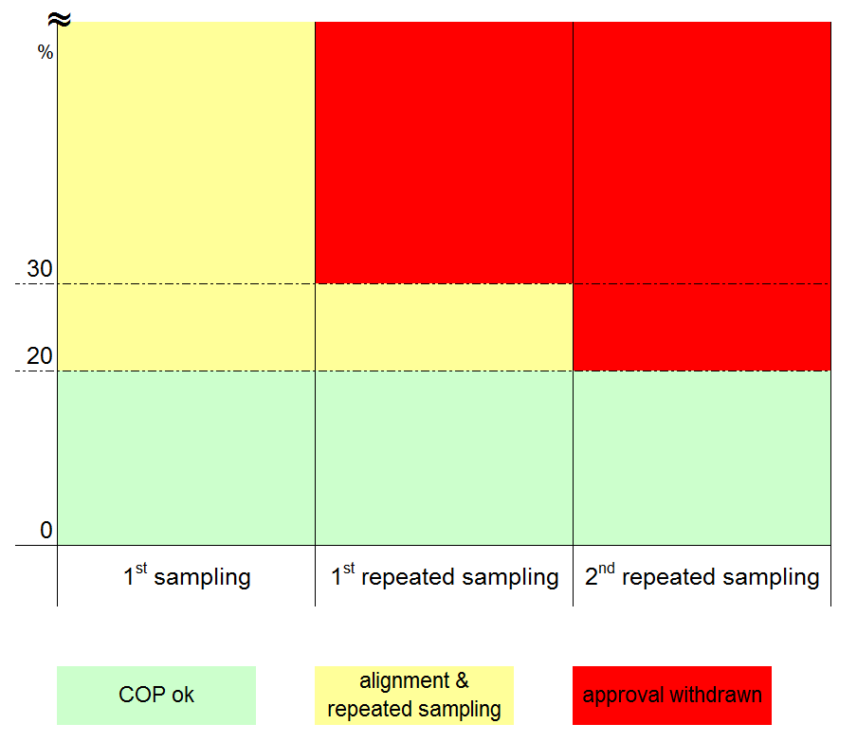
9. The existing Figure 1 could therefore be deleted, because this Figure has rather increased than clarified the confusion - and with the new simplified description it is not necessary anymore.

* * In accordance with the programme of work of the Inland Transport Committee for 2010–2014 (ECE/TRANS/208, para. 106 and ECE/TRANS/2010/8, program activity 02.4), the World Forum will develop, harmonize and update Regulations in order to enhance the performance of vehicles. The present document is submitted in conformity with that mandate

